Running an open experiment: transparency and reproducibility in soil and ecosystem science

Ben Bond-Lamberty1, A. Peyton Smith2, Vanessa Bailey2

February 2, 2016

1Joint Global Change Research Institute, DOE Pacific Northwest National Laboratory, College Park, MD USA; [bondlamberty@pnnl.gov](mailto:bondlamberty@pnnl.gov)

2Biological Sciences Division, Pacific Northwest National Laboratory, Richland, WA USA

#### Abstract

Researchers in soil and ecosystem science, and almost every other field, as increasingly being pushed--by funders, journals, governments, and themselves--to increase transparency and reproducibility of their work. A key part of this effort is a move towards *open data* as a way to fight post-publication data loss, improve data and code quality, enable powerful meta- and cross-disciplinary analyses, and increase trust in, and the efficiency of, publicly-funded research. Here we describe a recent "open experiment", in which we documented every aspect of a soil incubation experiment online, making all raw data, scripts, diagnostics, final analyses, and manuscripts publicly available in real time. We found that using tools such as version control, issue tracking, and open-source statistical software improved data integrity, accelerated our team's communication and productivity, and ensured transparency. There are many avenues to improve scientific reproducibility and data availability, of which is this only one example, and it is not an approach suited for every experiment or situation. Nonetheless, we encourage the communities in our respective fields to consider its advantages, and to lead rather than follow with respect to scientific reproducibility, transparency, and data availability.

#### Introduction

Science is becomingly increasingly collaborative and data-intensive (Adams 2012); in conjunction with revolutions in Internet-based communication, this has created new reserach opportunities across former geographic and disciplinary barriers. At the same time, a wide variety of factors are encouraging, at times pushing, scientists to increase data access and use "best practices" in dealing with data and code (Wilson et al. 2014, Hart et al. 2015).

These factors include journals, which are adopting increasingly stringent data access and deposition policies, e.g. *Scientific Data*[1], *PLOS ONE*[2], and *Science*[3]. These policies generally share common assumptions and goals: maximizing access to scientific data; encouraging deposition into structured repositories as opposed to journal supplementary information; and specifying that it is not acceptable for authors to be solely responsible for ensuring data access. Funders are moving in this direction as well, with organizations such as the U.S. National Science Foundation[4] and the U.K. Wellcome Trust[5], along with many others, requiring explicit data management plans, unfettered reasonable access to primary data, and use of established repositories.

Finally, growing numbers of scientists are pushing for open science and data on moral/political grounds, with respect to taxpayer-funded research, as well as purely scientific ones, in particular ensuring reproducibility (Stodden 2011) and enabling larger synthetic activities. Such analyses (Wolkovich et al. 2012b) are made possible by the assembly of large, internally consistent data sets. Examples in ecology, soil science, and biogeosciences include BAAD (Falster et al. 2015), TRY (Kattge et al. 2011), FLUXNET (Baldocchi et al. 2001), and SRDB (Bond-Lamberty and Thomson 2010). Online databases and collaborative tools have expanded the abilities of researchers to collaborate across large distances, both improving data access and facilitating multidisciplinary research partnerships (Markowitz et al. 2015).

We briefly discuss what we see as the primary arguments for data sharing and openness, before detailing a recent "open experiment" example.

**Repeatability and reproducibility**

Reproducibility of experimental results is at the heart of science and a requirement for results to be accepted as factual (Kuhn 1962). Too often, however, sufficient details and data are not publicly available to even attempt to repeat a study (i.e. perform it again in a comparable manner, while not expecting exactly the same result). For example, surveying the 2000-2014 biomedical literature, Iqbal et al. (2016) found that none of 441 randomly-chosen studies provided raw data, and only one provided full protocols. The issues of reproducibility and repeatability in ecology (and its many related fields) have been raised and debated for years (Cassey and Blackburn 2006, Ellison 2010) but ecological, soil science, and global change journals differ widely in their data deposition requirements, when such requirements exist at all.

As code and data have become increasingly intertwined, the availability of the former has become a fundamental problem as well. Specialized modeling groups have worked to improve reproducibility and archiving practices (Thornton et al. 2005). More generally, scientists in all fields are increasingly building and using software in their work, though often without strong training in this area (Wilson et al. 2014). In addition to open-source data analysis languages such as R (R Development Core Team 2016), scientific workflow systems such as Kepler (<https://kepler-project.org>) or Taverna (<http://www.taverna.org.uk>) record information about the data processing, analytical process and decisions, and statistical analysis. Providing open code does not magically produce bug-free code, mistake-free analyses, or instantly better science (Easterbrook 2014). But it does encourage authors to invest the time upfront to clean up their code, data, and documentation when a paper is written, rather than deferring this task (often until key details have been forgotten, if not forever).

**Data loss**

Vines et al. (2014) published a shocking finding, based on a survey of 516 biology articles from 2 to 22 years old: the odds of a data set being available fell by 17% each year, and the chances that the contact author's email address still worked declined by 7% per year. Similarly, Reichman et al. (2011) estimated that less than 1% of ecological data collected is made available after publication, and noted, as an example, that much current and historical data relevant to the recent *Deepwater Horizon* oil spill are already inaccessible or lost (Reichman et al. 2011). In global change ecology, Wolkovich et al. (2012b) reported that only ~10% of raw data sets were eventually shared in their attempt to conduct a meta-analysis (Wolkovich et al. 2012a).

Data loss hits ecosystem, soil, and global change ecology particularly hard, as climate changes make ecological data effectively irreproducible (Wolkovich et al. 2012b): we can never remeasure exactly the same system state. This results in a critical role for syntheses and meta-analyses (Cassey and Blackburn 2006, Ellison 2010), which depend on the existence of documented protocols and (ideally raw) data. A subtler data loss issue is the "file drawer problem" (Rosenthal 1979), where unpublished but potentially valuable data are lost forever. Scientists' use of strong and consistent data curation practices (Rüegg et al. 2014, Hart et al. 2015) can mitigate the problem, but all our anecdotal experience and quantitative studies (Vines et al. 2014) suggest that in the long term, data cannot be reliably preserved by individual researchers.

This in turns means that the role of established, structured data and code repositories is critical. These provide a much-needed improvement on "Supplementary Information" sections accompanying journal articles, which have become *de facto* repositories of data, but often accessible only in inconvenient formats (e.g. PDF), have restrictions for use, and uncertain long-term availability (Molloy 2011, Neylon 2012). Most journals do not have expertise in data storage and management (Cassey and Blackburn 2006). In contrast, the best repositories provide easy data uploading, assignment of data digital object identifiers (DOIs), and long-term stability and availability. They do not, however, eliminate all risks: for example, the genomics sciences have a long history of requiring sequences to be deposited, but there are multiple repositories of varying curatorial levels, data quality, and formats, causing longer-term problems (Lagesen et al. 2010).

**Institutional and social trust**

Finally, there are longer-term issues of trust to consider--in particular, the public's trust in science and science's trust in people (Grand et al. 2012). Both of these have been weakened by public controversies over particular issues--most particularly relevant to our fields of research, climate change (IPCC 2013). In addition to such issues of trust in the *correctness* of science, there is that of trust in *utility* of science: why should the public fund scientists if the latter are not producing demonstrably replicable and reusable results? Why should politicians and other stakeholders not push for greater return on public investment in scientific research, and conclude that more data openness serves this cause (Neylon 2012)?

These reasons have led, at least in part, to governments efforts to have the results of federally funded scientific research made available to the public, industry, and across the scientific community (Holdren 2013). Strong "open science" and "open data" movements argue that the completeness of information provided by open science is fundamentally beneficial, complementing and perhaps replacing older systems for establishing trust within science (Grand et al. 2012), and between science and the public. These movements increasingly deny that "the intellectual property rights of publishing [scientists]" (Cassey and Blackburn 2006) take precedence over all other factors, at least as far as publicly-funded research is concerned.

#### An open experiment: one example

In early 2015, we planned a laboratory incubation experiment to characterize the chemical and biological properties of sub-Arctic, active layer soils subjected to changes in temperature and moisture. In this experiment, we would measure greenhouse gas fluxes from soil cores over 100 days, and measure the cores' physical, chemical, and biological characteristics under temperature and moisture changes. This required (i) a multidisciplinary team that was not located in one time zone; (ii) integrating a variety of different data; (iii) performing quality control and diagnostics rapidly, so if e.g. instrument problems arose we would lose only the minimum amount of time and data; (iv) tightly integrating data, statistical analyses, and manuscript results.

We used GitHub, a web-based Git repository hosting service, to store our data, scripts, and manuscripts. "Git" is a popular, free, and open source version control software: it tracks changes (when, what, by whom) made in a "repository", a collection of folders and files. Many scientific and other users of Git use the "GitHub" web service, as it offers excellent performance and a wide variety useful additional functinality, particularly for teams or collaborative projects.

The design of our repository is shown in **Figure 1**, and the repository itself can be found at <https://github.com/bpbond/cpcrw_incubation>. It consists of a series of scripts that feed their results from one to the next, starting with raw data and ending with final analyses, figures, and manuscripts.

This system had a number of characteristics:

* The entire data processing and analytical system is online and documented. It is written in R (R Development Core Team 2016), an open-source and widely used language and environment for statistical computing and graphics.
* The version control system let us make incremental changes, work out problems, look at histories (i.e., who made what change when).
* An issue tracker let us discuss problems, reference changes in the repository, create to-do lists, and assign responsibilities.
* An informational webpage provided non-technical explanations of the experiment and broader project.
* Manuscripts were directly tied into the data system (cf. **Figure 1**), with numerical results flowing directly into e.g. results sections. This meant that changes to the data (and thus statistical results, etc.) propagated automatically and consistently. Tools such as R Markdown[6] have made this process much easier to build and maintain.
* Log files provide an audit trail (Ellison 2010) of what analytical steps were taken and, critically, the specific versions used for each unit of software, including the main R system itself. This is critical as software changes with time, a potentially big problem in reproducing previous analyses.

We found a number of advantages to this system:

* The public nature of the repository encouraged us to flesh out documentation, use clean and clear coding, and think about the longer-term ramifications of decisions.
* Real-time diagnostics (**Figure 2**) let the team, our DOE program managers, and other interested parties see at a glance the progress of the experiment.
* The issue tracker helped our team--which was not physically located all in one place--to communicate, discuss, and track "issues" (i.e., problems or questions that arose).
* Investing the effort to set up a software pipeline before, not after, the experiment was performed meant that we could reliably and easily identify and diagnose problems.
* The real-time collaboration, and the public exposure of all stages inspired us to keep all activities moving quickly--in this case, it was less than ten months between sampling soil cores in the Alaskan forest and submitting two resulting manuscripts.
* Our project and experiment received more exposure and publicity than it otherwise would have.

#### Conclusions

Transparency is no magic panacea ensuring repeatability and reproducibility (Easterbrook 2014), and may raise genuine concerns about, for example, protecting scientists from harassment (Lewandowsky and Bishop 2016). Nor will open science by itself fundamentally enhance public trust in science, as there are still many social and political challenges to overcome (Grand et al. 2012).

Scientists also frequently cite other concerns: about data sharing, being "scooped", not receiving sufficient credit, and time constraints (Wolkovich et al. 2012b). The benefits are not always clear to researchers who might otherwise be open to following open-data practices (Molloy 2011). We cannot easily dismiss all of these concerns: for example, does our community adequately credit researchers who contribute to global databases that subsequently produce high-impact papers? Such meta-analyses rely on the collection of primary data, and it is critical that field and experimental researchers efforts are adequately valued and cited (Kueffer et al. 2011).

We also recognize that, in general, our professional and career incentives do not yet align well with "an open research culture" (Nosek et al. 2015). That is, scientists do not receive 'proper' credit for datasets relative to publications, even when the former may be much more broadly valuable, in almost every area: hiring, promotion and tenure decisions, impact metrics, etc. The advent of 'data descriptor' articles, in journals such as *Scientific Data*, improves but does not solve this problem.

The model we present here--a public repository updated throughout the experiment, analysis, and publication process--is far from perfect. First, there are a number of "best practices" of scientific computing (Wilson et al. 2014) that we did not employ, in particular with respect to automation. Second, this approach may not be appropriate for, nor applicable to, all study types, even just in our professional fields of soil, ecosystem, and global change science; it certainly is not appropriate for sensitive human-subject data. Third, Git and GitHub are designed for working with code, not data. Although this situation continues to improve on a technical level[7], it still requires a fair amount of coding expertise to set up and run a experimental repository such as the one detailed here.

In summary, a variety of forces continue to push scientists towards more transparency in their methods, code, and data, with the goals of increasing reproducibility, enabling syntheses and meta-analyses, and improving trust in, and return from, publicly-funded science. While imperfect, the open experiment example we highlight here does offer instrument-to-final product reproducibility and a very high level of transparency. Elements of it (e.g., the use of issue-tracking software) might be usefully adopted in isolation, but we hope the entire experiment will be an example of individual scientists' decisions and practices (Wolkovich et al. 2012b) having a larger impact. We encourage the communities in our respective fields to consider its advantages, and to lead rather than follow with respect to scientific reproducibility, transparency, and data availability.

**References**

Adams, J. 2012. Collaborations: The rise of research networks. Nature **490**:335-336.

Baldocchi, D. D., E. Falge, L. Gu, R. J. Olson, D. Y. Hollinger, S. W. Running, P. M. Anthoni, C. Bernhofer, K. J. Davis, and R. D. Evans. 2001. FLUXNET: a new tool to study the temporal and spatial variability of ecosystem-scale carbon dioxide, water vapor, and energy flux densities. Bulletin of the American Meteorological Society **82**:2415-2434.

Bond-Lamberty, B., and A. M. Thomson. 2010. A global database of soil respiration data. Biogeosciences **7**:1915-1926.

Cassey, P., and T. M. Blackburn. 2006. Reproducibility and repeatability in ecology. BioScience **56**:958-959.

Easterbrook, S. M. 2014. Open code for open science? Nature Geoscience **7**:779-781.

Ellison, A. M. 2010. Repeatability and transparency in ecological research. Ecology **91**:2536-2539.

Falster, D. S., R. A. Duursma, M. I. Ishihara, D. R. Barneche, R. G. FitzJohn, A. Vårhammar, M. Aiba, M. Ando, N. Anten, M. J. Aspinwall, J. L. Baltzer, C. Baraloto, M. Battaglia, J. J. Battles, B. Bond-Lamberty, M. van Breugel, J. Camac, Y. Claveau, L. Coll, M. Dannoura, S. Delagrange, J.-C. Domec, F. Fatemi, W. Feng, V. Gargaglione, Y. Goto, A. Hagihara, J. S. Hall, S. Hamilton, D. Harja, T. Hiura, R. Holdaway, L. S. Hutley, T. Ichie, E. J. Jokela, A. Kantola, J. W. G. Kelly, T. Kenzo, D. King, B. D. Kloeppel, T. Kohyama, A. Komiyama, J.-P. Laclau, C. H. Lusk, D. A. Maguire, G. le Maire, A. Mäkelä, L. Markesteijn, J. Marshall, K. McCulloh, I. Miyata, K. Mokany, S. Mori, R. W. Myster, M. Nagano, S. L. Naidu, Y. Nouvellon, A. P. O'Grady, K. L. O'Hara, T. Ohtsuka, N. Osada, O. O. Osunkoya, P. L. Peri, A. M. Petritan, L. Poorter, A. Portsmuth, C. Potvin, J. Ransijn, D. Reid, S. C. Ribeiro, S. D. Roberts, R. Rodríguez, A. Saldaña-Acosta, I. Santa-Regina, K. Sasa, N. G. Selaya, S. C. Sillett, F. Sterck, K. Takagi, T. Tange, H. Tanouchi, D. Tissue, T. Umehara, H. Utsugi, M. A. Vadeboncoeur, F. Valladares, P. Vanninen, J. R. Wang, E. Wenk, R. Williams, F. de Aquino Ximenes, A. Yamaba, T. Yamada, T. Yamakura, R. D. Yanai, and R. A. York. 2015. BAAD: a Biomass And Allometry Database for woody plants. Ecology **96**:1445-1445.

Grand, A., C. Wilkinson, K. Bultitude, and A. F. T. Winfield. 2012. Open Science: a new "trust technology"? Science Communication **34**:679-689.

Hart, E., P. Barmby, D. S. LeBauer, F. Michonneau, S. Mount, T. Poisot, K. H. Woo, N. ZImmerman, and J. W. Hollister. 2015. Ten simple rules for digital data storage. PeerJ.

Holdren, J. P. 2013. Increasing Access to the Results of Federally Funded Scientific Research.

IPCC. 2013. Working Group I contribution to the IPCC Fifth Assessment Report Climate Change 2013: The Physical Science Basis.

Iqbal, S., J. D. Wallach, M. J. Khoury, S. D. Schully, and J. P. A. Ioannidis. 2016. Reproducible research practices and transparency across the biomedical literature. PLoS Biology **14**:e10023333.

Kattge, J., S. Díaz, S. Lavorel, I. C. Prentice, P. Leadley, G. Bönisch, E. Garnier, M. Westoby, P. B. Reich, I. J. Wright, J. H. Cornelissen, C. Violle, S. P. Harrison, P. M. van Bodegom, M. Reichstein, B. J. Enquist, N. A. Soudzilovskaia, D. D. Ackerly, M. Anand, O. K. Atkin, M. Bahn, T. R. Baker, D. D. Baldocchi, R. Bekker, C. C. Blanco, B. Blonder, W. J. Bond, R. A. Bradstock, D. E. Bunker, F. Casanoves, J. Cavender-Bares, J. Q. Chambers, F. S. Chapin, J. Chave, D. A. Coomes, W. K. Cornwell, J. M. Craine, B. H. Dobrin, L. Duarte, W. Durka, J. J. Elser, G. Esser, M. Estiarte, W. F. Fagan, J. Fang, F. Fernández-Méndez, A. Fidelis, B. Finegan, O. Flores, H. Ford, D. C. Frank, G. T. Freschet, N. M. Fyllas, R. V. Gallagher, W. A. Green, A. G. Gutierrez, T. Hickler, S. I. Higgins, J. G. Hodgson, A. Jalili, S. Jansen, C. A. Joly, A. J. Kerkhoff, D. Kirkup, K. Kitajima, M. Kleyer, S. Klotz, J. Knops, K. Kramer, I. Kühn, H. Kurokawa, D. Laughlin, T. D. Lee, M. Leishman, F. Lens, T. Lenz, S. L. Lewis, J. Lloyd, J. Llusià, F. Louault, S. Ma, M. D. Mahecha, P. Manning, T. Massad, B. E. Medlyn, J. Messier, A. T. Moles, S. C. Müller, K. Nadrowski, S. Naeem, Ü. Niinemets, S. Nöllert, A. Nüske, R. Ogaya, J. Oleksyn, V. G. Onipchenko, Y. Onoda, J. Ordoñez, G. Overbeck, W. A. Ozinga, S. Patiño, S. Paula, J. G. Pausas, J. Peñuelas, O. L. Phillips, V. Pillar, H. Poorter, L. Poorter, P. Poschlod, A. Prinzing, R. Proulx, A. Rammig, S. Reisch, B. Reu, L. Sack, B. Salgado-Negret, J. Sardans, S. Shiodera, B. Shipley, A. Siefert, E. Sosinski, J.-F. Soussana, E. Swaine, N. G. Swenson, K. Thompson, P. E. Thornton, M. Waldram, E. Weiher, M. A. White, S. White, S. J. Wright, B. Yguel, S. Zaehle, A. E. Zanne, and C. Wirth. 2011. TRY – a global database of plant traits. Global Change Biology **17**:2905-2935.

Kueffer, C., Ü. Niinemets, R. E. Drenovsky, J. Kattge, P. Milberg, H. Poorter, P. B. Reich, C. Werner, M. Westoby, and I. J. Wright. 2011. Fame, glory and neglect in meta-analyses. Trends in Ecology and Evolution **26**:493-494.

Kuhn, T. 1962. The structure of scientific revolutions. University of Chicago Press.

Lagesen, K., D. W. Ussery, and T. M. Wassenaar. 2010. Genome update: the 1000th genome – a cautionary tale. Microbiology **156**:603-608.

Lewandowsky, S., and D. Bishop. 2016. Research integrity: Don't let transparency damage science. Nature **529**:459-461.

Markowitz, V. M., I.-M. A. Chen, K. Chu, A. Pati, N. N. Ivanova, and N. C. Kyrpides. 2015. Ten years of maintaining and expanding a microbial genome and metagenome analysis system. Trends in Microbiology **23**:730-741.

Molloy, J. C. 2011. The Open Knowledge Foundation: open data means better science. PLoS Biology **9**:e1001195.

Neylon, C. 2012. Science publishing: Open access must enable open use. Nature **492**:348-349.

Nosek, B. A., G. Alter, G. C. Banks, D. Borsboom, S. D. Bowman, S. J. Breckler, S. Buck, C. D. Chambers, G. Chin, G. Christensen, M. Contestabile, A. Dafoe, E. Eich, J. Freese, R. Glennerster, D. Goroff, D. P. Green, B. Hesse, M. Humphreys, J. Ishiyama, D. Karlan, A. Kraut, A. Lupia, P. Mabry, T. Madon, N. Malhotra, E. Mayo-Wilson, M. McNutt, E. Miguel, E. L. Paluck, U. Simonsohn, C. Soderberg, B. A. Spellman, J. Turitto, G. VandenBos, S. Vazire, E. J. Wagenmakers, R. Wilson, and T. Yarkoni. 2015. Promoting an open research culture. Science **348**:1422-1425.

R Development Core Team. 2016. R: A language and environment for statistical computing. Version 3.2.3. R Foundation for Statistical Computing, Vienna, Austria.

Reichman, O. J., M. B. Jones, and M. P. Schildhauer. 2011. Challenges and opportunities of open data in ecology. Science **331**:703-705.

Rosenthal, R. 1979. The file drawer problem and tolerance for null results. Psychological Bulletin **86**:638-641.

Rüegg, J., C. Gries, B. Bond-Lamberty, G. J. Bowen, B. S. Felzer, N. E. McIntyre, P. A. Soranno, K. L. Vanderbilt, and K. C. Weathers. 2014. Completing the data life cycle: using information management in macrosystems ecology research. Frontiers in Ecology and the Environment **12**:24-30.

Stodden, V. 2011. Trust Your Science? Open Your Data and Code. Amstat News **July**:21-22.

Thornton, P. E., R. B. Cook, B. H. Braswell, B. E. Law, W. M. Post, H. H. Shugart, B. T. Rhyne, and L. A. Hook. 2005. Archiving numerical models of biogeochemical dynamics. Eos **86**:431-432.

Vines, T. H., A. Y. K. Albert, R. L. Andrew, F. Débarre, D. G. Bock, M. T. Franklin, K. J. Gilbert, J.-S. Moore, S. Renaut, and D. J. Rennison. 2014. The availability of research data declines rapidly with article age. Current Biology **24**:94-97.

Wilson, G., D. A. Aruliah, C. T. Brown, N. P. Chue Hong, M. Davis, R. T. Guy, S. H. D. Haddock, K. D. Huff, I. M. Mitchell, M. D. Plumbley, B. Waugh, E. P. White, and P. Wilson. 2014. Best practices for scientific computing. PLoS Biology **12**:e1001745.

Wolkovich, E. M., B. I. Cook, J. M. Allen, T. M. Crimmins, J. L. Betancourt, S. E. Travers, S. Pau, J. Regetz, T. J. Davies, N. J. B. Kraft, T. R. Ault, K. Bolmgren, S. J. Mazer, G. J. McCabe, B. J. McGill, C. Parmesan, N. Salamin, M. D. Schwartz, and E. E. Cleland. 2012a. Warming experiments underpredict plant phenological responses to climate change. Nature **485**:494-497.

Wolkovich, E. M., J. Regetz, and M. I. O'Connor. 2012b. Advances in global change research require open science by individual researchers. Global Change Biology **18**:2102-2110.

**Figure 1.** The 'repository' containing all code and data of a recent soil incubation experiment. From top to bottom: raw data from a lab analyzer is uploaded; an initial script processes raw data into a standardized, summarized form; a second script looks for inconsistencies and outliers in the data; a third computes final data products, summaries, statistics, and figures; and a final one integrates these products to produce a submission-ready manuscript. (This schematic slightly simplifies the actual repository structure.) The repository is publicly available at <https://github.com/bpbond/cpcrw_incubation>, and throughout the experiment showed real-time updated diagnostics summarizing progress.

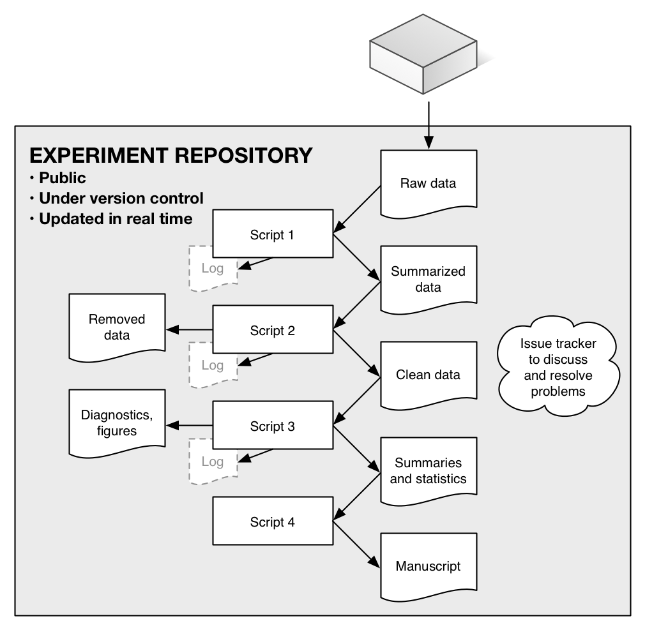

**Figure 2.** Two of the many diagnostic figures that were produced, in real time, as the incubation experiment proceeded. They show (top) the number of replicate measurements made on each soil core, by date of measurement, and (bottom) measurements with a data mismatch problem, indicating a data entry or other error (in the figure no errors, which would be in red, are extant). A wide range of similar diagnostic graphics (see <https://github.com/bpbond/cpcrw_incubation#current-diagnostics>) and statistics let us quickly identify problems or interesting patterns in the data.

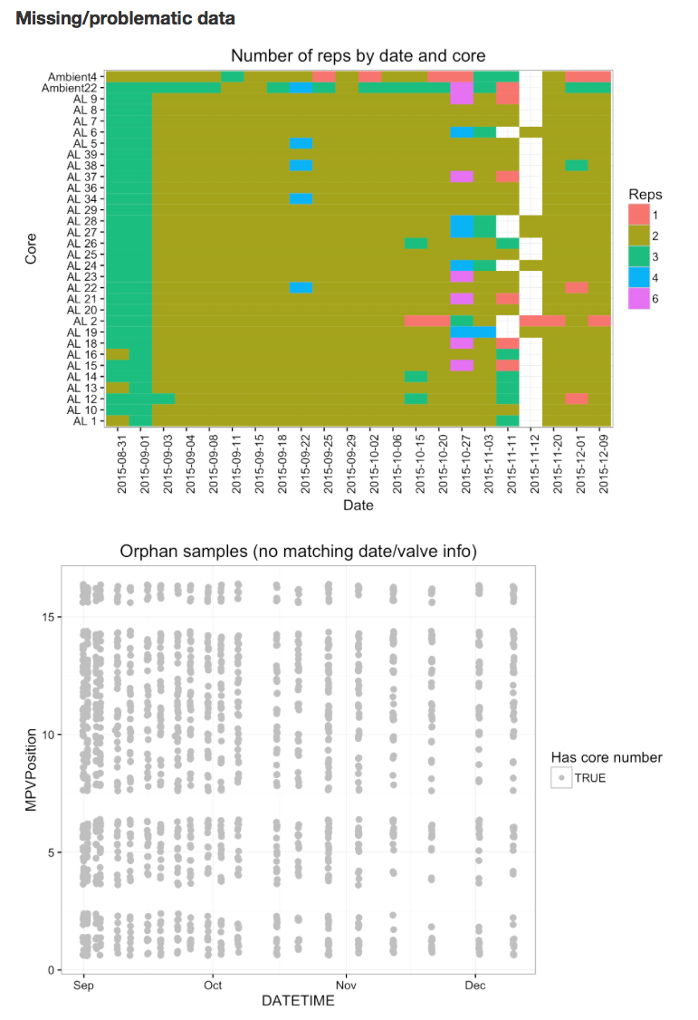

1. <http://www.nature.com/sdata/data-policies>
2. <http://journals.plos.org/plosone/s/data-availability>
3. <http://www.sciencemag.org/authors/science-editorial-policies#data-deposition>
4. <http://www.nsf.gov/bfa/dias/policy/dmp.jsp>
5. <http://www.wellcome.ac.uk/About-us/Policy/Spotlight-issues/Data-sharing/Data-management-and-sharing/index.htm>
6. <https://github.com/blog/1885-better-word-highlighting-in-diffs>
7. <https://github.com/blog/1885-better-word-highlighting-in-diffs>