Data Cleaning & Reporting Automation
Automated preprocessing and report generation using Python

1. Introduction
Real-world data is rarely ready for analysis. It contains missing values, duplicates and inconsistent formats, and cleaning it by hand every time is slow and error-prone. This project automates the full workflow: a single Python script cleans the raw data, records every change in a log, and produces an Excel report and a visual dashboard.

2. Objectives
- Handle missing values, duplicates and inconsistent data automatically.
- Keep a log of every cleaning action for transparency.
- Generate an automated Excel report and a visual summary dashboard.
- Make the process reusable with one command.

3. Dataset
The Superstore Sales dataset (train.csv) was used: 9,800 rows and 18 columns covering orders, customers, products, regions and sales from January 2015 to December 2018.

4. Automation Workflow
- Load the raw CSV file.
- Clean: trim text, fix categories, convert dates, remove duplicates, fill missing values, validate dates, flag outliers.
- Summarize: sales by category, region, segment, year, month and top products.
- Export: cleaned CSV, formatted Excel report with charts, and a dashboard image.
The whole process runs with one command: python auto_clean_report.py

5. Data Cleaning Results
Every action is saved in the Cleaning Log sheet of the Excel report.
Step | Issue found | Action taken | Rows
Text | Extra or double spaces | Trimmed and normalised | 251
Dates | Order and Ship Date stored as text | Converted to datetime | 9,800
Duplicates | Fully duplicated rows | Removed | 1
Duplicates | Same Order ID + Product ID repeated | Removed (kept first) | 7
Missing | Postal Code blank | Filled from same City/State | 11
Validation | Ship Date earlier than Order Date | Checked, none found | 0
Outliers | Extremely high or low Sales | Flagged, not deleted | 659
Result: the dataset reduced from 9,800 rows to 9,792 clean rows. The dataset was already fairly clean, so only a few issues were found. The script is designed to handle messier files as well.

6. Report Summary
Metric | Value
Date range | 03-Jan-2015 to 30-Dec-2018
Total sales | 2,259,845.49
Average order line value | 230.78
Customers / Orders | 793 / 4,922
Top category | Technology (827,062)
Top region | West (710,117)
Yearly sales: 2015: 479,575; 2016: 459,346 (-4.2%); 2017: 599,519 (+30.5%); 2018: 721,405 (+20.3%).

7. Visual Dashboard
The dashboard shows the monthly trend, sales by category, region and segment, top products and the cleaning actions performed.
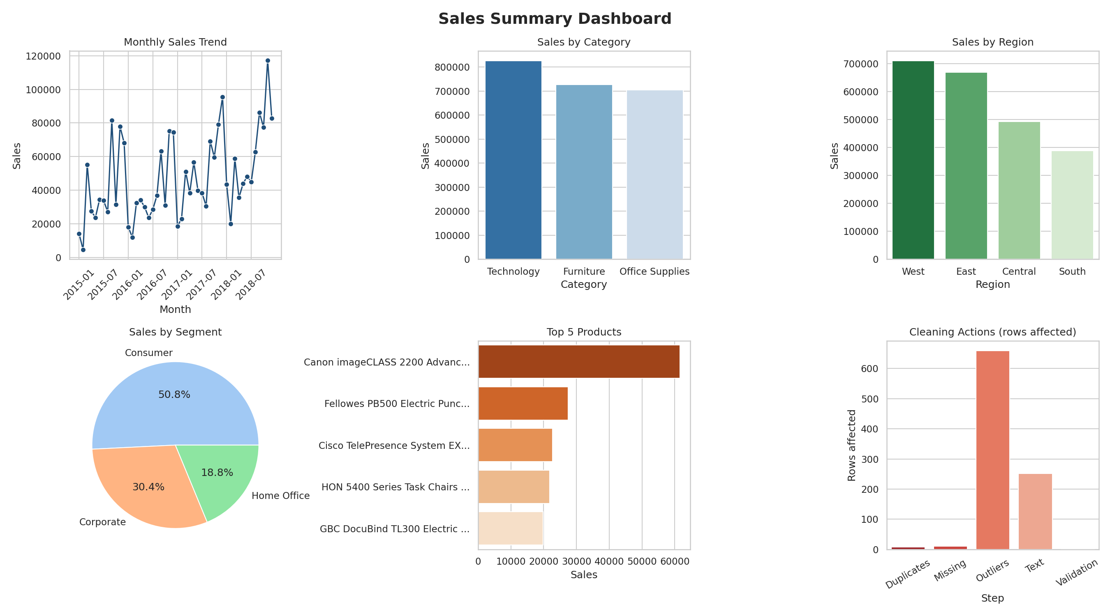
Figure 1: Automatically generated sales dashboard

8. Benefits of Automation
- Saves time: the full cleaning and reporting runs in seconds.
- Consistent: same rules are applied every time, which reduces human error.
- Transparent: the cleaning log shows exactly what was changed.
- Reusable: works for any new file with the same column structure.

9. Conclusion
The project shows how data preprocessing and reporting can be automated end to end. One script converts a raw dataset into a clean file, a formatted Excel report and a visual dashboard, improving reporting efficiency and reliability.

10. Future Work
- Schedule the script to run daily using Windows Task Scheduler.
- Email the report automatically.
- Connect cleaned_data.csv to a Power BI dashboard.

11. Tools Used
Python, pandas, NumPy, openpyxl, matplotlib and seaborn.

