CUSTOMER SEGMENTATION PROJECT
Segmenting customers based on behavior and demographics

1. Objective
The objective of this project is to group mall customers into meaningful segments based on their annual income and spending behavior, and to visualize the key characteristics of each segment so that the business can plan targeted marketing strategies.

2. Dataset
The Mall Customers dataset contains 200 customers (112 Female and 88 Male). It has the following fields:
- CustomerID: unique ID of each customer
- Genre: Male or Female
- Age: age of the customer
- Income: annual income in thousand dollars (k$)
- SpendingScore: score from 1 to 100 assigned by the mall based on spending behavior

3. Methodology
- Loaded the dataset into Power BI.
- Applied K-Means clustering with 5 clusters using Income and Spending Score.
- Named each cluster according to its average income and spending.
- Built an interactive dashboard with charts, a summary table, and slicers for Genre and Age.

4. Dashboard
The dashboard below shows the segment distribution, the income versus spending score scatter plot, the gender split, the average age and average spending score for each segment, and the key insights.
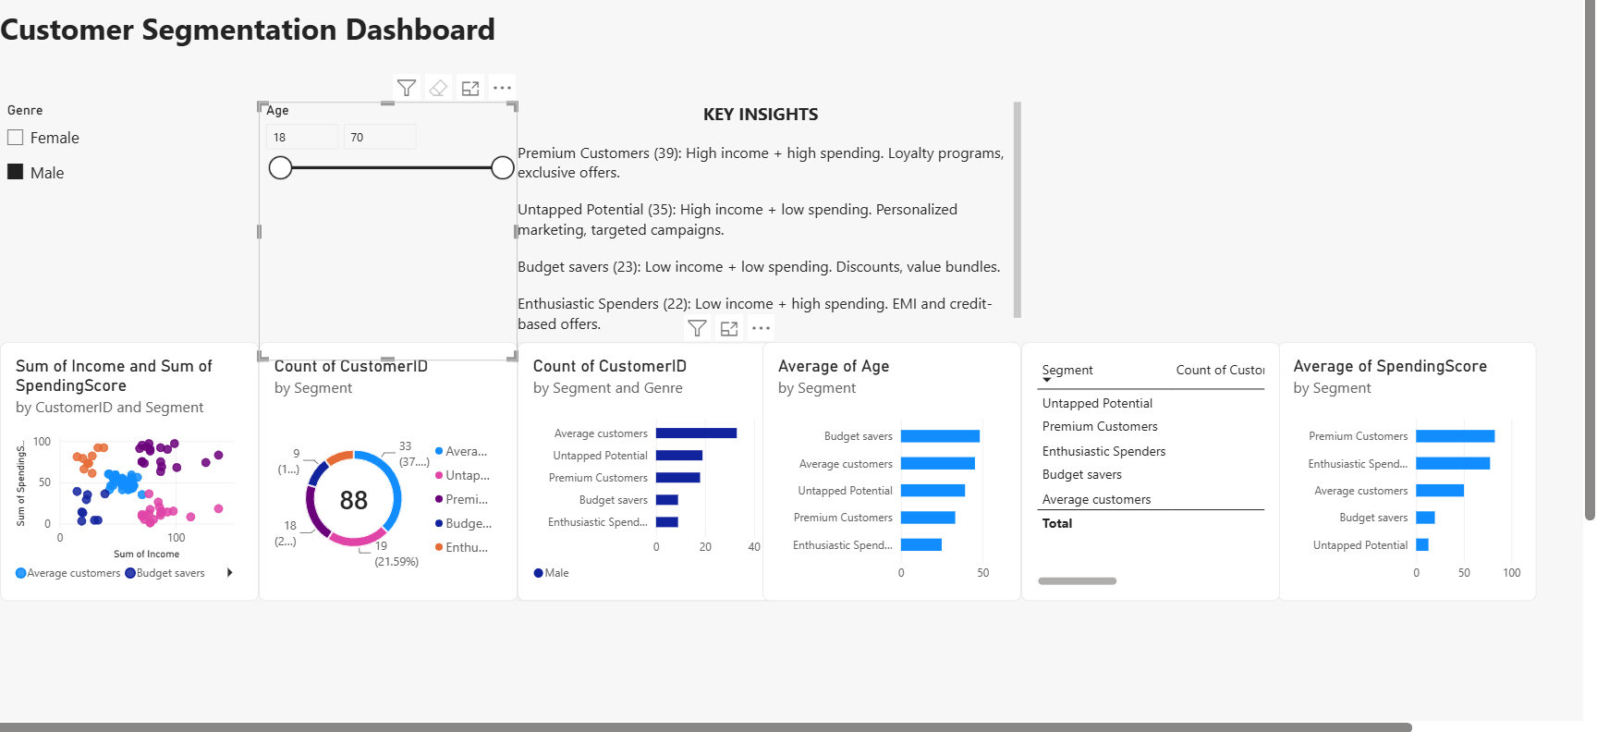
Figure 1: Customer Segmentation Dashboard

5. Segment Analysis
The table below summarizes the five segments found by the clustering.
Segment | Customers | Avg Age | Avg Income (k$) | Avg Spending Score
Average customers | 81 | 42.7 | 55.3 | 49.5
Premium Customers | 39 | 32.7 | 86.5 | 82.1
Untapped Potential | 35 | 41.1 | 88.2 | 17.1
Budget savers | 23 | 45.2 | 26.3 | 20.9
Enthusiastic Spenders | 22 | 25.3 | 25.7 | 79.4

6. Key Insights
- Average customers are the largest group, about 40% of all customers.
- Premium Customers are young (average age 33) with high income and high spending.
- Untapped Potential customers earn as much as Premium Customers but spend very little, so they are the biggest growth opportunity.
- Enthusiastic Spenders are the youngest group (average age 25) and spend a lot despite low income.
- Budget savers are the oldest group (average age 45) with low income and low spending.

7. Recommendations
Segment | Marketing Strategy
Premium Customers | Loyalty programs, exclusive offers, early access to new products
Untapped Potential | Personalized marketing and targeted campaigns to increase spending
Budget savers | Discounts and value bundles
Enthusiastic Spenders | EMI and credit-based offers, trendy products
Average customers | Upselling and cross-selling

8. Limitations
- The dataset has no purchase history, so Spending Score is used as a proxy for purchase behavior.
- Clustering used only Income and Spending Score. Age and Gender were used to profile the segments.
- The dataset is small (200 customers).

9. Conclusion
The project divided customers into five clear segments and showed what makes each segment different. The dashboard lets the business filter by gender and age, and the recommendations give a starting point for targeted marketing. The biggest opportunity is the Untapped Potential segment, which has high income but low spending.

