Predictive Analytics Using Historical Data
Sales Forecasting with Regression and Time-Series Models

1. Introduction
Forecasting future trends from historical data helps businesses plan inventory, staffing and targets. This project builds a predictive model that forecasts monthly sales for the next 12 months using historical retail data. Both a regression model and a time-series model are used and compared.

2. Objectives
- Clean and preprocess a historical sales dataset.
- Build regression and time-series models for prediction.
- Evaluate model accuracy using standard error metrics.
- Visualize predictions and forecast future sales.

3. Dataset
The Superstore Sales dataset (train.csv) was used. It contains 9,800 orders from January 2015 to December 2018. The columns used are Order Date and Sales. Daily orders were aggregated into 48 monthly sales values, since monthly data shows trend and seasonality more clearly.

4. Methodology
Data preprocessing
- Converted dates from dd/mm/yyyy format and sorted records in time order.
- Removed duplicate records and checked missing values.
- Detected outliers using the IQR method and filled gaps by time interpolation.
- Aggregated daily orders into monthly total sales.
Train / test split
- A time-based split was used: the last 20% of months formed the test set, with no shuffling, so the model never sees the future during training.
Models
- Naive baseline: predicts the last observed value (used for comparison).
- Linear Regression: uses a time trend and month-of-year seasonality features.
- Holt-Winters Exponential Smoothing: time-series model with additive trend and seasonality.
Evaluation metrics
- MAE (Mean Absolute Error), RMSE (Root Mean Squared Error) and MAPE (Mean Absolute Percentage Error).

5. Results
The table below shows model performance on the test set. Lower values are better.
Model | MAE | RMSE | MAPE
Naive baseline | 21,796 | 26,375 | 32.7%
Linear Regression | 11,535 | 15,205 | 16.5%
Holt-Winters (best) | 11,966 | 13,282 | 19.5%
Both models clearly outperform the naive baseline. Holt-Winters achieved the lowest RMSE and was selected to generate the final forecast.

6. Visualizations
The figure shows (1) the historical sales trend, (2) actual versus predicted values on the test set, (3) model comparison by RMSE, and (4) the 12-month forecast.
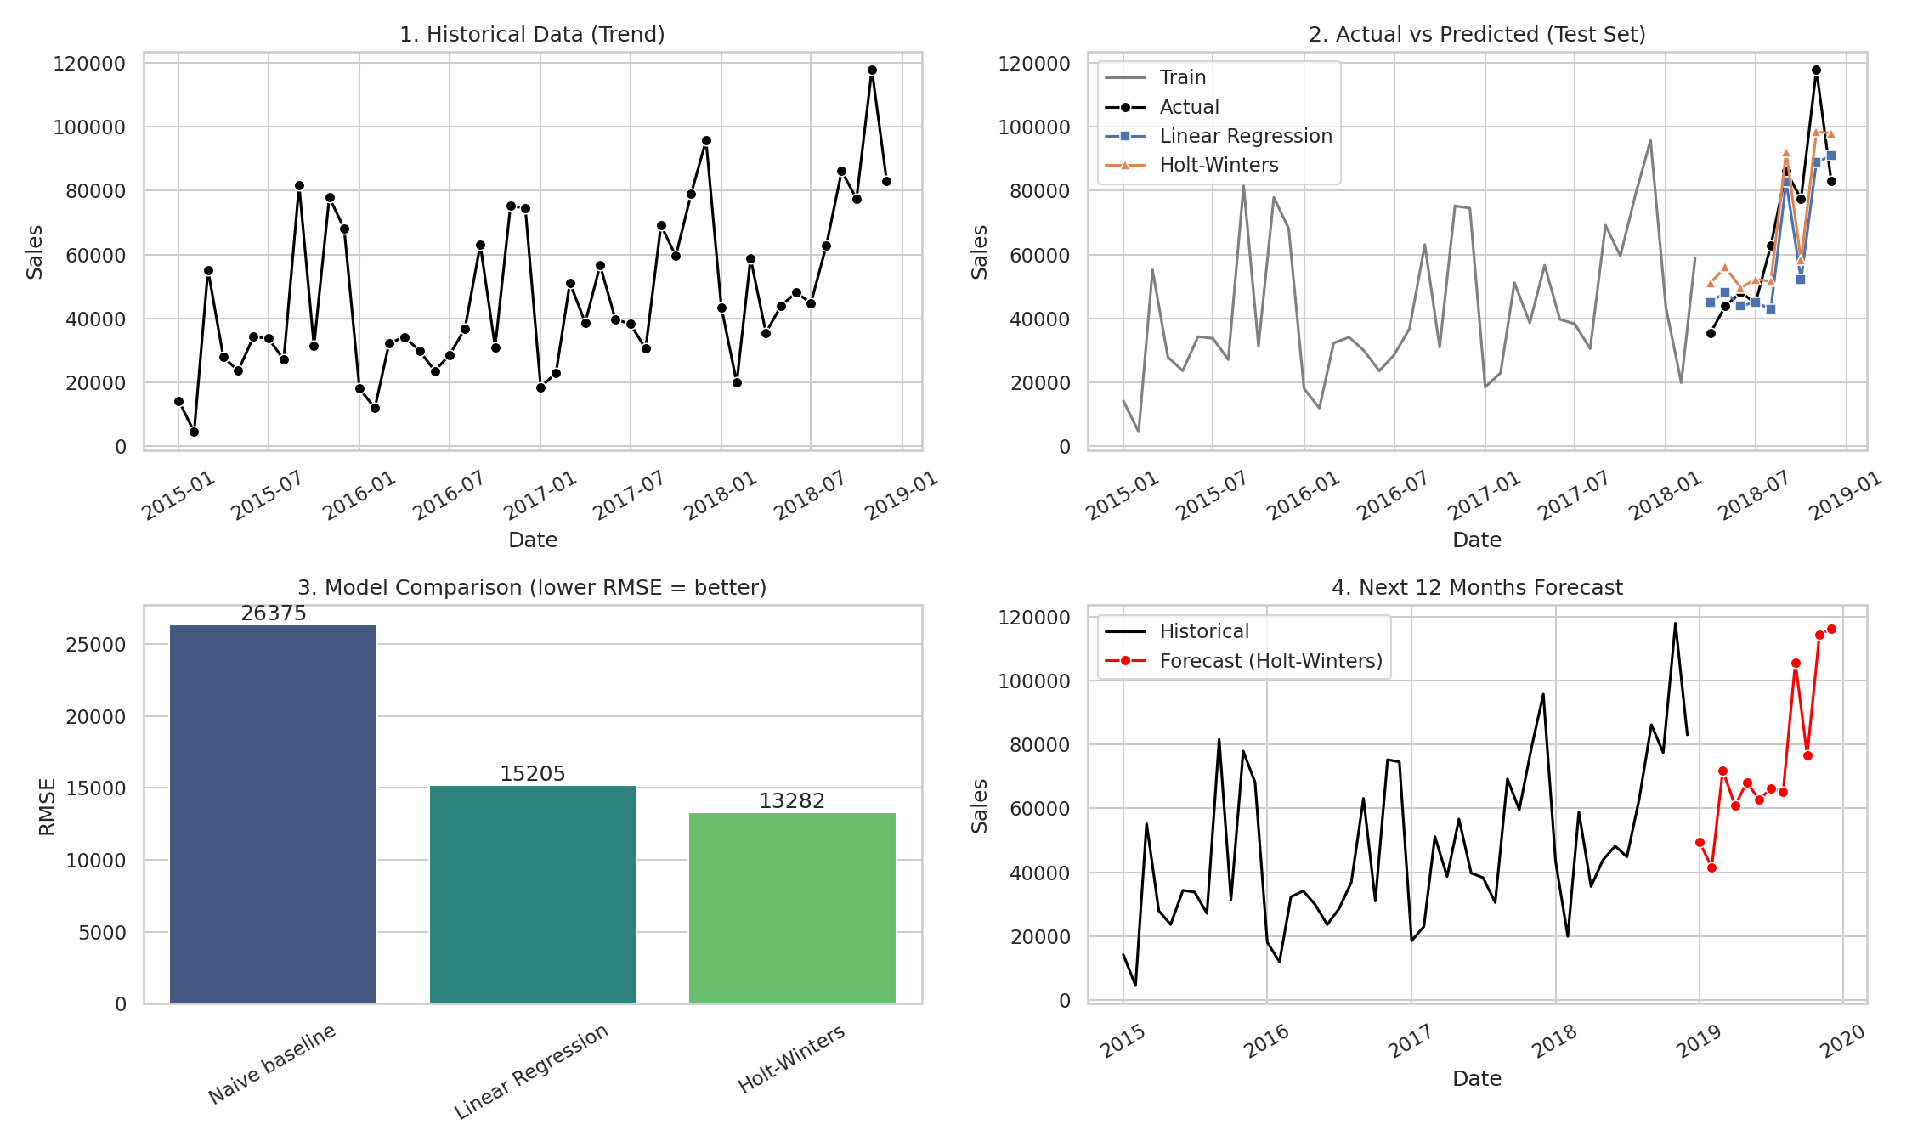
Figure 1: Historical sales, model predictions, comparison and 12-month forecast

7. Key Insights
- Sales show an overall upward trend from 2015 to 2018.
- There is strong seasonality: sales peak from September to December and are lower in the early months of the year.
- The forecast expects the same seasonal pattern to continue in 2019, with the highest sales in November and December.

8. Conclusion
The project demonstrates a complete predictive analytics workflow: data cleaning, feature engineering, model training, evaluation and visualization. Holt-Winters gave the best accuracy and produced a realistic 12-month forecast that captures both trend and seasonality.

9. Limitations and Future Work
- Only 48 monthly data points were available, so errors remain noticeable (MAPE about 16 to 20%).
- Promotions, regions and product categories were not modelled.
- Future work: try ARIMA/SARIMA or Prophet, add external features, and forecast per category or region.

10. Tools Used
Python, pandas, NumPy, scikit-learn, statsmodels, matplotlib and seaborn.

