Chapter 12

Implementation

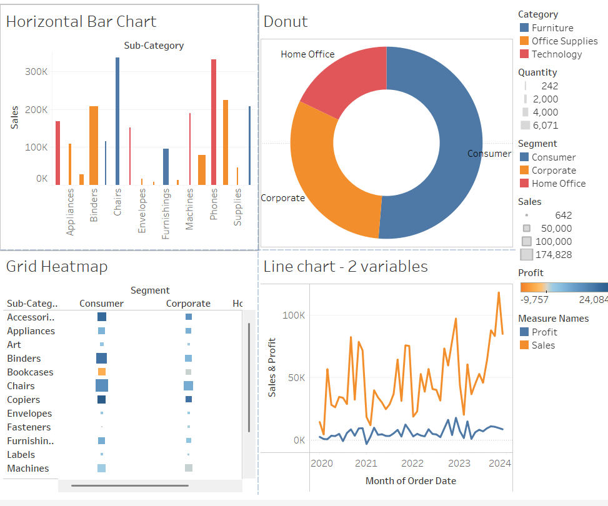
Figure 12.1: Tableau dashboard
Source: Tool screenshot

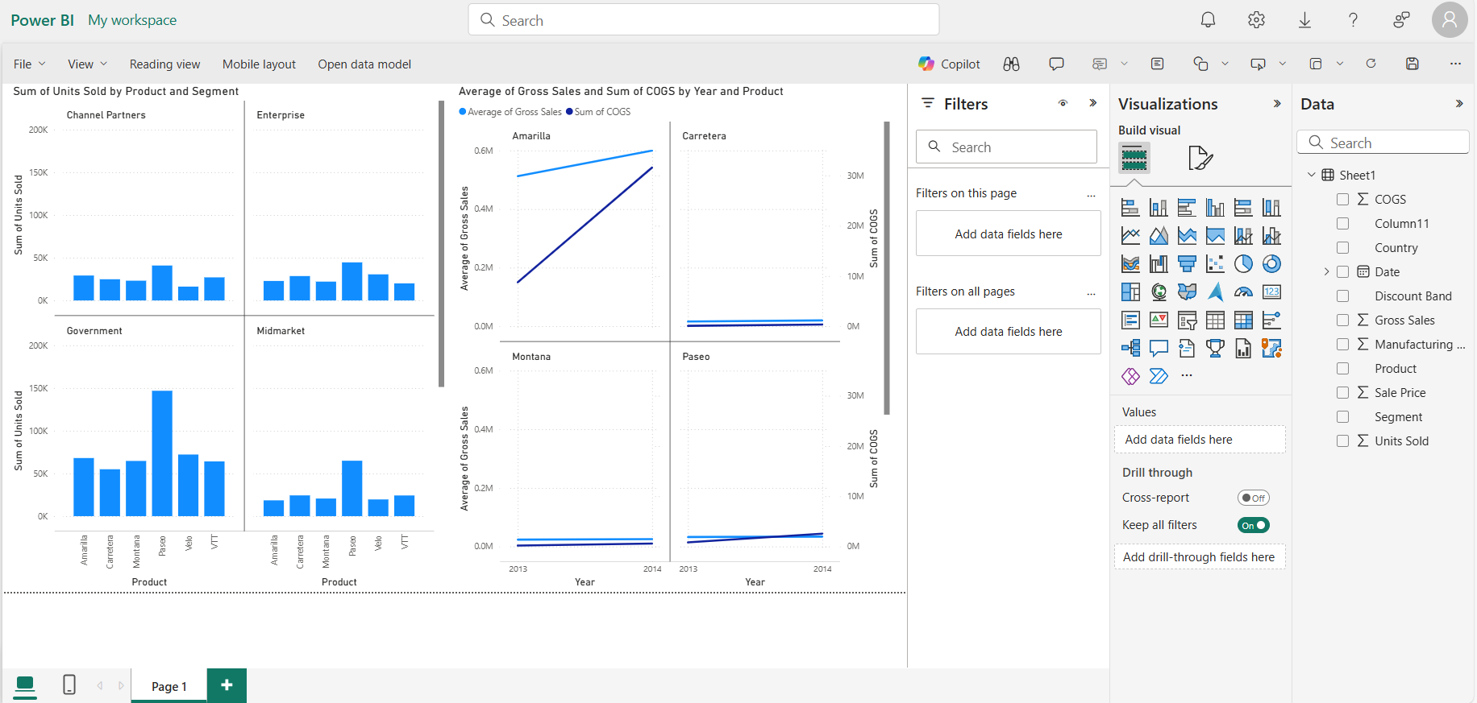
Figure 12.2: PowerBI interface
Source: Tool screenshot

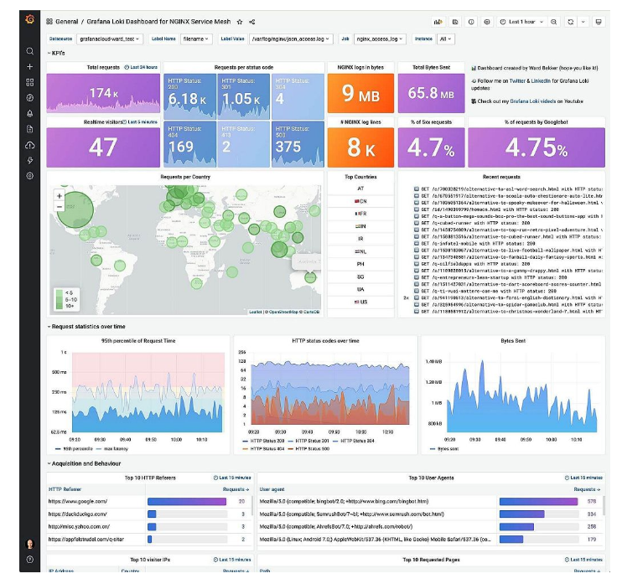
Figure 12.3: Grafana dashboard
Source: https://grafana.com/blog/2021/06/22/grafana-dashboard-showcase-visualizations-for-prometheus-home-energy-usage-github-and-more/
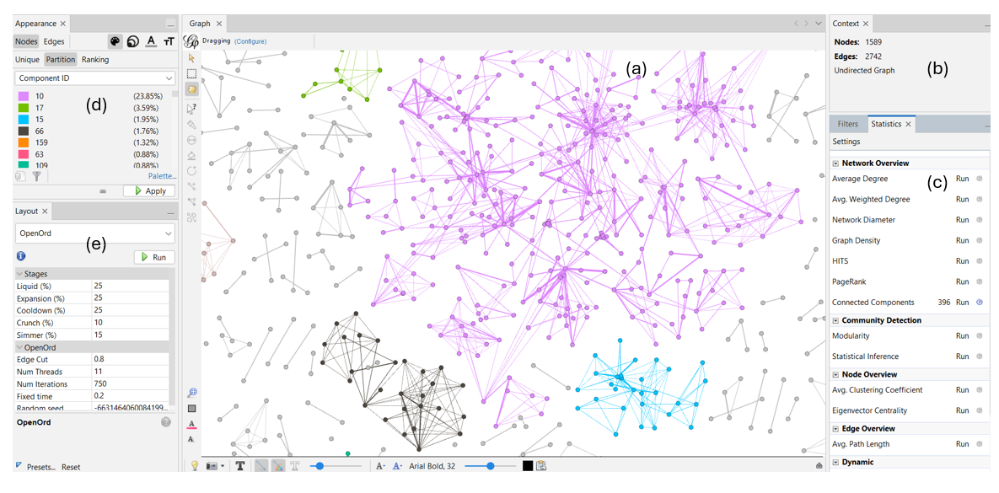
Figure 12.4: Gephi
Source: Tool screenshot

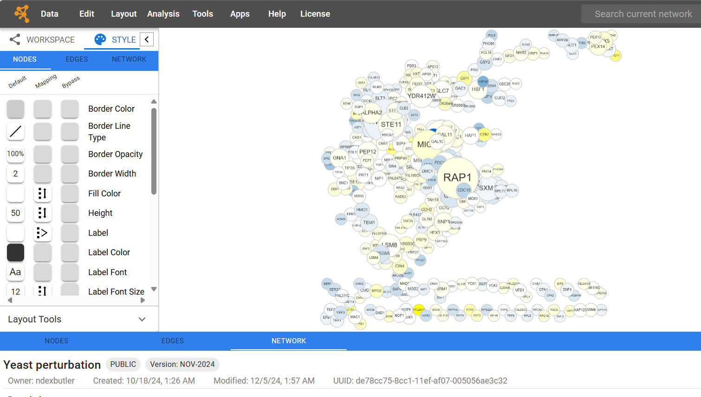
Figure 12.5: Cytoscape Web
Source: Tool screenshot
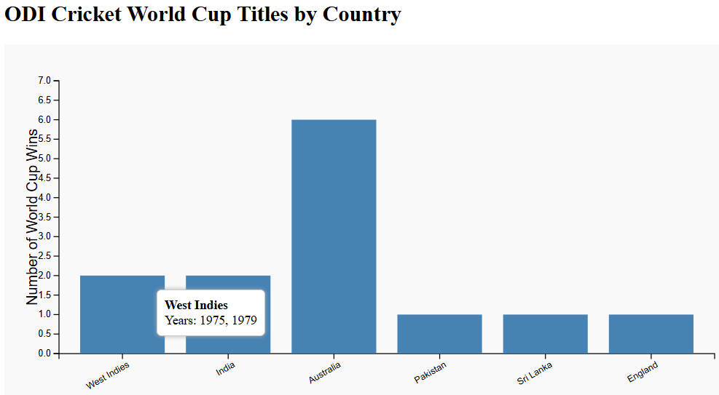

Figure 12.6: Bar chart created by D3.js
Source: Self-drawn by code

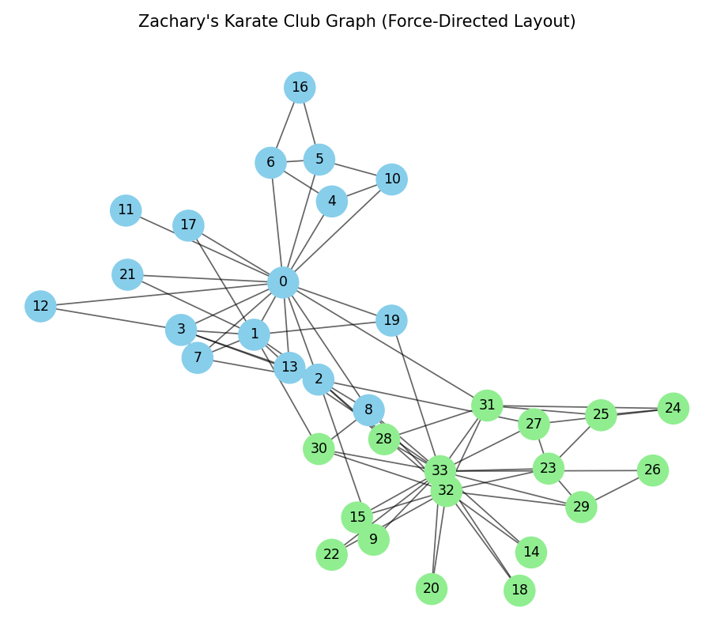
Figure 12.7: Graph created by Python libraries
Source: Self-drawn by code

