**Allocation.Tab**

|  |  |  |  |
| --- | --- | --- | --- |
| **Version** | **Date** | **Author** | **Comments** |
| Refer to PROTON history |  | Rob Reeves  AndreyKornienko | Initial Version including main mapping rules. The BI mapping inputs provided by the BI team and MD04 extraction. |
|  |  | Kshitij Jathar | PROTON Administration and finalize the document with the following changes:-   1. Document History removed as Proton will have its own version tracking 2. Reference columns to one-drive folders deleted. 3. Different colours, text highlights etc. have been removed. 4. Format. is changed and standardized |
| 0.1 Version | 14-04-2021 | Santosh Reddy | As per TicketNumber-(**20999**) Country requirement, the filter conditions (Supplying site = Receiving site) were commented for files Allocation Stock Transfer Orders for both IM and SZ.  Check Page No: 5 Header: Allocations for Stock Transfer Orders. |

**Attachments**

|  |  |  |
| --- | --- | --- |
| **Attachment** | **Filename** | **Description** |
| **1** | **Allocation_FileFormat** | **This file provides the to be structure of this file** |

**IBI Extracts and Filtering**

|  |  |  |  |  |
| --- | --- | --- | --- | --- |
|  | PHARMA | SANDOZ |  | Filtering |
| 1 | MD04 |  | MD04 | BB – for reservations against subcontracting Planned Order, Purchasing Requisition and Purchase Order  SB – against production planner order  U1 – for Stock Transport Orders  AR – against Process Order  VC – Sales Order for intercompany  VC, VI, VJ – Sales Order for Consignment  U2 – for Stock Transport Requisitions  U3 – for transfers w/ PlOrd  MR – against Transfer with MRP area |
| 2 | RESB | RESB | Reservations | NA |
| 3 | VBKD | VBKD | Sales Orders | NA |
| 4 | KNA1 | KNA1 | Customer Master | NA |

**Note:**

* Purchase Requisitions Allocations (when they are transmitted with IDOC as IndReq) are covered by Forecast data mapping file (*PD_DETAIL (origin “D”) for IM/SZ )
* Returns / material reservations MR, RP are covered by Independent Demand - ReturnsReservations
* This file covers sales orders for intercompany piece (where link to receiving PO is possible)
* Sales Orders and Deliveries for Consignment Replenishment are considered.
* Other sales orders and outbound deliveries are considered as Independent Demand (as this is considered as fixed execution element where no change is possible).
* Allocations for Subcontracting are not accepted when respective partsite does not exist. Respective Stock (see onhand file) is also marked in this case as non-MRP relevant

**Allocations for Subcontracting Purchase Orders**

**Purchase Order and PREQ/ PlOrd Allocations: filter by MRP element (DELKZ) = “BB”**

* **Purchase Orders – always (does not matter, whether a site is planned in RR or not).**
* **Filter by those related to Purchase Order, see NVS.OrderType row comment.**
* ***In case of Vendor from MRP Area and Plant (LIFNR and WERKS) are part of InternalVendorMap, then filter this record out (Toll Manufacturing scenario)***

|  |  |  |  |  |
| --- | --- | --- | --- | --- |
| Ordinal | RR Field | Source | Source field | (IM) Src Field |
| 1 | ScheduledReceipt.Order.Id | **MD04** | AUFVR | From MD04 – take from MD04 header PO number |
| 2 | Reservation.Id | **MD04** | DELNR | From MD04 – Provision Number |
| 3 | ReservationItem.Id | **MD04** | DELPS | From MD04 – Item number in provision |
| 4 | ScheduledReceipt.Order.Type.Value | **Talend** | See comment | “SubPO” |
| 5 | ScheduledReceipt.Order.Site.Value | **MD04**  **Talend** | LIFNR _ WERKS or WERKS only  See comment | Derive the Site of respective SUBCON Schedule Receipt by Order Id and Line (MD04 file can be used by looping with NVS.OrderType (DELVR) to MRP Element ID DELKZ as well as Item Number POSVR = DELPS and Sequence EINVR = DELET and Order ID AUFVR = DELNR and Material = BAUGR (ASSEMBLY in BI)). Then:  Then apply the same logic for Site determination as in SR_PO specification. |
| 6 | ScheduledReceipt.Line | **MD04** | POSVR _ EINVR | MD04 item number (see above – p.1) CONCATENATED with SEQ number (see above – p.1) and MRPElement Indicator |
| 7 | Part.Name | **MD04** | MATNR | MD04 - MATNR |
| 8 | Part.Site.Value | **Talend** | See comment | 1. if SOBKZ is empty and PLANR <> “” and LIFNR <> “”, then WERKS_LIFNR 2. if MRP Area BERID is available in MDLL table, then WERKS _ vendor number (get it from MDLL by MRP Area and Plant, field LBEAR)   **Else** keep WERKS. |
| 7 | DueDate | **MD04** | DAT00 | From MD04 – “Requirement Date” |
| 8 | TotalQuantity | **MD04** | TPMNG | From MD04 |
| 9 | RemainingQuantity | **MD04** | MNG01 | From MD04 – “Requirement Qty” |
| 10 | QuantityPer | **Talend** | See comment | 0 |
| 11 | Batch | **MD04** | CHARG | RESB-CHARG (loop by provision number and reservation number id from MD04 – p.2 and p.3 above) |
| 12 | UOM | **Talend** | MEINH | MARA-MEINH – take base unit of measure for the material |
| 13 | NVS.OrderType | **MD04** | DELVR  See comment | Here filter only by those equal to "BE" or "LA" (it means it is allocation against PO) |
| 14 | LocationID | MD04 | LGORT | Talend; if Location is not empty and NOT nettable (see Location tab), do not load this element as allocation. |

**Allocations for subcontracting Purchase Requisitions and Planned Orders**

* **Allocation by Purchase Requisitions / Planned Order – filter by MRP element (DELKZ) = “BB”**
* **Filter by those “BB” elements related to Purchase Requisitions and Planned Orders (see NVS.OrderType below)**
* **Load only those, which are not planned in RR.**
* ***In case of Vendor from MRP Area and Plant (LIFNR and WERKS) are part of InternalVendorMap, then filter this record out (Toll Manufacturing scenario)***

|  |  |  |  |  |
| --- | --- | --- | --- | --- |
| Ordinal | RR Field | Source | Source Field | (IM) Src Field |
| 1 | ScheduledReceipt.Order.Id | **MD04** | AUFVR | From MD04 – take header PREQ /PlOrd number |
| 2 | Reservation.Id | **MD04** | DELNR | From MD04 – Provision Number |
| 3 | ReservationItem.Id | **MD04** | DELPS | From MD04 – Item number in provision |
| 4 | ScheduledReceipt.Order.Type.Value | **Talend** | See comment | “SubPReq” |
| 5 | ScheduledReceipt.Order.Site.Value | **MD04**  **Talend** | LIFNR _ WERKS or WERKS only  See comment | Derive the Site of respective SUBCON Schedule Receipt by Order Id and Line (MD04 file can be used by looping with NVS.OrderType AUFVR = MRP Element Indicator DELKZ, Order ID AUFVR = DELNR as well as Item Number POSVR = DELPS and Material = BAUGR (ASSEMBLY in BI)). Then:  Then apply the same logic for Site determination as in SR_PReq specification. |
| 6 | ScheduledReceipt.Line | **MD04** | POSVR | NA |
| 7 | Part.Name | **MD04** | MATNR | MD04 - MATNR |
| 8 | Part.Site.Value | **Talend** | See comment | 1. if SOBKZ is empty and PLANR <> “” and LIFNR <> “”, then WERKS_LIFNR 2. if MRP Area BERID is available in MDLL table, then WERKS _ vendor number (get it from MDLL by MRP Area and Plant, field LBEAR)   Else keep WERKS. |
| 7 | DueDate | **MD04** | DAT00 | From MD04 – “Requirement Date” |
| 8 | TotalQuantity | **MD04** | TPMNG | NA |
| 9 | RemainingQuantity | **MD04** | MNG01 | From MD04 – “Requirement Qty” |
| 10 | QuantityPer | **Talend** | See comment | 0 |
| 11 | Batch | **MD04** | CHARG | From MD04 |
| 12 | UOM | **Talend** | See comment | MARA-MEINH – take base unit of measure for the material |
| 13 | NVS.OrderType | **MD04** | DELVR  See comment | Filter by "BA" or "PA" (it means it is allocation against Preq or PlOrd) |
| 14 | LocationID | MD04 | LGORT | Talend; if Location is not empty and NOT nettable (see Location tab), do not load this element as allocation. |

**Allocations for Stock Transfer Orders**

* **Allocations for Stock Transfer Orders: filter by MRP element (DELKZ) = “U1” (Scenario when both receiving and sending site are in one SAP client).**
* **To be taken into account always, does not matter when receiving site is in RR or not.**
* **As per SPEED release 3 (20999) Country requirement: Supp_Site = Receiving_site Filter condition is commented in Tmap for both IM and SZ. Please find below screenshot for more details**

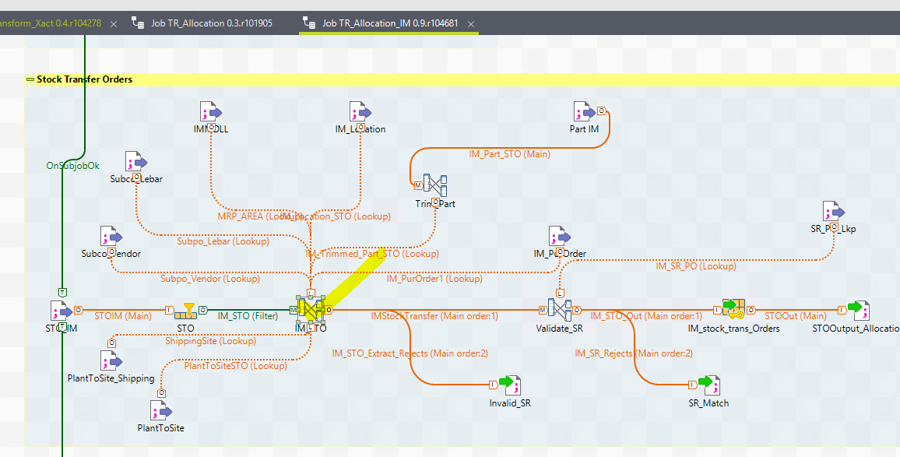

**In tmap transformation (in Talend):**

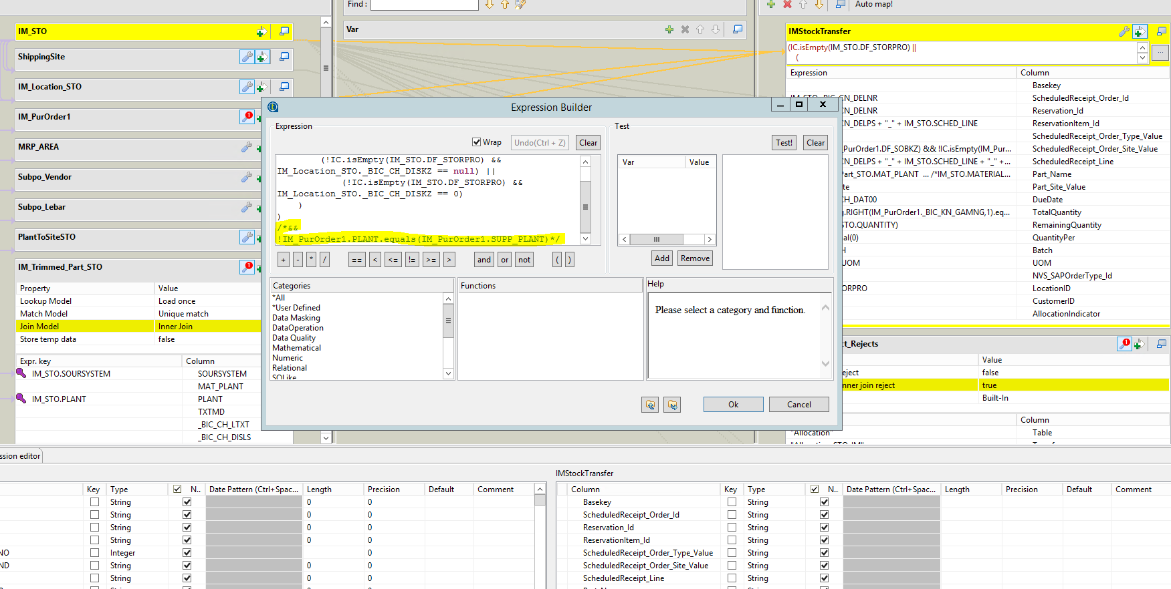

|  |  |  |  |  |
| --- | --- | --- | --- | --- |
| Ordinal | RR Field | Source | Source field | (IM) Src Field |
| 1 | ScheduledReceipt.Order.Id | **MD04** | DELNR | From MD04 – take Order number (also for p.6 item number and sequence is required). |
| 2 | Reservation.Id | **MD04** | DELNR | From MD04 – **the same** as SR Order Id (see p.1) |
| 3 | ReservationItem.Id | **MD04** | DELPS _ DELET | From MD04 – Item number in provision (the same as SR Line p.6 – concatenate item number and sequence number) |
| 4 | ScheduledReceipt.Order.Type.Value | **Talend** | See comment | “STO” |
| 5 | ScheduledReceipt.Order.Site.Value | **MD04** | WRK02 | Receiving Site in Stock Transport Order. Visible in U1 Element in MD04 – see screenshot above as Order Plant (e.g. CH01 above)  Talend Logic  a) if SOBKZ is empty and PLANR <> “”, then WRK02_PLANR  b) if MRP Area BERID is available in MDLL table, then WRK02_ vendor number (get it from MDLL by MRP Area and Plant, field LBEAR)  c) Else keep WRK02 |
| 6 | ScheduledReceipt.Line | **MD04** | DELPS _ DELET | See p.1 – concatenate item number and sequence number from MD04. Also concatenate with DELKZ |
| 7 | Part.Name | **MD04** | MATNR | MATNR from MD04 |
| 8 | Part.Site.Value | **MD04** | WERKS | Shipping Site (plant for which MD04 is executed) – e.g. CH28 in example above |
| 9 | DueDate | **MD04** | DAT00 | MD04 requirement date |
| 10 | TotalQuantity | **Talend** | See comment | Take from MD04 – look by the same Material Number MATNR and WERKS = “WRK02” and the same DELNR, DELPS, DELET. Result is in column TPMNG |
| 11 | RemainingQuantity | **MD04** | MNG01 | Quantity from MD04 |
| 12 | QuantityPer | **Talend** | See comment | 0 |
| 13 | Batch | **MD04** | CHARG | NA |
| 11 | UOM | **Talend** | See comment | MARA-MEINH – take base unit of measure for the material |
| 12 | LocationID | **MD04** | RESLO | Talend; if Location is not nettable and not empty, do not load this element as allocation. |

**Allocations against Process Order**

**Process Order Allocations: filter by MRP element (DELKZ) = “AR”**

* **Process Order – take it always (does not matter planned in RR or not)**

|  |  |  |  |  |
| --- | --- | --- | --- | --- |
| Ordinal | RR Field | Source | Source Field | (IM) Src Field |
| 1 | ScheduledReceipt.Order.Id | **MD04** | DEL12 | From MD04 – |
| 2 | Reservation.Id | **MD04** | DELNR | From MD04 – Reservation Number and item number |
| 3 | ReservationItem.Id | **MD04** | DELPS | From MD04 – see above |
| 4 | ScheduledReceipt.Order.Type.Value | **Talend** | See comment | “WO” |
| 5 | ScheduledReceipt.Order.Site.Value | **MD04** | WERKS | Derive Site in TALEND from MD04 by DELKZ = “BR” and Order ID DEL12 = DEL12 from Allocation and Material = Pegged requirement (ASSEMBLY field in BI). Otherwise (not found), use current Site (WERKS) |
| 6 | ScheduledReceipt.Line | **Talend** | ”1” | Code to 1 to match SR_ProcessOrder. |
| 7 | Part.Name | **MD04** | MATNR | MD04 - MATNR |
| 8 | Part.Site.Value | **MD04** | WERKS | Plant of MD04 |
| 9 | DueDate | **MD04** | DAT00 | From MD04 – “Requirement Date” |
| 10 | TotalQuantity | **MD04** | TPMNG | NA |
| 11 | RemainingQuantity | **MD04** | MNG01 | From MD04 – “Requirement Qty” |
| 12 | QuantityPer | **Talend** | See Comment | 0 |
| 13 | Batch | **MD04** | CHARG | NA |
| 14 | UOM | **Talend** | See comment | MARA-MEINH – take base unit of measure for the material |
| 15 | LocationID | **MD04** | LGORT | Talend: if Location is not nettable and not empty, do not load this element as allocation. |

**Allocations against Planned Orders used for internal production**

**Planned Order Allocations: filter by MRP element (DELKZ) = “SB”**

* **Planned Order allocations – only for materials, which are not planned in RR (Release 2).**

|  |  |  |  |  |
| --- | --- | --- | --- | --- |
| Ordinal | RR Field | Source | Source field | (IM) Src Field |
| 1 | ScheduledReceipt.Order.Id | **MD04** | AUFVR | From MD04 – “Planned Order number” |
| 2 | Reservation.Id | **MD04** | DELNR | From MD04 – Reservation Number (see above) |
| 3 | ReservationItem.Id | **MD04** | DELPS | From MD04 – see above (e.g. 000012 above) |
| 4 | ScheduledReceipt.Order.Type.Value | **Talend** | See Comment | “PlnWO” |
| 5 | ScheduledReceipt.Order.Site.Value | **MD04** | WERKS | Derive the Site in TALEND using Order ID (AUFVR from Allocation to match in MD04 with DELNR) and DELKZ element equal to DELVR from allocation (should be “PA”) and Material number = BAUGR (ASSEMBLY field in BI) |
| 6 | ScheduledReceipt.Line | **MD04** | POSVR | “1” |
| 7 | Part.Name | **MD04** | MATNR | MD04 - MATNR |
| 8 | Part.Site.Value | **MD04** | WERKS | Plant from MD04 |
| 9 | DueDate | **MD04** | DAT00 | From MD04 – “Requirement Date” |
| 10 | TotalQuantity | **Talend** | N/A | Leave blank |
| 11 | RemainingQuantity | **MD04** | MNG01 | From MD04 – “Requirement Qty” |
| 12 | QuantityPer | **Talend** | See Comment | 0 |
| 13 | Batch | **MD04** | CHARG | NA |
| 14 | UOM | **Talend** | See comment | MARA-MEINH – take base unit of measure for the material |
| 15 | LocationID | **MD04** | LGORT | Talend; if Location is not nettable and not empty, do not load this element as allocation. |

**Allocations against Sales Orders for Intercompany**

**Sales Order Allocations: filter by MRP element (DELKZ) = “VC”**

* **TALEND: Allocations – filter further only for materials, where Sold-To customer (KUNNR from MD04) belongs to “ZICP” Account Group (look in Customer tab)**
* **Note TALEND: Sales Order has a reference to PO by number at receiving site (VBKD-BSTKD). If PO with such number cannot be found at receiving site, insert this Sales Order as Independent Demand.**

|  |  |  |  |  |
| --- | --- | --- | --- | --- |
| Ordinal | RR Field | Source | Source Field | (IM) Src Field |
| 1 | ScheduledReceipt.Order.Id | **BI** | **VBKD-BSTKD** | Get it from **VBKD-BSTKD** using Order number from MD04 (DELNR) and item number from MD04 (e.g. 1 below) (POSNR) |
| 2 | Reservation.Id | **MD04** | DELNR | From MD04 – Order Number (see below) |
| 3 | ReservationItem.Id | **MD04** | DELPS _ DELET | From MD04 (see above) – concatenation of item number in sales and schedule line number - see above (e.g. 1_2) |
| 4 | ScheduledReceipt.Order.Type.Value | **Talend** | See comment | “PO” |
| 5 | ScheduledReceipt.Order.Site.Value | **Talend** | See comment | Talend: to get Plant number from PO – look in MD04 extract based on line 1 (VBKD-BSTKD) = DELNR in MD04 and DELPS = DELPS in MD04 and DELKZ = “BE” or “LA”. |
| 6 | ScheduledReceipt.Line | **MD04** | DELPS | See p.3 above – item 1 in sales order is linked to item 1 in PO, or item 10 in sales order is item 10 in PO Also concatenate DELKZ. |
| 7 | Part.Name | **MD04** | MATNR | MD04 – MATNR (for the site for which MD04 is executed) |
| 8 | Part.Site.Value | **MD04** | WERKS | MD04 – WERKS (for the site for which MD04 is executed)  if SOBKZ is empty and PLANR <> “”, then WERKS_PLANR  if MRP Area BERID is available in MDLL table, then WERKS _ vendor number (get it from MDLL by MRP Area and Plant, field LBEAR)  Else keep WERKS. |
| 9 | DueDate | **MD04** | DAT00 | From MD04 – “Requirement Date” |
| 10 | TotalQuantity | **Talend** | NA | Leave blank |
| 11 | RemainingQuantity | **MD04** | MNG01 | From MD04 – “Requirement Qty” |
| 12 | QuantityPer | **Talend** | See comment | 0 |
| 13 | Batch | **MD04** | CHARG | NA |
| 14 | UOM | **Talend** | See comment | MARA-MEINH – take base unit of measure for the material |
| 15 | NVS. AllocationIndicator | **MD04** | VPZUO | Take from MD04 – might be needed to identify whether forecast consumption is allowed or not for this sales order (when empty, forecast consumption is not allowed) |
| 16 | CustomerID | **MD04** | KUNNR | Customer Sold-To from MD04 |
| 17 | LocationID | **MD04** | LGORT | Talend; if Location is not empty and NOT nettable (see Location tab), do not load this element as allocation. |

**Allocations against Sales Orders, Deliveries for Consignment Replenishment**

**Sales Order Allocations: filter by MRP element (DELKZ) = “VC”, “VI”, “VJ”.**

* **TALEND: only consider sales orders and deliveries to Sold-To Customer (from MD04), which is specified in ConsignmentCustomerMap table as customer consignment relevant for separate planning.**
* **TALEND: For such Sales Orders and Deliveries Scheduled Receipt at Customer Site in RR has to be created in Talend (will not appear in MD04) – see Purchase Order files as well.**

|  |  |  |  |  |
| --- | --- | --- | --- | --- |
| Ordinal | RR Field | Source | Source Field | (IM) Src Field |
| 1 | ScheduledReceipt.Order.Id | **Talend** | DELNR | The same as Sales Order / Delivery Number appearing in MD04 (see below) |
| 2 | Reservation.Id | **MD04** | DELNR | From MD04 – Order Number or Delivery Number (see below) |
| 3 | ReservationItem.Id | **MD04** | DELPS _ DELET | From MD04 (see above) – concatenation of item number and schedule line number - see above (e.g. 10_1) |
| 4 | ScheduledReceipt.Order.Type.Value | **Talend** | See comment | “ConsPO” |
| 5 | ScheduledReceipt.Order.Site.Value | **MD04** | WERKS _ KUNNR | **Talend**: concatenation of Plant and Customer number |
| 6 | ScheduledReceipt.Line | **Talend** | See comment | The same as ReservationItem.Id |
| 7 | Part.Name | **MD04** | MATNR | MD04 – MATNR (for the site for which MD04 is executed) |
| 8 | Part.Site.Value | **MD04** | WERKS | MD04 – WERKS (for the site for which MD04 is executed) |
| 9 | DueDate | **MD04** | DAT00 | From MD04 – “Requirement Date” |
| 10 | TotalQuantity | **Talend** | NA | Leave blank |
| 11 | RemainingQuantity | **MD04** | MNG01 | From MD04 – “Requirement Qty” |
| 12 | QuantityPer | **Talend** | NA | 0 |
| 13 | Batch | **MD04** | CHARG | NA |
| 14 | UOM | **Talend** | See comment | MARA-MEINH – take base unit of measure for the material |
| 15 | AllocationIndicator | **MD04** | VPZUO | Take from MD04 – might be needed to identify whether forecast consumption is allowed or not for this sales order (when empty, forecast consumption is not allowed) |
| 16 | LocationID | MD04 | LGORT | Talend; if Location is not empty and NOT nettable (see Location tab), do not load this element as allocation. |

**Allocations for Stock Transfer Requisitions (PReqRel and PlORel in MD04)**

* **filter by MRP element (DELKZ) = “U2” and “U3” (Scenario when both receiving and sending site are in one SAP client, mostly SHAPE cases)**
* **TALEND: to cut those, which are coming from RR receiving sites (take only when receiving site is out of RR planning)**
* **These allocations only created for IM. SZ MD04 STReqs create IndDmd records instead. See Mapping below.**

|  |  |  |  |  |
| --- | --- | --- | --- | --- |
| Ordinal | RR Field | Source | Source  Field | (IM) Src Field |
| 1 | ScheduledReceipt.Order.Id | **MD04** | DELNR | From MD04 – number as shown in red – it is the same as Reservation number – PREQREL:    Release from planned order (PlORel): |
| 2 | Reservation.Id | **MD04** | DELNR | From MD04 – the same as SR Order Id (see p.1) |
| 3 | ReservationItem.Id | **MD04** | DELPS | From MD04 – Item number (see in yellow above, item number)  Not valid for U3 elements – there it is always “1” (see above, it is 000000, not valid) |
| 4 | ScheduledReceipt.Order.Type.Value | **Talend** | See comment | “STR” |
| 5 | ScheduledReceipt.Order.Site.Value | **MD04** | WRK02 | Receiving Site in Stock Transport Requisition. Visible in MD04 – see screenshot above as Order Plant (e.g. RU01 above)  Talend Logic  For “UR” make concatenation of WRK02 _ LIFNR.  For “BA” and “PA”:  a) if SOBKZ is empty and PLANR <> “”, then WRK02 _PLANR  b) if MRP Area BERID is available in MDLL table, then WRK02 _ LBEAR (get it from MDLL by MRP Area BERID and Plant WRK02)  c) Else keep WRK02. |
| 6 | ScheduledReceipt.Line | **MD04** | DELPS | See p.3 – item number from MD04 |
| 7 | Part.Name | **MD04** | MATNR | MATNR from MD04 |
| 8 | Part.Site.Value | **MD04** | WERKS | Shipping Site (plant for which MD04 is executed) – e.g. DE21 in example above |
| 9 | DueDate | **MD04** | DAT00 | MD04 requirement date |
| 10 | TotalQuantity | **Talend** | N/A | Leave blank |
| 11 | RemainingQuantity | **MD04** | MNG01 | Quantity from MD04 |
| 12 | QuantityPer | **Talend** | See comment | 0 |
| 13 | Batch | **MD04** | CHARG | NA |
| 14 | UOM | **Talend** | See comment | MARA-MEINH – take base unit of measure for the material |
| 15 | LocationID | MD04 | RESLO | If Location is not empty and not nettable (as per Location tab), do not load this record to Allocation |

**IndDmd Mapping for Stock Transfer Requisitions (PReqRel and PlORel in MD04) - SZ Only**

Create Data file: IndDmd_

|  |  |  |  |  |  |  |
| --- | --- | --- | --- | --- | --- | --- |
|  | Ordinal | RR Field | **Source** | **ECC Field** | BI Field | Comments |
|  | 1 | Order.Id | **MD04** | **DELNR** | CRM_FMREID | Order number from MD04  cid:image010.jpg@01D5E7E9.0D1035A0 |
|  | 2 | SAPOrderType | NA | NA | NA | empty |
|  | 3 | Order.Type | **Talend** | NA | NA | “STRRes” |
|  | 4 | Order.Customer.ID | **MD04** | **NA** | NA | Empty |
|  | 5 | Order.Site.Value | **MD04** | **WERKS2** | SUPP_PLANT | From MD04 – WERKS2 |
|  | 6 | Part.Site.Value | **MD04** | **WERKS** | PLANT | From MD04 – WERKS |
|  | 7 | Part.Name | **MD04** | **MATNR** | MATERIAL | From MD04 - MATNR |
|  | 8 | Line | **MD04** | **DELPS** | REFER_ITM | Item number from MD04 |
|  | 9 | Batch.Number | **MD04** | **CHARG** | /BIC/C9_IPMBCH | CHARG |
|  | 10 | OrderPriority.Value | **Talend** | NA | NA | “Med” |
|  | 11 | UnitSellingPrice | **Talend** | NA | NA | “0” |
|  | 12 | DueDate | **MD04** | **DAT00** | /BIC/C9_IDAT00 | Requirement Date from MD04 |
|  | 13 | RequestDate | **NA** | **NA** | NA | Empty |
|  | 14 | Quantity | **MD04** | **MNG01** | QUANTITY | From MD04 - Reqmts qty |
|  | 15 | Status.Value | **Talend** | NA | NA | "Open"  When not relevant for planning (as per Location tab), adjust status to “**Open_noMRP** |
|  | 16 | MinimumShelfLife | **Talend** | **Talend** | NA | Check by Sales order number and material in new table in RR where exceptions at batch level are maintained. |
|  | 17 | NVS.AllocInd | **NA** | **NA** | NA | Empty |
|  | 18 | LocationID | **MD04** | **LGORT** | RESLO | To check nettable/ not nettable |
|  | 19 | ShipmentPolicy | NA | NA | NA | “Complete” |

**Allocations for Transfer Reservations to Vendor MRP Area (TrnRes in MD04)**

* **filter by MRP element (DELKZ) = “MR” (when Vendor number is NOT empty in MD04 – see below in blue).**
* **TALEND: to cut those, which are planned in RR.**

|  |  |  |  |  |
| --- | --- | --- | --- | --- |
| Ordinal | RR Field | Source | Source  Field | (IM) Src Field |
| 1 | ScheduledReceipt.Order.Id | **MD04** | DELNR | From MD04 – number as shown in red for Material Reservation  C:\Users\muravmi1\AppData\Local\Temp\10\SNAGHTML36f1b23c.PNG |
| 2 | Reservation.Id | **MD04** | DELNR | From MD04 – the same as SR Order Id (see p.1 above).  **Note** – it should correspond to “UR” element number at receiving site (TrnRes) |
| 3 | ReservationItem.Id | **MD04** | DELPS | From MD04 – Item number in (see in yellow above, item number) |
| 4 | ScheduledReceipt.Order.Type.Value | **Talend** | See comment | “STR” |
| 5 | ScheduledReceipt.Order.Site.Value | **MD04** | WERKS _ LIFNR | **Talend:** Receiving Site. Take as concatenation of Plant Number for which MD04 is executed and Vendor Number from Material Reservation, e.g. DE21_305837 from the screenshot above. |
| 6 | ScheduledReceipt.Line | **MD04** | DELPS | See p.3 – item number from MD04 |
| 7 | Part.Name | **MD04** | MATNR | MATNR from MD04 |
| 8 | Part.Site.Value | **MD04** | WERKS | Shipping Site (plant for which MD04 is executed) – e.g. DE21 in example above |
| 9 | DueDate | **MD04** | DAT00 | MD04 requirement date |
| 10 | TotalQuantity | **Talend** | N/A | Leave blank |
| 11 | RemainingQuantity | **MD04** | MNG01 | Quantity from MD04 |
| 12 | QuantityPer | **Talend** | N/A | 0 |
| 13 | Batch | **MD04** | CHARG | NA |
| 14 | UOM | **Talend** | See comment | MARA-MEINH – take base unit of measure for the material |
| 15 | LocationID | MD04 | LGORT | If Location is not empty and not nettable (as per Location tab), do not load this record to Allocation |