# Bhanu Prakash Chintapalli AWS Certified Solutions Architect – Associate

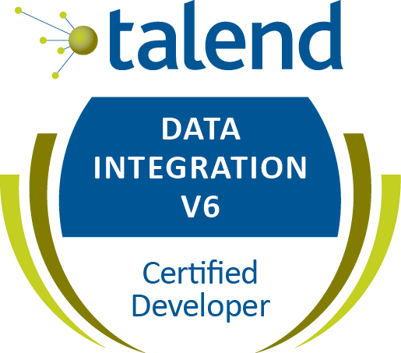

Email – chintapalli.bhanu@gmail.com

Contact No - +91-9566094644

Experience Summary

* Over 10+ **years** of experience in Information Technology.
* **Certified in Talend Enterprise Data Integration Consultant.**
* Experience in installing Talend 7.3 Data Management Server components and configuring TAC.
* Experienced in using Talend Data Management Platform (Talend DI, Talend DQ,TAC )
* Experienced in Talend Service Oriented Web Services using **SOAP, REST** components.
* Experienced in Scheduling Talend jobs using Talend Admin Console(TAC).
* Extensive experience with Data Extraction, Transformation, and Loading (ETL) from disparate Data sources like Oracle, SQL Server and Worked on integrating data from flat files, CSV files into a common reporting and analytical Data Model.
* Having experience in Debugging, Error Handling, and performance tuning of sources, targets and jobs.
* Experience in migrating jobs from Datastage7.5.2 to 8.1 version.
* Having experience on Data stage 8.0.1 & Data stage 7.5x2 Parallel Jobs.
* Having experience on Informatica 8.5.1.
* Significant knowledge in Data warehousing concepts.

Core Competencies

* **ETL Tools**
  + Talend5.x,Talend 6.4.1
  + Data stage 9.1.2
  + Informatica Power Center v9.1
* **Database**
  + MS SQL Server 2005, 2008
  + Oracle

Educational Qualifications

* BTech in ECE from Royal College of Eng. (JNTU Affiliated).

Experience

* **Company**: Mahindra Satyam, Chennai, Period: March 2011 – May 2012
* **Company** : Virtusa Software services From July 2012 – Nov 2020
* **Current Company**: Cognizant Technology Services From Jan 2021 – Till date

Achievements & Certifications

* **Awarded “Merit increase based on my contributions to our team”** Cognizant Sept 2021
* **Awarded “Top Talent Bonus”** Virtusa Aug 2015, July 2017.
* **Talend Enterprise Data Integration Consultant(6.3)**
* **Certified AWS Solutions Architect - Associate (SAA-C02) –** Validation number (B2PZWVGKYNV4Q3KQ)

**Projects Worked**

|  |  |
| --- | --- |
| Project | Novartis Pharma AG (Jan 2021 To Till Date) |
| Role | Integration Lead |
| Domain | HealthCare |
| Technology | Talend Data Integration Platform 6.4, Kinaxis Rapid Response |
| Novartis Statement of work | Cognizant will provide services to complete Program Management, R2 Roll-out, R3 Build and Change Man-agement for Kinaxis Program. |
| Roles | * Create a plan for Data Integration work stream in collaboration with the Program manager. * Participate in Knowledge transition from the existing vendor * Ensure that requirements are received for each and every site implementation. * Understand Talend to Kinaxis integration architecture. * Understand and guide the team on SAP Talend Template job details and Configure template jobs * Understand SAP->Kinaxis source to target mappings attribute details and work in collaboration with the BA to finalize the mappings. * Update Talend to Kinaxis design document as per the requirements of each site. * Customized business rules/transformations, metadata tables, audit tables, DQ framework. |

|  |  |
| --- | --- |
| Project | COLT NMTS (Number Management Translation Services) (Feb 2019 To Nov 2020) |
| Role | Talend Developer |
| Domain | Telecom |
| Technology | Talend Data Integration Platform 5.3, Oracle |
| NMTS IssuesDescription | An inventory system – NMTS - Maintains those numbers that are reserved, allocated, activated and ported (in or out) to customers. The NMTS allocates number ranges to customers via the Order Management system through appropriate sales channels.  Numbers allocated to customers will be deployed and activated upon completion of order management process. Once activated the number will be registered within the switches and ready for use.  It has been found that the switch data and NMTS data are not in sync. This means, the number ranges shown within NMTS do not actually reflect the true state of the numbers in the switches. This result in a number of problems for end users such as:   1. Number purported to be available for use has been found to be already in use when attempting to deployment 2. Number Range shown in NMTS does not reflect breaks occurred by numbers ported out 3. NMTS also not correctly showing ported in numbers from other operators (OLO)   Therefore there is a trust deficit in the use of NMTS during number allocation and reporting process. |
| Roles | * Data is received from multiple sources like NMTS, Switch and Kenan. * Switch data can be from different sources like PSX and DMS/EWSD. * Switch base line rules are provided by business. . If the length of CLI is fixed for the country, the start number and end number is padded with 0’s and 9’s respectively to construct fixed length of CLI. * Singleton numbers are generated between range of start number and end number. * Based on switch baseline rules, switch consolidation is executed. * The numbers are compared across NMTS, Switch & Kenan and the status is evaluated. * The analysis is carried out and the reconciliation reports are shared with business. |

|  |  |
| --- | --- |
| Project | Datastage to Talend Migration (August 2018 To Jan 2019) |
| Role | Talend Developer |
| Domain | Banking |
| Technology | Talend Data Integration Platform 5.3, Teradata |
| Project Description | Objective of this Project  Efficiently migrate DataStage jobs into Talend.  Achieve DataStage jobs conversion into Talend in an accelerated way.  Ensure desired behaviour is retained post migration without impacting business functionality (AS-IS). |
| Roles | * Export DataStage (Jobs) Metadata into XML files. * Collect/Receive DataStage Metadata XML in shared location. * Process XMLs through internal accelerator and generate Talend code. * Perform sanity checks and reruns for runtime failure cases. * Ensure DS XML jobs have been converted to Talend code base files. * Transfer the Talend code base files into shared location. * Import Talend jobs into Talend Studio and perform sanity checks. * Run DS jobs & record results for validation. * Run Talend jobs & record results for validation. * Match results from Step11 & 12 and iterate cycle as necessary. * Deploy Talend jobs into UAT environment and close. |

**HomeServe Retention Campaigns March 2017 - July 2018**

**Virtusa Software Services**

**NYL FT WAVE 1.1 Nov 2014 - Jan 2017**

**Virtusa Software Services**

**Network Rail, UK Oct 2013 – May 2014**

**Virtusa Software Services**

**TUI Travels Dec 2012 – Mar 2013**

**Virtusa Software Services**

**University of Arizona Aug 2012 – Nov 2012**

**Virtusa Software Services**