**PurchaseOrders.tab**

|  |  |  |  |
| --- | --- | --- | --- |
| **Version** | **Date** | **Author** | **Comments** |
| Refer to PROTON history |  | Rob Reeves  AndreyKornienko | Initial Version including main mapping rules. The BI mapping inputs provided by the BI team and MD04 extraction. |
|  |  | Kshitij Jathar | PROTON Administration and finalize the document with the following changes:-   1. Document History removed as Proton will have its own version tracking 2. Reference columns to one-drive folders deleted. 3. Different colours, text highlights etc. have been removed. 4. Format. is changed and standardized |
| 0.1 Version | 14-04-2021 | Santosh Reddy | As per TicketNumber-(**20999**) Country requirement, the filter conditions (Supplying site = Receiving site) were commented for files PurchaseOrders Stock Transfer Orders for both IM and SZ.  Check Page No: 3 Header: Additional Filter |

|  |  |  |  |  |  |
| --- | --- | --- | --- | --- | --- |
|  | File | PHARMA | SANDOZ | Filtering | Existing in Tab |
| 1 | Purchase Orders Header | EKKO | EKKO | NA | NA |
| 2 | Purchase Orders Item | EKPO | EKPO | NA | NA |
| 3 | Vendor Confirmation | EKES | EKES | NA | NA |
| 4 | Schedule Lines for PO | EKET | EKET | NA | NA |
| 5 | MD04 | NA | NA | For POs: Filter by MRP element indicators “BE”, “LA”, “LE”  For consignments:  “VC”, “VI”, “VJ” | IM/SZ: new Function Module |
| 6 | PO Item Category | T163Y | T163Y | Filter by SPRAS = “EN”, get PTEXT | Description of PO item category |

**Comment: EKKO, EKPO, EKES and EKET can be refreshed daily before MD04 refresh (not necessarily simultaneously). During MD04 data processing in BI – make JOIN with them.**

**Fields required in BI:**

For PO number and PO item number:

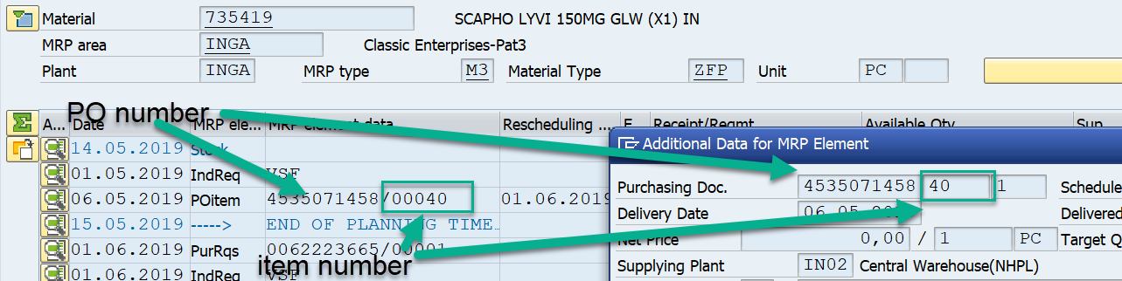

For Supplying plant:

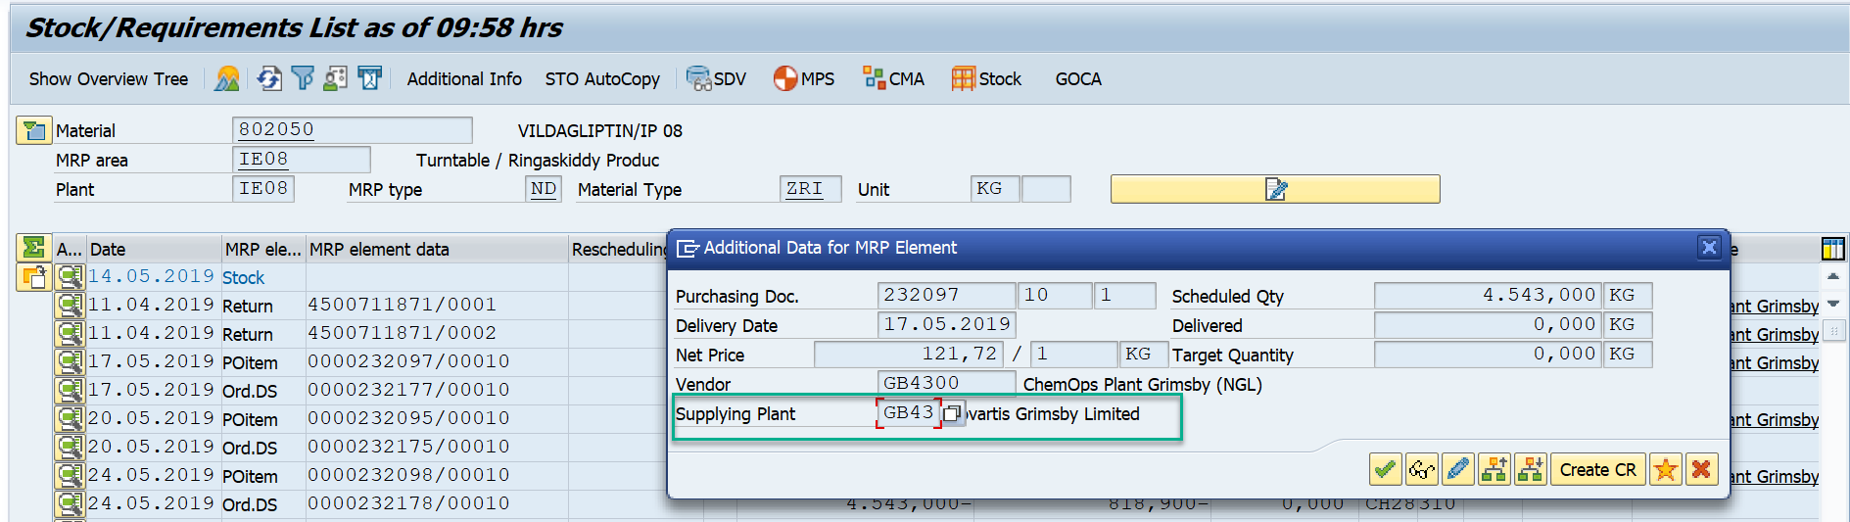

For determination of Statistical Delivery Date (for confirmed PO).

Get the Statistical Delivery Date (EKET-EINDT) where Purchase Order Number EKET-EBELN and Position EKET- EBELP for each Position.

Note: in case of multiple position take the latest one for each PO/Position combination.

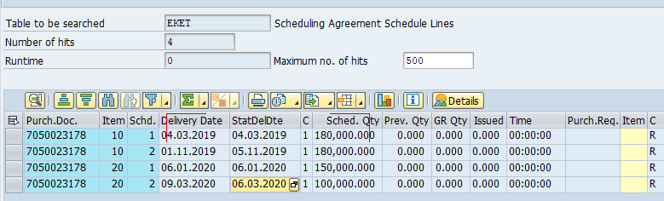

*Ie: in the above example for order 7050023178: position 10 take 05.11.2019 and for position 20 take 06.03.2020.*

Apply to each Confirmation position in EKES where Purchase Order Number EKET-EBELN = EKET-EBELN and Position EKES- EBELP = EKET- EBELP.

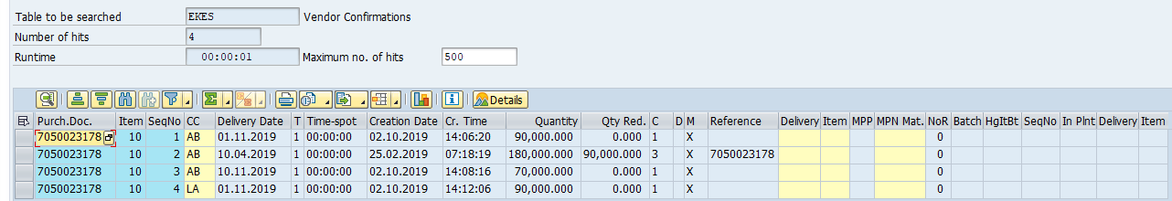

*Ie: in the above example for order 7050023178 only position 10 has confirmation therefore the date should be 05.11.2019*

Date of Purchase Order: visible in MD04 depending on the mode (AV – availability date, GR – GR date)

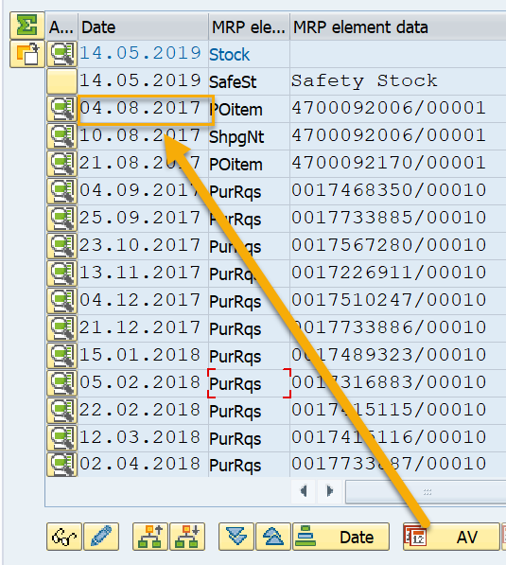

Storage Location where the goods will be received to (NVS.StLoc):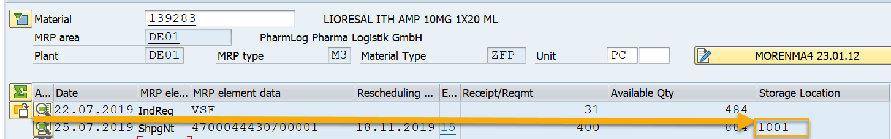

**Additional Filter:**

Remove records with OrderType STO which are recursive (Supplying Plant = Receiving Plant)

**Remove records with OrderType SubPO which are recursive (Material = Allocation -Assembly)**

**Enhancement:** As per SPEED release 3 (20999) Country requirement: Supp_Site = Receiving_site Filter condition is commented in Tmap for both IM and SZ. Please find below screenshot for more details.

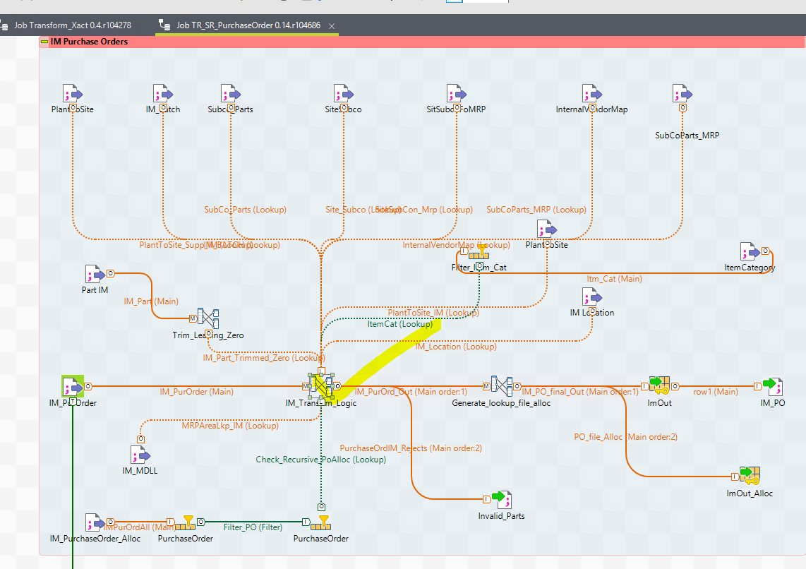

In tmap (Talend):

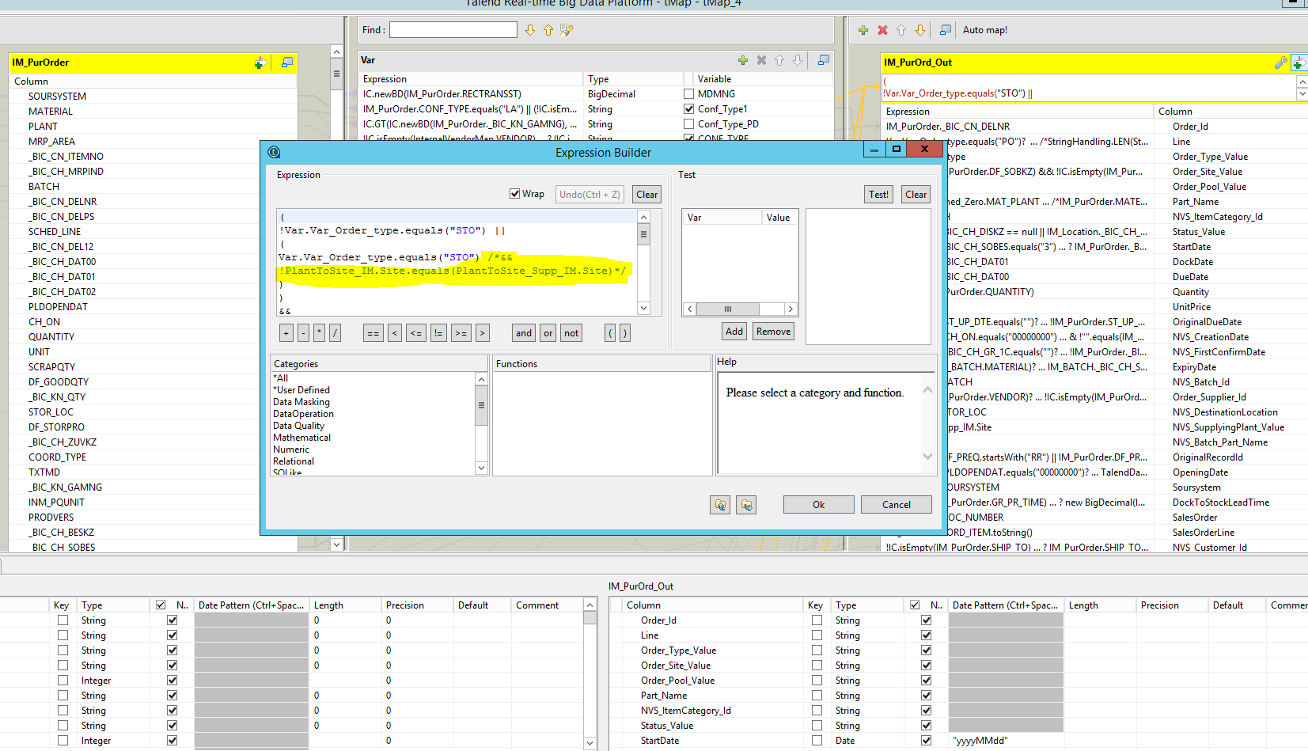

| Index | RR Fields | ERP (IM) | ERP (SZ) | Source | Fields | Comments | IM | SZ |
| --- | --- | --- | --- | --- | --- | --- | --- | --- |
| 1 | Order.Id | EKKO-EBELN | EKKO-EBELN | **MD04** | DELNR | See screenshot above | /BIC/CN_DELNR | CRM_FMREID |
| 2 | Line | NA | NA | **Talend** | **Talend** | **Concatenate DELPS _ DELET _ DELKZ** | NA | NA |
| - | Item | EKPO-EBELP | EKPO-EBELP | **MD04** | DELPS | See screenshot above | /BIC/CN_DELPS | REFER_ITM |
| - | SchLineSeq | NA | NA | **MD04** | DELET | See screen shot above - sequence or schedule line number as appears in MD04 (one PO, as example, item can be subdivided due to several confirmations) | SCHED_LINE | SCHED_LINE |
| 3 | Order.Type.Value | “PO”, “STO”, “SubPO”, “SCHLNE” | “PO”, “STO”, “SUBPO”, “SCHLNE” | **MD04** | SOBES  WRK02 | Attempt link to InternalVendorMap using PO~PLANT =IVM~_BIC_CN_PLANT, PO VENDOR = IVM.VENDOR. If found, then type remains “PO”.  Otherwise -  When Supplying Plant WRK02 <> “” from MD04, then the type is “STO”.  When SOBES in MD04 is subcontracting (SOBES =”3”), then “SUBPO”  Otherwise – “PO”.  When DELKZ = “LE”, then “SchLne” | /BIC/CH_SOBES  SUPP_PLANT | /BIC/C9_I35PRT  SUPP_PLANT |
| 4 | Order.Site.Value | EKPO-WERKS | EKPO-WERKS | **MD04**  **Talend** | WERKS  BERID  PLANR  SOBKZ | 1. if SOBKZ is empty and PLANR <> “” and Vendor <> “” and Site <> “”, then WERKS_PLANR 2. if MRP Area BERID is available in MDLL table, then WERKS _ vendor number (get it from MDLL by MRP Area and Plant, field LBEAR) 3. **Else** keep WERKS. | PLANT  MRP_AREA  /BIC/CH_PLNRA  DF_SOBKZ | PLANT  MRP_AREA  /BIC/C9_IPLANR  DF_SOBKZ |
| 4 | Part.Site.Value | EKPO-WERKS | EKPO-WERKS | **Talend** | **Talend** | The same as Order.Site – see above. | NA | NA |
| 5 | Order.Pool.Value | “unpooled” | “unpooled” | NA | NA | Not foreseen to be used | NA | NA |
| 6 | Part.Name | EKPO-MATNR | EKPO-MATNR | **MD04** | MATNR | NA | MAT_PLANT | MATERIAL |
| 7 | ItemCategory | EKPO-PSTYP | EKPO-PSTYP | **MD04** | SOBES | Join SourceSystem and SOBES and get ItemCategory Description | /BIC/CH_SOBES  TXTSH | /BIC/C9_I35PRT  TXTSH |
| 8 | Status | **Based on EKES-EBTYP**  “Open”,  “Confirmed”  “InTransit”  **And for subcontracting:**  “SubConOpen”,  “SubConConfirmed”  “SubConInTransit” | **Based on EKES-EBTYP**  “Open”,  “Confirmed”  “InTransit”  **And for subcontracting:**  “SubConOpen”,  “SubConConfirmed”  “SubConInTransit” | **BI** | **BI** | Get confirmation type EBTYP from EKES by PO Number (EBELN), Item (POSNR) and Seq Number (ETENS)  When “LA” - then “In Transit”  When “AB” – then “Confirmed”  Else – “Open”  When PO is type “SubPO” (SOBES =”3”, see above) and related PartSource is planned in RR, then add prefix “SubCon” to the status, e.g. “SubConOpen” – this will allow RR to make demand signal (explode in RR) at vendor location  For MRP element BE with WRK02 populated we need to put Status “InTransit”, if MDMNG > 0  For total quantity exceeding the open quantity, “PartiallyDelivered” to be used.  **TALEND**: If Location is marked as not planning relevant in Location tab, then add suffix “_noMRP” to Status | CONF_TYPE | CONF_TYPE |
| 9 | StartDate | NA | NA | **Talend** | **Talend** | Ship date from Supplier  When PO is type “SUBCON” (SOBES =”3”), then StartDate = DockDate.  Else, **leave empty** (even for STOs) | NA | NA |
| 10 | DockDate | EKET-EINDT (from MD04 – Good Receipt Date) | EKET-EINDT (from MD04 – Good Receipt Date) | **MD04** | DAT01 | Date when it is received (GR date) – take from MD04 | /BIC/CH_DAT01 | /BIC/C9_IDAT01 |
| 11 | DueDate | From MD04 – Availability Date | From MD04 – Availability Date | **MD04** | DAT00 | Available date – take from MD4 | /BIC/CH_DAT00 | /BIC/C9_IDAT00 |
| 12 | Quantity | NA | NA | **MD04** | MNG01 | NA | QUANTITY | QUANTITY |
| 13 | UnitPrice | NA | NA | NA | NA | Do not populate | NA | NA |
| 14 | NVS::OriginDueDate | EKET-SLFDT | EKET-SLFDT | **BI** | **BI** | Take first element. Statistical Date from Schedule Line. | ST_UP_DTE | STAT_DATE |
| 15 | Creation Date | EKKO-ERDAT | EKKO-ERDAT | **MD04** | BEDAT | Date when PO has been created (ESO requirement). | CH_ON | /BIC/C9_IPOD |
| 16 | First Conf Date | EKPO-ZZCONFDATE | EKPO-ZZC9_T5 | **BI** | **BI** | Date when first confirmation has been issued by intercompany supplier. | /BIC/CH_GR_1C | C9_IPIT5 |
| 17 | ExpiryDate | Identify from Batch Master in Talend (MCHA-VFDAT by MATNR and WERKS) | Identify from Batch Master in Talend (MCHA-VFDAT by MATNR and WERKS) | **Talend** | **Talend** | If batch found (see below), then take from MCHA. Otherwise - RR to estimate. | NA | NA |
| 18 | Batch | EKES-CHARG | EKES-CHARG | **MD04** | CHARG | NA | BATCH | BATCH |
| 19 | Order.Supplier.Id | EKKO-RESWK /  EKKO-LIFNR /  EKPO_WERKS concatenate to EKKO-LIFNR | EKKO-RESWK /  EKKO-LIFNR /  EKPO_WERKS concatenate to EKKO-LIFNR | **MD04** | LIFNR/  WRK02 | Get Vendor number from MD04 (LIFNR).  If blank, then get Supplying Plant in MD04 (see below, RESWK)  **Make explosion in RR, when status starts with “SubCon”** | VENDOR / SUPP_PLANT | VENDOR / SUPP_PLANT |
| 20 | LocationID | EKPO-LGORT | EKPO-LGORT | **MD04** | LGORT | See screenshot above. Needed to identify whether PO is going to nettable location or not. Exclude, when goes to non-nettable location.  Select Location file passing SourceSystem (SOURSYSTEM), Plant (PLANT) and Location (STOR_LOC).  If record found and /BIC/CH_DISKZ (IM) or /BIC/C9_IDISK (SZ) = “1” then skip the record  If record not found, keep the original Location from PO even if blank. | STOR_LOC | STOR_LOC |
| 21 | Supplying Plant | As per screen shot logic | As per screen shot logic | **MD04** | WRK02 | Check screenshot above (field Supplying Plant in MD04) | SUPP_PLANT | SUPP_PLANT |
| 22 | NVS_Batch_Part_Name | NA | NA | **NA** | NA | NA | NA | NA |
| 23 | OriginalRecordId | EKPO-BANFN  EKPO-BNFPO | EKPO-BANFN  EKPO-BNFPO | **BI** | BI | Linkage to the Purchasing Requisition Number and its Item number (for RR to be able to link Schedule Receipt to Firmed Planned Order)  Concatenate DF_PREQ and DF_PREQITM | DF_PREQ  DF_PREQITM | BBP_REQ_ID  DF_PREQITM |
| 24 | OpeningDate | PLAF- PERTR | PLAF- PERTR | **MD04** | DAT03 | NA | PLDOPENDAT | PLDSTARTDT |
| 25 | SOURSYSTEM | NA | NA | **NA** | NA | NA | SOURSYSTEM | SOURSYSTEM |
| 26 | DockToStockLeadTime | WEBAZ | WEBAZ | **MD04** | MD04 | If found then pass else pass ZERO | GR_PR_TIME | GR_PR_TIME |
| 27 | SalesOrder | KDAUF | KDAUF | **MD04** | MD04 | NA | DOC_NUMBER | DOC_NUMBER |
| 28 | SalesOrderLine | KDPOS | KDPOs | **MD04** | MD04 | NA | SORD_ITEM | SORD_ITEM |
| 29 | NVS_Customer_Id | SHIP_TO | CUSTOMER | **MD04** | MD04 | If found concatenate with SourceSystem otherwise just pass the value | SHIP_TO | CUSTOMER |
| 30 | NVS_LeadingIndicator | NA | NA | **MD04** | **MD04** | NA | /BIC/CH_LSIND | BIC/C9_ISYS |

**Purchase Order created in Talend for ScheduledReceipt to Consignment Location:**

**MRP element “VC”, “VI”, “VJ” (see Allocation file for this part as well).**

* **TALEND: only consider sales orders and deliveries to Sold-To Customer (from MD04), which is specified in RR table as customer consignment relevant for separate planning.**
* **TALEND: For such Sales Orders / Deliveries Scheduled Receipt at Customer Site in RR has to be created in Talend (will not appear in MD04)**

| Index | RR Fields | MD04 | Comments | IM | SZ |
| --- | --- | --- | --- | --- | --- |
| 1 | Order.Id | **MD04**  **DELNR** |  | /BIC/CN_DELNR | CRM_FMREID |
| 2 | Line | **Talend** | Concatenate fields below, e.g. 10_1 | NA | NA |
|  | Item | **DELPS** | See above in yellow e.g. 10 | /BIC/CN_DELPS | REFER_ITM |
|  | SchLineSeq | **DELET** | See above in yellow, e.g. 1 | SCHED_LINE | SCHED_LINE |
| 3 | Order.Type.Value | **Talend** | **“ConsPO”** | **NA** | **NA** |
| 4 | Order.Site.Value | **Talend**  **WERKS**  **KUNNR** | **Talend**: concatenation of Plant and Customer number from MD04 | **PLANT**  SHIP_TO | **PLANT**  CUSTOMER |
| 5 | Part.Site.Value | **Talend** | The same as Order.Site – see above. | NA | NA |
| 6 | Order.Pool.Value | n/a | Not foreseen to be used | NA | NA |
| 7 | Part.Name | **MATNR** | na | MATERIAL | MATERIAL |
| 8 | ItemCategory | **Talend** | Leave blank | NA | NA |
| 9 | Status | **Talend** | “Open” | NA | NA |
| 10 | StartDate | **DAT00** | Requirement Date from MD04 | /BIC/CH_DAT00 | /BIC/C9_IDAT00 |
| 11 | DockDate | **Talend** | Calculate in Talend as StartDate + PreShipLT + Transport Time from Part Source between SupplyingSite (see below SupplierID) and this site (Customer site) | NA | NA |
| 12 | DueDate | **Talend** | Calculate in Talend as DockDate + DockToStock from Part Source between this Site and Customer Site | NA | NA |
| 13 | Quantity | **MNG01** |  | QUANTITY | QUANTITY |
| 14 | Order.Supplier.Id | **WERKS** | Get Supplying Plant in MD04 (where Sales Order or Delivery are placed on)  **Make explosion in RR, when status starts with “SubCon”** | PLANT | PLANT |
| 15 | Supplying Plant | **WERKS** | Same as Order Supplyier ID above | PLANT | PLANT |
| 16 | DockToStockLeadTime | WEBAZ | If found then pass else pass ZERO | GR_PR_TIME | GR_PR_TIME |
| 17 | SalesOrder | KDAUF | NA | DOC_NUMBER | DOC_NUMBER |
| 18 | SalesOrderLine | KDPOS | NA | SORD_ITEM | SORD_ITEM |
| 19 | NVS_LeadingIndicator | NA | NA | /BIC/CH_LSIND | BIC/C9_ISYS |

Item Category:

|  |  |  |  |  |
| --- | --- | --- | --- | --- |
| **S.No** | **Description** | **Field Name** | **IM - BW InfoObject** | **SZ BW object** |
| 1 | Language Key | SPRAS | LANGU | LANGU |
| 2 | Item Category in Purchasing Document | PSTYP | ITM_CAT | /BIC/C9_IPSTYP |
| 3 | Text for Item Category | PTEXT | TXTSH | TXTSH |