Task 1: Install Nginx inside the Ubuntu machine and host a website.

Nginx Installation:

Commands used:

1. Apt-get update
2. Apt-get install nginx

1. Systemctl restart nginx
2. Systemctl enable nginx
3. Systemctl status nignx

Created new HTML file as html file with body as given below and the file location is:

Path: /var/www/html/index.html

Tested the webpage is launching

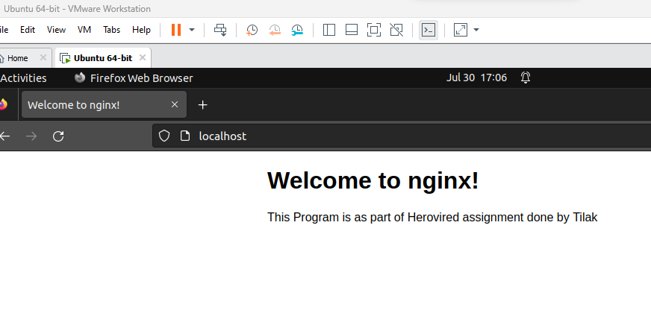

Now on my local Machine I have used zenmap for scanning the ports

