Genomic Selection
Jinliang Yang
04-24-2025

Path Normalization

A real world example: Loblolly pine data
In this example, we will use the breeding values of crown width across the planting beds at age 6 (CWAC6).
# read phenotype and SNP files
pheno_file <- "https://jyanglab.com/img/data/DATA_nassau_age6_CWAC.csv"
geno_file <- "https://jyanglab.com/img/data/Snp_Data.csv"
pheno <- read.csv(pheno_file, header=TRUE, stringsAsFactors = FALSE)
hist(pheno$Derregressed_BV, main="Crown width at Age 6", xlab="width")
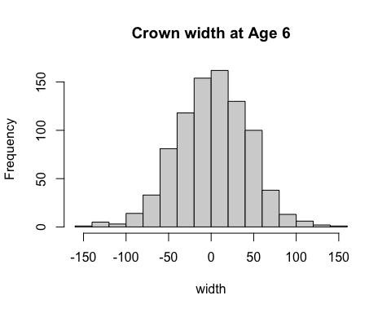
# geno[1:10, 1:10]

Loblolly pine data

Remove missing phenotypes
There are some accessions containing no phenotype. We need to remove these accessions first.
na.index <- which(is.na(pheno$Derregressed_BV))
# length(na.index)
pheno <- pheno[-na.index, ]
# phenotypes
y <- pheno$Derregressed_BV
y <- matrix(y, ncol=1)

Genotype data: SNP quality control
In the geno matrix, row indicates individual, column indicates SNPs.

Missingness and MAF
geno <- read.csv(geno_file, header=TRUE, stringsAsFactors = FALSE)
dim(geno)
## [1] 926 4854
# Keep genotypes for these remaining lines
geno <- geno[geno$Genotype %in% pheno$Genotype, ]
# markers
geno <- geno[,-1] # 861 x 4853
geno[geno == -9] <- NA
# missing rate
missing <- apply(geno, 2, function(x){sum(is.na(x))/length(x)})
# minor allele frequency
maf <- apply(geno, 2, function(x){
frq <- mean(x, na.rm=TRUE)/2 # 1 allele
return(ifelse(frq > 0.5, 1-frq, frq))
})

Genotype data: SNP quality control
In the geno matrix, row indicates individual, column indicates SNPs.

Plot the results
hist(missing, breaks=100, col="blue", xlab="SNP Missing rate")
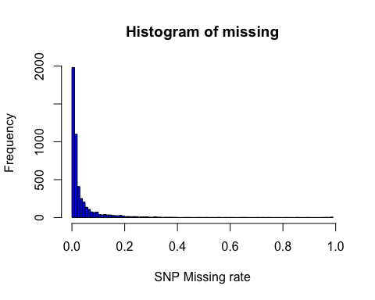
hist(maf, breaks=100, col="blue", xlab="Minor Allele Freq")
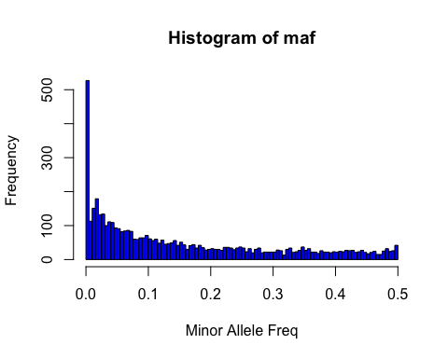
Removing SNPs with high missing rate (missingness > 0.2) and low MAF (MAF < 0.05)
- Question: How many markers are removed?
idx1 <- which(missing > 0.2) #154
idx2 <- which(maf < 0.05) #1647
idx <- unique(c(idx1, idx2)) #1784
geno2 <- geno[, -idx]
dim(geno2)
## [1] 861 3069

Missing marker imputation
Replace missing marker genotypes with mean values. Then store the marker genotypes in a matrix object Z.
Z <- matrix(0, ncol=ncol(geno2), nrow=nrow(geno2))
for (j in 1:ncol(geno2)){
#cat("j = ", j, '\n')
Z[,j] <- ifelse(is.na(geno2[,j]), mean(geno2[,j], na.rm=TRUE), geno2[,j])
}
# sum(is.na(Z))
write.table(Z, "data/Z.txt", sep="\t", row.names = FALSE,
col.names=FALSE, quote=FALSE)

Genomic relationship

SNP Matrix standardization
Standardize the genotype matrix to have a mean of zero and variance of one. Save this matrix as Zs.
Zs <- scale(Z, center = TRUE, scale = TRUE)
# dimensions
n <- nrow(Zs)
m <- ncol(Zs)

Calcualte genomic relationship
- Compute the second genomic relationship matrix of VanRaden (2008) using the entire markers.
- Then add a very small positive constant (e.g., 0.001) to the diagonal elements so that G matrix is invertible. A singular matrix cannot be inverted, which poses computational challenges.
# Given matrices x and y as arguments, return a matrix cross-product.
# This is formally equivalent to (but usually slightly faster than)
# the call t(x) %*% y (crossprod) or x %*% t(y) (tcrossprod).
G <- tcrossprod(Zs) / ncol(Zs)
# G <- Zs %*% t(Zs) /ncol(Zs)
G <- G + diag(n)*0.001
- tcrossprod(Zs) computes the matrix product of Zs and its transpose, yielding an n x n matrix where n is the number of individuals.
- Dividing by the number of markers (ncol(Zs)) standardizes the matrix.

Solve MME for GBLUP
Set up mixed model equations (MME) by fitting the model:
$$y=1μ+Zu+e$$
- where $μ$ is the intercept,
- $Z$ is the incident matrix of individuals,
- $u$ is the breeding value of the individuals,
- and $e$ is the residual.
Directly take the inverse of LHS to obtain the solutions for GBLUP. Report the estimates of intercept and additive genetic values. Use $λ=1.35$.
lambda <- 1.35 # fit$Ve / fit$Vg
Ginv <- solve(G)
ones <- matrix(1, ncol=1, nrow=n)
Z <- diag(n)
# Given matrices x and y as arguments, return a matrix cross-product.
#This is formally equivalent to (but usually slightly faster than)
#the call t(x) %*% y (crossprod) or x %*% t(y) (tcrossprod).
LHS1 <- cbind(crossprod(ones), crossprod(ones, Z))
LHS2 <- cbind(crossprod(Z, ones), crossprod(Z) + Ginv*lambda)
LHS <- rbind(LHS1, LHS2)
RHS <- rbind( crossprod(ones, y), crossprod(Z,y) )
sol <- solve(LHS, RHS)
head(sol)
## [,1]
## [1,] 2.275528
## [2,] 12.915583
## [3,] -15.949010
## [4,] 18.411816
## [5,] 4.649033
## [6,] -23.828528
tail(sol)
## [,1]
## [857,] -3.877303
## [858,] 5.900186
## [859,] 7.631312
## [860,] -49.125424
## [861,] -8.490103
## [862,] -37.223103

R package: rrBLUP
Fit GBLUP by using the mixed.solve function in the rrBLUP R package.
- Report the estimates of intercept and additive genetic values.
- Do they agree with previous estimates?
- Also, report the estimated genomic heritability and the ratio of variance components $λ=\frac{V_{e}}{V_{A}}$.
#install.packages("rrBLUP")
library(rrBLUP)
fit <- mixed.solve(y = y, K=G)
# additive genetic variance
fit$Vu
## [1] 721.3393
# residual variance
fit$Ve
## [1] 997.0729
# intercept
fit$beta
## [1] 2.275528
# additive genetic values
head(fit$u)
## [1] 12.872001 -16.009856 18.153310 4.307152 -23.873051 16.372003
tail(fit$u)
## [1] -3.964626 6.047412 7.634191 -48.812717 -8.437586 -36.961484
# genomic h2
fit$Vu / (fit$Vu + fit$Ve)
## [1] 0.4197708
# ratio of variance components
fit$Ve / fit$Vu
## [1] 1.382252
# plot(x=sol[-1], y=fit$u)

RR-BLUP
Set up mixed model equations (MME) by fitting the model $y=1b+Zm+e$, where $b$ is the intercept, $Z$ is the standardized marker genotypes (Zs), $m$ is the additive marker genetic effects, and $e$ is the residual.

Directly take the inverse of LHS to obtain the solutions for marker-based GBLUP (RR-BLUP). Report the estimates of intercept and marker additive genetic effects. Use $λ=4326.212$.
–
lambda <- 4326.212 # fit$Ve / fit$Vu
ones <- matrix(1, ncol=1, nrow=n)
I <- diag(m)
LHS1 <- cbind(crossprod(ones), crossprod(ones, Zs))
LHS2 <- cbind(crossprod(Zs, ones), crossprod(Zs) + I*lambda)
LHS <- rbind(LHS1, LHS2)
RHS <- rbind( crossprod(ones, y), crossprod(Zs,y) )
sol2 <- solve(LHS, RHS)
head(sol2)
## [,1]
## [1,] 2.27552828
## [2,] 0.25984118
## [3,] -0.03032116
## [4,] -0.12452689
## [5,] 0.15758584
## [6,] -0.13104812
tail(sol2)
## [,1]
## [3065,] 0.009042828
## [3066,] 0.065547947
## [3067,] -0.235825005
## [3068,] 0.042984822
## [3069,] 0.102930180
## [3070,] 0.262549987

Use rrBLUP package
Fit RR-BLUP by using the mixed.solve function in the rrBLUP R package.
- Report the estimates of intercept and marker additive genetic effects.
- o they agree with the estimates with the manual calculation?
- Also, report the ratio of variance components $λ=\frac{V_{e}}{V_{A}}$.
library(rrBLUP)
fit2 <- mixed.solve(y = y, Z=Zs)
# marker additive genetic variance
fit2$Vu
## [1] 0.2350402
# residual variance
fit2$Ve
## [1] 997.7947
# intercept
fit2$beta
## [1] 2.275528
# marker additive genetic effects
head(fit2$u)
## [1] 0.26285584 -0.03075328 -0.12570117 0.16019719 -0.13267752 -0.06454280
tail(fit2$u)
## [1] 0.008232377 0.066259519 -0.237935580 0.042789624 0.103950959
## [6] 0.264838013
# ratio of variance components
fit2$Ve / fit2$Vu
## [1] 4245.208
# plot(x=sol2[-1], y=fit2$u)

K-fold validation
Repeat GBLUP but treat the first 600 individuals as a training set and predict the additive genetic values of the remaining individuals in the testing set. - What is the predictive correlation in the testing set? Use $λ=1.348411$.
n.trn <- 600
n.tst <- 261
y.trn <- y[1:n.trn]
y.tst <- y[n.trn+1:n.tst]
Zs.trn <- Zs[1:n.trn,]
Zs.tst <- Zs[n.trn+1:n.tst,]
Gtrn <- tcrossprod(Zs.trn) / ncol(Zs.trn)
Gtrn <- Gtrn + diag(n.trn)*0.001
Gtst.trn <- tcrossprod(Zs.tst, Zs.trn) / ncol(Zs.tst)
#Gtrn <- G[1:n.trn, 1:n.trn]
#Gtst.trn <- G[n.trn+1:n.tst, 1:n.trn]
lambda <- 1.348411 # fit$Ve / fit$Vu
Ginv.trn <- solve(Gtrn)
ones <- matrix(1, ncol=1, nrow=n.trn)
Z <- diag(n.trn)
LHS1 <- cbind(crossprod(ones), crossprod(ones, Z))
LHS2 <- cbind(crossprod(Z, ones), crossprod(Z) + Ginv.trn*lambda)
LHS <- rbind(LHS1, LHS2)
RHS <- rbind( crossprod(ones, y.trn), crossprod(Z,y.trn) )
sol.trn <- solve(LHS, RHS)
# prediction
y.hat <- Gtst.trn %*% Ginv.trn %*% matrix(sol.trn[c(2:(n.trn+1))])
cor(y.hat, y[(n.trn+1):n])
## [,1]
## [1,] 0.4635443
# plot(y.hat, y[(n.trn+1):n])
Repeat RR-BLUP but treat the first 600 individuals as a training set and predict the additive genetic values of the remaining individuals in the testing set. - What is the predictive correlation in the testing set? Use $λ=4326.212$. - Also, compare this predictive correlation to the one from GBLUP.
Zs.trn <- Zs[1:n.trn, ]
Zs.tst <- Zs[n.trn+1:n.tst, ]
lambda <- 4326.212 # fit$Ve / fit$Vu
ones <- matrix(1, ncol=1, nrow=n.trn)
I <- diag(m)
LHS1 <- cbind(crossprod(ones), crossprod(ones, Zs.trn))
LHS2 <- cbind(crossprod(Zs.trn, ones), crossprod(Zs.trn) + I*lambda)
LHS <- rbind(LHS1, LHS2)
RHS <- rbind( crossprod(ones, y.trn), crossprod(Zs.trn, y.trn) )
sol.trn <- solve(LHS, RHS)
# prediction
y.hat2 <- Zs.tst %*% matrix(sol.trn[-1])
cor(y.hat2, y[(n.trn+1):n])
## [,1]
## [1,] 0.4635768
plot(y.hat2, y[(n.trn+1):n])
