Nieves Soka University Telescope
Department of Natural Sciences — Soka University of America
NSUT Control Panel
A Student’s Guide to Image Reduction and Photometry
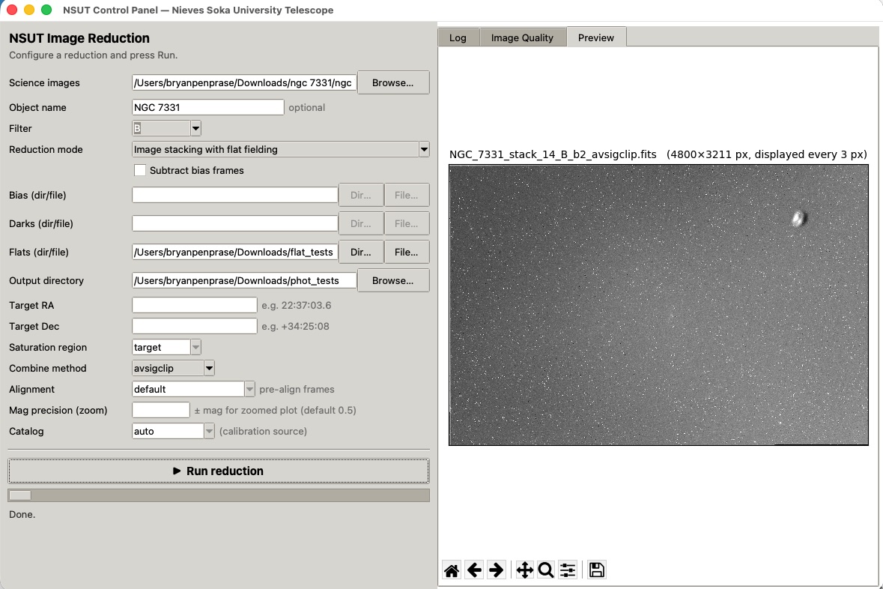
The NSUT Control Panel: a single window that runs the whole reduction pipeline.
From a folder of raw frames to a calibrated light curve, without the command line.

Contents
1. Getting Oriented
2. Finding and Excluding Bad Frames (Saturation Check)
3. Stacking Frames in One Filter (Simple Image Stacking)
4. Choosing a Combine Method
5. Stacking with Flat Fielding
6. Stacking with Dark Subtraction
7. Adding Bias Subtraction
8. Differential Photometry
9. A Complete Observing Workflow

1. Getting Oriented
The NSUT Control Panel brings the four programs of the telescope’s software suite — the saturation checker, the image combiner, the photometry engine, and the light-curve plotter — together behind one window. You choose a folder of images, pick what you want to do with them, and press one button. Everything that used to require typing long commands now happens through menus and file pickers, which makes the suite practical to hand to students during an observing run.
The window has two halves. On the left is the control panel, where you configure a run. On the right is a dashboard with three tabs: a Log that streams each step as it happens, an Image Quality table, and a Preview that shows the resulting image or light curve. You configure on the left, press Run reduction, and watch the right.

The controls, top to bottom
Most controls stay the same across every task, so it is worth learning them once:
Control |  | What it does
Science images |  | The folder holding the frames you want to process. Use Browse to find it.
Object name |  | Optional. The target’s name. It becomes the prefix of every output file and, for photometry, the headline on the plots. Leave it blank and the software reads the OBJECT keyword from the image headers instead.
Filter |  | Which filter’s frames to use. The special choice autoselect handles a folder containing several filters at once (covered in Section 3).
Reduction mode |  | The task to perform: a saturation check, one of four stacking recipes, or differential photometry.
Subtract bias frames |  | A checkbox that adds bias subtraction to any stacking mode (Section 7).
Bias / Darks / Flats |  | Folders (or ready-made master files) of calibration frames. Each is enabled only when the chosen mode needs it.
Output directory |  | Where results are written.
Target RA / Target Dec |  | The target’s sky coordinates, needed only for photometry.
Saturation region |  | Which part of the frame the saturation checker inspects.
Combine method |  | The statistical recipe used to stack frames (Section 4).
Alignment |  | For photometry: whether to pre-align the series before measuring (Section 8).
Mag precision (zoom) |  | For photometry: the vertical range of the zoomed light-curve page.
Catalog |  | For photometry: the survey used to put magnitudes on a standard scale.
Tip
Fields you don’t need are greyed out automatically. If a box looks dim, the current mode doesn’t use it — that is the panel telling you what matters for the task you picked, so you can ignore the rest.

The general rhythm of a run
- Point Science images at your folder and set the Output directory.
- Type an Object name (recommended) so your files are easy to find later.
- Choose a Reduction mode and fill in only the fields it leaves active.
- Press Run reduction and watch the Log tab; a timer shows elapsed time.
- When it finishes, open the Preview or Image Quality tab to inspect the result.
Note
Large frames take time. A multi-night folder of 60-megapixel frames can take several minutes, and during the slow steps the Log may pause between lines. The elapsed-time clock in the status bar tells you the run is still alive. A run is only stuck if the clock stops moving and no new log line has appeared for many minutes.

2. Finding and Excluding Bad Frames (Saturation Check)
Before stacking or measuring anything, it is worth weeding out frames that are overexposed. A saturated pixel is one that hit the detector’s ceiling — about 65,000 counts on a 16-bit camera — and stopped recording. Saturated pixels lie about how bright something really is, so even a handful on your target ruins photometry, and badly saturated frames pollute a stack. The Saturation check mode scans a folder and reports, frame by frame, how many pixels are saturated.
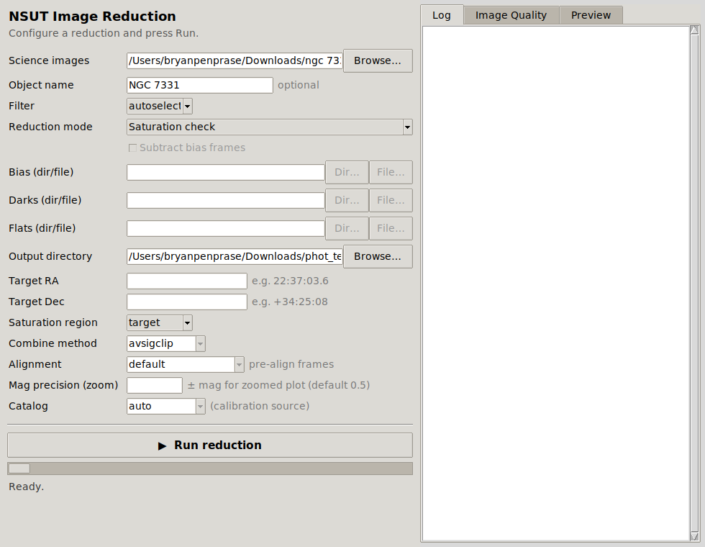
Saturation check mode. Only the Science images, Object name, Output directory, and Saturation region fields are active; everything else is greyed out.

Running it
- Set Science images to the folder you want to inspect.
- Choose Saturation check as the Reduction mode.
- Pick a Saturation region (explained below).
- Press Run reduction.

Which region to inspect
The checker can look at the whole frame or just the middle, depending on what you care about:
Region | Inspects | Best for
target | The central 20% | A science target centered in the frame — a galaxy core, a transit host star. Ignores bright field stars near the edges.
center | The central 50% | Flat fields and calibration frames, where you want a broad check but want to avoid edge vignetting.
all | The entire frame | Full quality control, or hunting for any saturated star anywhere in the field.

Reading the results
The run writes a CSV report into your output folder and fills the Image Quality tab with a sortable table. Each row is one frame, with its object name, exposure time, filter, date, the count and percentage of saturated pixels, and the mean level in the inspected region. Click any column heading to sort; clicking % Saturated pushes the worst offenders to the top.
A rough rule of thumb for deciding what to keep:
% Saturated | Verdict
0% | Ideal. Keep.
below ~1% | Usually fine, but check whether the saturated pixels sit on your target or are just a hot field star.
above ~1% | Likely overexposed. Exclude from photometry, and think twice before stacking.
To exclude a bad frame, simply move it out of the folder (or into a “rejects” subfolder) before you stack or measure. The other programs only see what remains. The stacker has its own automatic safeguards too — it quietly skips frames whose sky level is wildly inconsistent with the rest — but a deliberate look here, early, saves confusion later.
Tip
Run the saturation check the same night you observe. If frames are saturating, you still have the telescope and can re-shoot with a shorter exposure. Caught a week later, the data are simply lost.

3. Stacking Frames in One Filter (Simple Image Stacking)
Stacking combines many exposures of the same field into one deeper image. The payoff is signal-to-noise: combine N frames and the random noise shrinks relative to the signal by roughly the square root of N, so sixteen frames give a result about four times cleaner than one. Combining also rejects cosmic rays and other transient specks that appear in only one frame. Simple image stacking does this with no calibration applied — the right choice when you only want a quick, deeper look, or when your frames were already calibrated elsewhere.
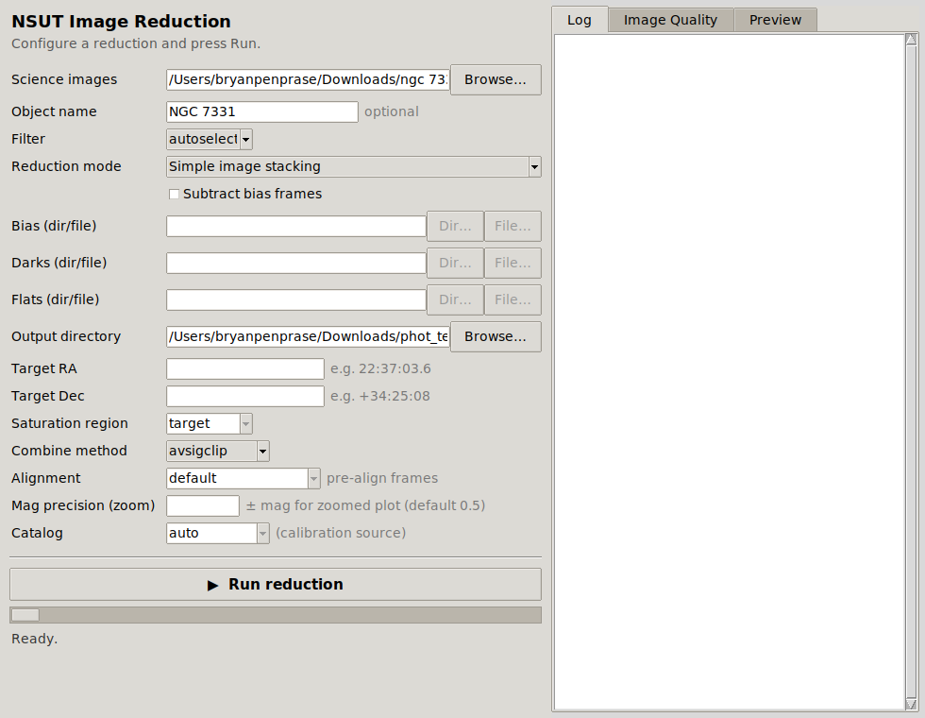
Simple image stacking with Filter set to autoselect. Bias, Darks, and Flats are greyed out because this mode applies no calibration.

Running it
- Set Science images and the Output directory.
- Type an Object name so the stack is easy to identify.
- Choose your Filter (or autoselect — see below).
- Choose Simple image stacking as the mode, and a Combine method (Section 4).
- Press Run reduction. The frames are aligned to the first one by matching star patterns, then combined.

What if the folder holds several filters?
This is the question that trips up most students, and the panel gives you two clear answers depending on the Filter setting.

Option A — pick one filter
If you choose a specific filter, say r', the stacker uses only the frames whose header says they were taken through that filter and ignores the rest. It prints a line for each frame it skips and why. You get a single stacked image in that one filter. This is what you want when a folder mixes filters but you only care about one of them.

Option B — autoselect (one stack per filter)
If you choose autoselect, the stacker reads every frame, discovers which filters are present, and produces one stacked image for each filter automatically. A folder containing r′, g′, and i′ frames yields three stacks in a single run, each named for its filter, each with its own diagnostics file. You do not have to run the program three times or sort the frames by hand.
Because the filter groups come from the image headers themselves, autoselect also handles filters the software was never explicitly told about. If a folder happens to contain frames through a U filter, autoselect finds them and makes a U-band stack alongside the others. Nothing needs to be pre-configured.
In short
Specific filter → one stack, from the matching frames only. autoselect → a separate stack for every filter found in the folder, including unexpected ones.
Note
autoselect is for stacking only. It cannot be combined with flat fielding (each filter would need its own flat — see Section 5) or with differential photometry (which measures one target through one filter). The panel will tell you this if you try.

What you get
Every stacking run, simple or calibrated, produces the same two kinds of output:
- The stacked image, a FITS file named from the object, frame count, filter, binning, and method — for example NGC_7331_stack_14_rp_b1_avsigclip.fits. It appears in the Preview tab as a zscale thumbnail (or, for autoselect, a grid of thumbnails, one per filter).
- An alignment diagnostics file, a CSV sharing the stack’s name with the suffix _alignment_diagnostics.csv. It records, for each frame, how many stars were matched, the measured shift and rotation, the fit residual, and whether the frame made it into the stack. This is where you look if a stack seems blurry: a frame with few matched stars or a large residual is the suspect.
Tip
The frame count in the filename always reflects what was actually combined. If you stacked a 15-frame folder and the output says stack_14, one frame was excluded — the diagnostics file will tell you which and why.

4. Choosing a Combine Method
The Combine method menu decides how the aligned frames are merged, pixel by pixel. The right choice depends mostly on how many frames you have and how many cosmic rays you expect.
Method | How it works | Use when
avsigclip | Sigma-clipped average: discards pixels far from the local median, then averages the rest. The recommended default. | Most science stacking. Good signal-to-noise while still rejecting outliers.
average | Plain mean of all frames. Best possible noise reduction, but no outlier rejection. | Very clean data with no cosmic rays, or building master bias frames.
median | Takes the middle value at each pixel. Excellent at rejecting cosmic rays. | Five or more frames, or building robust master darks.
nomax | Drops the single brightest value at each pixel, averages the rest. | Three or four frames where cosmic rays always brighten pixels.
When in doubt, leave it on avsigclip. It is the all-round choice and rarely the wrong one.

5. Stacking with Flat Fielding
A flat field corrects for the fact that no detector responds perfectly evenly. Dust on the optics casts faint shadows, the corners of the field receive less light than the center (vignetting), and individual pixels differ slightly in sensitivity. A flat is an image of a uniformly lit surface — the twilight sky or an illuminated panel — that records this pattern, so the science frames can be divided by it to cancel it out. The mode Image stacking with flat fielding does this automatically before stacking.

Running it
- Set Science images, Object name, Filter, and Output directory.
- Choose Image stacking with flat fielding as the mode.
- In the Flats (dir/file) row, point to either a folder of raw flat frames or a ready-made master flat.
- Press Run reduction.
If you give a folder of flats, the panel builds a master flat first: it combines the flats with sigma clipping (to remove stray stars or specks), restricts them to your chosen filter, and normalizes the result so its median is 1.0 — which is what lets the division rescale your science frames correctly rather than darkening them. If you already have a master flat, point to that file instead and the build step is skipped.
Why flats are filter-specific
Dust shadows and vignetting look different through different filters, so a flat is only valid for the filter it was taken in. This is exactly why autoselect cannot be used with flat fielding — each filter needs its own master flat. Choose one specific filter when flat fielding.

What you get
- The master flat (when built from a folder), named master_flat_<filter>.fits.
- The flat-fielded stack and its alignment diagnostics, named as in Section 3.
Note
The screenshot on the title page shows a flat-fielded NGC 7331 stack in the Preview tab. The bright doughnut-shaped blob near the right edge is an out-of-focus dust shadow that the flat did not fully remove — a good reminder to inspect your master flat and, ideally, take flats close in time to your science frames.

6. Stacking with Dark Subtraction
A dark frame is an exposure taken with the shutter closed, for the same length of time and at the same temperature as your science frames. It records the detector’s thermal signal — the slow accumulation of counts that happens even with no light — and its hot pixels. Subtracting a master dark removes this fixed pattern from every science frame. Two modes use darks:
- Image stacking with dark subtraction — darks only.
- Image stacking with flat fielding and dark subtraction — the full reduction, darks and flats together.

Running it
- Set Science images, Object name, Filter, and Output directory.
- Choose one of the two dark-subtraction modes.
- Point Darks (dir/file) at a folder of dark frames (a master dark is built with a median combine) or at an existing master dark.
- If you chose the flat-fielding-and-dark mode, also fill in Flats.
- Press Run reduction.

The order of operations
Whatever combination you select, calibration is applied to each frame before alignment and stacking, in the physically correct order: bias is subtracted first, then the dark, then the frame is divided by the flat. Doing this per frame, up front, is what removes the fixed-pattern noise cleanly; if it were done after stacking, the shifts between frames would smear the pattern and the correction would fail.

What you get
- A master dark (when built from a folder), named master_dark.fits.
- A master flat as well, if you used the combined mode.
- The calibrated stack and its alignment diagnostics.

7. Adding Bias Subtraction
A bias frame is a zero-second exposure. It captures the small electronic offset the camera adds to every readout — the baseline that is present even before any thermal signal accumulates. Removing it is the first and most fundamental calibration step. In the panel, bias is a checkbox rather than a mode, because it can be added on top of any stacking recipe.

Running it
- Configure your stacking mode as usual (simple, flat, dark, or flat-and-dark).
- Tick Subtract bias frames. The Bias (dir/file) row becomes active.
- Point it at a folder of bias frames (a master bias is built with a median combine) or an existing master bias.
- Press Run reduction.
With the box ticked, bias is subtracted from every science frame first, ahead of any dark and flat. It is also removed from the calibration masters as they are built — the master dark has the bias taken out before it is used — which is the textbook way to keep the calibration chain consistent. Combining Image stacking with flat fielding and dark subtraction with the bias checkbox gives you a complete reduction: bias, dark, and flat all applied, in order, to every frame before stacking. For most targets this is the gold-standard recipe.
The full calibration chain
calibrated frame = ( raw − bias − dark ) ÷ flat — applied to every frame, then the frames are aligned and combined.

What you get
A master bias file (when built from a folder), named master_bias.fits, alongside the other masters and the final calibrated stack. As always, the stack and its diagnostics carry your object name as their prefix, so a fully reduced NGC 7331 run yields files beginning NGC_7331_stack_... that sort together and never collide with another target’s output.

8. Differential Photometry
The stacking modes make pretty, deep pictures. Differential photometry does something different: it measures how the brightness of a single target changes over time, by comparing it against steady reference stars in the same field. Because clouds, haze, and the rising and setting of the field affect the target and the references together, comparing them cancels those effects out and leaves only the target’s real variation. This is how you detect an exoplanet transit, trace a variable star’s pulsation, or watch an asteroid tumble.
Crucially, photometry runs on your individual calibrated frames, not on a stack — the whole point is to keep the time information that stacking would merge away.
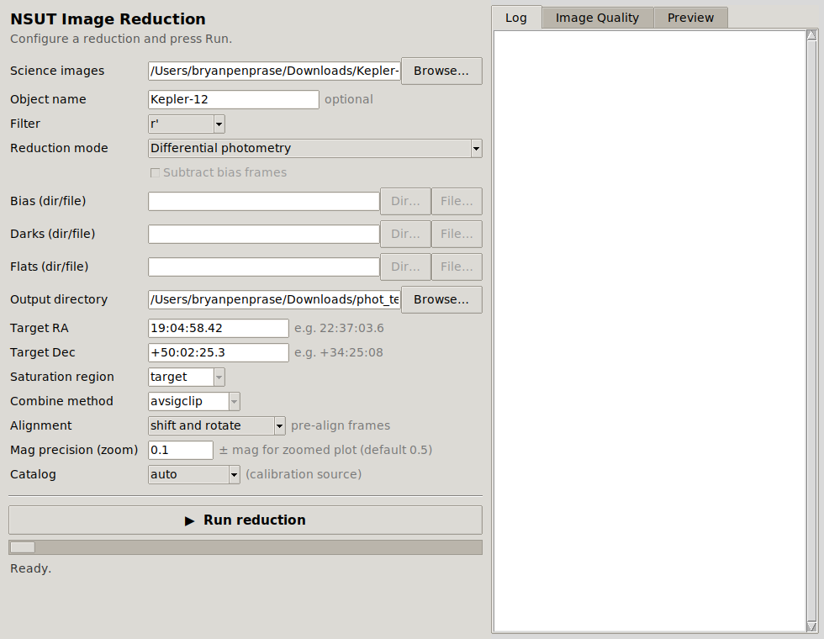
Differential photometry mode. Target RA/Dec, Alignment, Mag precision, and Catalog are now active; the calibration-frame rows are not used here.

Running it
- Set Science images to your folder of calibrated, WCS-solved frames, plus Object name and Output directory.
- Choose Differential photometry and set the Filter to the one filter you observed in.
- Enter the target’s Target RA and Target Dec (either sexagesimal like 19:04:58.42 or decimal degrees).
- Optionally choose an Alignment mode, a Catalog, and a Mag precision (all explained below).
- Press Run reduction.

How it finds reference stars
You do not pick the reference stars by hand — the pipeline chooses them, and it is careful about it. Working from the first frame, it:
- Locates your target at the coordinates you gave.
- Searches the central part of the field for candidate reference stars — bright enough to measure well, but not saturated, and reasonably close to the target’s brightness.
- Verifies each candidate by checking that it appears in image after image across the series. A star found in at least 70% of the sampled frames is accepted; one that keeps vanishing (a cosmic ray, a hot pixel, a star near the edge that drifts out of frame) is rejected.
- Keeps the best few — three by default — ranked by signal-to-noise, brightness similarity to the target, and central location.
If the field is sparse and the first pass finds too few candidates, the pipeline does not give up: it relaxes its criteria in announced stages, widening the brightness range it will accept (favoring brighter, cleaner reference stars) until it has enough. Every relaxation is printed to the Log, so you can always see what standards a run actually used.
Tip
If a photometry run ever fails to find references, the Log now names the specific frames that broke the verification — usually ones that are misaligned or missing a WCS solution — and suggests pre-aligning. That leads to the Alignment control.

The Alignment control
Photometry locates each star by its sky coordinates, which relies on every frame having an accurate WCS (the mapping between pixels and sky). When a series has large dithers, field rotation between nights, or frames with missing or inconsistent plate solutions, that assumption breaks and references fail to verify. The Alignment menu fixes this by pre-registering the frames first:
Setting | What it does
default | Measures each frame as-is, trusting its own WCS. Fastest; correct when the series is already well aligned.
shift | Pre-aligns every frame to the first by matching star patterns and correcting translation, then measures the aligned copies.
shift and rotate | Pre-aligns correcting both translation and rotation. The robust choice for multi-night series or any data with field rotation.
For NSUT’s typical multi-night targets, shift and rotate is the safe default when default struggles.

Putting magnitudes on a standard scale
Differential photometry on its own gives relative brightness — the target compared to the references. To turn that into a real, catalog-comparable magnitude, the pipeline looks up the reference stars in a published all-sky survey, compares their known magnitudes to the instrumental ones it measured, and derives a zero point (the offset between the two scales). The Catalog menu selects the survey:
Catalog | Source
auto | Tries the best available survey for your field automatically. Recommended.
apass | The AAVSO Photometric All-Sky Survey (includes Johnson B and V as well as Sloan bands).
panstarrs | Pan-STARRS DR1 (Sloan-like g, r, i, z).
sdss | Sloan Digital Sky Survey DR12.
none | Skip calibration entirely and report differential magnitudes only.
The zero point is computed as a robust, error-weighted average across all the catalog reference stars, with outliers rejected, so one mislabeled catalog star cannot skew the result. The catalogs are queried online, so an internet connection is needed; with none, or if the catalogs are unreachable, the pipeline still produces a complete differential light curve — it simply omits the calibrated-magnitude scale.
Note
Narrowband filters (H-α, OIII, SII) have no broadband catalog equivalents, so photometry through them is differential only. That is expected, not an error.

The outputs
A photometry run produces a measurements table and a multi-page plot, both prefixed with your object name:
- A photometry CSV (for example Kepler-12_photometry_rp.csv) with one row per frame: Julian Date, the target’s instrumental and calibrated magnitudes with errors, signal-to-noise, saturation flags, and the same for every reference star. This is your raw scientific result, ready for further analysis.
- A light-curve PDF (for example Kepler-12_lightcurve_rp.pdf) with four pages, described next.
- Optional diagnostic PDFs per frame, showing each star’s aperture placement and radial profile, useful for spotting contamination or misplacement.

Page 1 — Differential photometry
The headline result. The top panel shows the target minus the weighted average of all references — the cleanest view of its variation — and the three panels below compare the target against each reference individually. A real change shows up consistently in every panel; a wobble in just one panel means that particular reference is itself variable and should be distrusted.
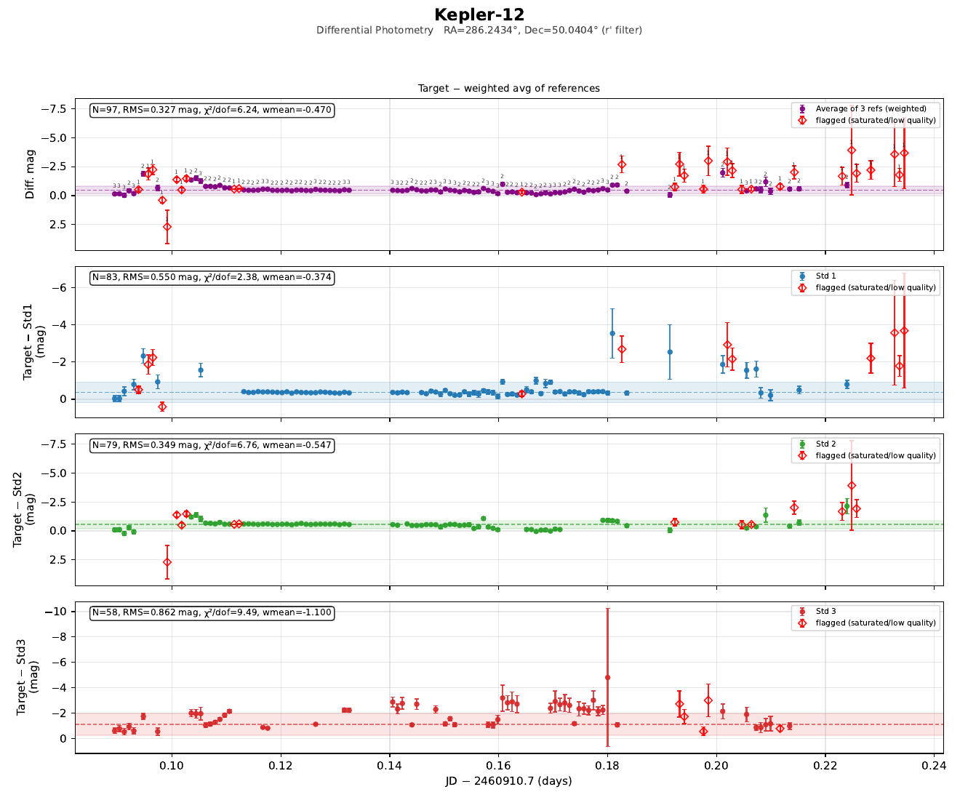
Page 1 for Kepler-12: target minus the weighted average of references (top), then each reference individually. The target name headlines the page.

Page 2 — Instrumental magnitudes
The raw, uncorrected brightness of the target and each reference. Here the target and references usually rise and fall together as conditions change through the night; that shared wobble is exactly what the differential technique cancels on Page 1. Divergent behavior in one star flags it as a problem.

Page 3 — Calibrated photometry
The target’s magnitude on the real, catalog scale, with the zero point shown in a lower panel along with which survey supplied it. This is the page to cite when you report “the star was magnitude X.”
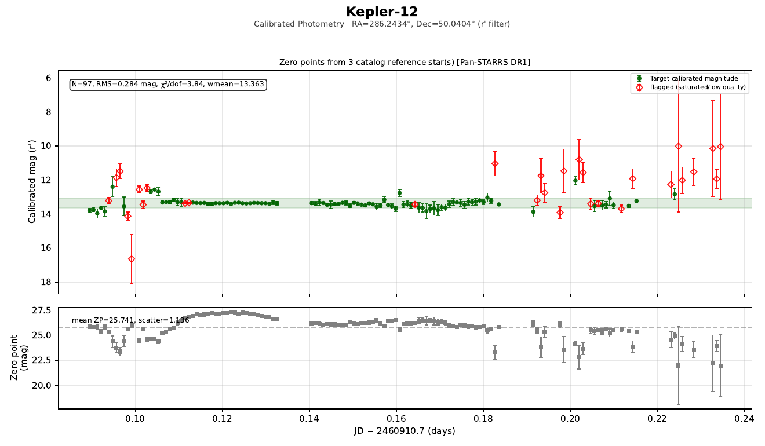
Page 3: calibrated magnitude (here from Pan-STARRS DR1), with the zero point and its scatter in the lower panel.

Page 4 — Zoomed light curve
The same calibrated data, but with the vertical axis pinned to the median magnitude plus or minus the value you set in Mag precision (zoom) (0.5 magnitudes by default, or tighter if you enter a smaller number). Auto-scaled plots let a single bad point stretch the axis until the real signal is invisible; this page fixes the scale so the genuine variation fills the frame. Points that fall outside the window are noted in the corner rather than allowed to dominate.
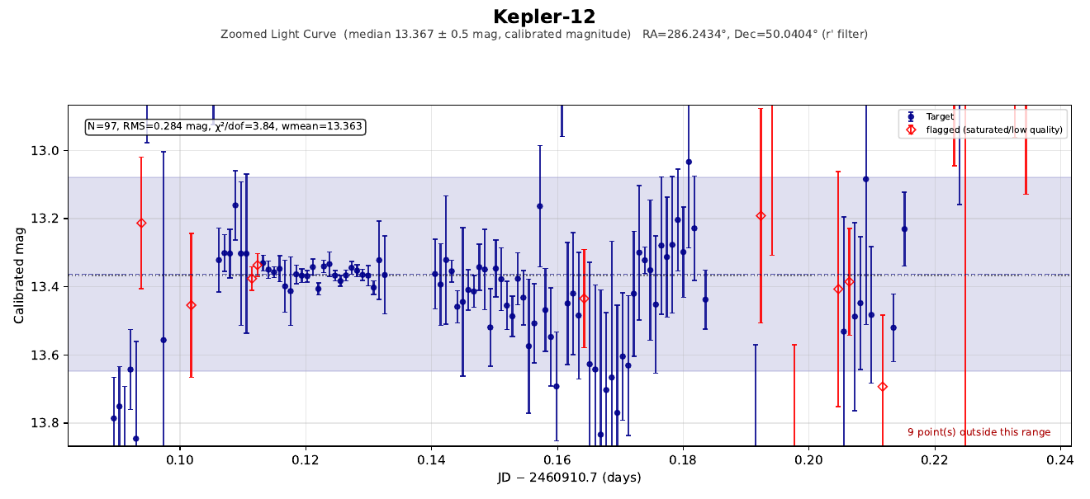
Page 4: the light curve zoomed to the median ± 0.1 mag, so small variations are visible despite a few off-scale outliers.
Tip
Set Mag precision small (say 0.05) to hunt for a shallow exoplanet transit, or leave it at 0.5 for a first look at a more dramatic variable. It only affects this zoomed page; the other three always show the full range.

9. A Complete Observing Workflow
The modes are designed to be used in sequence. A typical night’s data flows through the panel like this:
Step | Mode | What you accomplish
1 | Saturation check | Scan science and calibration frames; move any overexposed frames out of the folder.
2 | Stacking (with calibration) | Build a deep, calibrated image of the field for inspection and finding charts — bias + dark + flat for the full treatment.
3 | Differential photometry | Measure the target against reference stars across the individual calibrated frames, with catalog calibration.
4 | (automatic) | Read the four-page light curve to assess the result — is the variation real, consistent across references, and well-calibrated?
For deep imaging you may stop after step 2; for a transit hunt, steps 1 and 3 matter most. Either way, the panel keeps the outputs organized: every file a run produces is prefixed with your target’s name, so weeks of observing different objects stay sorted and unique on disk.
Remember the essentials
Name your target. Let dim fields stay dim — they don’t apply. Use autoselect for multi-filter stacking, a specific filter for flats and photometry. Reach for shift and rotate when photometry can’t find its references. And always glance at the diagnostics — the alignment CSV for stacks, the four-page PDF for photometry — before trusting a result.
Nieves Soka University Telescope — Soka University of America

