Nieves Soka University Telescope
Astronomical Image Processing Software Suite

Quick Reference Guide
Soka University of America — Department of Natural Sciences
Program | Purpose
ExposeCheck | Saturation analysis of FITS images
FITS Image Combiner | Image stacking, alignment, and calibration frame creation
PhotoCalib | Robust differential photometry pipeline for time-series observations
Differential Photometry Plotter | Publication-quality light curve generation from PhotoCalib output

1. ExposeCheck — FITS Image Saturation Analysis
ExposeCheck (exposecheck.py) is a quick-diagnostic utility that scans a directory of FITS astronomical images and reports pixel saturation statistics. Saturation occurs when pixel values exceed the detector’s maximum (typically ~65,000 ADU for a 16-bit camera), rendering those pixels unreliable for photometry or other quantitative analysis. The program offers three analysis modes: -target (inner 20% of the image, ideal for checking your science target), -center (inner 50%, ideal for calibration frames and flat fields), and -all (the full image, for comprehensive quality control).
To run ExposeCheck, point it at a directory of FITS files and choose a mode—for example, python exposecheck.py /NGC7331 -target. The program reads each FITS header to extract the object name, exposure time, filter, date, and Julian Date, then counts pixels above the saturation threshold in the selected region. Results are printed as a formatted table to the console and automatically saved as a CSV file named {directory}_{mode}.csv. Key output columns include the number of saturated pixels, total pixels analyzed, percentage saturated, and the mean ADU value, giving you an immediate read on whether any frames are overexposed and should be excluded from further analysis.
Required Files:
• exposecheck.py — Main analysis script
• A directory of FITS images (.fits, .fit, or .fts)
• Python packages: numpy, astropy

2. FITS Image Combiner — Image Stacking & Calibration
The FITS Image Combiner (fits-image-combiner.py) stacks multiple astronomical exposures into a single, higher-quality result. Combining N images improves the signal-to-noise ratio by a factor of √N while removing transient artifacts such as cosmic rays. The program provides four combination methods: average (maximum SNR, no outlier rejection), median (excellent cosmic-ray rejection), avsigclip (sigma-clipped average, the recommended default for most science work), and nomax (removes the single brightest pixel at each position). It also performs automatic star-based image alignment using DAOStarFinder, shifting frames to sub-pixel accuracy before combining.
A typical science workflow begins by building master calibration frames—bias (-c average --noalign), darks (-c median --noalign), and flats (-c avsigclip --noalign --normalize)—then combining science frames with those calibrations applied via the -dark and -flat flags. The --normalize option scales the output so its median equals 1.0, which is essential for flat fields. The program outputs a single combined FITS file with statistics printed to the console (min, max, mean, median pixel values) and alignment details showing matched-star shifts for each frame.
Required Files:
• fits-image-combiner.py — Main stacking script
• A directory of FITS science or calibration images
• Optional: master dark frame (-dark) and master flat frame (-flat)
• Python packages: numpy, scipy, astropy, photutils

3. PhotoCalib — Robust Differential Photometry Pipeline
PhotoCalib (photcalib_robust_fixed.py) is the core photometric measurement engine of the suite. Given a directory of calibrated FITS images, a target’s sky coordinates, and a filter name, it automatically selects non-saturated reference stars from the central region of the field, verifies that each reference is present in every frame using WCS-based tracking, and performs aperture photometry with background subtraction on both target and references throughout the entire image stack. This makes it suitable for detecting exoplanet transits, monitoring variable stars, and measuring asteroid light curves—any application requiring precise relative brightness measurements over time.
The pipeline is invoked from the command line with required arguments specifying the image directory, filter, output CSV filename, and target RA/Dec. Optional parameters let you control the FWHM estimate, detection threshold, number of reference stars (default 3), aperture size, and saturation level. When run with --create-diagnostics, PhotoCalib produces a two-page diagnostic PDF for every image: page one shows radial flux profiles for each star with the aperture and background annulus boundaries overlaid, while page two shows image cutouts with centroid positions, aperture circles, and saturation flags. The primary output is a CSV file containing one row per image with Julian Date, instrumental magnitudes, fluxes, SNRs, saturation flags, and pixel coordinates for both the target and all reference stars.
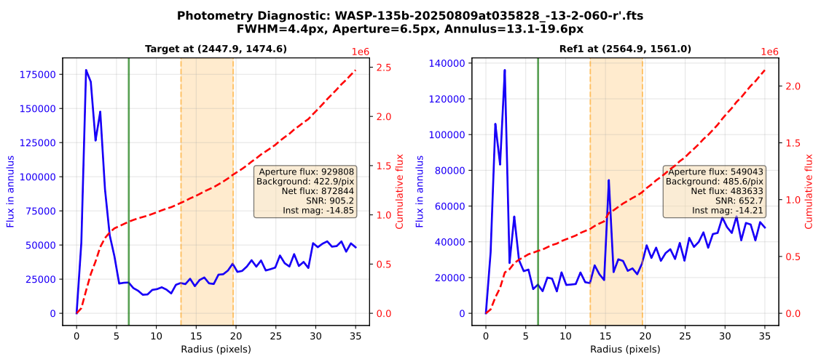
Figure 1. PhotoCalib diagnostic output — Page 1: Radial flux profiles showing aperture boundaries (green), background annulus (orange), and cumulative flux curves for each measured star.
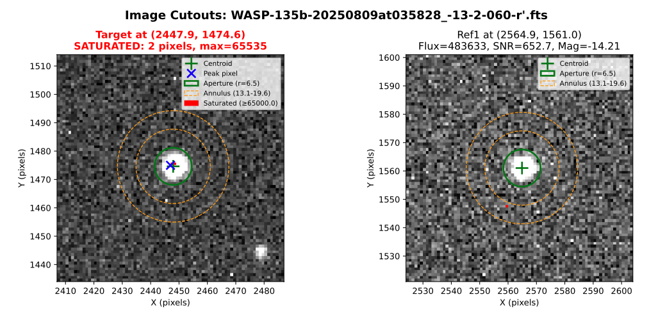
Figure 2. PhotoCalib diagnostic output — Page 2: Image cutouts showing centroid positions (green cross), photometry apertures (green circle), background annuli (orange dashed), and saturated pixels (red).
Required Files:
• photcalib_robust_fixed.py — Main photometry pipeline
• A directory of WCS-solved, calibrated FITS images
• Target RA and Dec (sexagesimal or decimal degrees)
• Python packages: numpy, pandas, matplotlib, astropy, photutils, scipy
• Optional: astroquery (for catalog matching)

4. Differential Photometry Plotter — Light Curve Visualization
The Differential Photometry Plotter (plot_differential_photometry.py) transforms the CSV output of PhotoCalib into publication-quality multi-panel light curves. Differential photometry—subtracting reference star magnitudes from the target—automatically corrects for atmospheric extinction changes, instrumental drift, and sky brightness variations, isolating real astrophysical signals such as exoplanet transits, variable-star pulsations, or asteroid rotation. The plotter generates a two-page PDF: page one shows four panels of differential photometry (the weighted average of all references plus each individual reference star), and page two shows four panels of raw instrumental magnitudes for the target and each reference.
Running the plotter is straightforward—pass the CSV file and an output filename, e.g., python3 plot_differential_photometry.py hatp23_photometry.csv -o hatp23_lightcurve.pdf. Optional arguments let you set a custom title, marker size, figure dimensions, and fixed Y-axis limits for zooming in on small variations. With --verbose, the program prints detailed statistics for each reference star including the RMS scatter, reduced χ², and weighted mean. Key diagnostic metrics to watch for: RMS below ~0.01 mag indicates good precision for bright stars; χ²/dof near 1.0 means error bars are correctly estimated; and consistent patterns across all reference panels confirm that detected variations are real.
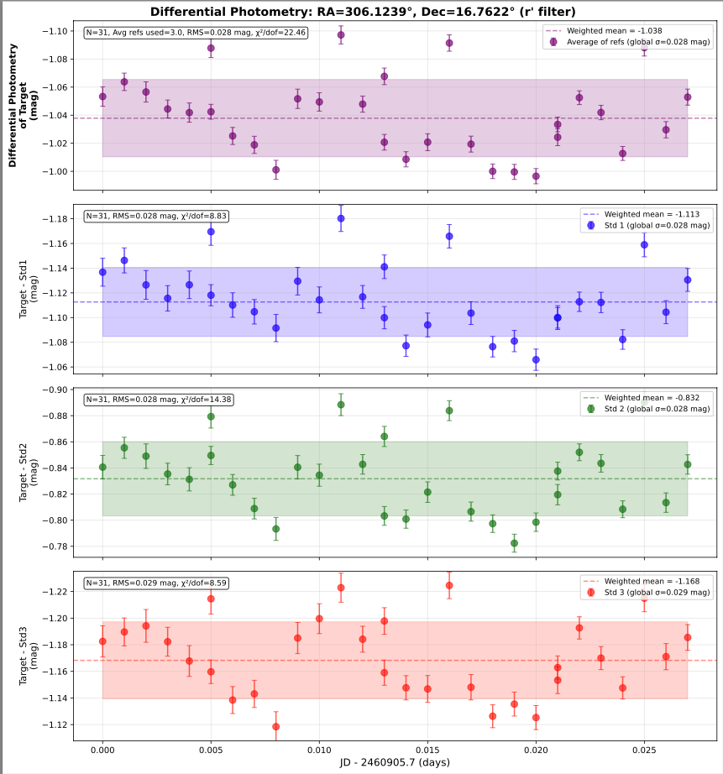
Figure 3. Differential photometry output — Page 1: Target minus weighted average of references (top), followed by individual reference star subtractions. The transit ingress is visible starting around JD 0.09.
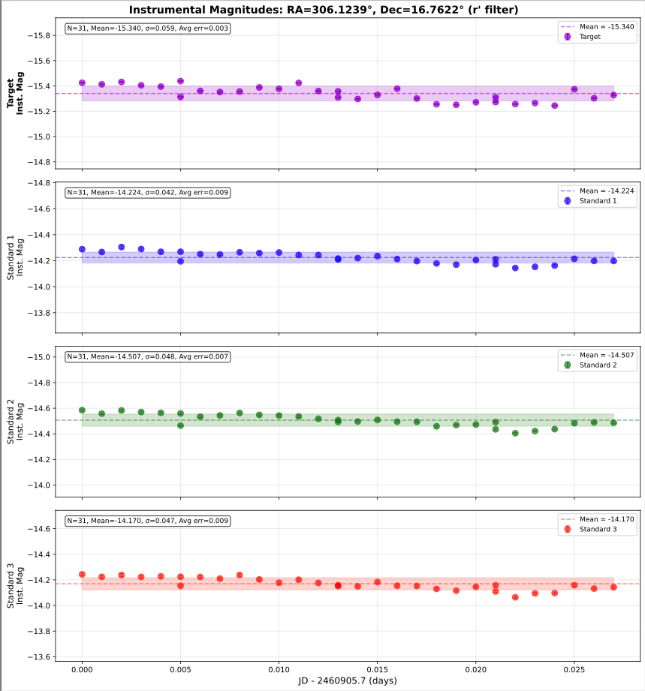
Figure 4. Instrumental magnitudes output — Page 2: Raw brightness measurements for target and each reference star, showing common atmospheric trends that cancel in the differential analysis.
Required Files:
• plot_differential_photometry.py — Light curve plotter
• CSV output file from PhotoCalib (e.g., wasp135b_photometry.csv)
• Python packages: numpy, pandas, matplotlib

Typical End-to-End Workflow
The four programs in this suite form a natural data-reduction pipeline for observations taken with the Nieves Soka University Telescope. A typical observing session proceeds as follows. First, after collecting your science frames and calibration data (biases, darks, and flat fields), run ExposeCheck on each set to verify that no frames are saturated, flagging any overexposed images for exclusion. Next, use the FITS Image Combiner to build master calibration frames (bias, dark, and normalized flat) and then stack your science images with those calibrations applied and automatic star alignment enabled.
With a clean, combined image stack in hand, run PhotoCalib on the individual calibrated frames (not the combined image) to measure your target’s brightness relative to field reference stars across the full time series. Enable diagnostic output to verify aperture placement and reference star stability. Finally, pass the resulting CSV into the Differential Photometry Plotter to generate publication-ready light curves that reveal transits, pulsations, or rotational modulation—with atmospheric and instrumental systematics removed by the differential technique.
Step | Program | Action
1 | ExposeCheck | Check all frames for saturation; exclude overexposed images
2 | FITS Image Combiner | Build master bias, dark, and flat; stack science frames with calibration
3 | PhotoCalib | Measure target and reference star photometry across the time series
4 | Diff. Phot. Plotter | Generate differential light curves and assess data quality

