Nieves Soka University Telescope
Department of Natural Sciences — Soka University of America
RGB Image Generator
A Student’s Guide to Building Color Images from FITS Frames
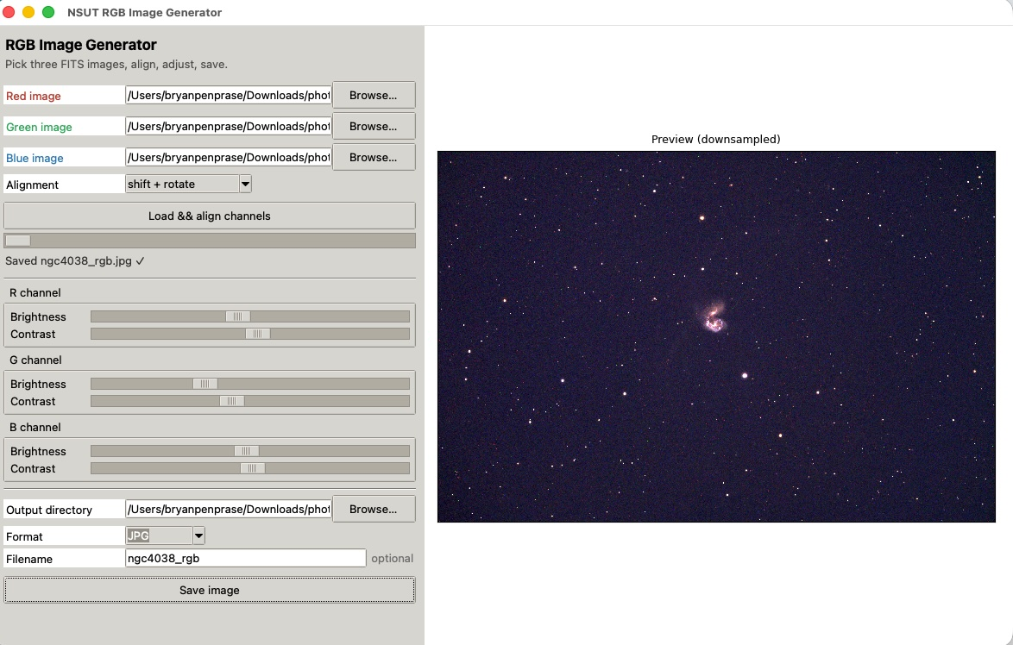
The RGB Image Generator: three FITS frames in, one color picture out. Align on the left, judge the result on the right.
From three black-and-white exposures to a true-color portrait of the sky, without the command line.

Contents
1. Getting Oriented
2. The Three Channels and Where They Come From
3. Aligning the Channels (Image Shifting)
4. Bringing the Picture to Life (Brightness and Contrast)
5. Getting the Color Balance Right
6. Saving Your Image
7. A Complete Color-Imaging Workflow

1. Getting Oriented
Every astronomical camera records light in black and white. To make a color picture you photograph the same field three times — once through a red filter, once through a green one, and once through a blue one — and then combine those three exposures, assigning each to its own color channel. The RGB Image Generator is the program that does the combining. You hand it three FITS frames, line them up, balance their brightness and color, and it writes out a finished color image you can print, publish, or drop into a poster.
The window has two halves, in the same spirit as the NSUT Control Panel. On the left is the control panel, where you load the three channels, choose how they are aligned, and adjust each one. On the right is a live preview that redraws the moment you touch a slider, so you can see the effect of every change as you make it. You work entirely by eye: nudge a control, watch the picture, repeat until it looks right.

The controls, top to bottom
Most of the panel is the same three things repeated for red, green, and blue. It is worth learning the layout once:
Control | What it does
Red / Green / Blue image | The three FITS frames that become the color channels. Use Browse to find each one. The red frame is special: it sets the reference grid that the other two are aligned onto.
Alignment | How the green and blue frames are lined up onto the red one — by stars, by plate solution, or not at all (Section 3).
Load && align channels | Reads the three frames, aligns them, and draws the first preview. Press this once after choosing your files.
Brightness / Contrast | A pair of sliders for each channel that set how that channel’s data is mapped to screen brightness (Sections 4 and 5).
Output directory | Where the finished image is written.
Format | PNG, JPG, or TIFF. PNG or TIFF for archival quality; JPG for a smaller file to email or post.
Filename | Optional. Leave it blank and the program names the file from the red frame plus the alignment mode.
Save image | Writes the full-resolution color image to disk. Stays disabled until the channels are loaded.

Tip
The preview is downsampled — shrunk so it redraws instantly while you drag sliders. The image you save is rendered fresh at full resolution, so it will look sharper and cleaner than the preview suggests. Judge color and balance from the preview; judge fine detail from the saved file.

The general rhythm of a run
- Browse to your three FITS frames — red, green, and blue.
- Choose an Alignment mode and press Load && align channels.
- When the preview appears, adjust the brightness and contrast sliders, one channel at a time, until the sky is black and the colors look natural.
- Set the Output directory and Format, optionally type a Filename, and press Save image.

Note
The three frames do not need to be the same size or even the same camera binning. The alignment step reconciles modest differences automatically, and the WCS mode (Section 3) can even combine frames taken at different pixel scales. What they do need is to be the same patch of sky.

2. The Three Channels and Where They Come From
Before combining anything, it helps to know what makes a good set of input frames, because the color image can only be as good as the three pictures that go into it.
Each channel should be a stacked, calibrated frame in one filter — exactly the kind of image the NSUT Control Panel produces when you run a flat-fielded, dark-subtracted stack. Stacking matters here for the same reason it matters everywhere: it deepens the signal and smooths the noise, and a color image built from three smooth frames has a clean dark sky, while one built from three noisy frames has a grainy, mottled background that no amount of slider adjustment can fix.
Which filters you assign to which channel is up to you, but the natural choice mirrors human vision: a red-band frame (such as r′ or a Johnson R) for red, a green or visual band for green, and a blue band (g′ or Johnson B) for blue. Map the filters this way and stars come out close to their true colors. You are free to depart from this — narrowband emission lines are often mapped to dramatic false-color palettes — but for a true-color portrait of a galaxy like the Antennae, stay close to the natural ordering.
Tip
Run each filter through the same reduction before you bring it here: same calibration, same stacking method. Three channels reduced consistently sit on top of one another cleanly. A channel that was treated differently — say, flat-fielded while the others were not — will carry a brightness gradient the others lack, and that gradient turns into a colored wash across the final picture.

3. Aligning the Channels (Image Shifting)
Three exposures of the same field are almost never perfectly registered. Between one filter and the next the telescope drifts a little, the field rotates slightly, and the star patterns land on different pixels. If you stacked such frames into color without correcting this, every star would split into a red, a green, and a blue ghost, like a misprinted newspaper photo. Aligning — shifting each channel until its stars sit exactly on top of the red frame’s stars — is what fuses the three pictures into one.
The program always aligns the green and blue frames onto the red frame, which stays fixed as the reference. The Alignment menu chooses the method:
Mode | How it lines the frames up | Use when
none | Trusts the frames as they are and combines them unchanged. | The three frames are already registered — for example, output from a pipeline that aligned them for you.
shift | Matches star patterns and slides each frame sideways and up-down to match the red one (translation only). | The frames share the same orientation and scale and differ only by a small pointing drift. The common case.
shift + rotate | Matches stars and corrects both the sideways slide and any rotation between frames. | There is a slight field rotation between exposures — common across a long night or between nights. The robust default.
WCS | Uses each frame’s own plate solution (its sky-to-pixel map) to resample the green and blue onto the red grid. | Frames have accurate WCS solutions, or differ in pixel scale or binning — WCS handles all of that at once.

How the star-matched modes work. For shift and shift + rotate, the program finds the star centroids in the red frame and in the channel being aligned, then searches for the shift (and, if allowed, the rotation) that makes the largest number of stars fall on top of one another. It reports what it found in the status line — for instance, the number of stars matched and the measured offset in pixels — so you can confirm the alignment was based on real, plentiful matches rather than a lucky few. If a channel has too few stars to match confidently, the program says so and suggests switching to WCS mode.
Cleaning up the edges. When a frame is shifted or rotated, one edge slides in from outside the picture and leaves a blank strip with no data. Stacked into color, those strips would show up as colored fringes along the border — a red edge here, a blue one there. The program trims them away automatically, cropping to the rectangle where all three channels overlap, so the saved image has clean edges and no colored margins.

Tip
Start with shift + rotate. It corrects everything the simpler shift does plus field rotation, and the extra work is negligible. Drop to shift only if you are certain there is no rotation and want the gentlest possible change to the frames. Reach for WCS when star matching struggles or when your three frames were taken at different binnings.

4. Bringing the Picture to Life (Brightness and Contrast)
Once the channels are aligned, the preview appears — and at first it rarely looks its best. Raw astronomical data packs an enormous range of brightness into each frame: a galaxy core can be thousands of times brighter than the faint sky around it. A computer screen cannot show that whole range at once, so you have to choose which slice of it becomes visible. That is what the brightness and contrast sliders do. Each channel has its own pair, and they update the preview live as you drag them.

What each slider actually does
It is worth understanding these two controls precisely, because together they decide both how bright the picture is and how the colors balance.
Slider | What it controls | Push it higher and…
Brightness | Which data level is shown as mid-gray. In effect, it sets the floor: everything dimmer fades toward black, everything brighter climbs toward full color. | the channel gets brighter, and fainter material — outer spiral arms, faint nebulosity — emerges from the dark.
Contrast | How wide a range of brightness is spread across the visible scale. Low contrast shows a gentle, wide range; high contrast maps a narrow range punchily. | the image gets punchier and more saturated, but very bright regions blow out to flat white sooner.

Both sliders work relative to each channel’s own sky background, which the program measures for you when the frames load. This is the key to why they balance color so well: setting the same brightness on all three channels does not mean three identical numbers of counts, it means three channels each lifted the same amount above their own sky. That is almost always what you want.

A reliable starting routine
- Begin with all six sliders near the middle. The preview will show a roughly balanced, if unpolished, image.
- Adjust brightness first, channel by channel, until the faint structure you care about — the spiral arms, the tidal tails — is just visible against the sky. Resist the urge to crank it: if the sky stops being black, you have gone too far (Section 5).
- Then adjust contrast to taste. A little extra contrast makes a galaxy’s structure pop; too much flattens the bright core into a featureless white blob and loses the texture inside it.
- Step back and look at the whole picture, not one feature. The goal is a black sky, bright but un-blown stars, and a galaxy that shows its structure.
Tip
Adjust one slider at a time and watch the preview before moving the next. Color balancing is a chain of small judgments, and changing two things at once makes it impossible to tell which one helped. If you lose your way, reset all six to the middle and start again — it takes only a moment.

5. Getting the Color Balance Right
This is the heart of color imaging, and the part that rewards a careful eye. The brightness and contrast sliders do not just make the picture lighter or darker — by raising or lowering the three channels relative to one another, they set the overall color cast of the image. If the red channel sits a little too high, the whole picture drifts warm; too much blue, and the sky turns navy instead of black. Balancing color means adjusting the three channels until nothing carries a false tint. You do not need a color meter to do this. Two features of any real star field tell you everything you need to know.

Test 1: the sky between the stars should be black
Point your eye at an empty patch of sky, away from the galaxy and the bright stars, and ask what color it is. In a correctly balanced image it is black — a true neutral, with no color in it at all. If that empty sky looks faintly red, the red channel’s brightness is set too high; ease it down until the tint disappears. If it looks blue or green, do the same for that channel. The sky is the most honest reference in the whole frame, because you know for a fact it should have no color: any tint you see there is an imbalance you have introduced, not something in the sky.
Be careful not to over-correct in the other direction. If you push a channel’s brightness so low that the sky goes pure inky black with no faint detail at all, you may be clipping away real signal — the outermost wisps of a tidal tail, the faintest haze of a galaxy’s halo. The aim is a sky that reads as black to the eye while still preserving the faintest real structure just above it. A neutral, slightly textured dark — not a dead flat void.

Test 2: the stars should be natural colors
Now look at the stars, and at the field as a whole rather than any single one. A real star field is a mix of colors that reflect the stars’ temperatures: mostly white, a good number of warm orange and yellow ones, and a scattering of distinctly blue ones. That natural variety is the signature of a well-balanced image. Two warning signs tell you something is off:
- Green stars. There is essentially no such thing as a green star to the eye — stars that emit strongly in green also emit across the rest of the spectrum and read as white. So if your stars look green, the green channel is set too bright relative to red and blue. Bring the green brightness down until the green tint vanishes and the stars settle to white. Green cast is the single most common color error in RGB imaging, and the easiest to spot once you know to look for it.
- A uniform tint across many stars. If a great many stars share the same faint red, or the same faint blue, that is not stellar physics — real stars vary individually, they do not all drift the same way. A shared tint means one channel is riding too high across the whole frame. A field where every star leans red means too much red overall; pull the red channel down. The test is the crowd, not the individual: one orange star is a cool star, but a hundred faintly orange stars is a red channel out of balance.
When the empty sky is neutral black and the stars show their natural spread of white, orange, and blue with no green and no shared tint, the image is balanced. At that point the colors of the galaxy itself can be trusted too — its blue star-forming regions, its golden older core, its pink emission knots will all be sitting at their true hues.
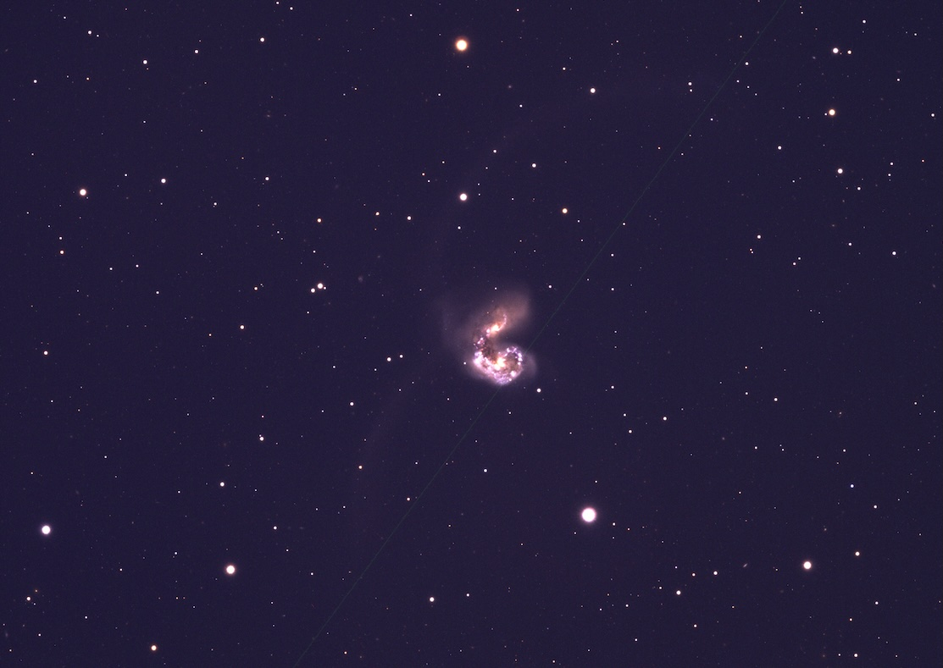
A finished color image of the interacting galaxies NGC 4038 and NGC 4039 — the Antennae — captured by Soka University of America students using the Las Campanas Remote Observatory telescope in Chile. Note the neutral black sky, the natural mix of white, orange, and blue stars, and the blue star-forming knots threaded through the colliding pair.
Tip
Work the two tests in order: sky first, then stars. Get the empty sky to a clean neutral black, and most of the star-color problems disappear on their own, because a neutral sky means the three channels are already close to balanced. Then fine-tune by the stars. Fixing the stars before the sky is balanced is chasing a moving target.

6. Saving Your Image
When the preview looks right — black sky, natural star colors, a galaxy showing its structure — you are ready to write the finished image to disk. The preview you have been adjusting is downsampled for speed; saving renders the picture again at full resolution using the exact slider settings you see, so the file is sharper than the preview.

Running it
- Set the Output directory with Browse.
- Choose a Format: PNG or TIFF preserve full quality and are the right choice for archiving, printing, or further editing; JPG makes a smaller file that is easy to email or post, at a slight cost in quality.
- Optionally type a Filename. Leave it blank and the program builds one for you from the red frame’s name and the alignment mode — so a shift-and-rotate combination of an NGC 4038 red frame saves as something like ngc4038_r.shift.rotate.rgb.png, which records how the image was made right in its name.
- Press Save image. The status line confirms the file was written, with a checkmark and the filename.
Note
The settings live entirely in the sliders, so you can save several versions without starting over: save one image, nudge the contrast or rebalance the color, change the filename, and save again. Each press of Save image writes the picture exactly as the preview shows it at that moment.

7. A Complete Color-Imaging Workflow
Color imaging is the natural sequel to the reduction work done in the NSUT Control Panel. A typical path from raw frames to a finished color picture runs like this:
Step | Where | What you accomplish
1 | NSUT Control Panel | Reduce and stack each filter separately — a calibrated, flat-fielded, dark-subtracted stack in red, in green, and in blue. Three clean black-and-white frames.
2 | RGB Image Generator | Load the three stacks, choose shift + rotate, and press Load && align channels. The channels register and the first preview appears.
3 | RGB Image Generator | Balance brightness and contrast: get the empty sky to neutral black, then tune the stars to a natural white-orange-blue mix with no green and no shared tint.
4 | RGB Image Generator | Save the result as PNG or TIFF for archiving, or JPG to share.

Remember the essentials
Feed it three clean, consistently reduced stacks — one per filter. Align onto the red frame, reaching for shift + rotate unless you have a reason not to. Balance by eye in two steps: make the empty sky black, then make the stars natural — white, orange, and blue, with no green stars and no tint shared across the whole field. When the sky is neutral and the stars look real, the galaxy’s own colors can be trusted. Then save, and save more than one version if you like — the sliders remember nothing once you close the window, but they cost nothing to redo.
Nieves Soka University Telescope — Soka University of America

