Output, Running 5 times:

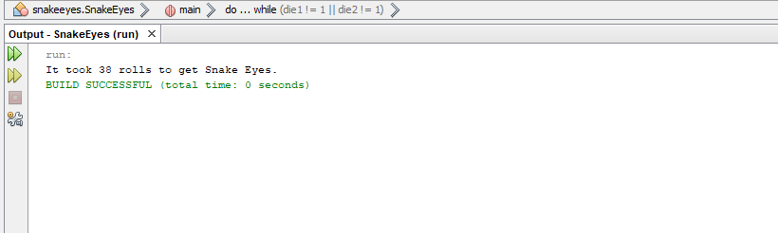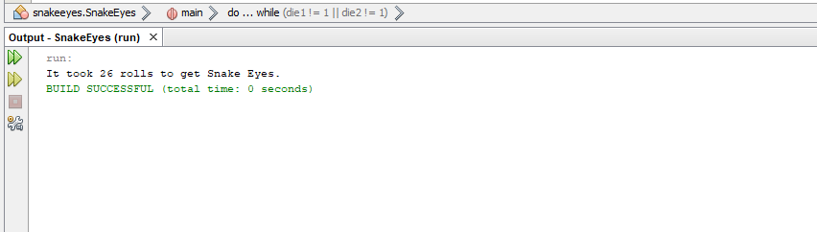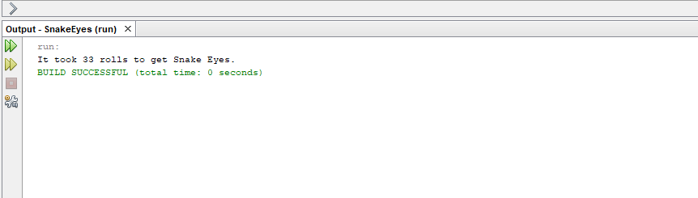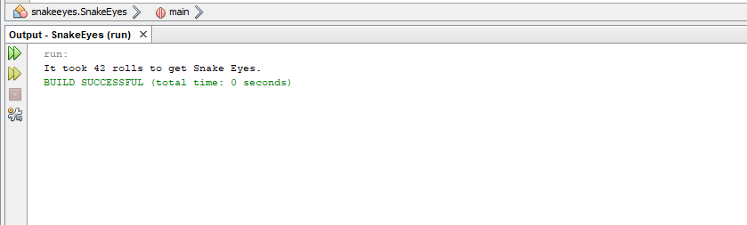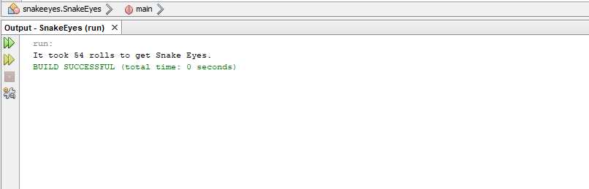

Output, Running 1,000 times

