**Software construction**

**Lab5**

**Bisma Pervaiz**

**BESE 6B**

Git: https://github.com/bpervaiz/labs

Task 4

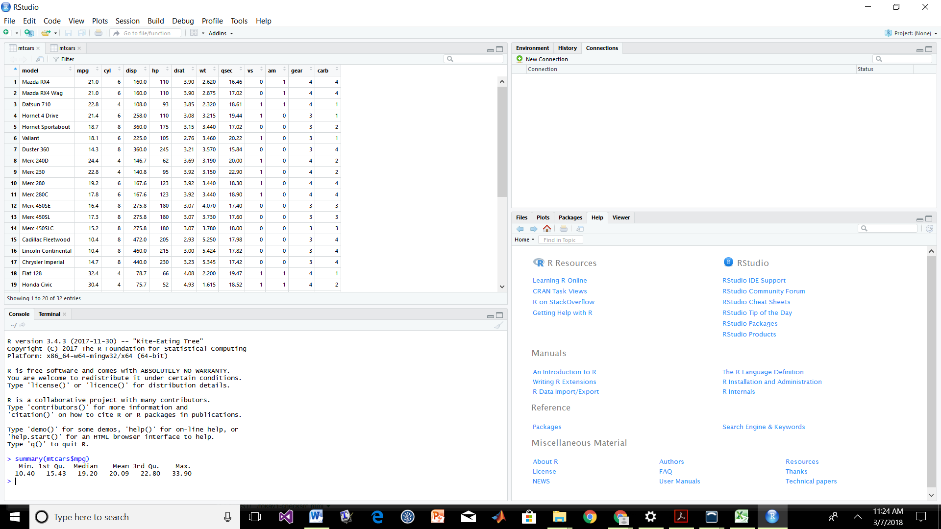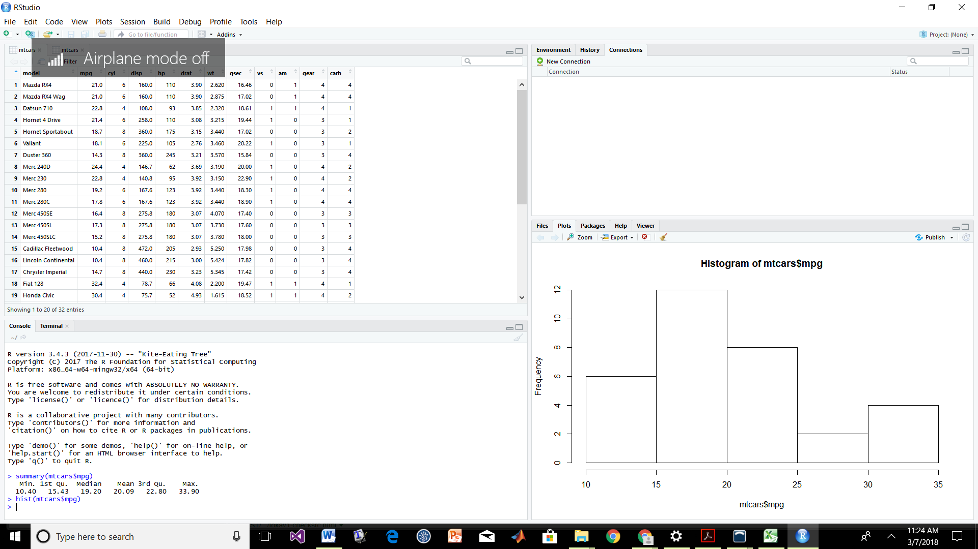

Bar plot of mpg

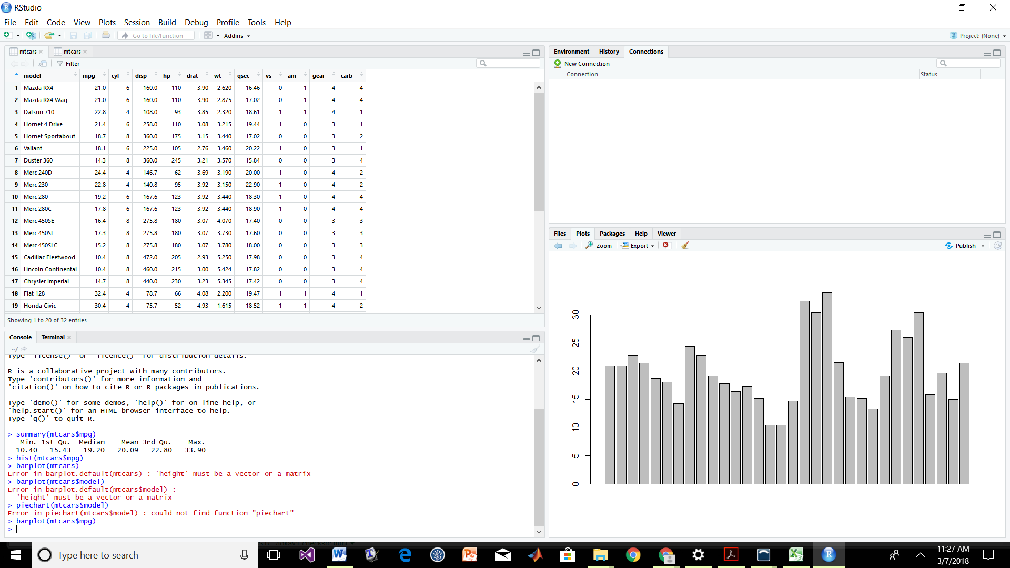

Mean of hp

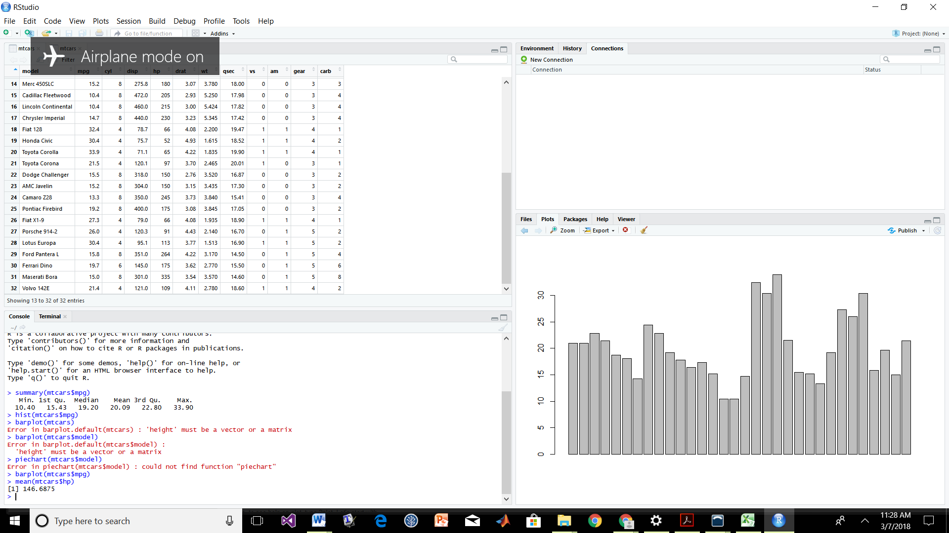

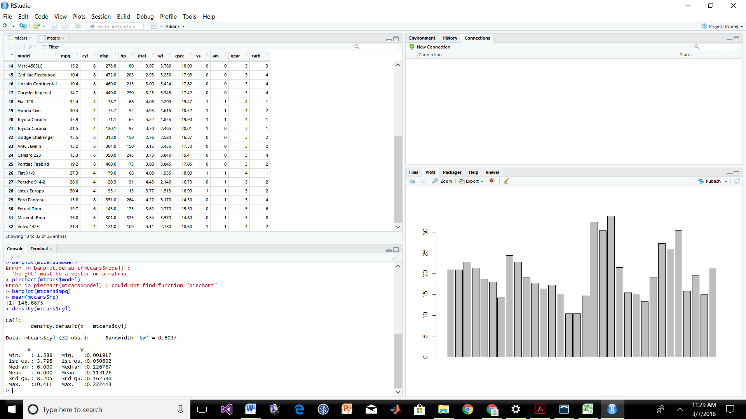

Barplot of gear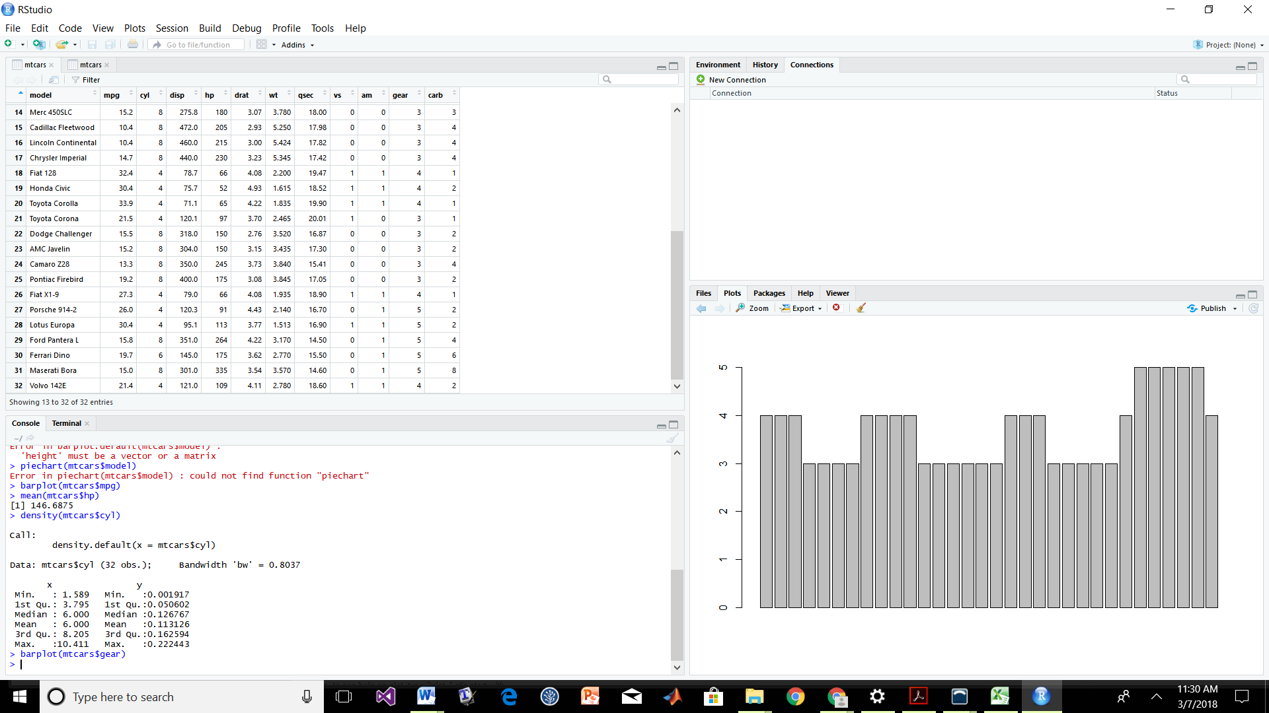

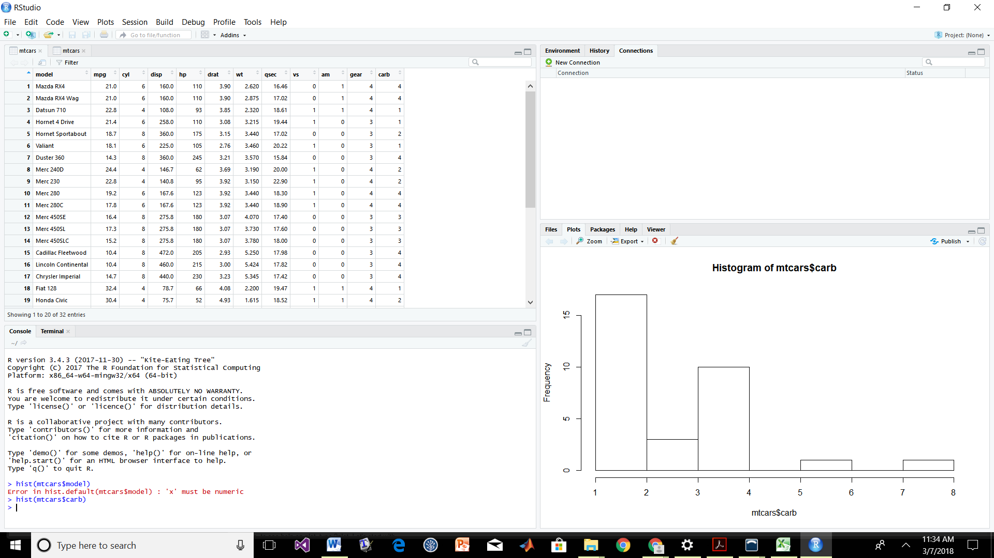

Task 6

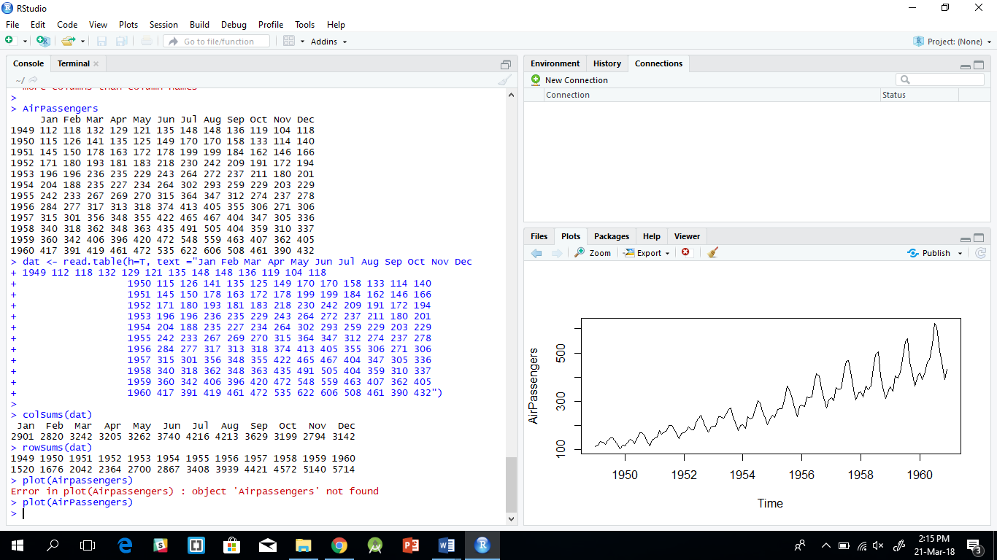

1. So most profitable month is July
2. So most profitable year is 1960

c)

Task 7

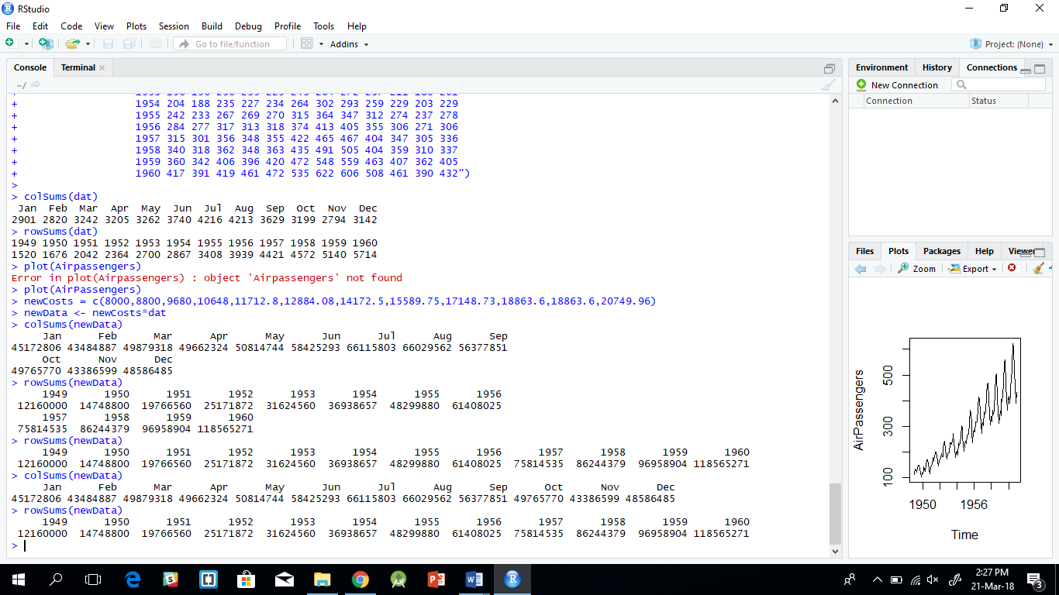

1. Most revenue was generated in the month of July
2. Most revenue was generated in the year 1960
3. 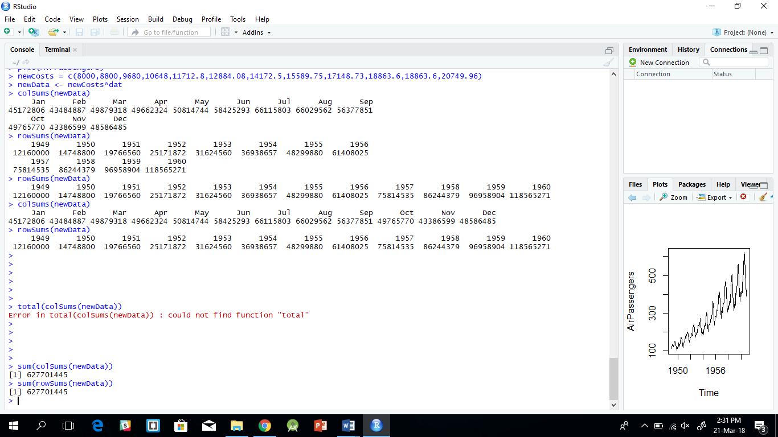

Total revenue is 627701445

Task 8

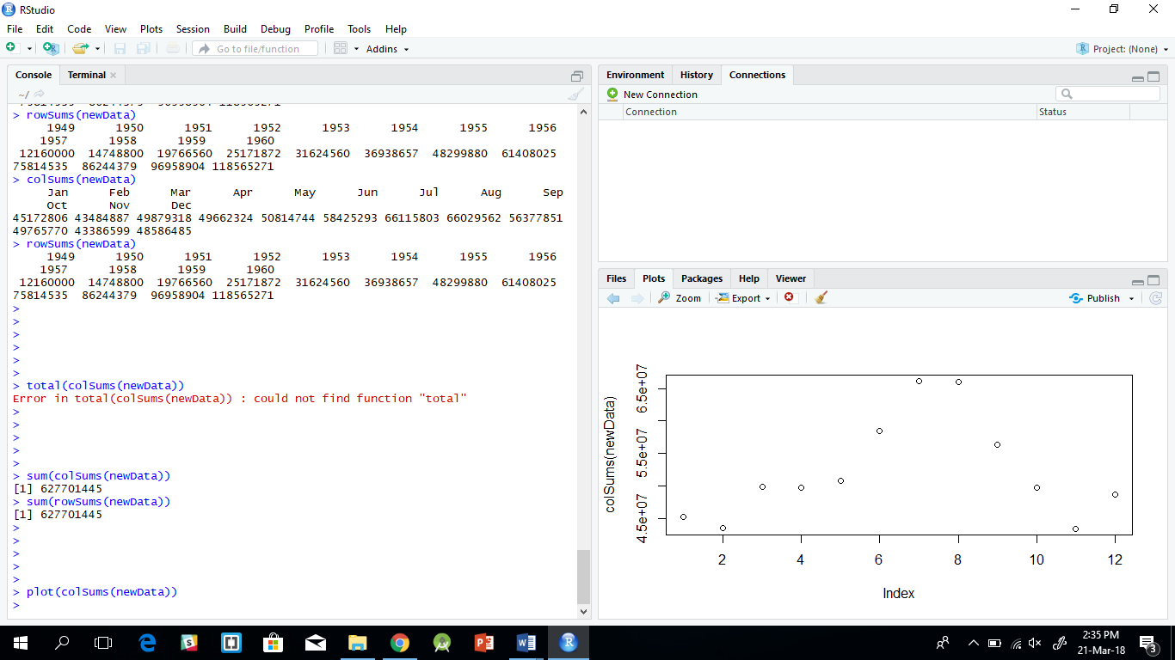



July is the most travelled month