Software Requirements Specification
for
Car Rental System
Version 1.0 approved
Prepared by
Bisma Pervaiz
Raaiha Humayun Kabir
Tayyeba Muhammad Khan
Muhammad Ali
BESE-6B
11TH April 2018
Table of Contents
Table of Contents ii
Revision History ii
1. Introduction 1
1.1 Description 1
1.2 Product Scope 1
2. System Features 1
2.1 Signup 1
2.2 Login 2
2.3 Car search 2
2.4 Booking 2
2.5 Admin Functionality 3
3. Other Nonfunctional Requirements 3
3.1 Security Requirements 3
3.2 Software Quality Attributes 3
4. Other Requirements 3
4.1 Inverse requirements: 3
5. Interface requirements 3
6. Product Functionality 4
6.1 Class Diagram 4
7. Work Division 4

Revision History
Name | Date | Reason For Changes | Version

Introduction

Description
This project is aimed at facilitating the customers so that they can rent the car of their choice. This car rental system will allow the users to book a car for a specific period of time while sitting at home. The user will be shown a list of cars that are available and he can choose the desired car from the list of available cars.

Product Scope
This system will be providing services to people of Islamabad, Karachi and Lahore. The user will be shown a list of available cars in their respective city and at selected dates. The product can later on be extended to other cities where the company can afford to dispense their services.

System Features

Signup

Description and Priority
This feature will allow a new user to register themselves on the system and use it as needed. The user can only use the system if he has registered himself so this feature is very important.

Stimulus/Response Sequences
Initially the used will press the sign up button upon which a new screen will appear prompting the user to register as a customer. Then it will prompt the user to enter the relevant details. If valid details have been entered the system will register the user and confirm the registration. Then the system will allot a unique identifier to the new user. Next the system will generate an empty record with the fields listed below in the requirements.

Functional Requirements
- The system shall allow a new user to create an account.
- The system shall ask the user to register as a customer or as admin
- The system shall prompt the user to enter their username, password, CNIC number, phone number at the time of registration.
- The system shall prompt the user to enter a unique username and password for the account.
- The system shall allocate a unique identifier to each new user at the time of registration.

Login

Description and Priority
- After sign up the user should be able to login and access their account.

Stimulus/Response Sequences
- The login screen will prompt the user to enter their username and password. The user will press the login button. If the user name and password is correct the user will be able to access their account. Otherwise user will have to enter the information again.

Functional Requirements

- The system shall allow an already existing user to login to his/her account.

Car search

Description and Priority
- This feature will allow the user to search the available cars based on the city and dates required.

Functional Requirements
- The system shall allow a user to enter the desired city and dates
- The system shall generate a list of available cars in the specified dates and city.

Booking

Description and Priority
- This feature will allow the user to rent the desired available car.

Functional Requirements
- The system shall allow the patient to book a car that is available.
- The system shall maintain the history of the bookings done by the user.
- The system shall make the car unavailable after it has been booked by a specific person.

Admin Functionality

Description and Priority
- The system shall allow the administrator to perform some tasks.

Functional Requirements
- This feature will allow the administrator to delete or confirm the order.
- The system shall allow the administrator to enter the data of cars in the database.

Other Nonfunctional Requirements

Security Requirements
- System shall allow access to only authorized users that are registered on system.

Software Quality Attributes
- The system shall recover from system crash within four hours.
- The system shall maintain a backup of the database.

Other Requirements

Inverse requirements:
- The system shall not allow the user to choose unavailable cars.

Interface requirements
- The system should have a web based interface for users’ bookings
- The system should have a desktop based interface for the administrator.

Product Functionality

Class Diagram
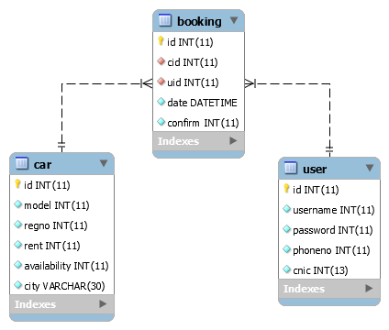

Work Division

Tayyeba Muhammad Khan: Login and Signup

Bisma Pervaiz: Booking of cars
GitHub: https://github.com/bpervaiz/labs

Raaiha Humyaun Kabir: Searching cars
GitHub: https://github.com/rhkabir/lab9

Muhammad Ali: Administration part
GitHub: https://github.com/ali28729/SE312_Labs/tree/master/Lab09

