**Supporting Information for**

**Bubble Plume Distribution Supports Methane Hydrate Decomposition**

**on the Cascadia Margin**

H. Paul Johnson1*, Una K. Miller2*, Marie S. Salmi3*, Evan A. Solomon4*

1 [paulj@uw.edu](mailto:paulj@uw.edu), corresponding author

2 unam@uw.edu

3 maries3@uw.edu

4 esolomn@uw.edu

* all at School of Oceanography

University of Washington

Seattle, WA 98195

**Contents of this file**

**Figures S1 to S4, Tables S1 and S2 and Methods for hydrate stability calculations shown in Table S1 and Figure 8.**

Excel files with the basic data for the Cascadia methane plumes used in this study (latitude, longitude, depth, source of identification) are available on the following UW public web site.<https://catalyst.uw.edu/workspace/paulj/17643/372058>

Also available on the same web site are Excel files with the basic data used to generate Figures S5, S6 and Table S1 for the U.S. Atlantic coast.

**Supplemental Figure S1**- Examples of acoustic images of bubble plumes, showing variable profiles that depend on the type of instrumentation used. **Top**: EM302 acoustic image from the R/V Thompson, **Middle left**: example of fishing sonar plume, **Middle right:** Sub-bottom CHIRP profiles from the R/V Thompson with underlying sediment structure, **Bottom:** 200 kHz profile of methane bubble plume from Salmi et al, (2011) showing vertical bubble plumes and horizontal bright reflectors from krill and fish swarms associated with methane emission site.

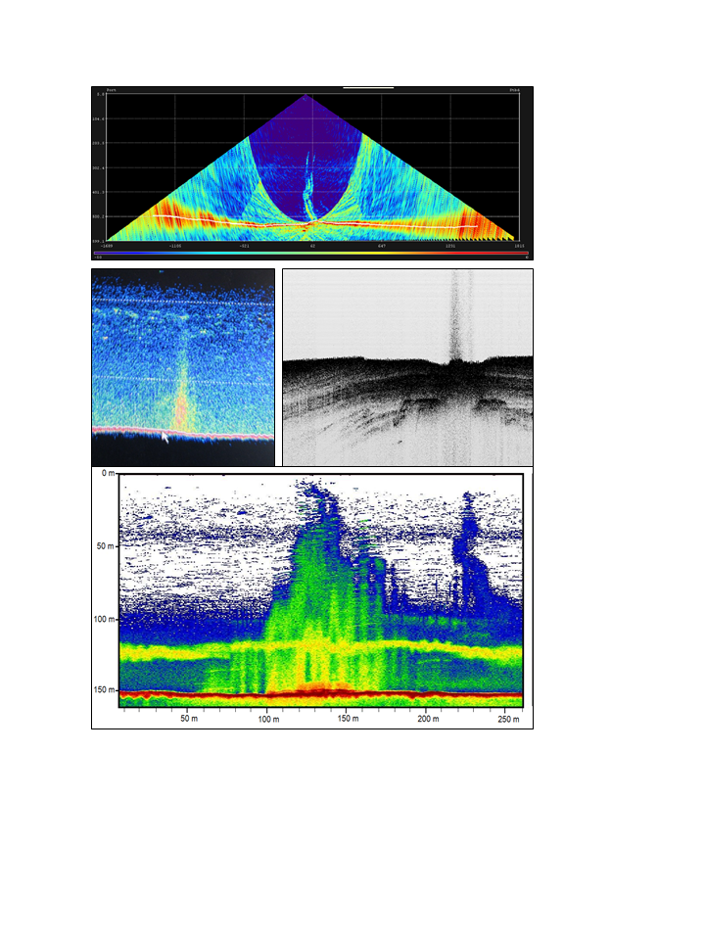

**Supplemental Figure S2**- Histogram showing the area of the individual depth bins for the Cascadia margin after partitioning into 100 meter depth intervals, beginning at 50 to 149 meters water depth. Note that the partition containing the shallow continental shelf between 50 and 149 meters has the largest area. Cascadia shelf break varies along-strike, but lies at approximately 180 to 200 meters water depth.

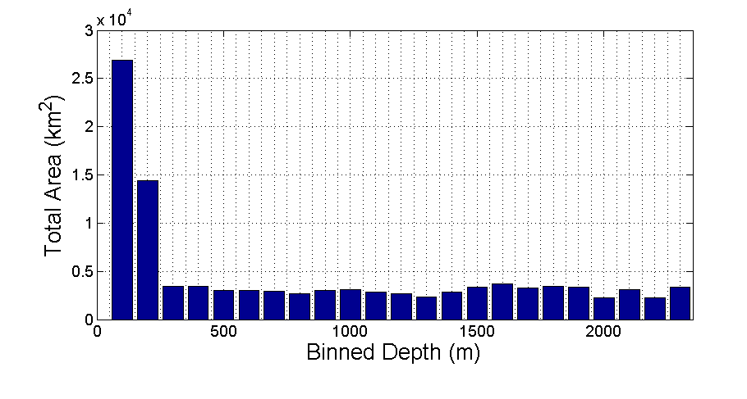

**Supplemental Figure S3**: Summary count of the total number of emission sites on the Washington and Oregon segments of the Cascadia margin after applying bubble stream clustering radii of 0, 150, 300 and 500 meters. A clustering radius of 0 meters would count every distinct individual bubble stream as an emission site. A clustering radius of 300 meters rather than 500 meters was used in Figures 3,4 and 5 since some sites on the continental shelf are associated with quasi-linear faults and do not show a characteristic clustering parameter (see Figure 1 in text)

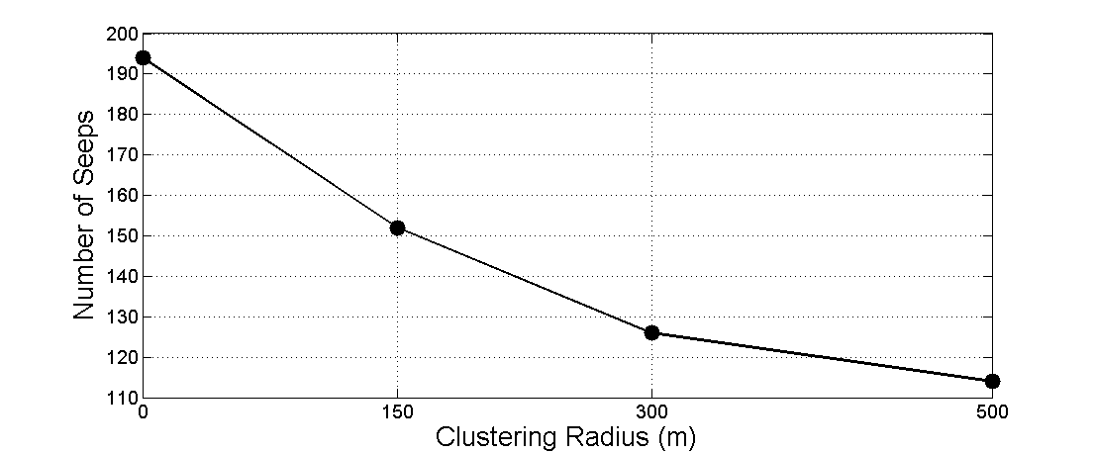

**Supplemental Figure S4**: Comparison of all primary source depths (fishing sonar, research sites, literature) with their equivalent depths obtained using the GeoMapApp database (multibeam bathymetry overlay data only). The R2 value for a linear fit of a 1:1 slope is 0.9823. The strong linear correlation implies that most depths used are consistent with independent swath bathymetry depth sources and therefore likely to be reliable for this compilation.

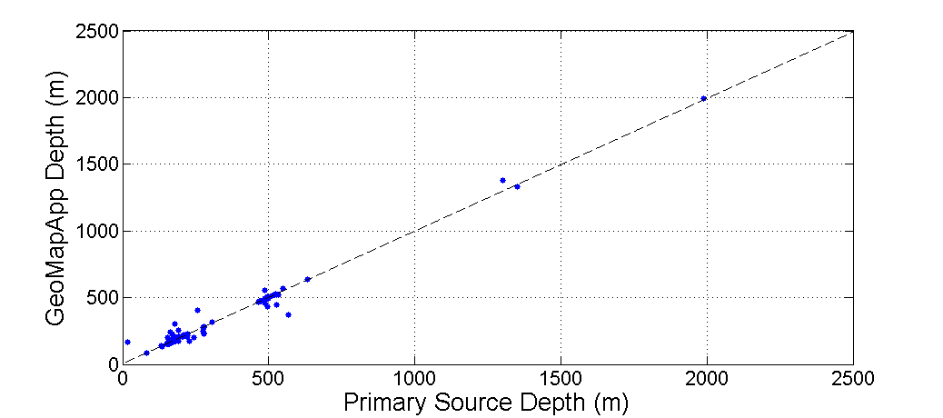

**Table S1:** Calculation of the upper limit of methane hydrate stability based on archive National Ocean Database CTD and heat flow data from the Southeast Atlantic margin of North America in the area covered by Skarke et al (2014), calculated at 0.5 degree latitude intervals. Latitudinal temperature variability along-strike of the SE North American margin covered by the Skarke et al (2014) survey is higher than that present on the WA/OR Cascadia margin, due to variable ocean currents in that area (Phrampus and Hornbach, 2012). A similar analysis along the Cascadia margin indicated that the Methane Hydrate Stability Depth (MHSD) is 500 meters with an along-strike variability of 0.075 C per degree latitude (Hautala et al., 2014), and the MHSD only varies by a few meters from Oregon to Vancouver Island.

**C:\Users\Johnson\Dropbox\Touched Up\tiffs\Table.tif**

**Methods for hydrate stability calculations shown in Table S1 and Figure S6.**

The upper limit of methane hydrate stability was estimated for the US East Coast from the 1o gridded water column temperature data in the World Ocean Atlas 2013 compiled by the National Oceanographic Data Center (World Ocean Atlas, 2013). The mean annual data (1955-2012) was visualized and extracted through Ocean Data View (http://odv.awi.de). The upper limit of the methane hydrate stability zone was computed assuming Structure I gas hydrate and hydrostatic conditions [Tishchenko et al., 2005].

**References**

World Ocean Atlas 2013 Product Documentation. T. Boyer, Ed.; A. Mishonou, Technical Ed.; 14 pp.  
Available at: <http://www.nodc.noaa.gov/oc5/indprod.html>.

**Supplemental Table S2 – Master Spreadsheet of Methane Plume Inventory on the Washington and Oregon Segments of the Cascadia Subduction Zone.**

|  |  |  |  |  |  |
| --- | --- | --- | --- | --- | --- |
|  |  |  | |  | | --- | |  | |  |
| Lat | Lon | Source | Unclustered Depth (m) | Clustered Depth (m) |
|  |  |  |  |  |
| 43.0333 | -124.6700 | Collier et al (2005) | 132 | 132 |
| 43.8760 | -124.9190 | Torres et al. (2009) | 493 | 493 |
| 44.0033 | -124.8700 | Collier et al (2005) | 83 | 83 |
| 44.0070 | -124.9360 | Torres et al. (2009) | 223 | 223 |
| 44.1120 | -124.9430 | Torres et al. (2009) | 219 | 219 |
| 44.1920 | -124.9690 | Torres et al. (2009) | 275 | 275 |
| 44.2170 | -125.0000 | Torres et al. (2009) | 462 | 462 |
| 44.2790 | -124.9020 | Torres et al. (2009) | 221 | 221 |
| 44.2810 | -124.9810 | Torres et al. (2009) | 633 | 633 |
| 44.5330 | -124.9170 | Torres et al. (2009) | 471 | 471 |
| 44.5580 | -124.8970 | Torres et al. (2009) | 539 | 539 |
| 44.6750 | -125.1250 | Carson et al. (1991) | 678 | 678 |
| 44.6750 | -125.2916 | Carson et al. (1990) | 2017 | 2017 |
| 44.6830 | -125.2850 | Carson et al. (1990) | 2104 | 2104 |
| 44.7320 | -124.8830 | Torres et al. (2009) | 565 | 565 |
| 44.7330 | -124.8830 | Torres et al. (2009) | 587 | 587 |
| 44.8360 | -124.8360 | Torres et al. (2009) | 344 | 344 |
| 44.8370 | -124.9630 | Torres et al. (2009) | 747 | 747 |
| 44.8410 | -124.9570 | Torres et al. (2009) | 711 | 711 |
| 44.8470 | -124.8380 | Torres et al. (2009) | 567 | 567 |
| 44.8655 | -124.8878 | Oregon Plume from Evan | 529 | 529 |
| 45.8726 | -124.6450 | "New" Pete Plumes | 200 | 200 |
| 45.8770 | -124.6456 | "New" Pete Plumes | 199 | 199 |
| 45.8785 | -124.6465 | "New" Pete Plumes | 199 |  |
| 45.8805 | -124.6500 | "New" Pete Plumes | 200 | 199.5 |
| 45.8820 | -124.6390 | "New" Pete Plumes | 183 | 188 |
| 45.8825 | -124.6470 | "New" Pete Plumes | 199 |  |
| 45.8830 | -124.6427 | "New" Pete Plumes | 194 |  |
| 45.8830 | -124.6420 | "New" Pete Plumes | 190 |  |
| 45.8840 | -124.6411 | "New" Pete Plumes | 185 |  |
| 45.8850 | -124.6386 | "New" Pete Plumes | 182 | 180.394125 |
| 45.8857 | -124.6370 | "New" Pete Plumes | 181 |  |
| 45.8860 | -124.6380 | "New" Pete Plumes | 181 |  |
| 45.8860 | -124.6355 | "New" Pete Plumes | 177.5765 |  |
| 46.1950 | -124.6650 | "New" Pete Plumes | 526.6944 | 526.6944 |
| 46.21031667 | -124.656894 | TN314 Plume 6D | 497.1 | 497.1 |
| 46.2130 | -124.6570 | "New" Pete Plumes |  |  |
| 46.2145 | -124.6660 | "New" Pete Plumes | 548.64 | 548.64 |
| 46.2163 | -124.6550 | "New" Pete Plumes |  |  |
| 46.222155 | -124.656762 | TN314 Plume 6B | 504.6 | 504.6 |
| 46.26523167 | -124.251607 | TN-177 | 70 | 70 |
| 46.50456617 | -124.4406662 | TN-207 | 109 | 109 |
| 46.64399183 | -124.313437 | TN-177 | 66 | 66 |
| 46.66629683 | -124.3146268 | TN-177 | 66 | 66 |
| 46.68335517 | -124.315577 | TN-177 | 64 | 64 |
| 46.69977517 | -124.3164968 | TN-177 | 65 | 65 |
| 46.7006035 | -124.317252 | TN-177 | 65 |  |
| 46.74022183 | -124.382997 | TN-177 | 78 | 78 |
| 46.7484 | -125.4197 | August 2013 Cruise | 1988 | 1988 |
| 46.7823 | -125.26414 | August 2013 Cruise- from Rick | 1027 | 1051.16667 |
| 46.78243 | -125.26348 | August 2013 Cruise- from Rick | 1034 |  |
| 46.78291 | -125.26227 | August 2013 Cruise- from Rick | 1068 |  |
| 46.7830 | -125.2642 | August 2013 Cruise | 1046 |  |
| 46.7833 | -125.26357 | August 2013 Cruise- from Rick | 1051 |  |
| 46.7840 | -125.2617 | August 2013 Cruise- from Rick | 1081 |  |
| 46.83223683 | -124.5639053 | TN-177 | 104 | 104 |
| 46.83359017 | -124.5851903 | TN-177 | 106 | 106 |
| 46.83421017 | -124.4989437 | TN-177 | 90 | 90 |
| 46.83452517 | -124.5212703 | TN-177 | 94 | 94 |
| 46.8343335 | -124.2698487 | TN-177 | 51 | 51 |
| 46.83460183 | -124.426177 | TN-177 | 79 | 79 |
| 46.84064867 | -124.6950912 | TN-207 | 132 | 132 |
| 46.8457685 | -124.493447 | TN-177 | 90 | 90 |
| 46.8458035 | -124.541202 | TN-177 | 97 | 97 |
| 46.84592017 | -124.5942737 | TN-177 | 107 | 107 |
| 46.86965683 | -124.5365737 | TN-177 | 91 | 91 |
| 46.87982183 | -124.8356628 | TN-207 | 165 | 168.333333 |
| 46.88116067 | -124.8401718 | TN-207 | 173 |  |
| 46.8813515 | -124.8313675 | TN-207 | 166 | 165.5 |
| 46.88135917 | -124.8323212 | TN-207 | 165 |  |
| 46.882515 | -124.835823 | TN-207 | 167 |  |
| 46.8850 | -124.7770 | Marie's Plume | 153 | 153 |
| 46.8851815 | -124.7765198 | TN-207 | 152 |  |
| 46.8852615 | -124.7809317 | TN-207 | 154 |  |
| 46.88584517 | -124.776535 | TN-207 | 153 |  |
| 46.88671117 | -124.7778168 | TN-207 | 153 |  |
| 46.89015583 | -124.7851563 | TN-207 | 156 | 156 |
| 46.89070133 | -124.8447418 | TN-207 | 204 | 204 |
| 46.8915185 | -124.7173387 | TN-177 | 131 | 131 |
| 46.8934885 | -124.6180753 | TN-177 | 107 | 107 |
| 46.89399717 | -124.8124467 | TN-207 | 183 | 183 |
| 46.898407 | -124.8760452 | TN-207 | 303 | 303 |
| 46.89974017 | -124.6331537 | TN-177 | 109 | 109 |
| 46.90524683 | -124.6856587 | TN-177 | 126 | 126 |
| 46.90913017 | -124.8177643 | TN-207 | 239 | 239 |
| 46.90996517 | -124.5160503 | TN-177 | 87 | 87 |
| 46.9155045 | -124.89402 | TN-207 | 253 | 253 |
| 46.91586517 | -124.5150753 | TN-177 | 84 | 84 |
| 46.9162635 | -124.9029007 | TN-207 | 406 | 406 |
| 46.91725683 | -124.6611153 | TN-177 | 114 | 114 |
| 46.91904833 | -124.9265365 | TN-207 | 492 | 492 |
| 46.91934967 | -124.889183 | TN-207 | 226 | 226 |
| 46.92648183 | -124.5170303 | TN-177 | 84 | 84 |
| 46.93190183 | -124.5220803 | TN-177 | 83 | 83 |
| 46.94059367 | -124.955072 | TN-207 | 218 | 218 |
| 46.9422263 | -124.9574508 | TN-207 | 214 | 214 |
| 46.944748 | -124.9341355 | TN-207 | 210 | 210 |
| 46.944973 | -124.9338683 | TN-207 | 210 |  |
| 46.9460945 | -124.9168472 | TN-207 | 206 | 206 |
| 46.9517135 | -124.9161835 | TN-207 | 199 | 190.5 |
| 46.9547996 | -124.9203415 | TN-207 | 182 |  |
| 46.955967 | -124.9401932 | TN-207 | 208 | 208 |
| 46.958908 | -124.9442978 | TN-207 | 208 |  |
| 46.96186067 | -124.92099 | TN-207 | 172 | 172 |
| 46.96381767 | -124.9230118 | TN-207 | 172 |  |
| 46.96704483 | -124.9193343 | TN-207 | 170 | 17 |
| 46.969952 | -124.9413833 | TN-207 | 179 | 179 |
| 46.97291183 | -124.9643632 | TN-207 | 182 | 180.5 |
| 46.97566 | -124.9673615 | TN-207 | 179 |  |
| 46.97640983 | -124.9503173 | TN-207 | 168 | 168 |
| 46.98126217 | -124.970665 | TN-207 | 172 | 172 |
| 46.983036 | -124.9777527 | TN-207 | 202 | 202 |
| 46.98417283 | -124.961235 | TN-207 | 162 | 161.5 |
| 46.98468783 | -124.96241 | TN-207 | 161 |  |
| 46.98811333 | -124.948494 | TN-207 | 155 | 155.333 |
| 46.98899083 | -124.9443283 | TN-207 | 155 |  |
| 46.989502 | -124.941246 | TN-207 | 156 |  |
| 46.99304583 | -124.9636383 | TN-207 | 157 | 155.6667 |
| 46.9935875 | -124.9745788 | TN-207 | 177 | 177 |
| 46.993618 | -124.9484787 | TN-207 | 155 | 155 |
| 46.99165733 | -124.9480515 | TN-207 | 155 |  |
| 46.9942893 | -124.9612732 | TN-207 | 155 |  |
| 46.99447633 | -124.943634 | TN-207 | 155 |  |
| 46.99452583 | -124.948288 | TN-207 | 155 |  |
| 46.99496833 | -124.9448472 | TN-207 | 155 |  |
| 46.99518583 | -124.9743652 | TN-207 | 175 | 175 |
| 46.99518583 | -124.9584275 | TN-207 | 155 |  |
| 46.995369 | -124.9658203 | TN-207 | 158 | 158 |
| 46.99588017 | -124.9485168 | TN-207 | 155 |  |
| 46.99627683 | -124.9391022 | TN-207 | 155 |  |
| 46.9982033 | -124.9443588 | TN-207 | 155 | 155 |
| 46.998787 | -124.9724578 | TN-207 | 166 | 165 |
| 46.99883267 | -124.9725265 | TN-207 | 166 |  |
| 47.00130083 | -124.971283 | TN-207 | 163 |  |
| 47.00716517 | -124.9574583 | TN-207 | 162 | 162 |
| 47.007454 | -124.966423 | TN-207 | 164 | 164 |
| 47.0578 | -125.0780 | "Old" Pete Plumes | 1396 | 1396 |
| 47.0584 | -125.0544 | "Old" Pete Plumes | 1253 | 1253 |
| 47.0828 | -125.0588 | "Old" Pete Plumes | 1113 | 1112 |
| 47.0832 | -125.0568 | "Old" Pete Plumes | 1111 |  |
| 47.2729635 | -124.7195737 | TN-177 | 122 | 122 |
| 47.38408517 | -124.753087 | TN-177 | 133 | 133 |
| 47.5763 | -125.0677 | "Old" Pete Plumes | 306 | 319.25 |
| 47.5766 | -125.0703 | "Old" Pete Plumes | 323 |  |
| 47.5772 | -125.0706 | "Old" Pete Plumes | 320 |  |
| 47.5773 | -125.0652 | "Old" Pete Plumes | 283 | 278.75 |
| 47.5774 | -125.0720 | "Old" Pete Plumes | 328 |  |
| 47.5781 | -125.0652 | "Old" Pete Plumes | 277 |  |
| 47.5788 | -125.0662 | "Old" Pete Plumes | 285 |  |
| 47.5790 | -125.0647 | "Old" Pete Plumes | 277 |  |
| 47.5791 | -125.0660 | "Old" Pete Plumes | 277 |  |
| 47.5792 | -125.0647 | "Old" Pete Plumes | 276 |  |
| 47.5792 | -125.0647 | "Old" Pete Plumes | 274 |  |
| 47.5793 | -125.0660 | "Old" Pete Plumes | 281 |  |
| 47.5828 | -125.0588 | "Old" Pete Plumes | 235 | 263 |
| 47.5833 | -125.0568 | "Old" Pete Plumes | 277 |  |
| 47.5840 | -125.0544 | "Old" Pete Plumes | 277 |  |
| 47.842631 | -125.24433 | TN314 Plume 4E | 471.8 | 472.25 |
| 47.8427 | -125.2500 | "Old" Pete Plumes |  |  |
| 47.843042 | -125.24404 | TN314 Plume 4D | 472.7 |  |
| 47.8437 | -125.2497 | "Old" Pete Plumes |  |  |
| 47.8441 | -125.2500 | "Old" Pete Plumes |  |  |
| 47.8440556 | -125.249547 | TN314 Plume 4B | 468.2 | 468.2 |
| 47.9220 | -125.6532 | "Old" Pete Plumes | 560 | 560 |
| 47.9287 | -125.6406 | "Old" Pete Plumes |  |  |
| 47.9295 | -125.6401 | TN314 Plume 2A_1 | 519 | 526.8 |
| 47.9298 | -125.6393 | "Old" Pete Plumes | 533 |  |
| 47.9288 | -125.6452 | "Old" Pete Plumes |  |  |
| 47.93003 | -125.6409 | TN314 Plume 2A_2 | 528.4 |  |
| 48.0278 | -125.6627 | "Old" Pete Plumes | 402 | 402 |
| 48.0392 | -125.66631 | TN314 Plume 1 | 487 | 487 |
| 48.0398 | -125.6657 | "Old" Pete Plumes |  |  |
| 48.06697533 | -124.9634803 | TN-177 | 98 | 98 |
| 48.107377 | -124.9781437 | TN-177 | 120 | 120 |
| 48.6330 | -126.9167 | Amnesiac Flare | 1300 | 1300 |
| 48.7183 | -126.9042 | Spinnaker Flare | 1350 | 1350 |

**Supplemental Table S3 – Clustered plume inventory from Skarke et al (2014), where clustering process is described in the text.**

|  |  |  |  |
| --- | --- | --- | --- |
| Lat | Lon | Unclustered Depths (m) | Clustered Depths (m) |
| 40.5698 | -69.8706 | 58.6 | 58.45 |
| 40.5696 | -69.8735 | 58.33 |  |
| 40.5696 | -69.8805 | 57.72 | 57.94 |
| 40.5695 | -69.8836 | 57.81 |  |
| 40.5693 | -69.8686 | 58.42 |  |
| 40.5692 | -69.8863 | 58.33 |  |
| 40.5691 | -69.9074 | 57.9 |  |
| 40.5691 | -69.8838 | 58.07 | 58.07 |
| 40.5685 | -69.9247 | 57.81 | 57.81 |
| 40.5677 | -69.9608 | 56.58 | 56.58 |
| 40.5676 | -70.2165 | 53.85 | 53.94 |
| 40.5674 | -70.2146 | 54.02 |  |
| 40.5673 | -69.9843 | 55.87 | 55.74 |
| 40.5672 | -69.9866 | 55.61 |  |
| 40.4212 | -67.6731 | 501.13 | 501.13 |
| 40.2442 | -68.1842 | 281.43 | 279.30 |
| 40.2441 | -68.1865 | 276.45 |  |
| 40.2437 | -68.1863 | 280.01 |  |
| 40.0203 | -69.2423 | 150.2 | 155.93 |
| 40.0184 | -69.2364 | 158.8 |  |
| 40.0181 | -69.2368 | 158.8 |  |
| 40.0138 | -69.2107 | 209.96 | 206.48 |
| 40.0137 | -69.2128 | 207.9 |  |
| 40.0133 | -69.2120 | 205.84 |  |
| 40.0123 | -69.2067 | 222.92 | 230.89 |
| 40.0121 | -69.2056 | 227.37 |  |
| 40.0121 | -69.2049 | 230.71 |  |
| 40.0117 | -69.2130 | 202.23 |  |
| 40.0116 | -69.2054 | 231.26 |  |
| 40.0113 | -69.2041 | 237.38 |  |
| 40.0112 | -69.2050 | 235.71 |  |
| 40.0089 | -69.0980 | 281.86 | 281.86 |
| 40.0064 | -69.0994 | 295.08 | 262.70 |
| 40.0063 | -69.2144 | 213.47 |  |
| 40.0059 | -69.2160 | 209.58 |  |
| 40.0057 | -69.2130 | 219.03 |  |
| 40.0055 | -69.1015 | 288.03 |  |
| 40.0052 | -69.1017 | 288.91 |  |
| 40.0050 | -69.1011 | 291.56 |  |
| 40.0036 | -69.1026 | 295.96 |  |
| 40.0010 | -69.1168 | 280.09 | 281.42 |
| 40.0009 | -69.1299 | 362.09 | 362.09 |
| 40.0002 | -69.1949 | 324.51 | 338.63 |
| 39.9999 | -69.1961 | 311.84 |  |
| 39.9998 | -69.1181 | 282.74 |  |
| 39.9997 | -69.1954 | 317.55 |  |
| 39.9993 | -69.1949 | 322.64 |  |
| 39.9984 | -69.1916 | 362.28 |  |
| 39.9983 | -69.1209 | 294.2 | 297.58 |
| 39.9982 | -69.1911 | 368.04 |  |
| 39.9981 | -69.1909 | 372.27 |  |
| 39.9979 | -69.1250 | 318 | 317.12 |
| 39.9978 | -69.1227 | 305.66 |  |
| 39.9978 | -69.1188 | 289.79 |  |
| 39.9978 | -69.1210 | 295.96 |  |
| 39.9977 | -69.1217 | 300.37 |  |
| 39.9975 | -69.1953 | 329.89 |  |
| 39.9975 | -69.1209 | 299.49 |  |
| 39.9974 | -69.1249 | 316.24 |  |
| 39.9966 | -69.1914 | 373.46 | 348.40 |
| 39.9966 | -69.1267 | 334.76 | 370.36 |
| 39.9963 | -69.1263 | 331.23 |  |
| 39.9961 | -69.1260 | 326.82 |  |
| 39.9957 | -69.1909 | 385.46 |  |
| 39.9955 | -69.1906 | 390.87 |  |
| 39.9952 | -69.1284 | 362.09 |  |
| 39.9924 | -69.1238 | 361.2 | 361.20 |
| 39.9854 | -69.1893 | 384.72 | 392.37 |
| 39.9851 | -69.1891 | 389 |  |
| 39.9847 | -69.1885 | 395.17 |  |
| 39.9846 | -69.1879 | 400.59 |  |
| 39.9041 | -69.2577 | 1057.46 | 1103.34 |
| 39.9036 | -69.2504 | 1169.58 | 1169.58 |
| 39.9022 | -69.2551 | 1109.58 |  |
| 39.9017 | -69.2567 | 1120.98 |  |
| 39.9013 | -69.2575 | 1125.33 |  |
| 39.8692 | -69.2857 | 1402.58 | 1402.58 |
| 39.8114 | -69.5895 | 1410.16 | 1412.28 |
| 39.8113 | -69.5901 | 1411.09 |  |
| 39.8112 | -69.5898 | 1405.55 |  |
| 39.8106 | -69.5898 | 1415.09 |  |
| 39.8104 | -69.5902 | 1419.49 |  |
| 39.8070 | -69.5924 | 1417.52 | 1417.86 |
| 39.8062 | -69.5922 | 1423.82 |  |
| 39.8051 | -69.5930 | 1412.23 |  |
| 39.6770 | -72.4866 | 118.32 | 124.40 |
| 39.6762 | -72.4857 | 123.44 |  |
| 39.6754 | -72.4843 | 131.43 |  |
| 39.6623 | -72.4237 | 97.02 | 97.29 |
| 39.6623 | -72.4238 | 97.55 |  |
| 39.6601 | -72.4366 | 96.57 | 96.66 |
| 39.6600 | -72.4367 | 96.22 |  |
| 39.6599 | -72.4367 | 96.57 |  |
| 39.6598 | -72.4561 | 181.84 | 181.84 |
| 39.6597 | -72.4365 | 97.28 |  |
| 39.6522 | -72.4326 | 223.25 | 226.90 |
| 39.6498 | -72.4304 | 230.54 |  |
| 39.6271 | -72.4090 | 262.45 | 263.23 |
| 39.6266 | -72.4097 | 267.92 |  |
| 39.6265 | -72.4081 | 259.71 |  |
| 39.6265 | -72.4074 | 256.98 |  |
| 39.6264 | -72.4088 | 263.36 |  |
| 39.6262 | -72.4077 | 259.71 |  |
| 39.6261 | -72.4094 | 272.48 |  |
| 39.6050 | -72.4197 | 365.92 | 363.16 |
| 39.6048 | -72.4197 | 367.85 |  |
| 39.6041 | -72.4221 | 355.71 |  |
| 39.5527 | -72.4447 | 142.89 | 142.89 |
| 39.5484 | -72.4063 | 531.48 | 531.48 |
| 39.5460 | -72.4023 | 530.35 | 530.35 |
| 39.5459 | -72.4450 | 134.55 | 136.36 |
| 39.5453 | -72.4445 | 136.63 |  |
| 39.5448 | -72.4000 | 512.71 | 529.50 |
| 39.5446 | -72.4058 | 533.79 | 531.35 |
| 39.5446 | -72.4109 | 515.87 | 508.13 |
| 39.5445 | -72.4441 | 137.89 |  |
| 39.5441 | -72.4008 | 531.33 |  |
| 39.5441 | -72.4012 | 531.33 |  |
| 39.5438 | -72.4049 | 521.53 |  |
| 39.5436 | -72.4093 | 519.47 |  |
| 39.5435 | -72.3994 | 529.38 |  |
| 39.5433 | -72.4046 | 535.37 |  |
| 39.5433 | -72.3987 | 523.12 |  |
| 39.5432 | -72.4101 | 514.45 |  |
| 39.5431 | -72.4001 | 530.63 |  |
| 39.5427 | -72.4123 | 501.06 |  |
| 39.5427 | -72.4128 | 497.71 |  |
| 39.5426 | -72.4038 | 534.7 |  |
| 39.5426 | -72.4133 | 500.22 |  |
| 39.5423 | -72.4018 | 536.88 |  |
| 39.5414 | -72.3997 | 540.63 |  |
| 39.5409 | -72.3966 | 539.38 | 539.38 |
| 39.5406 | -72.3960 | 539.38 |  |
| 39.5378 | -72.3948 | 550.8 | 550.80 |
| 39.5331 | -72.3665 | 545.03 | 315.03 |
| 39.5328 | -72.3662 | 549.46 |  |
| 39.5292 | -72.3659 | 581.29 |  |
| 38.3268 | -73.5781 | 175.04 | 178.58 |
| 38.3264 | -73.5772 | 178.86 |  |
| 38.3259 | -73.5792 | 174.62 |  |
| 38.3258 | -73.5773 | 182.25 |  |
| 38.3252 | -73.5837 | 168.14 |  |
| 38.3252 | -73.5817 | 167.37 |  |
| 38.3248 | -73.5823 | 169.96 |  |
| 38.3246 | -73.5856 | 165.83 |  |
| 38.3240 | -73.5832 | 173.14 |  |
| 38.3152 | -73.5767 | 237 | 237.00 |
| 38.2534 | -73.6104 | 351.13 | 351.13 |
| 38.0515 | -73.8229 | 377.91 | 380.93 |
| 38.0513 | -73.8221 | 391 |  |
| 38.0507 | -73.8241 | 365.83 |  |
| 38.0503 | -73.8258 | 350.73 |  |
| 38.0502 | -73.8251 | 357.78 |  |
| 38.0498 | -73.8201 | 432.27 |  |
| 38.0498 | -73.8245 | 363.82 |  |
| 38.0498 | -73.8234 | 376.9 |  |
| 38.0497 | -73.8214 | 404.08 |  |
| 38.0495 | -73.8222 | 388.98 |  |
| 38.0476 | -73.8266 | 362.81 | 372.12 |
| 38.0476 | -73.8293 | 362.81 |  |
| 38.0473 | -73.8227 | 386.97 |  |
| 38.0463 | -73.8260 | 375.9 |  |
| 37.9080 | -73.9864 | 258.39 | 258.39 |
| 37.9073 | -73.9775 | 296.98 | 296.98 |
| 37.8983 | -73.9649 | 387.28 | 387.28 |
| 37.8955 | -73.9695 | 348.2 | 348.20 |
| 37.8341 | -74.0303 | 341.53 | 350.99 |
| 37.8340 | -74.0308 | 347.58 |  |
| 37.8338 | -74.0293 | 357.03 |  |
| 37.8327 | -74.0297 | 353.88 |  |
| 37.8316 | -74.0311 | 354.93 |  |
| 37.8306 | -74.0385 | 365.14 | 361.50 |
| 37.8300 | -74.0336 | 356.78 |  |
| 37.8299 | -74.0336 | 359.67 |  |
| 37.8293 | -74.0328 | 361.55 |  |
| 37.8291 | -74.0373 | 364.36 |  |
| 37.8278 | -74.0361 | 365.36 | 373.83 |
| 37.8273 | -74.0378 | 374.89 |  |
| 37.8269 | -74.0380 | 382.33 |  |
| 37.8268 | -74.0357 | 369.17 |  |
| 37.8267 | -74.0357 | 367.49 |  |
| 37.8261 | -74.0382 | 376.8 |  |
| 37.8259 | -74.0382 | 380.77 |  |
| 37.8246 | -74.0355 | 376.86 | 376.86 |
| 37.7761 | -74.1134 | 289.98 | 289.98 |
| 37.7739 | -74.1197 | 269.28 | 272.78 |
| 37.7735 | -74.1204 | 269.05 |  |
| 37.7733 | -74.1195 | 270.92 |  |
| 37.7731 | -74.1194 | 273.73 |  |
| 37.7715 | -74.1194 | 280.92 |  |
| 37.7706 | -74.1240 | 262.49 | 267.92 |
| 37.7702 | -74.1218 | 276.86 |  |
| 37.7698 | -74.1237 | 267.53 |  |
| 37.7696 | -74.1248 | 267.14 |  |
| 37.7694 | -74.1245 | 269.47 |  |
| 37.7694 | -74.1182 | 298.79 | 298.79 |
| 37.7693 | -74.1260 | 264.43 |  |
| 37.7682 | -74.1252 | 266.76 |  |
| 37.7674 | -74.1256 | 268.69 |  |
| 37.7666 | -74.1196 | 301.65 | 302.43 |
| 37.7665 | -74.1270 | 268.69 | 268.69 |
| 37.7655 | -74.1198 | 303.2 |  |
| 37.7638 | -74.1211 | 303.59 | 306.56 |
| 37.7632 | -74.1213 | 307.08 |  |
| 37.7625 | -74.1211 | 309.02 |  |
| 37.7600 | -74.1250 | 309.41 | 309.41 |
| 37.7542 | -74.1180 | 369.15 | 382.73 |
| 37.7530 | -74.1152 | 396.3 |  |
| 37.7271 | -74.1606 | 302.14 | 310.81 |
| 37.7259 | -74.1579 | 319.47 |  |
| 37.7233 | -74.1411 | 481.28 | 452.10 |
| 37.7233 | -74.1413 | 476.78 |  |
| 37.7230 | -74.1408 | 484.95 |  |
| 37.7229 | -74.1411 | 475.96 |  |
| 37.7098 | -74.1786 | 341.53 | 341.53 |
| 37.7084 | -74.1721 | 445.51 | 438.94 |
| 37.7081 | -74.1735 | 423.45 |  |
| 37.7077 | -74.1810 | 294.26 | 311.07 |
| 37.7074 | -74.1844 | 275.36 | 275.36 |
| 37.7073 | -74.1778 | 322.62 |  |
| 37.7072 | -74.1790 | 316.32 |  |
| 37.7071 | -74.1737 | 412.42 |  |
| 37.7060 | -74.1712 | 451.81 |  |
| 37.7060 | -74.1699 | 458.11 |  |
| 37.7059 | -74.1720 | 442.36 |  |
| 37.7056 | -74.1798 | 305.29 | 299.51 |
| 37.7051 | -74.1797 | 300.56 |  |
| 37.7049 | -74.1807 | 292.69 |  |
| 37.6884 | -74.1738 | 478.32 | 478.32 |
| 37.6686 | -74.1909 | 406.54 | 413.91 |
| 37.6686 | -74.1878 | 426.21 |  |
| 37.6684 | -74.1910 | 407.81 |  |
| 37.6680 | -74.1908 | 412.44 |  |
| 37.6676 | -74.1909 | 416.56 |  |
| 37.6354 | -74.2260 | 310.18 | 315.76 |
| 37.6354 | -74.2260 | 311.12 |  |
| 37.6330 | -74.2258 | 325.97 |  |
| 37.6194 | -74.2627 | 187.92 | 187.92 |
| 37.6000 | -74.2536 | 331.21 | 344.03 |
| 37.6000 | -74.2524 | 345.5 |  |
| 37.5996 | -74.2527 | 339.45 |  |
| 37.5996 | -74.2532 | 338.9 |  |
| 37.5995 | -74.2523 | 347.7 |  |
| 37.5995 | -74.2525 | 344.95 |  |
| 37.5994 | -74.2531 | 342.2 |  |
| 37.5982 | -74.2535 | 351 |  |
| 37.5975 | -74.2542 | 355.39 |  |
| 37.5921 | -74.2752 | 252.16 | 252.16 |
| 37.5838 | -74.2824 | 251.18 | 266.42 |
| 37.5811 | -74.2814 | 281.66 |  |
| 37.5798 | -74.2862 | 260.97 | 260.97 |
| 37.5789 | -74.2754 | 325.71 | 376.62 |
| 37.5773 | -74.2688 | 388.38 |  |
| 37.5772 | -74.2709 | 371.34 |  |
| 37.5770 | -74.2700 | 375.73 |  |
| 37.5770 | -74.2705 | 372.43 |  |
| 37.5770 | -74.2697 | 377.93 |  |
| 37.5768 | -74.2705 | 374.08 |  |
| 37.5767 | -74.2710 | 375.73 |  |
| 37.5765 | -74.2700 | 377.38 |  |
| 37.5678 | -74.2821 | 427.53 | 427.53 |
| 37.5655 | -74.2816 | 444.83 | 463.03 |
| 37.5651 | -74.2808 | 462.12 |  |
| 37.5650 | -74.2815 | 453.48 |  |
| 37.5648 | -74.2807 | 460.68 |  |
| 37.5638 | -74.2806 | 463.57 |  |
| 37.5631 | -74.2803 | 463.57 |  |
| 37.5626 | -74.2801 | 476.54 |  |
| 37.5623 | -74.2799 | 479.42 |  |
| 37.5616 | -74.2831 | 519.78 | 508.90 |
| 37.5612 | -74.2838 | 512.57 |  |
| 37.5591 | -74.2851 | 506.66 |  |
| 37.5591 | -74.3189 | 190.45 | 192.94 |
| 37.5590 | -74.3193 | 187.67 |  |
| 37.5588 | -74.2853 | 496.6 |  |
| 37.5586 | -74.3183 | 194.42 |  |
| 37.5584 | -74.3182 | 196.01 |  |
| 37.5581 | -74.3206 | 183.69 |  |
| 37.5579 | -74.2990 | 367.2 | 372.90 |
| 37.5579 | -74.3214 | 180.91 |  |
| 37.5579 | -74.3169 | 206.34 |  |
| 37.5578 | -74.3183 | 197.2 |  |
| 37.5576 | -74.3194 | 192.43 |  |
| 37.5574 | -74.3179 | 203.56 |  |
| 37.5571 | -74.2982 | 381.67 |  |
| 37.5571 | -74.2988 | 376.41 |  |
| 37.5570 | -74.3022 | 343.52 |  |
| 37.5569 | -74.3208 | 186.47 |  |
| 37.5567 | -74.3213 | 184.09 |  |
| 37.5566 | -74.2995 | 369.83 |  |
| 37.5560 | -74.2971 | 398.77 |  |
| 37.5524 | -74.2897 | 505.48 | 507.44 |
| 37.5515 | -74.2893 | 516.14 |  |
| 37.5512 | -74.2899 | 510.22 |  |
| 37.5510 | -74.2906 | 506.07 |  |
| 37.5508 | -74.2894 | 511.99 |  |
| 37.5507 | -74.2901 | 509.63 |  |
| 37.5506 | -74.2899 | 509.63 |  |
| 37.5506 | -74.2915 | 495.41 |  |
| 37.5501 | -74.2898 | 517.33 |  |
| 37.5500 | -74.2912 | 498.97 |  |
| 37.5499 | -74.2909 | 502.52 |  |
| 37.5497 | -74.2906 | 504.3 |  |
| 37.5493 | -74.2899 | 509.03 |  |
| 37.5467 | -74.2939 | 464.55 | 459.95 |
| 37.5461 | -74.2940 | 455.34 |  |
| 37.5448 | -74.0971 | 1053.89 | 1053.89 |
| 37.5428 | -74.3031 | 331.95 | 329.45 |
| 37.5422 | -74.1024 | 1010.11 | 1010.11 |
| 37.5414 | -74.3033 | 322.07 |  |
| 37.5413 | -74.3032 | 323.85 |  |
| 37.5412 | -74.3019 | 340.57 |  |
| 37.5408 | -74.3025 | 325.08 |  |
| 37.5406 | -74.3027 | 325.82 |  |
| 37.5403 | -74.2947 | 401.34 | 390.55 |
| 37.5402 | -74.3018 | 334.11 |  |
| 37.5402 | -74.3331 | 167.8 | 180.15 |
| 37.5401 | -74.3017 | 334.67 |  |
| 37.5401 | -74.2995 | 351.38 | 343.34 |
| 37.5400 | -74.3315 | 174.16 | 181.27 |
| 37.5400 | -74.3318 | 173.36 |  |
| 37.5397 | -74.3298 | 181.31 |  |
| 37.5395 | -74.3004 | 339.58 |  |
| 37.5394 | -74.3000 | 342.53 |  |
| 37.5393 | -74.3298 | 182.1 |  |
| 37.5393 | -74.2995 | 346.46 |  |
| 37.5393 | -74.3283 | 190.45 |  |
| 37.5392 | -74.2983 | 355.31 |  |
| 37.5391 | -74.2948 | 392.31 |  |
| 37.5389 | -74.3275 | 194.42 |  |
| 37.5389 | -74.3013 | 337.62 |  |
| 37.5388 | -74.3013 | 341.14 |  |
| 37.5387 | -74.3330 | 170.19 |  |
| 37.5385 | -74.3317 | 177.73 |  |
| 37.5384 | -74.2917 | 416.39 | 418.40 |
| 37.5384 | -74.2948 | 386.29 |  |
| 37.5384 | -74.3285 | 190.84 |  |
| 37.5380 | -74.3295 | 186.87 |  |
| 37.5380 | -74.2948 | 382.27 |  |
| 37.5379 | -74.3326 | 172.57 |  |
| 37.5377 | -74.3011 | 332.7 |  |
| 37.5371 | -74.2910 | 420.4 |  |
| 37.5370 | -74.3069 | 297.99 | 305.01 |
| 37.5367 | -74.3066 | 293.1 |  |
| 37.5364 | -74.3338 | 171.38 | 173.98 |
| 37.5363 | -74.3332 | 174.16 |  |
| 37.5361 | -74.3088 | 284.95 |  |
| 37.5360 | -74.3086 | 284.57 |  |
| 37.5359 | -74.3079 | 292.97 |  |
| 37.5359 | -74.3067 | 301.24 |  |
| 37.5359 | -74.3063 | 299.8 |  |
| 37.5359 | -74.3331 | 174.56 |  |
| 37.5359 | -74.3350 | 167.8 |  |
| 37.5358 | -74.3071 | 299 |  |
| 37.5358 | -74.3070 | 296.75 |  |
| 37.5355 | -74.3066 | 304.01 |  |
| 37.5353 | -74.3083 | 286.95 |  |
| 37.5353 | -74.3083 | 287.47 |  |
| 37.5350 | -74.3072 | 297.99 |  |
| 37.5350 | -74.3328 | 176.94 |  |
| 37.5348 | -74.3069 | 301 |  |
| 37.5348 | -74.3068 | 299.19 |  |
| 37.5347 | -74.2842 | 474.45 | 474.45 |
| 37.5347 | -74.3057 | 302.01 |  |
| 37.5346 | -74.3056 | 302.22 |  |
| 37.5346 | -74.2831 | 482.95 |  |
| 37.5346 | -74.3071 | 299 | 299.00 |
| 37.5343 | -74.3362 | 165.02 |  |
| 37.5338 | -74.3057 | 304.07 |  |
| 37.5337 | -74.3070 | 298.58 |  |
| 37.5336 | -74.3074 | 295.53 |  |
| 37.5336 | -74.3313 | 185.68 |  |
| 37.5335 | -74.3351 | 170.19 |  |
| 37.5335 | -74.3327 | 180.12 |  |
| 37.5333 | -74.3064 | 303.01 |  |
| 37.5332 | -74.3069 | 299.8 |  |
| 37.5327 | -74.3358 | 169.79 | 168.70 |
| 37.5323 | -74.3352 | 173.76 |  |
| 37.5316 | -74.3373 | 167.01 |  |
| 37.5315 | -74.3384 | 164.23 |  |
| 37.5301 | -74.3339 | 183.49 | 184.13 |
| 37.5301 | -74.3340 | 181.71 |  |
| 37.5296 | -74.3331 | 186.1 |  |
| 37.5290 | -74.3336 | 185.23 |  |
| 37.5108 | -74.3018 | 415.21 | 415.21 |
| 37.4388 | -74.4178 | 256.76 | 280.48 |
| 37.4371 | -74.4159 | 287.98 |  |
| 37.4364 | -74.4158 | 296.7 |  |
| 37.4330 | -74.4081 | 370.15 | 373.98 |
| 37.4323 | -74.4081 | 374.87 |  |
| 37.4320 | -74.4077 | 376.04 |  |
| 37.4314 | -74.4068 | 374.87 |  |
| 37.3912 | -74.4516 | 320.25 | 320.25 |
| 37.3886 | -74.4493 | 335.19 | 325.65 |
| 37.3881 | -74.4439 | 385.62 | 368.56 |
| 37.3881 | -74.4436 | 386.79 |  |
| 37.3873 | -74.4499 | 315.84 |  |
| 37.3873 | -74.4502 | 310.56 |  |
| 37.3872 | -74.4472 | 346.91 |  |
| 37.3871 | -74.4503 | 312.23 |  |
| 37.3870 | -74.4479 | 335.77 |  |
| 37.3869 | -74.4438 | 364.51 |  |
| 37.3868 | -74.4496 | 312.9 |  |
| 37.3867 | -74.4433 | 365.09 |  |
| 37.3867 | -74.4418 | 364.98 |  |
| 37.3867 | -74.4418 | 366.27 |  |
| 37.3866 | -74.4473 | 335.77 |  |
| 37.3864 | -74.4425 | 360.12 |  |
| 37.3863 | -74.4425 | 361.54 |  |
| 37.3862 | -74.4424 | 362.16 |  |
| 37.3860 | -74.4455 | 338.12 | 334.12 |
| 37.3860 | -74.4458 | 337.53 |  |
| 37.3859 | -74.4472 | 328.15 |  |
| 37.3858 | -74.4456 | 338.12 |  |
| 37.3855 | -74.4452 | 335.77 |  |
| 37.3853 | -74.4446 | 342.05 |  |
| 37.3849 | -74.4439 | 339.29 |  |
| 37.3847 | -74.4430 | 341.64 |  |
| 37.3844 | -74.4372 | 386.86 | 359.30 |
| 37.3840 | -74.4480 | 308.8 |  |
| 37.3839 | -74.4446 | 331.72 |  |
| 37.3837 | -74.4396 | 346.63 |  |
| 37.3836 | -74.4364 | 395.09 |  |
| 37.3833 | -74.4408 | 338.53 |  |
| 37.3830 | -74.4407 | 336.31 |  |
| 37.3829 | -74.4415 | 336.31 |  |
| 37.3829 | -74.4386 | 361.15 |  |
| 37.3817 | -74.4381 | 373.49 |  |
| 37.3812 | -74.4352 | 419.77 | 402.39 |
| 37.3810 | -74.4361 | 402.29 |  |
| 37.3809 | -74.4368 | 396.12 |  |
| 37.3808 | -74.4366 | 391.36 |  |
| 37.3798 | -74.4335 | 417.71 | 417.71 |
| 37.3684 | -74.4431 | 498.95 | 496.55 |
| 37.3673 | -74.4441 | 490.73 |  |
| 37.3662 | -74.4433 | 499.98 |  |
| 37.2978 | -74.4829 | 259.81 | 262.10 |
| 37.2977 | -74.4849 | 246.56 |  |
| 37.2959 | -74.4817 | 271.02 |  |
| 37.2955 | -74.4826 | 265.92 |  |
| 37.2954 | -74.4833 | 260.83 |  |
| 37.2953 | -74.4841 | 256.75 |  |
| 37.2945 | -74.4857 | 251.66 |  |
| 37.2943 | -74.4812 | 284.27 |  |
| 37.2935 | -74.4854 | 255.73 | 259.47 |
| 37.2924 | -74.4869 | 250.64 |  |
| 37.2913 | -74.4846 | 272.04 |  |
| 37.2910 | -74.4812 | 308.72 | 314.33 |
| 37.2905 | -74.4804 | 319.93 |  |
| 37.2879 | -74.4893 | 259.81 | 272.72 |
| 37.2866 | -74.4899 | 268.98 |  |
| 37.2865 | -74.4896 | 273.06 |  |
| 37.2860 | -74.4904 | 277.13 |  |
| 37.2859 | -74.4901 | 277.13 |  |
| 37.2858 | -74.4898 | 280.19 |  |
| 37.0988 | -74.5377 | 462.01 | 465.54 |
| 37.0985 | -74.5376 | 469.07 |  |
| 37.0984 | -74.5459 | 463.67 | 492.34 |
| 37.0973 | -74.5447 | 495.25 |  |
| 37.0970 | -74.5449 | 501.9 |  |
| 37.0966 | -74.5443 | 508.55 |  |
| 37.0917 | -74.5452 | 486.94 | 486.94 |
| 37.0059 | -74.6371 | 107.92 | 107.92 |
| 36.8719 | -74.4759 | 1467.01 | 1475.45 |
| 36.8718 | -74.4786 | 1478.52 |  |
| 36.8716 | -74.4780 | 1479.11 |  |
| 36.8714 | -74.4753 | 1473.85 |  |
| 36.8713 | -74.4770 | 1480.84 |  |
| 36.8712 | -74.4742 | 1465.03 |  |
| 36.8711 | -74.4732 | 1452.7 |  |
| 36.8706 | -74.4877 | 1535.44 | 1542.37 |
| 36.8702 | -74.4870 | 1532.98 |  |
| 36.8699 | -74.4864 | 1535.27 |  |
| 36.8699 | -74.4875 | 1539.69 |  |
| 36.8699 | -74.4773 | 1506.5 |  |
| 36.8692 | -74.4870 | 1545.13 |  |
| 36.8682 | -74.4881 | 1565.68 |  |
| 36.8671 | -74.4893 | 1591.24 | 1601.98 |
| 36.8664 | -74.4906 | 1596.82 |  |
| 36.8650 | -74.4924 | 1608.29 |  |
| 36.8643 | -74.4929 | 1611.58 |  |
| 36.8455 | -74.5844 | 1055.51 | 1055.51 |
| 36.7251 | -74.5108 | 1301.44 | 1301.44 |
| 36.6634 | -74.6737 | 502.69 | 457.35 |
| 36.6625 | -74.6765 | 445.52 |  |
| 36.6610 | -74.6729 | 486.92 |  |
| 36.6607 | -74.6768 | 413.98 |  |
| 36.6607 | -74.6750 | 437.63 |  |
| 36.3919 | -74.6854 | 1101.38 | 1101.38 |
| 35.9358 | -74.8168 | 211.53 | 221.95 |
| 35.9355 | -74.8181 | 214.62 |  |
| 35.9348 | -74.8179 | 224.9 |  |
| 35.9341 | -74.8178 | 236.73 |  |
| 35.9280 | -74.8123 | 328.5 | 370.81 |
| 35.9276 | -74.8112 | 357.79 |  |
| 35.9272 | -74.8068 | 393.59 | 410.27 |
| 35.9263 | -74.8071 | 426.95 |  |
| 35.9260 | -74.8109 | 391.15 |  |
| 35.9257 | -74.8106 | 405.8 |  |
| 35.9068 | -74.8145 | 487.16 | 486.34 |
| 35.9063 | -74.8137 | 477.39 |  |
| 35.9054 | -74.8131 | 494.48 |  |
| 35.7387 | -74.8334 | 169.91 | 169.91 |
| 35.7357 | -74.8321 | 167.23 | 176.16 |
| 35.7347 | -74.8259 | 237.74 | 237.74 |
| 35.7338 | -74.8318 | 163.66 |  |
| 35.7336 | -74.8298 | 186.87 |  |
| 35.7335 | -74.8295 | 186.87 |  |
| 35.7319 | -74.8194 | 311.6 | 311.60 |
| 35.7078 | -74.8128 | 521.87 | 571.44 |
| 35.7078 | -74.8099 | 929.19 |  |
| 35.7072 | -74.8120 | 483.82 |  |
| 35.7064 | -74.8132 | 462.07 |  |
| 35.7064 | -74.8126 | 460.26 |  |
| 35.7006 | -74.8003 | 458.44 | 439.87 |
| 35.7002 | -74.8025 | 447.57 |  |
| 35.6996 | -74.8016 | 431.26 |  |
| 35.6996 | -74.8027 | 422.2 |  |
| 35.6915 | -74.7972 | 443.95 | 443.95 |
| 35.6759 | -74.7954 | 313.47 | 305.49 |
| 35.6758 | -74.7962 | 306.22 |  |
| 35.6757 | -74.7966 | 304.4 |  |
| 35.6756 | -74.7977 | 288.09 |  |
| 35.6737 | -74.7930 | 315.28 |  |
| 35.6507 | -74.7897 | 284.35 | 284.35 |
| 35.5662 | -74.8202 | 76.37 | 69.42 |
| 35.5654 | -74.8201 | 74.8 |  |
| 35.5650 | -74.8210 | 71.51 |  |
| 35.5645 | -74.8213 | 67.75 |  |
| 35.5642 | -74.8219 | 66.34 |  |
| 35.5641 | -74.8216 | 66.65 |  |
| 35.5635 | -74.8227 | 65.4 |  |
| 35.5633 | -74.8222 | 67.9 |  |
| 35.5632 | -74.8220 | 68.06 |  |
| 35.5477 | -74.8374 | 57.45 | 54.02 |
| 35.5475 | -74.8378 | 53.09 |  |
| 35.5474 | -74.8380 | 53.09 |  |
| 35.5473 | -74.8381 | 53.09 |  |
| 35.5470 | -74.8386 | 53.09 |  |
| 35.5463 | -74.8393 | 54.28 |  |
| 35.5360 | -74.8460 | 58.59 | 58.17 |
| 35.5360 | -74.8462 | 58.17 |  |
| 35.5360 | -74.8463 | 57.74 |  |
| 35.5287 | -74.8469 | 56.13 | 54.95 |
| 35.5287 | -74.8466 | 58.07 |  |
| 35.5287 | -74.8464 | 60.23 |  |
| 35.5281 | -74.8473 | 54.4 |  |
| 35.5281 | -74.8463 | 57.1 |  |
| 35.5281 | -74.8469 | 53.97 |  |
| 35.5280 | -74.8473 | 53.54 |  |
| 35.5279 | -74.8472 | 54.4 |  |
| 35.5275 | -74.8474 | 53.76 |  |
| 35.5275 | -74.8473 | 53.76 |  |
| 35.5275 | -74.8469 | 54.62 |  |
| 35.5274 | -74.8476 | 53.32 |  |
| 35.5274 | -74.8475 | 53.11 |  |
| 35.5273 | -74.8477 | 52.89 |  |
| 35.4629 | -74.8224 | 281 | 275.48 |
| 35.4628 | -74.8228 | 269.96 |  |
| 35.4580 | -74.8266 | 324.43 | 345.92 |
| 35.4569 | -74.8265 | 339.6 |  |
| 35.4559 | -74.8270 | 373.74 |  |
| 35.3656 | -74.8982 | 198.64 | 192.38 |
| 35.3646 | -74.9010 | 188.94 |  |
| 35.3638 | -74.9015 | 189.43 |  |
| 35.3637 | -74.9010 | 192.52 |  |
| 35.3619 | -74.9043 | 182.57 | 190.50 |
| 35.3618 | -74.9026 | 193.49 |  |
| 35.3616 | -74.9024 | 195.44 |  |
| 32.9803 | -75.9264 | 2600 | 2623.82 |
| 32.9790 | -75.9276 | 2647.63 |  |
| 32.5060 | -76.1958 | 2155 | 2155.00 |
| 32.5044 | -76.1975 | 2155 |  |
| 32.4959 | -76.1901 | 2165 | 2166.00 |
| 32.4956 | -76.1916 | 2163 |  |
| 32.4936 | -76.1902 | 2165 |  |
| 32.4897 | -76.1926 | 2171 |  |