Data sources
- Cetaceans:
  - ICES cetacean data provides 7407 observations between 1994 and 2010 occur in the North Sea
    - Of these data 2931 observations are not duplicative sitings (limiting double counting) and have been definitively identified
      - 22 species when not limiting by siting and identification status
    - Observations cover 15 species and genus classifications based on WoRMS
      - 5 species have fewer than 3 observations over that course of time
      - 3 species have 5, 7, as 12 observations
        - Cetacea – while above the threshold, it is not at genus level, so should get removed
        - Pinnipedia – while above the threshold, it is not at genus level so should get removed
      - Species above the 5 observations threshold
        - Balaenoptera acutorostrata
        - Halichoerus grypus
        - Lagenorhynchus acutus
        - Lagenorhynchus albirostris
        - Phoca vitulina
        - Phocoena Phocoena
        - Phocoena spinipinnis
      - Leaves 8 species
    - Given these are point data, would need to run a species distribution model
    - Costello et al. created species distribution models for species across Europe (use code to batch download data using WoRMS identifiers)
      - Balaenoptera acutorostrata – exists, LC
      - Halichoerus grypus – exists, LC
      - Lagenorhynchus acutus – exists, LC
      - Lagenorhynchus albirostris – exists, LC
      - Phoca vitulina – exists, LC
      - Phocoena phocoena – exists, LC
      - Phocoena spinipinnis – does not exist
      - Tursiops truncatus – exists, LC
- Seabirds
  - ICES European seabirds at sea dataset
    - Public data and North Sea
  - Species distribution modeling outputs by Costello and others can provide layers for seabirds as well
  - Bird species — Bird Life and SeaTrack data are getting excluded in this iteration as the license does not permit for commercial use
- Fishes
  - Gordó-Vilaseca et al. (2024) details future trends on fish species distribution model
  - Cesc is able to share the data present data combined fish species distribution models (107 species total, but across the North Sea and Barents Sea)
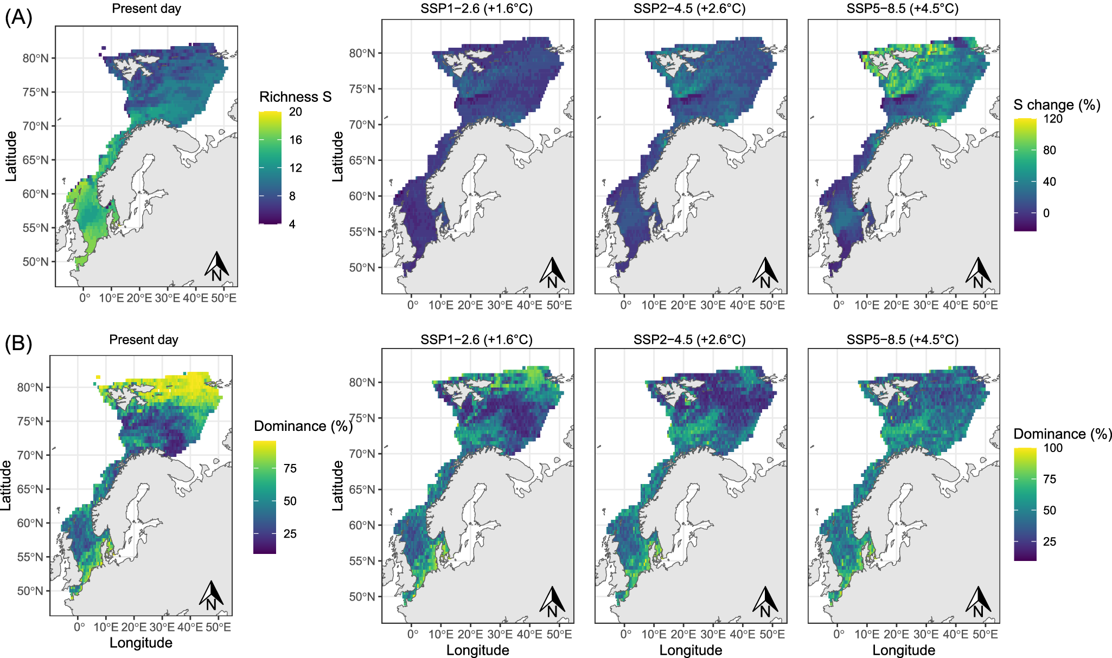
- Cold water coral — can include the dataset by Tong et al. (2023) as it is cited more than Balogh et al. (2023) which also does not have areas nor many points in the area of interest
  - Given the timeframe of the analysis, I recommend not including Fragkopolou et al. (2025) even though having a way to account for redistribution under climate change would be important
  - We will ignore OBIS as the dataset seems to have quality control issues — there is a point in Germany (land)
- Seagrass — will include the WCMC dataset but exclude the EMODnet data despite being from 2025 since the license only permits for non-commercial use
  - Allen Coral Atlas does have a seagrass layer but since the analysis aimed to map shallow tropical coral reefs, it did not get in latitudes for this research
- Eelgrass — excluded as it is too coastal for the analysis, but could get included in a future more robust analysis
- IMMA — included
- Essential fish habitat — EMODnet does have data that cover the North Sea, but they are in raster formats for Denmark so for the time being they will not get included
  - Other data in 2025 are only available for non-commercial use
Methods
- Data
  - Cetaceans
    - Download species distribution models from Costello et al. work
    - Limit to study area
    - Recalibrate data
    - Combine the species data

  - Seabirds
    - Download limit to study area
    - Combine the data layers
  - IMMA
    - Download
    - Limit to study region
    - Rescale values: 0 or 1
  - Protected Areas
    - Download data
    - Limit to study region
    - Rescale values: 0 or 1
  - Seagrass
    - Download data
    - Limit to study region
    - Rescale values: 0 or 1
  - Fishes
    - Obtain data
    - Limit to study area
    - Rescale values
- Model
  - Rescale the data layers
  - Combine

Considerations / Questions
- Which bird species are important?
- How to compare

Previous commentary
6 January 2026
So I have been trying to think about how to approach assessing fish populations / biodiversity in the North Sea.
To do this, I am leaning towards ICES data. It has both fisheries-independent and fisheries-dependent data, yet the dependent are put behind a log-in (which makes sense). So I cannot easily access the VMS and by-catch data. I was thinking VMS would help assess population size by proxy while by-catch could add to the picture around species composition.
The fisheries-independent data (DATRAS dataset) are split across multiple surveys that also have multiple records (e.g., haul data, length-based data, and aged-based data). I can fortunately access it through an R package. One of the surveys (North Sea international bottom) trawl survey has existed since 1965, but the survey has only been the same since 1997 (except for some extra quarters (it is supposed to be quarters 1 and 3 -- February and August).
I am leaning towards using 5 years of data, but using a longer time frame (maybe up to 20 years) would provide higher resolution — as there will be more points in smaller areas.
The haul data have at least probably the most fine geographic data as it has the point where the shoot begins and where the haul happens. Aged-based only has the area code for the statistical reference. Those rectangles are large (30 nautical miles by 30 nautical miles I believe). The North Sea comprises statistical areas 27.3.a.20, 27.3.a.21, 27.4, and 27.7.d.
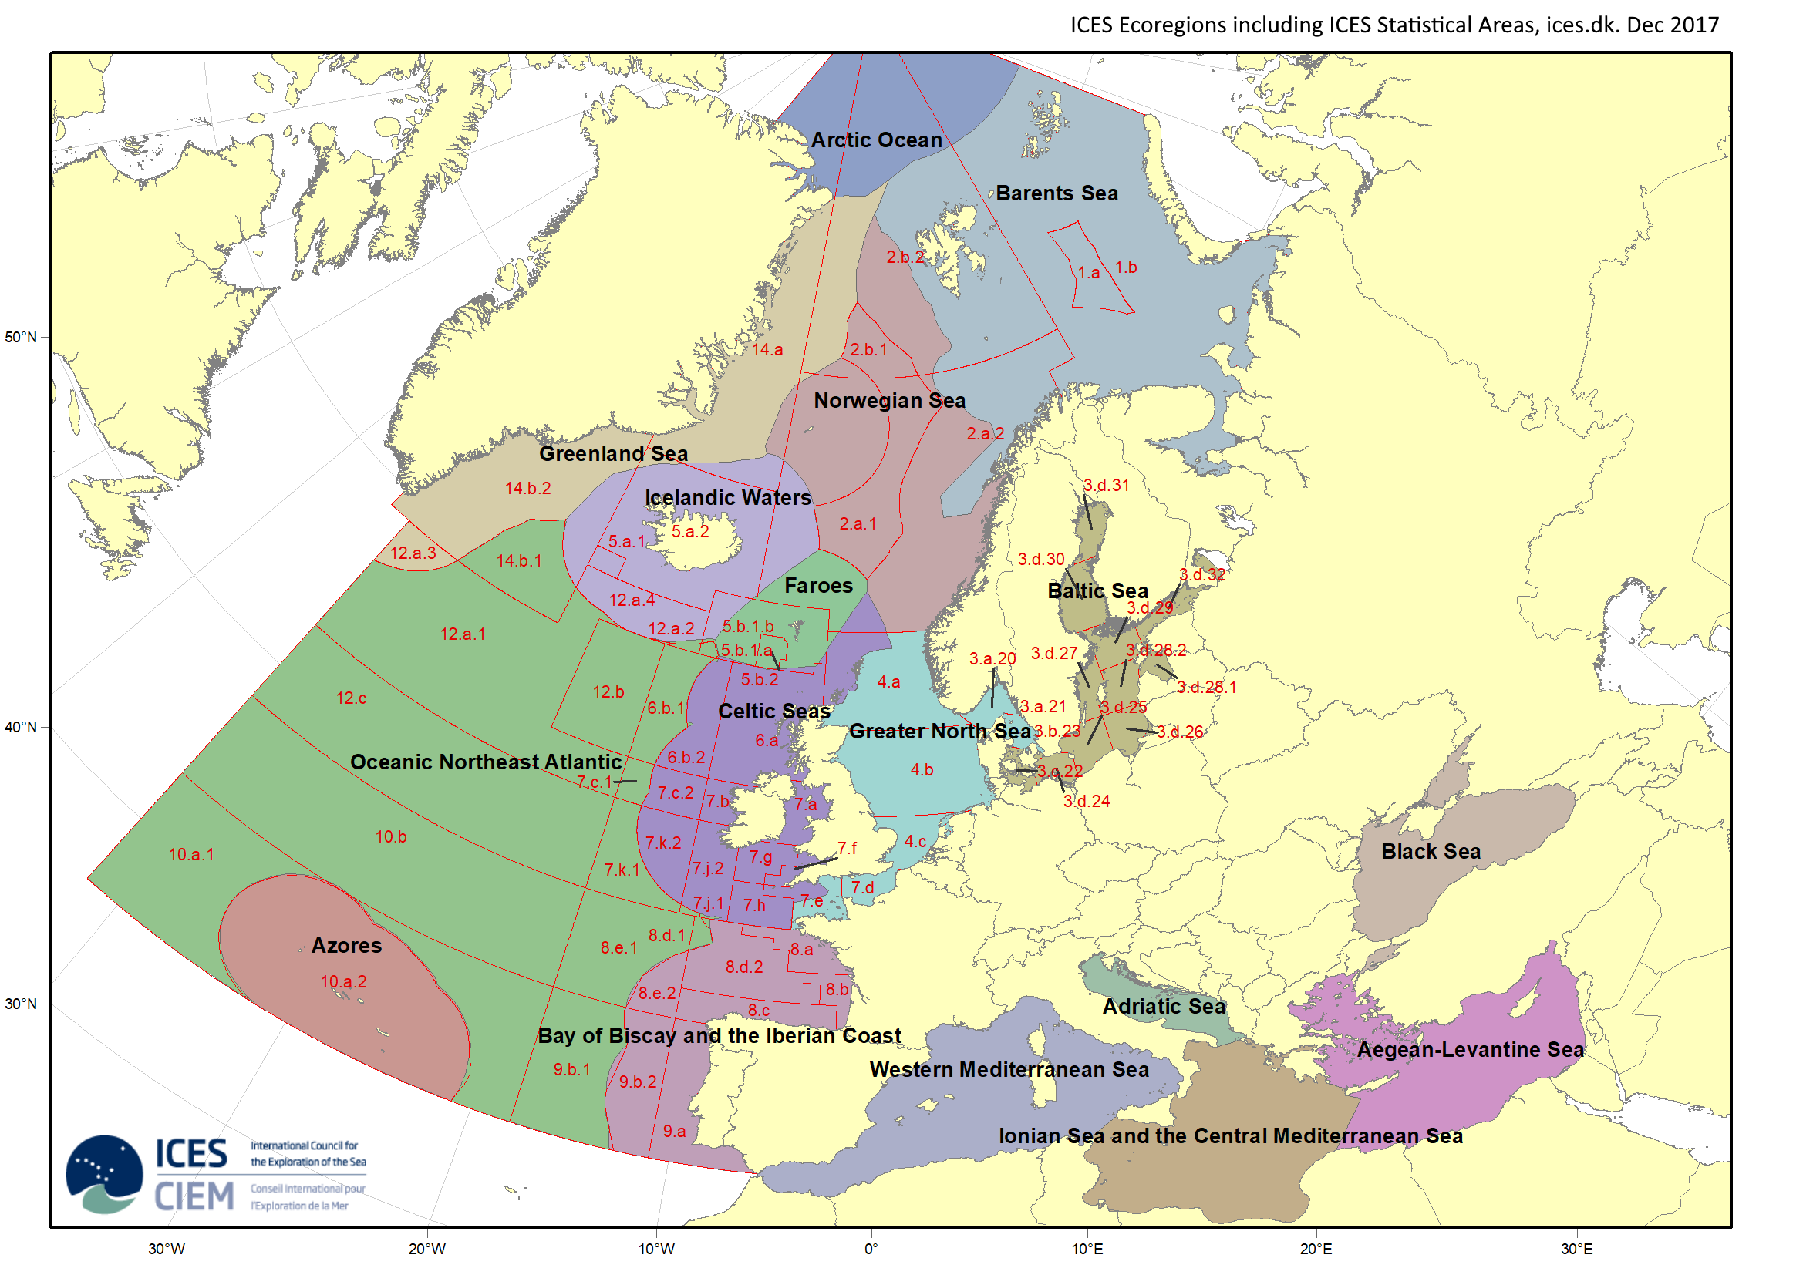
In the end to assess ecological relevance in the study region, I propose two parts of a fishing analysis:
- I can use Global Fishing Watch data to estimate fishing hours in grid cells to evaluate for the fisheries-dependent data — these would only be a subset of all the data since it requires a vessel to have AIS, but I expect not much data would actually be missed as the vessels would be further offshore so would comprise a higher percentage of the expected vessels actually represented
  - Often using only Global Fishing Watch data for an analysis would have under estimate artisanal fishing and so inaccurately assess the fisheries
- The second part is harder to achieve and would have two options: one more sophisticate and scientifically correct but more time intensive
  - The first would use the fisheries-independent data (the data from surveys by governments) and run a species distribution model template model builder (SDM-TMB) — this would basically create a species density surface across a smooth grid based on the observations per species.
    - These surfaces would then get combined to create the Simpson Index or some other index to assess biodiversity
    - A rough guess is this would take 6 months
  - Given that reality, the second option is to create a grid at a resolution that best fits the trawl survey data (this is where having perhaps a longer temporal component for the survey data can make a smaller resolution grid)
    - Trawl surveys use stratified random samples — basically they do not go to the same places every year — so there are gaps in space and time
    - We need to account for those gaps — to do that, we increase the resolution
    - With the grid cells having a few points in them, we can then calculate mean density per species per grid cell
    - Then with the grid cell surfaces we can then calculate the Simpson Index or other biodiversity metric
    - This could be done in a month if all goes well
- We don’t need to worry about age and length aggregation currently
- And we have OBIS data as a back-up — but they have issues that make them not the most desired dataset to use

I will talk to an expert on trawl surveys hopefully this week or next.

Resources
DATRAS -- the fisheries-independent database
- Units / codes
- Protocols for NS-IBTS (North Sea International Bottom Trawl Survey)
- Surveys that might also occur in the study region
  - North Sea sandeel survey
  - Inshore beam trawl survey
- Statistical calculations
- Variance estimation
- NS-IBTS protocols

