Analysis of Women Safety in Indian Cities Using Machine Learning on Tweets

In propose paper author is analysing social media tweets to detect women’s safety but the main problem is social media can be used by malicious users who will give fake ratings to worst products to boom their sale or can write fake tweets to raise finger at country safety towards Indian women and to overcome from this problem we have modified propose work with two algorithms which will check weather given tweets are fake or genuine. So by getting tweets authenticity peoples will comes to real conclusion on women safety.

In extension work we have added TFIDF (term frequency inverse frequency document) algorithm which will convert all tweets words into numeric vector which will contains average frequency of each tweet words.

This TFIDF vector will be input to Decision Tree algorithm which will predict weather given tweet is FAKE or GENUINE. Decision Tree algorithm is already trained on FAKE and REAL words so it can easily predict authenticity of each tweet.

To run project double click on ‘run.bat’ to get below output

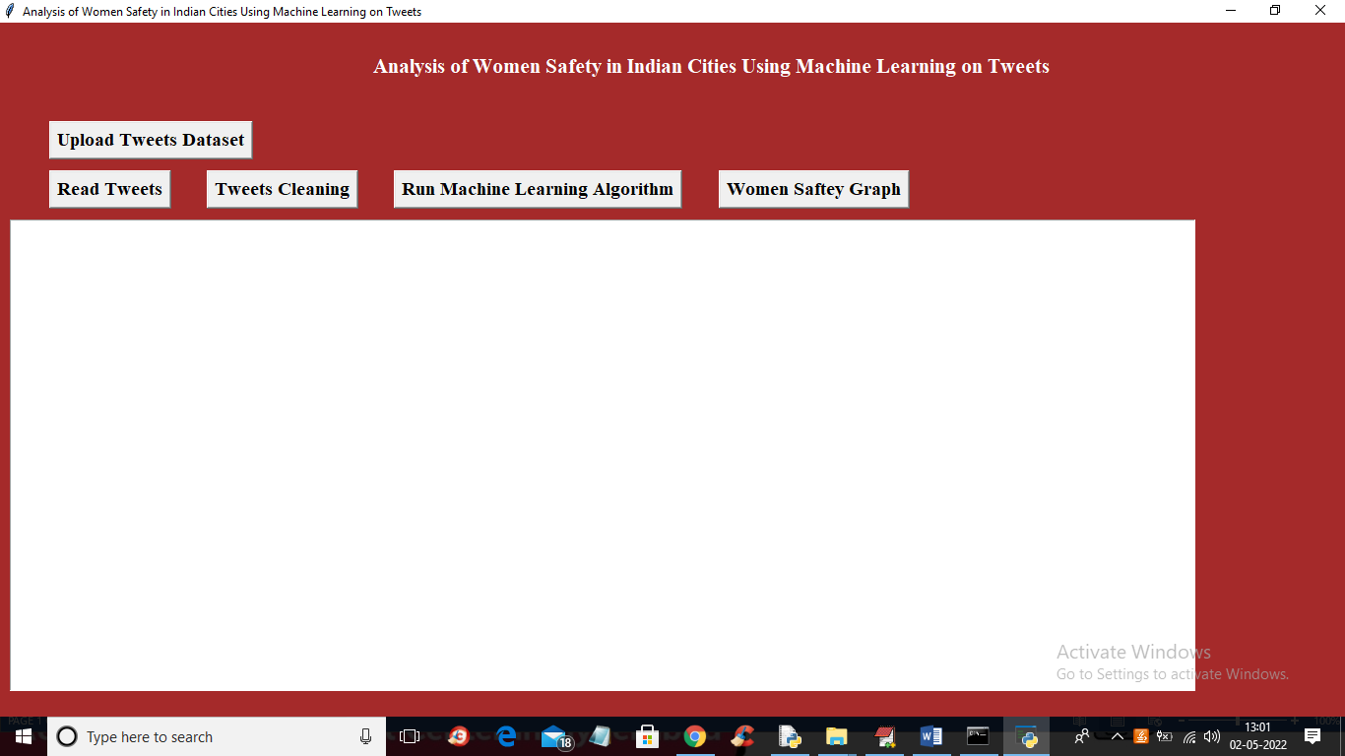

In above screen run all buttons and in last output you can see women’s sentiments and its authenticity

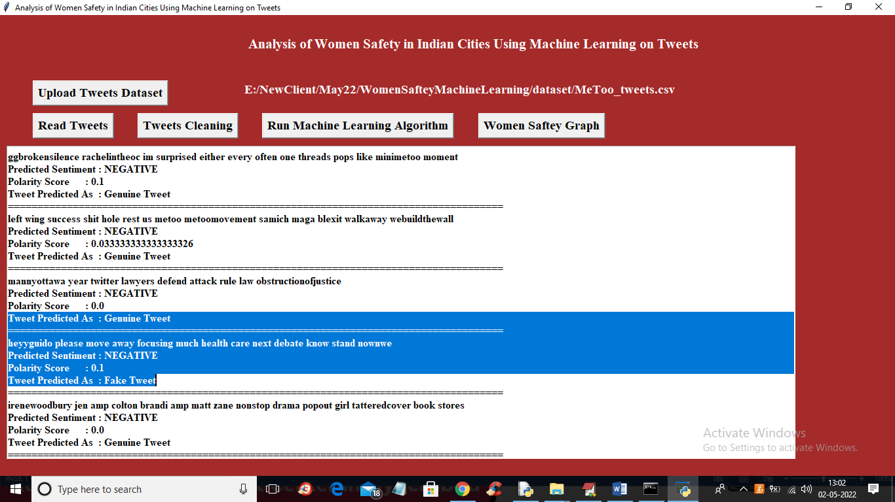

In above screen we are displaying tweets with sentiment and its authenticity as FAKE or GENUINE by using decision tree algorithm