Name: Breona Pizzuta Date: 10/28/24

“I pledge my honor that I have abided by the Stevens Honor System.”

Point values are assigned for each question. Points earned: ____ / 100

1. Consider the algorithm on page 148 in the textbook for Binary Reflected Gray Codes. What change(s) would you make so that it generates the usual binary numbers **in order** for a given length n? Your algorithm must be recursive and keep the same structure as the one in the textbook. Describe only the change(s). (10 points)

To generate the usual binary numbers in order I would copy list L1 to list L2 in order rather than in reversed order.

1. Show the steps to multiply 72 x 93 with Russian peasant multiplication, as seen in Figure 4.11b on page 154 in the textbook. (10 points)

|  |  |  |  |
| --- | --- | --- | --- |
| Step1:  N= 72 m= 93 | Step 2:  N m  72 93  36 186  18 372  9 744  4 1488  2 2976   1. 5952 | Step 3:  N m  72  36  18  9 744  4   1. 5952 | Step 4: 744+ 5952 = 6696= 9*744 |

Answer: 6696

1. Suppose you use the LomutoPartition() function on page 159 in the textbook in your implementation of Quicksort. (10 points, 5 points each)

* 1. Describe the types of input that cause Quicksort to perform its worst-case running time. Explain why these types of input cause the worst-case.

In the worst case each partition results in a very unbalanced partitioning of the array where one segment has size n - 1 and the other segment has size zero, this happens if the array is already sorted in non-decreasing order or non-increasing order.

* 1. What is that worst-case running time?

The worst case running time is Θ(n²)

1. Compute 2205 x 1132 by applying the divide-and-conquer Karatsuba algorithm outlined in the text. Repeat the process until the numbers being multiplied are each 1 digit. For each multiplication, show the values of c2, c1, and c0. Do not skip steps. (10 points)

2205 and 1132

A1= 22 and A0= 05 B1= 11 and B0= 32

C0= 5*32= 160

A=05= 0*10 +5

A1=0 A0= 5

B= 32= 3*10 +2

B1= 3, B0=2

C0= 5*2= 10

C1= 5*5 =25

C2=0*3= 0

A*B= 0*100+(25-0-10)*10+10 = 150+10= 160

C1= (22+5) * (11+32) = 27*43= 1161

A= 27 = 2*10+7

A1= 2, A0= 7

B= 43= 4*10+3

B1= 4, B0=3

C0= 7*3= 21

C1= 9*7= 63

C2= 2*4= 8

A*B= 8*100 + (63-8-21) *10 +21= 1161

C2= 22*11 = 242

A= 22= 2*10+2

A1= 2, A0= 2

B= 1*10+1

B1=1, B0=1

C0= 2*1= 2

C1= 4*2 = 8

C2= 2*1= 2

A*B= 2*100 + (8-2-2) *10 +2= 242

A*B= 242*10000 + (1161-242-160)*100+160

=242*100000 + 759*100+160

= 2420000+ 75900+160

= 2496060

1. Draw the binary search tree after inserting the following keys: 24 18 67 68 69 25 19 20 11 93   
   (10 points)

24

/ \

18 67

/ \ / \

11 19 25 68

\ \

20 69 \

93

1. Consider the following binary tree. (16 points, 2 points each)

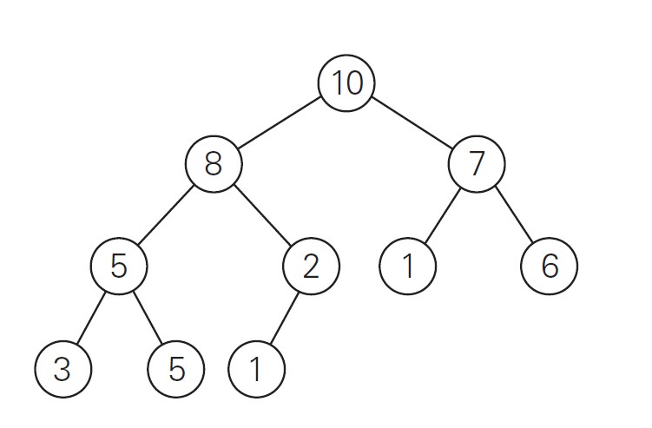

* 1. Traverse the tree preorder.

10,8,5,3,5,2,1,7,1,6

* 1. Traverse the tree inorder.

3, 5, 5, 8, 1, 2, 10, 1, 7, 6

* 1. Traverse the tree postorder.

3, 5, 5, 1, 2, 8, 1, 6, 7, 10

* 1. How many internal nodes are there?

5 internal nodes

* 1. How many leaves are there?

5 leaves

* 1. What is the maximum width of the tree?

4 is the maximum width of the tree

* 1. What is the height of the tree?

3 is the height of the tree

* 1. What is the diameter of the tree?

5 is the diameter of the tree

1. Use the Master Theorem to give tight asymptotic bounds for the following recurrences. (25 points, 5 points each)
   1. 𝑇(𝑛) = 2𝑇(𝑛/4) + 1

A= 2, B=4, d= 0

* 1. 𝑇(𝑛) = 2𝑇(𝑛/4) +

A= 2, B=4, d= 1/2

* 1. 𝑇(𝑛) = 2𝑇(𝑛/4) + 𝑛

A= 2, B=4, d= 1

* 1. 𝑇(𝑛) = 2𝑇(𝑛/4) + 𝑛2

A= 2, B=4, d= 2

* 1. 𝑇(𝑛) = 2𝑇(𝑛/4) + 𝑛3

A= 2, B=4, d= 3

$a<b^{d} so θ(n^{3})$

1. Consider the following function. (9 points)

int function(int n) {

if(n <= 1) {

return 0;

}

int temp = 0;

for(int i = 1; i <= 6; i++) {

temp += function(n / 3);

}

for(int i = 1; i <= n; i++) {

for(int j = 1; j * j <= n; j++) {

temp++;

}

}

return temp;

}

1. Write an expression for the runtime 𝑇(𝑛) for the function (with the correct asymptotic symbol for the *f(n)* part of the relation). (4 points)

T(n)= 6T(n/3) + $θ$ (n $\sqrt{n})$

1. Use the Master Theorem to give a tight asymptotic bound. Simplify your answer as much as possible. (5 points)

A= 6, B=3, d= 3/2

$a>b^{d} so θ(n^{\log_{3}6})$