Detailed System Design

Inventory Management System

Authors: Bradley Griffee, Brian Sizemore, Mark Morrison

Table of Contents

Sequence Diagrams 3

Login 3

Logout 3

Add Item 4

Remove Item 4

Edit Item 5

Search Item 5

Software Specification to the Function Level 6

Login 6

Logout 7

Add Item 8

Remove Item 9

Edit Item 10

Search Item 11

User Interface 12

Specification 12

Mockups 13

Login Screen 13

Home Screen 14

Settings Screen 15

Item Screen 16

Database Class Diagram 17

Failures 18

Fail-Soft 18

Login Failed 18

Invalid Input Provided 18

Maximum Inventory Size Reached 18

Fail-Safe 18

Power Outage 18

Hard Drive Failure 18

Environment 19

# Sequence Diagrams

## Login



## Logout



## Add Item



## Remove Item



## Edit Item



## Search Item



# Software Specification to the Function Level

## Login

**Name of Function:** Login

**Description:** Validates that the username is valid and the password provided is correct for that username.

**Inputs:** Username and password

**Source of Input:** User

**Outputs:** Confirmation

**Destination of Output:** Screen

**Processing:** When the user initiates the function, the system will validate with the active profiles in the management system to approve the request.

**Requirements:** Account exists

**Precondition:** Username and password is valid and user is not already logged in.

**Postcondition:** User is logged in.

**Side effects:** Invalid login counter incremented upon failure.

**Responses to Abnormal Behavior:** Error messages displayed: “Invalid username/password combination”

**Necessity:** Required

## Logout

**Name of Function:** Logout

**Description:** Logs the user out of the system.

**Inputs:** Pressing logout button

**Source of Input:** User

**Outputs:** Confirmation

**Destination of Output:** Screen

**Processing:** When the user initiates the function, the system will close out the user’s session on the management system

**Requirements:** None

**Precondition:** User is logged in

**Postcondition:** User is logged out

**Side effects:** None

**Responses to Abnormal Behavior:** Error messages displayed: “No user is currently logged in.”

**Necessity:** Required

## Add Item

**Name of Function:** AddItem

**Description:** Adds an item to the database

**Inputs:** Item details

**Source of Input:** User

**Outputs:** Confirmation of success

**Destination of Output:** User

**Processing:** When the user initiates the function, the system will create a new object in the database for the item with the appropriate fields.

**Requirements:** None

**Precondition:** Valid fields and tags for the item

**Postcondition:** Item is added to the database

**Side effects:** None

**Responses to Abnormal Behavior:** Error messages displayed describing specific reason, e.g. “Invalid fields provided”, “Item already exists”.

**Necessity:** Required

## Remove Item

**Name of Function:** RemoveItem

**Description:** Allows user to remove an item from the database

**Inputs:** Item name

**Source of Input:** User

**Outputs:** Confirmation of success

**Destination of Output:** User

**Processing:** System queries the database for the specific item and removes it from the database

**Requirements:** Database is running

**Precondition:** Item exists

**Postcondition:** Item is removed

**Side effects:** None

**Responses to Abnormal Behavior:** Error messages displayed: “Item does not exist”

**Necessity:** Required

## Edit Item

**Name of Function:** EditItem

**Description:** Changes the field values of an item in the database

**Inputs:** Item to be modified, fields to be modified

**Source of Input:** User

**Outputs:** Confirmationof success

**Destination of Output:** User

**Processing:** The system checks the database for the existence of the item and then makes modifications to its fields as necessary.

**Requirements:** Database is running

**Precondition:** Item exists and has the appropriate fields

**Postcondition:** Item fields are modified

**Side effects:** None

**Responses to Abnormal Behavior:** Error messages displayed: “Item does not exist”

**Necessity:** Required

## Search Item

**Name of Function:** SearchItem

**Description:** Searches the database for a specific item and returns all of the information stored about it.

**Inputs:** Item name

**Source of Input:** User

**Outputs:** Item details

**Destination of Output:** Screen

**Processing:** The system searches the database for an item and then requests all information that the database has pertaining to the item

**Requirements:** Database is running

**Precondition:** Item exists

**Postcondition:** Item fields are shown to the user

**Side effects:** None

**Responses to Abnormal Behavior:** Error messages displayed: “Item does not exist”

**Necessity:** Required

# User Interface

## Specification



## Mockups

### Login Screen

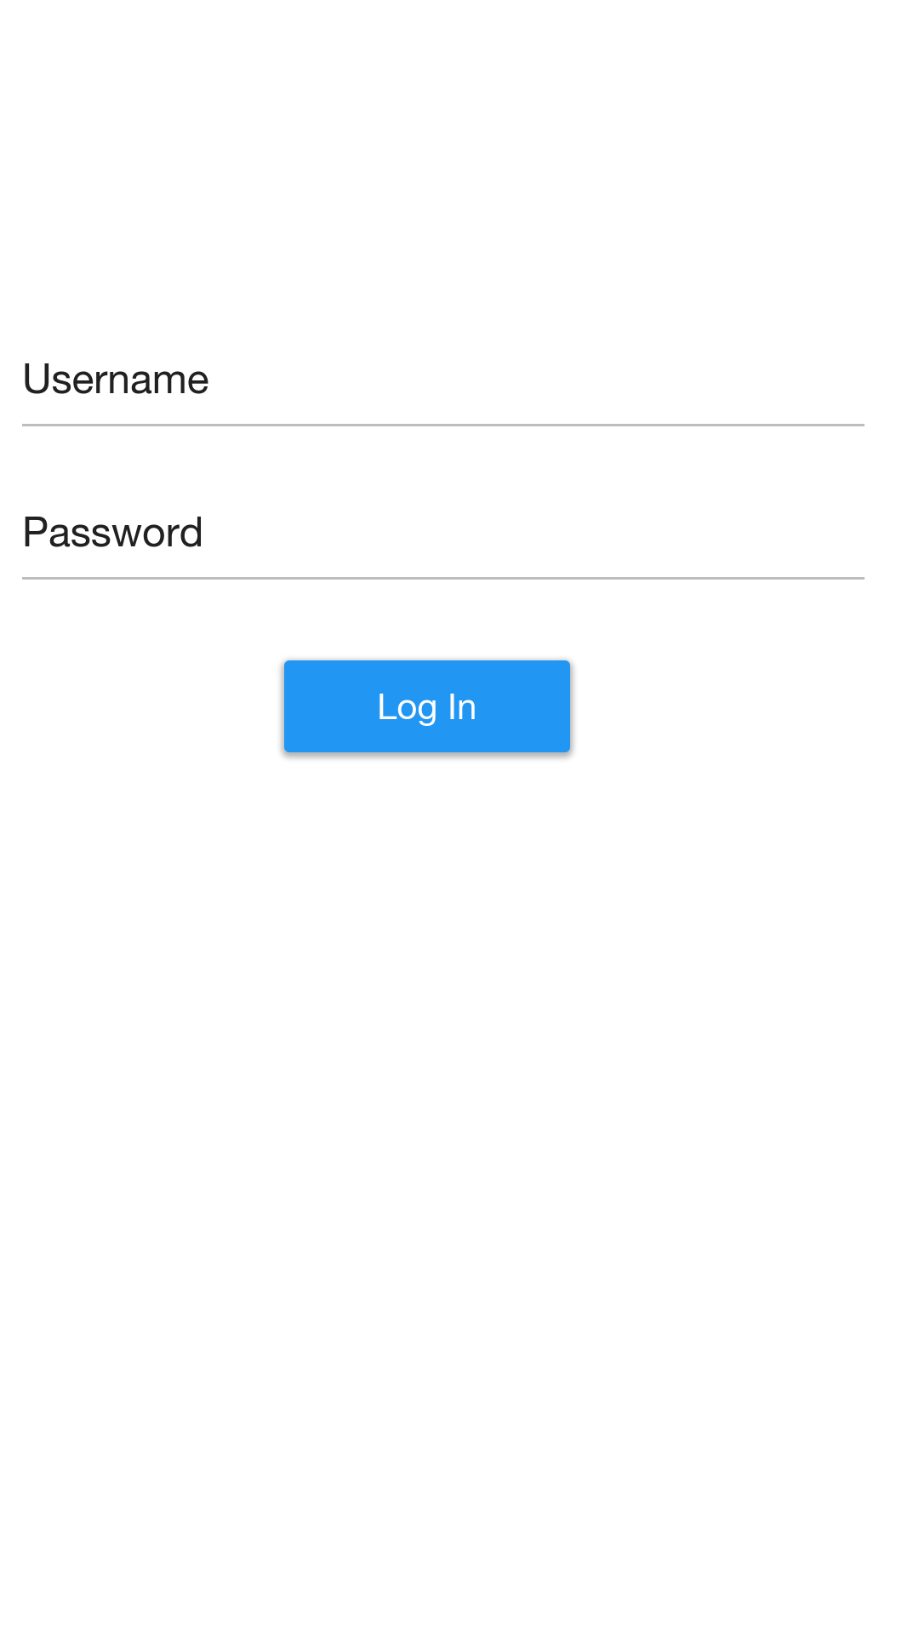

### Home Screen

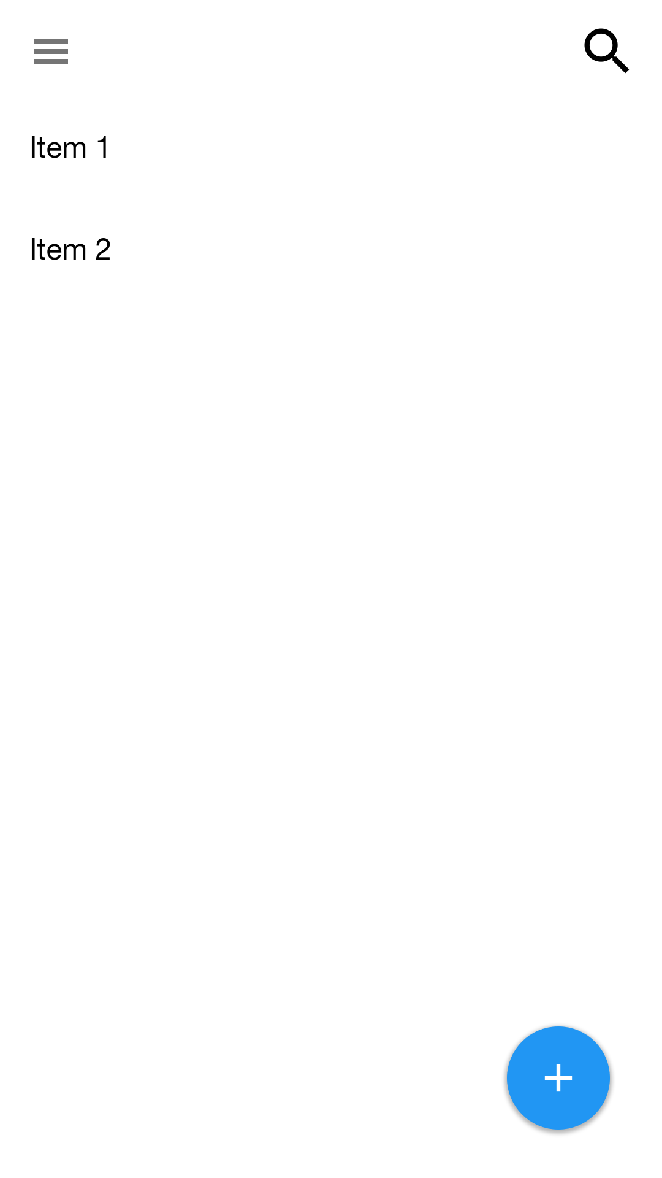

### Settings Screen

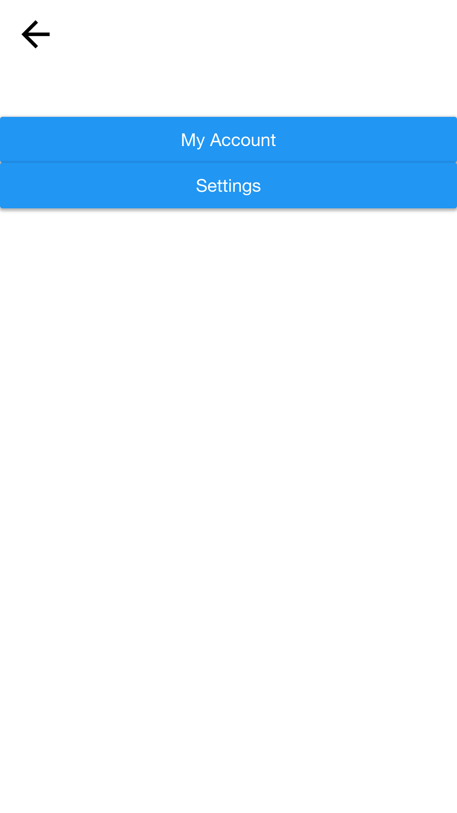

### Item Screen

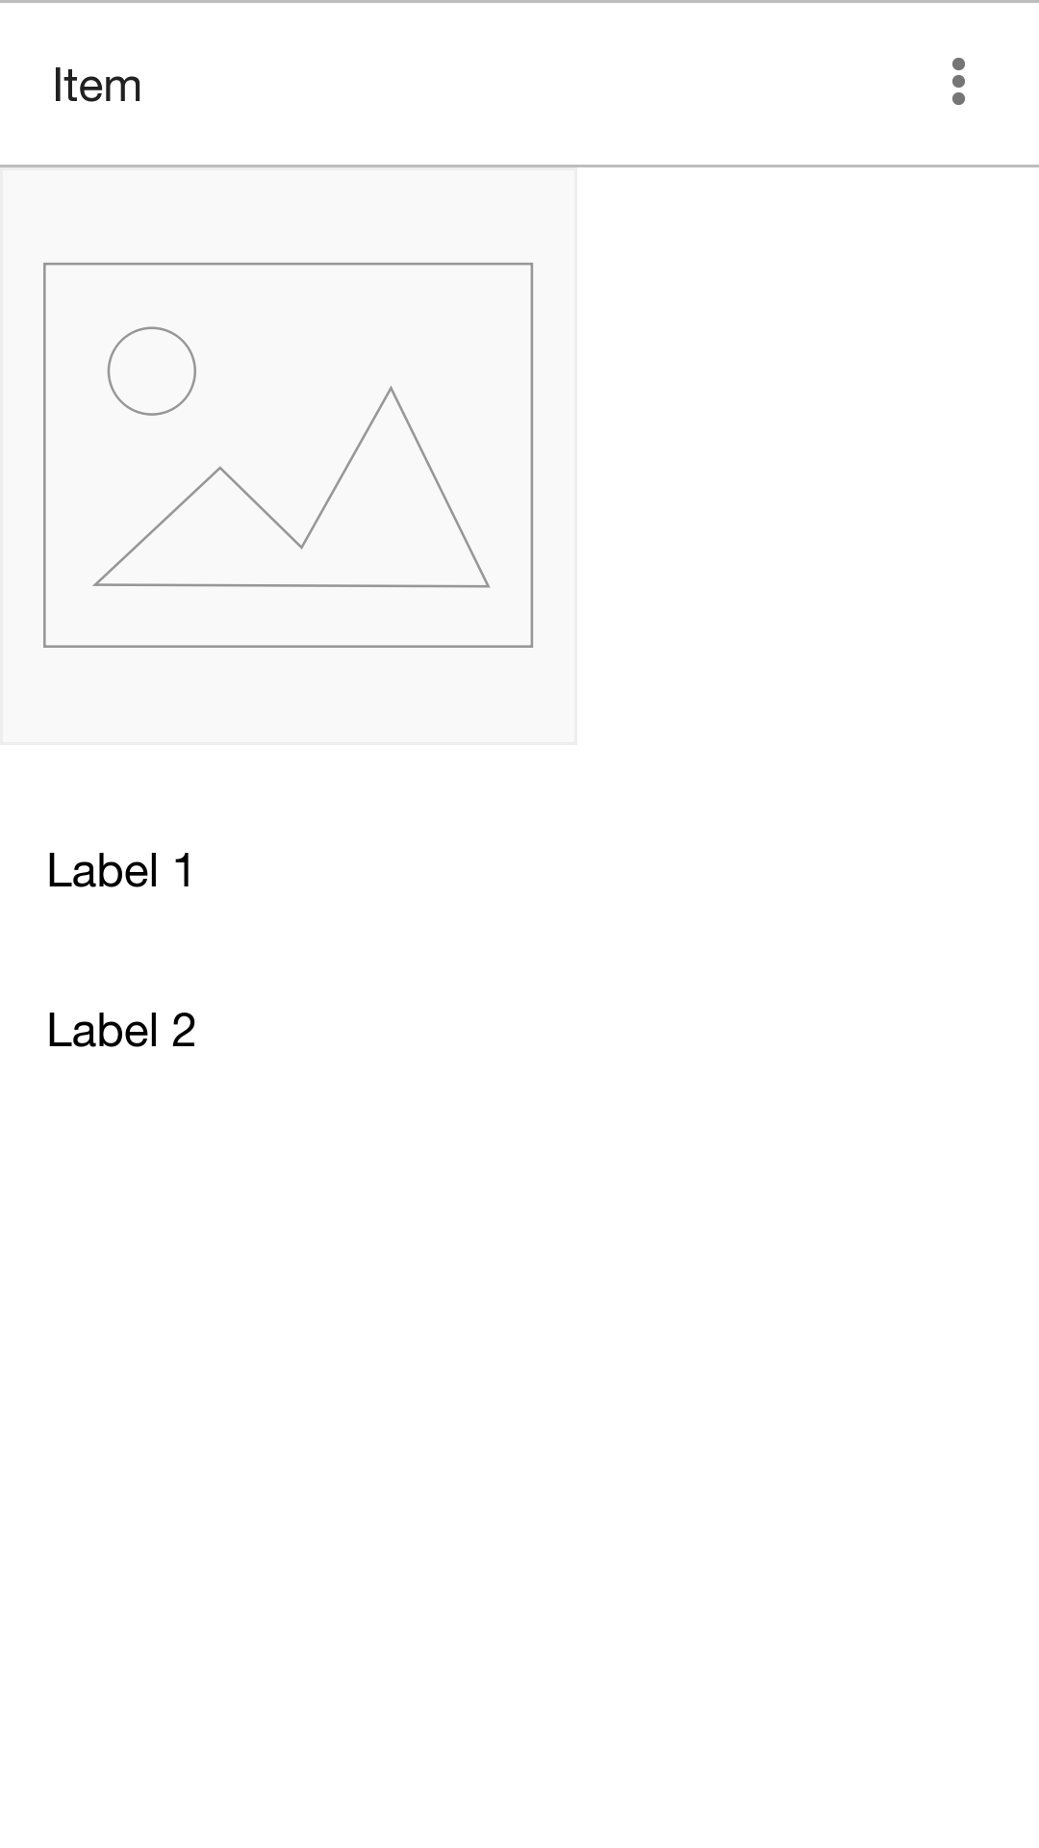

# Database Class Diagram



# Failures

## Fail-Soft

### Login Failed

Provided that the maximum login attempts have not be exceeded allow for the user to try again. If attempts have been exceeded an administrator must reset the password.

### Invalid Input Provided

Return the invalid field provided and allow the user to correct the information and try again.

### Maximum Inventory Size Reached

Inform the user and provide the option to remove items or upgrade the system.

## Fail-Safe

### Power Outage

Server connected to UPS to allow for graceful shutdown after power loss.

### Hard Drive Failure

Server set up with redundant hard drives in a RAID array as well as external backups taken nightly.

# Environment

