Inventory Management System

Email: bpgriffee@mix.wvu.edu

Github: github.com/bpgriffee/WVUIMS

Inventory Management System

Logistics simplified

Bradley Griffee

Brian Sizemore

Mark Morrison

Who We Are

Our small team consists of three senior engineering students at West Virginia University. Each of us come from a very different background, so we understand that people have varying responsibilities in life. But one thing we all have in common is that no one wants to do more work than they have to do. Our product aims to relieve some of the busy work from managing a small business

What We Are Doing

Our group is developing an inventory management system targeted to non-traditional inventories. All over the world small businesses are struggling with efficiently keeping up with all the logistics it takes to manage inventory. Many of these companies already have a solution through the Universal Product Code (UPC) system, which are the barcodes you see on nearly everything you buy. However, many other businesses don’t have this luxury and are required to do everything manually. We are going to fix this.

Background

Develop an inventory management system for non-traditional inventories with three core development principles:

1. User-Friendly
2. Use existing infrastructure
3. Scale with the business

By taking in to account the variety of customers who will benefit from our system we can create a more robust product for everyone.

Background

***Current systems rely on UPC codes.***With all modern systems using the existing barcode systems, the market for a more generalized system is prime.

***Current systems have too many unnecessary features.***By bombarding the end-user with confusing to use, ultimately fruitless, features and tools, the system becomes overly complicated and hard to manage

***Current systems try to do it all.***  
Even the most basic systems out there are trying todo everything at once: manage inventory, generate statistics, be a point of sale device, and be the database.

Objectives

***Stop relying on old technology****.*We want the system to assign the unique identifiers so that the user can more organically sort their inventory.

***Simplify the process.***Checking an item into inventory should take a few seconds, that’s it.

***Simplify the system.***Reinventing the wheel is a waste of time, by using tried and true technology we become more reliable and more scalable instantaneously.

***The user is paramount.***Ultimately a system is only as good as its user. There is nothing more important than keeping the user informed, happy, and making money.

Technologies

We want to use tried and true technologies to make the experience as seamless and reliable as possible. Just a few of what we will be using is:

* MySQL - Database
* Java - API and Core
* Android - Mobile Application
* Google Material Design – Principles

  
  


Process

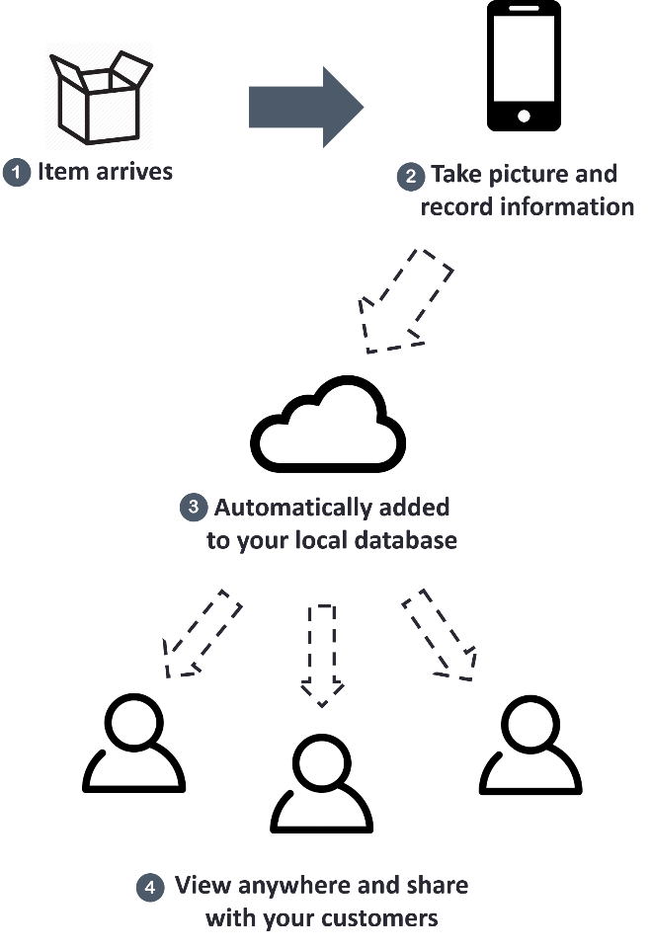

Conclusions

The US Navy developed the acronym KISS in the 1960s to stand for “Keep it simple, stupid.” With that as one of our core development principles we hope to simplify the logistics of managing businesses so that people can get back to what matters.