Mobile options for grid square are available. Phone apps for iPhone and Android exist.
Stand alone displays such as Griduino are as well. Of course, the https://griduino.com/ is really pretty, and comes with that type $$ but seems constantly out of stock.

So….
Working with Brian, NX9O, we created a really simple and affordable grid square display unit with esy to obtain Arduino modules. Brian was planning a long EME rove. He wrote about it here http://www.rfacres.com/EME/

the github repository is locacted at https://github.com/bpguy/gps_grid_sq_lcd
the git repository has the sketch, this document and the libraries I used in case they are not easy to find.

The github should be openly accessible.

This project hardware requires an Arduino of most any flavor, a GPS module, and an I2C LCD character display.
(that is really everything… besides of course the Arduino IDE on a computer.)

Wiring is relatively simple. The GPS module requires VCC, GND, and serial data. Since no data is sent to the GPS module, only the GPS serial TX line is required. Arduino jumpers are included with most kits.

The LCD module requires VCC, GND, and SDA and SCL I2C lines.

Use this handy diagram to attach the LCD.

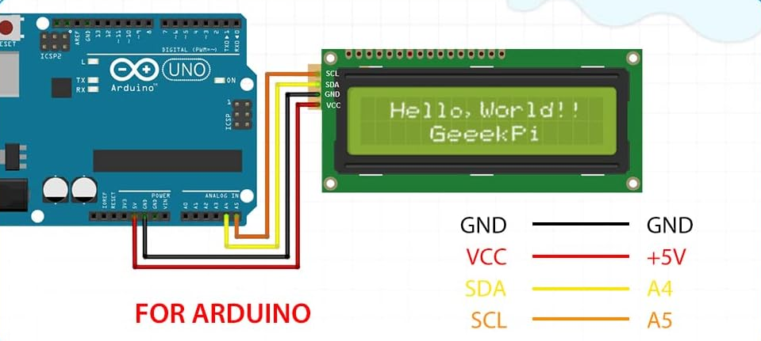

If you do not have much Arduino experience, there are several quick learning modules on the web. Adafruit has good tutorials https://learn.adafruit.com/category/learn-arduino and I also like circuit geeks. The below link will help teach how to use I2C LCD displays.
https://www.circuitgeeks.com/arduino-i2c-lcd-tutorial/

One important note is that the I2C address for the LCD display may not be the same as others. (Brian’s was a different address from the one I used to develop the sketch...) so the address will need to be discovered and may need updated.

An I2C “scanner” sketch like the one provided in the adafruit library will be used to find the address.
https://learn.adafruit.com/scanning-i2c-addresses/arduino
open the grid square sketch and put your LCD address into the code
#define LCD_ADDRESS <address>
LiquidCrystal_I2C lcd(LCD_ADDRESS, 16, 2); // LCD is 16 char x 2 lines

wire the GPS module similarly. The green wire is not needed and can be omitted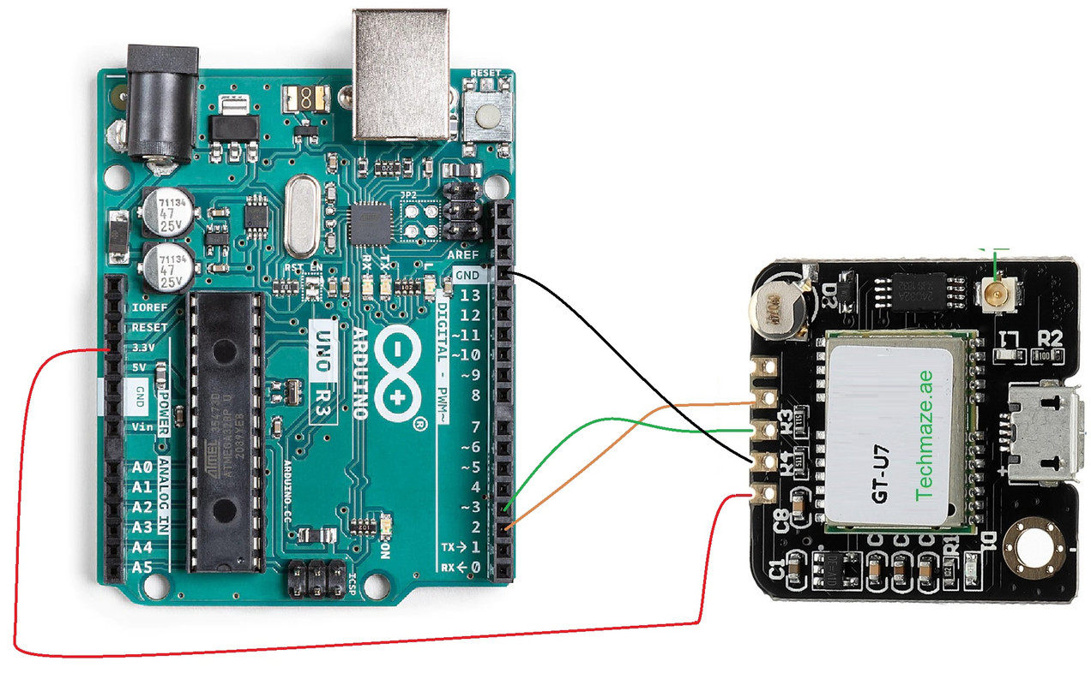

run the arduino sketch and the place the setup in a place tpo get GPS fixes. It can take several minutes for first fix…

In use, on power on, the GPS module will try to get a fix. Once this occurs, the Arduino will begin decoding and displaying the GSP info to the LCD display. The GPS info is also set via the serial port on the Arduino (via USB if the Arduino has USB…) and can be displayed. This is not required.

Here is an example of the LCD display.

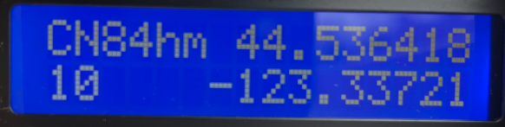

Bread boarding and mounting is flexible, including perhaps a cardboard case with tape.
Power can be as simple as providing 12v to the arduino if it includes an onboard 5v regulator. The GPS and LCD power requirements did not tax the Arduno Uno clone I used.

Heres an example of the LCD module
https://www.amazon.com/GeeekPi-Character-Backlight-Raspberry-Electrical/dp/B07S7PJYM6

and GPS module
https://www.amazon.com/gp/product/B01D1D0F5M/ref=ppx_yo_dt_b_asin_title_o01_s00?ie=UTF8&psc=1

here is a brief description of setting up the Arduino IDE

You can see the sketch folder location in the IDE menu
file -> preferences settings.
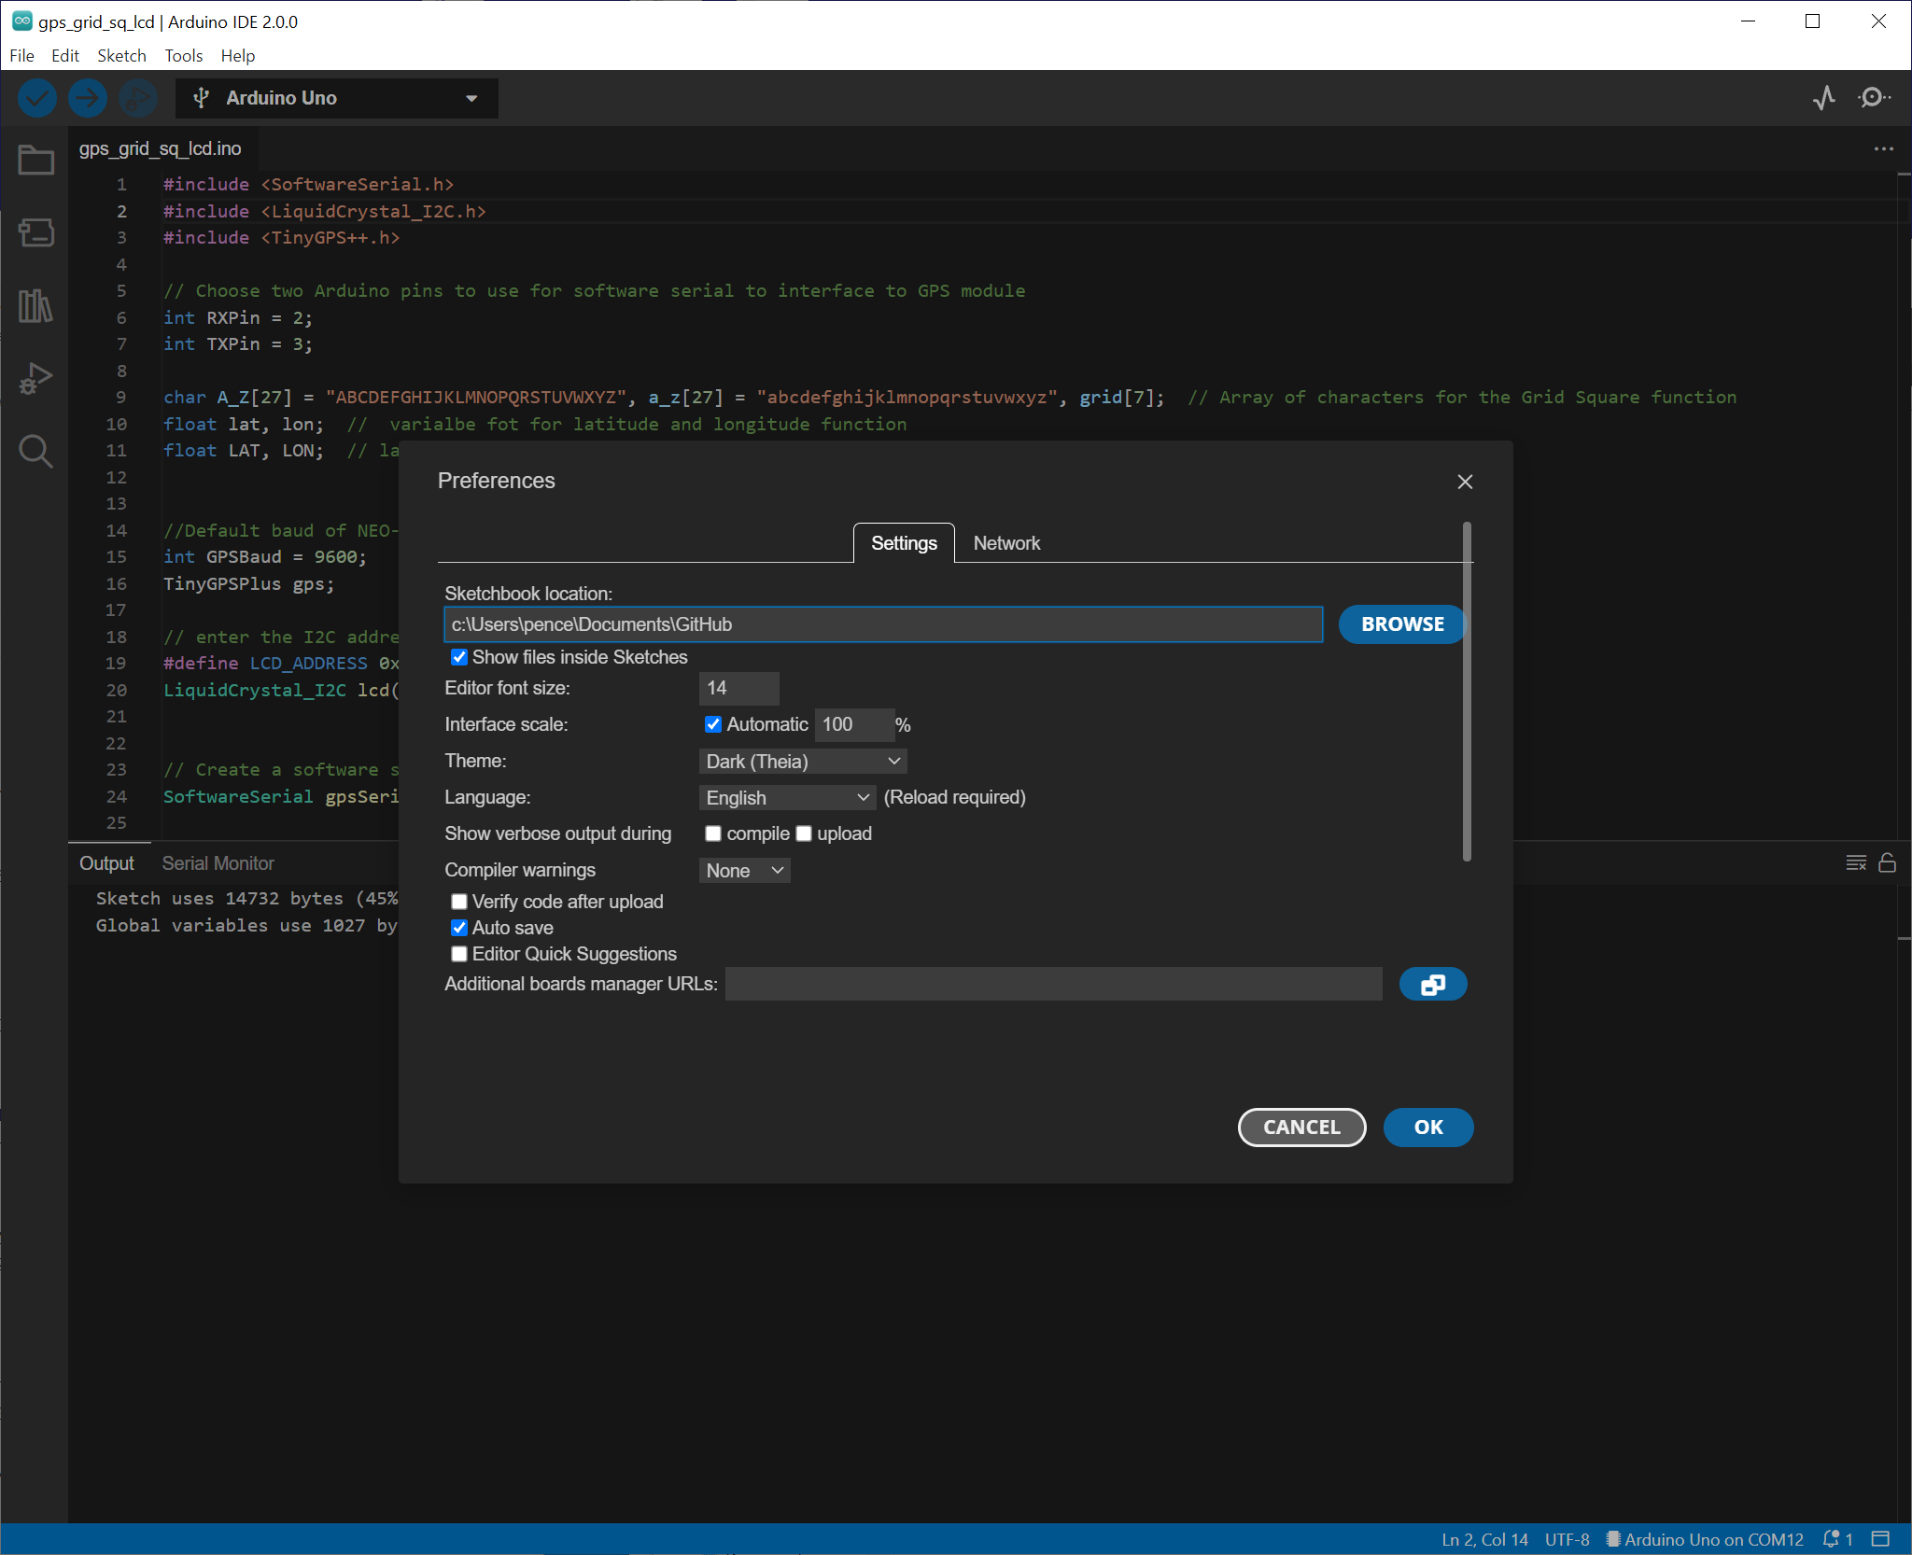

Make a folder in your Adruino sketchbook named gps_grid_sq_lcd and put the github files into this folder.

then open the sketch and select Arduino Uno from the board drop down.
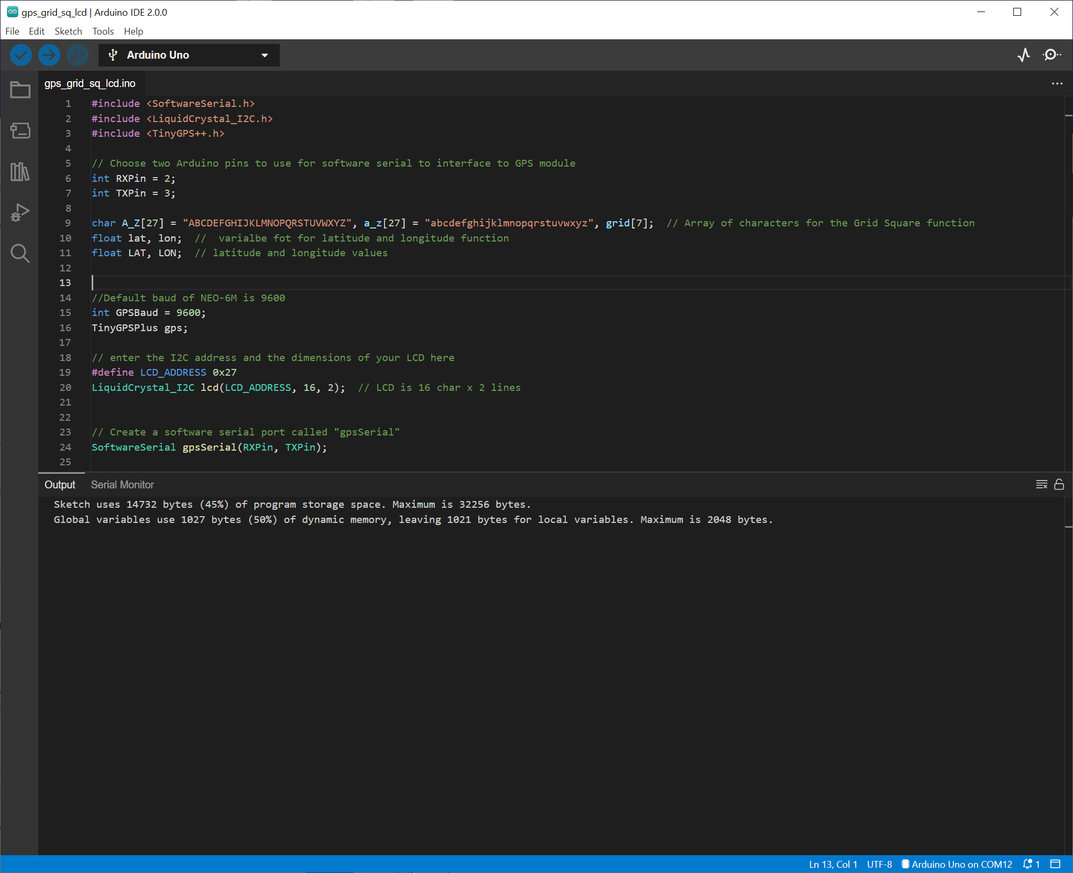

click the checkmark in the top left below file to try to compile. it should fail complaining about missing libraries.

in menu:
tools -> manage libraries
(or click the "books" on the left part of the window)
search for TinyGPSPlus and install this one
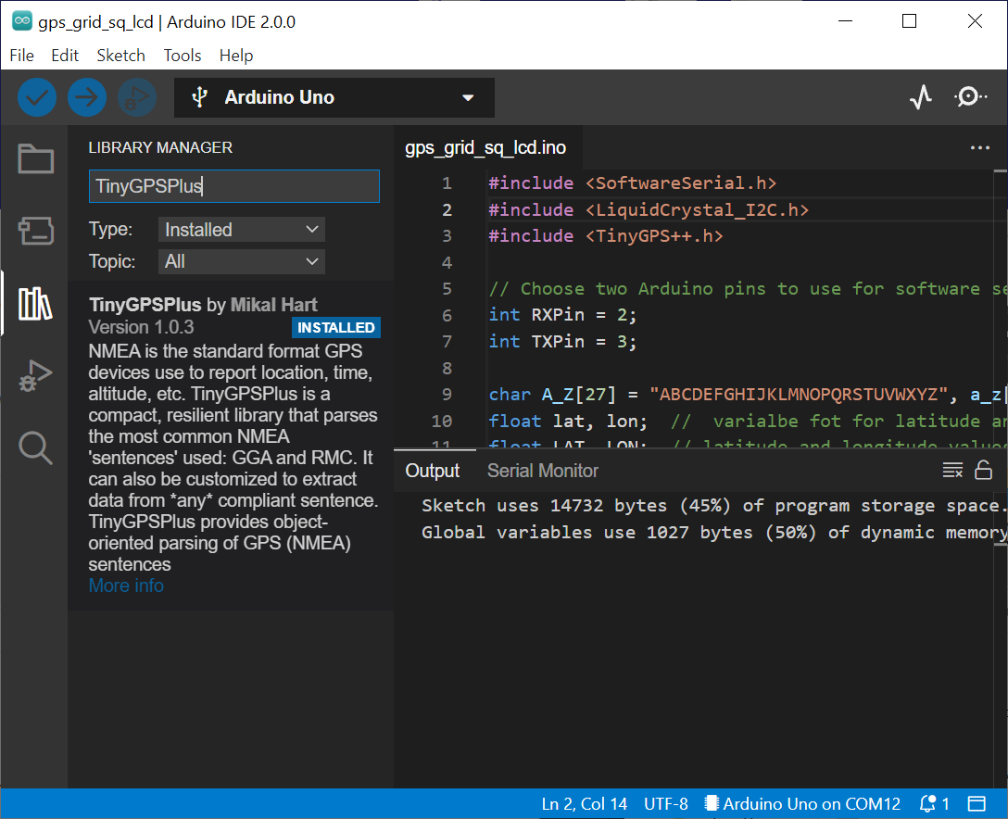

then search LiquidCrystal I2C and find and install this one.
