Background

Currently, test questions for checkboxes are broken. Contributors can pass any test questions by checking all of the checkboxes available. Using strict = ‘true’ (the default setting) contributors should only pass if their answer is a subset of the test question answer. However, this is not how the gold matching for checkboxes currently behaves. Instead, contributors will pass if any one of their answers aligns with any one of the test questions answers. By selecting all of the checkboxes, contributors are assured that at least one of their answers aligns with the correct one, and they will pass every time.

Using exact= ‘true’, compensates for this error but can make the test questions too harsh for most requesters needs. Exact requires the contributor’s answers to align exactly with the test question answer, making the job significantly harder to pass.

Solution

The code snippets attached provides a mechanism to catch contributors spamming checkboxes and remove them from the job. Essentially it works by a combination of CML, JavaScript, and answer distributions. The JavaScript detects if all of the checkboxes are selected, and checks a ‘hidden’ dummy checkbox in the cml. By setting answer distributions on that dummy checkbox, contributors can be removed from the job.

How to use it:

1. Add a class to each checkbox option
   * Make sure to include {{unit_id}} in the class name, this ensures the JavaScript will evaluate each unit on the page separately.
2. Create a new checkbox with a class different than the checkbox options and the *unit_*id. This will be the dummy checkbox used for setting answer distributions
   * It should look like the example blow:

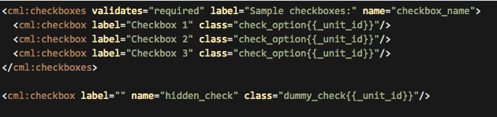

1. Hide the dummy checkbox by calling the class in CSS and setting the ‘display’ to ‘none’

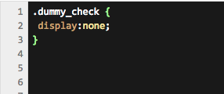

1. Copy and paste the JavaScript from the attached file into the JS style sheet.
2. In the JS, update (if needed) the class you set for the checkboxes and dummy checkboxes in the CML

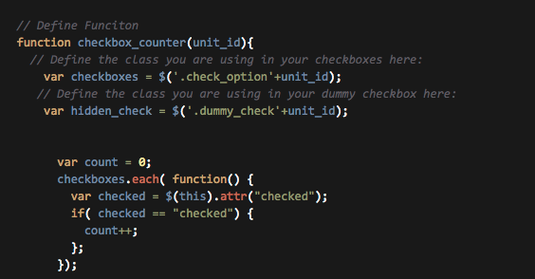

1. Save on the “Build Job” page and navigate to the “Contributors” tab
2. Under the “Answer Distributions” tab, add a rule to the dummy checkbox. Use “checked” as the answer and set the ‘min:’ to a very low number. See example:

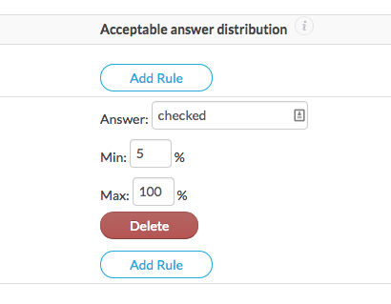

1. Make sure ‘Enable Monitoring’ is checked, and you are good to go. The answer distributions will automatically kick out any contributor that is cheating the test questions.