**PROJECT REPORT**

**DATA SCIENCE AND DATA VISUALIZATION**

**2016 U.S. Presidential Election**

**Group’s members:**

1. Lê Bảo Phúc - ITDSIU18033
2. Lê Trần Minh Hoàng - ITDSIU18043
3. Phan Quốc Khôi - ITDSIU18028

**Contents:**

1. **Introduction**
   * + 1. Overview
       2. Objectives
2. **Work progress**
3. **Source of data**
   * + 1. Raw data
       2. Dataset
4. **Demo**
   * + 1. Requirement Analysis
       2. Run demo
       3. Code
5. **Conclusion**
6. **Introduction**
7. **Overview:**

**Electoral College**

In other U.S. elections, candidates are elected directly by popular vote. But the president and vice president are not elected directly by citizens. Instead, they’re chosen by “electors” through [a process called the Electoral College](https://www.archives.gov/electoral-college/about).The process of using electors [comes from the Constitution](https://www.archives.gov/electoral-college/faq#whyec). It was a compromise between a popular vote by citizens and a vote in Congress.

**Presidential Primaries and Caucuses**

Before the general election, most candidates for president go through a series of [state primaries and caucuses](https://www.voanews.com/usa/how-us-presidential-caucus-primary-process-works). Though primaries and caucuses are run differently, they both serve the same purpose. They let the states choose the major political parties’ nominees for the general election.

## U.S. Constitutional Requirements for Presidential Candidates

The president must:

* Be a natural-born citizen of the United States
* Be at least 35 years old
* Have been a resident of the United States for 14 years

Anyone who meets these requirements can declare their candidacy for president. Once a candidate raises or spends more than $5,000 for their campaign, they must [register with the Federal Election Commission](https://www.fec.gov/help-candidates-and-committees/registering-candidate/). That includes naming a principal campaign committee to raise and spend campaign funds.

1. **Objectives:**
2. **Work progress**

Geomap: Lê Bảo Phúc

Bar chart, pie chart, interaction: Lê Trần Minh Hoàng

Content, dataset, storytelling : Phan Quốc Khôi

1. **Data**
   * + 1. **Raw data**

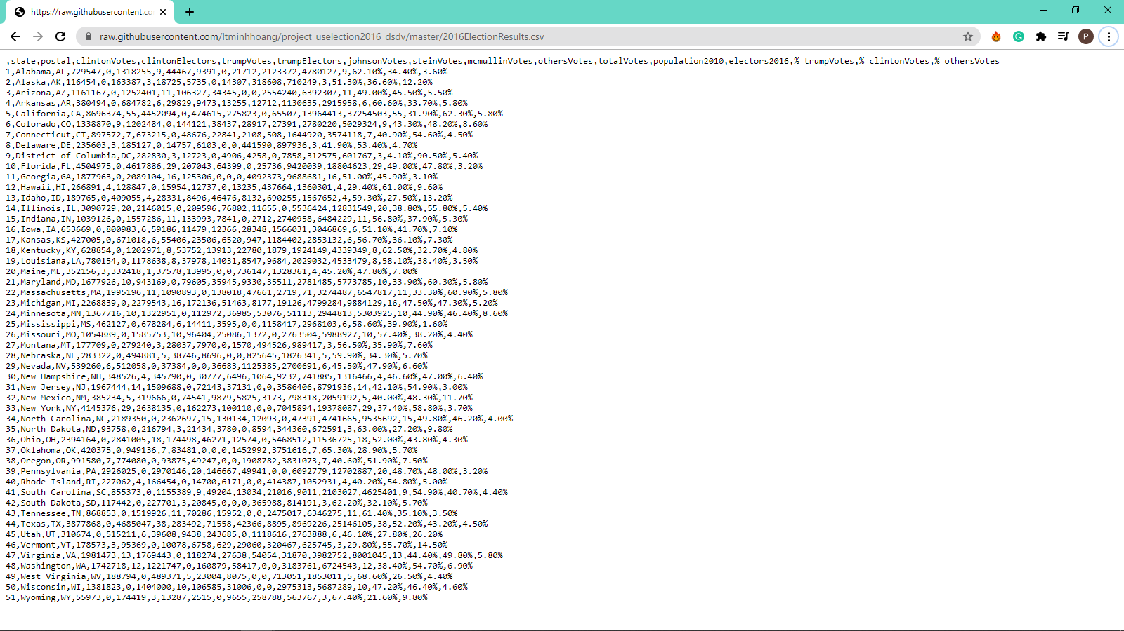

* + - 1. **Dataset**

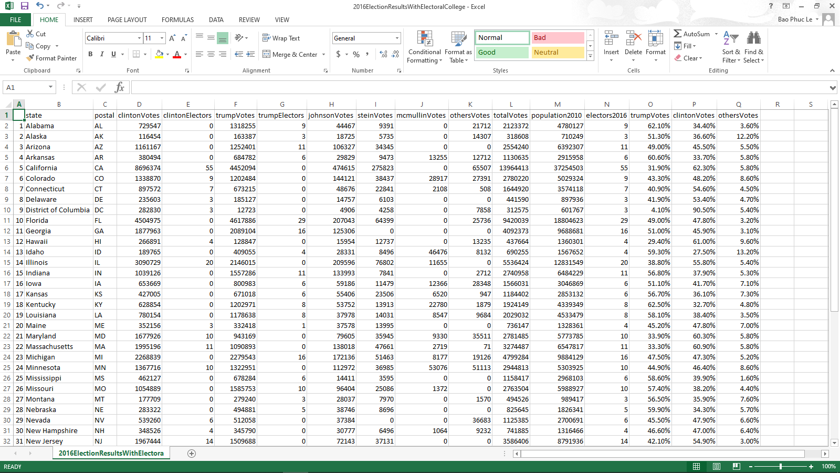

1. **Demo**
   * + 1. **Run demo**

Here is overview of our project

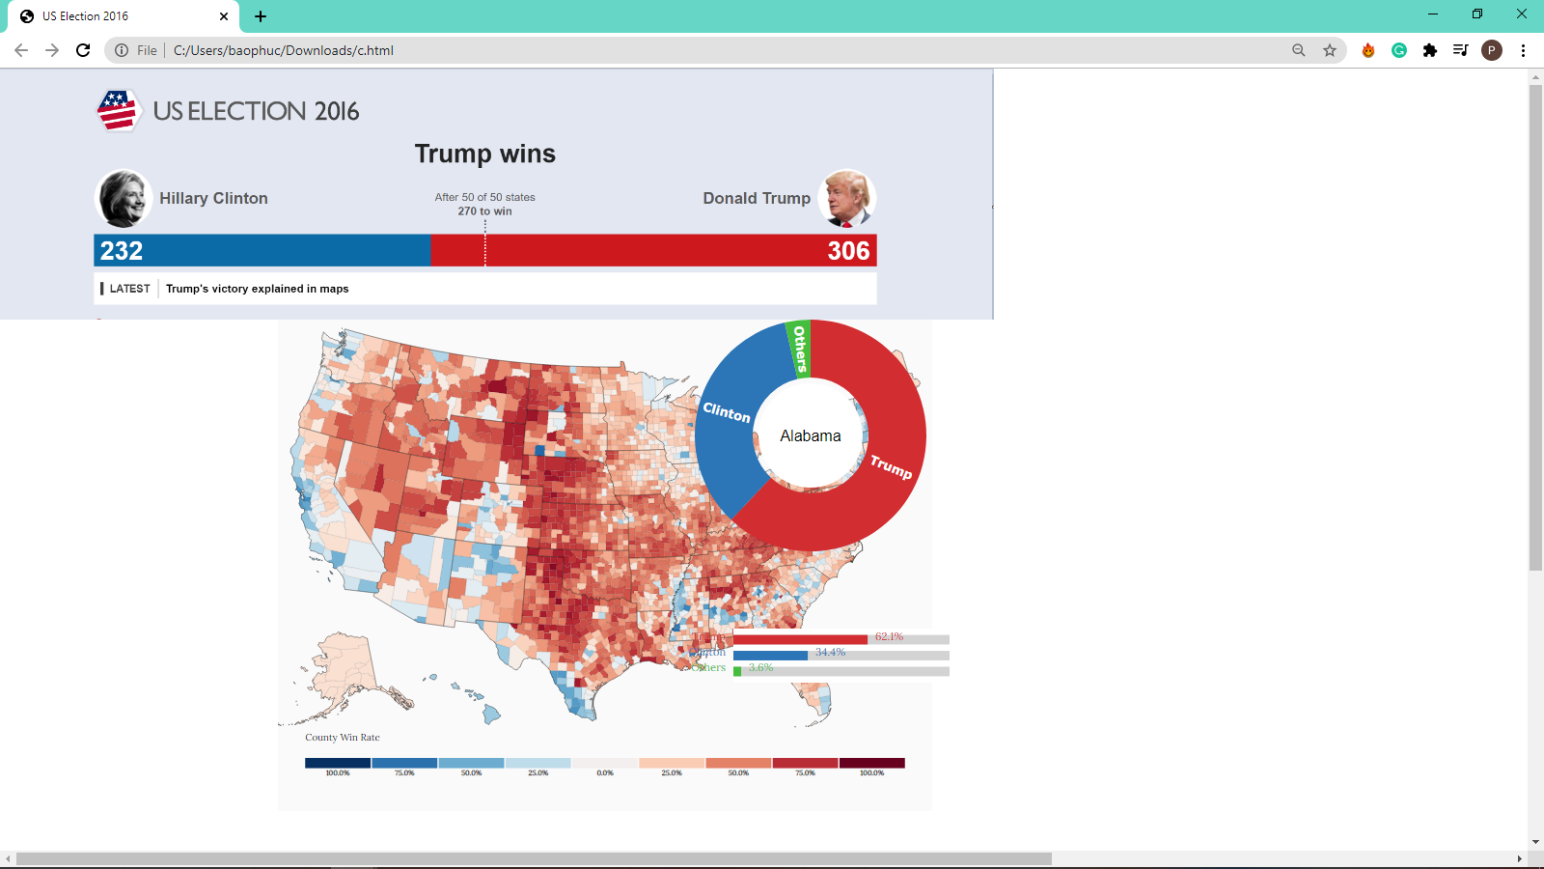

We use .mouseover to show details of each result for Clinton and Trump

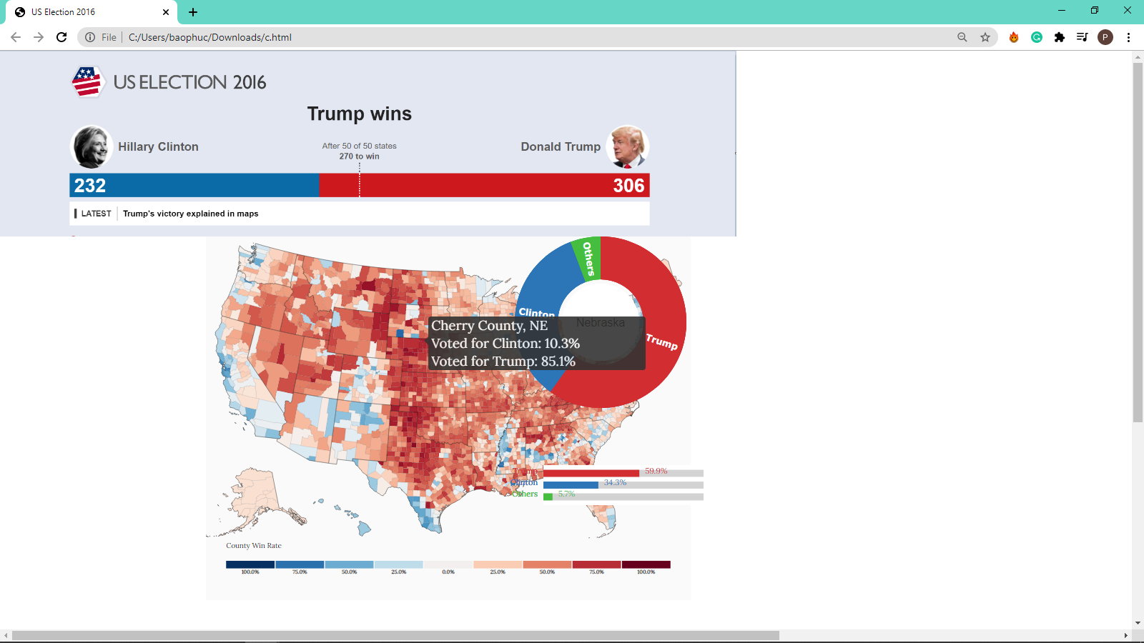

We add .tooltip for this geomap as well. After click on Cherry County, NE. You can see it zoom in.

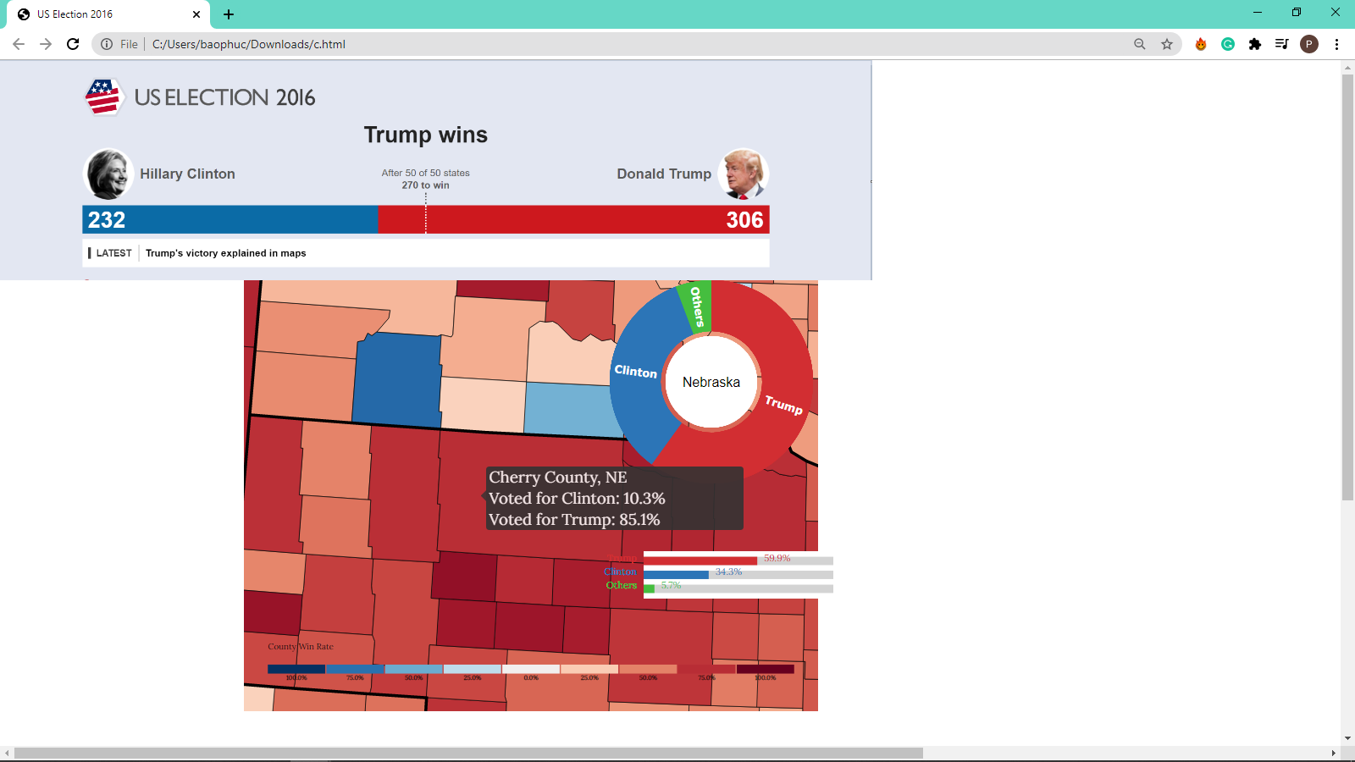

And then, this is Bennett County, SD. You can see the bar chart change for each states when we interact on them.

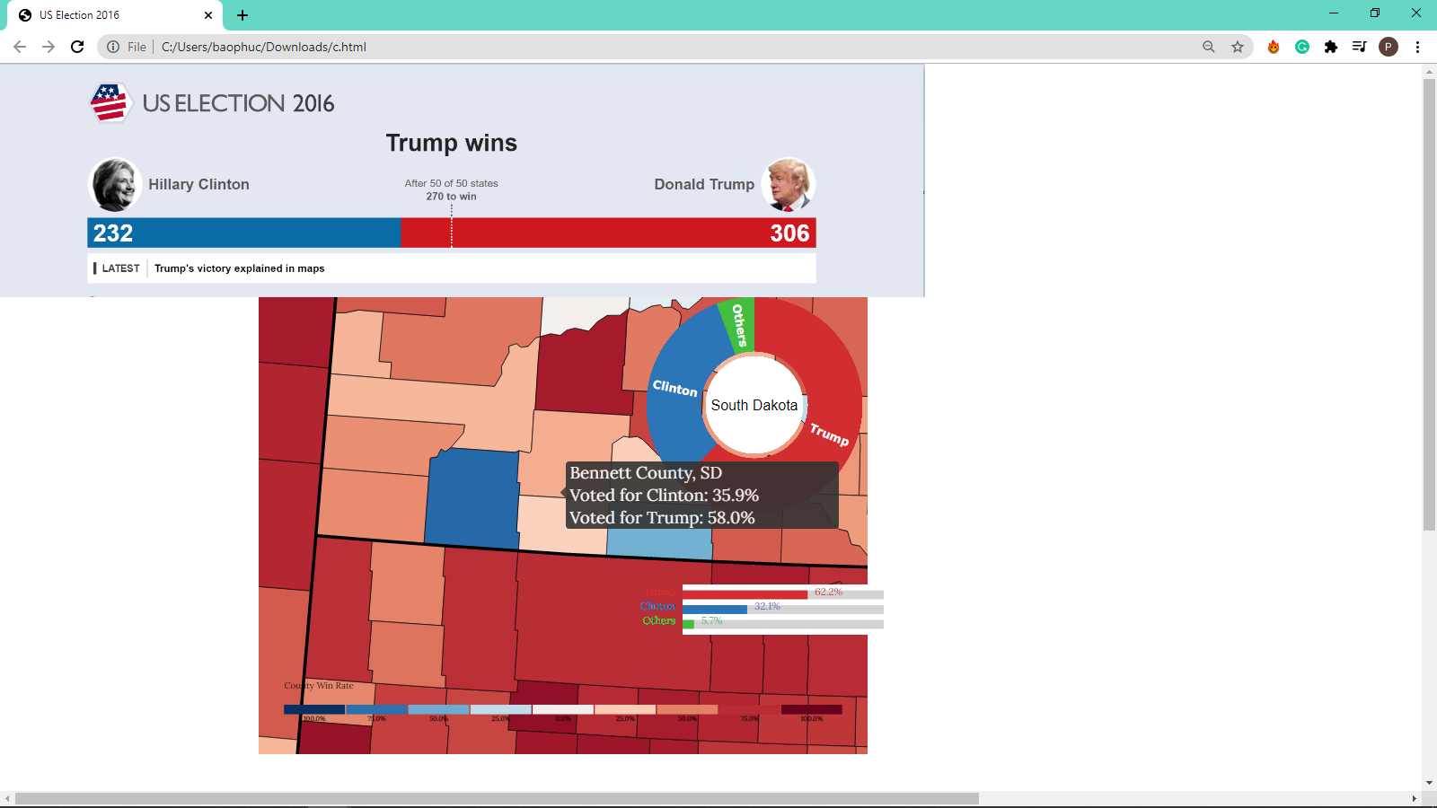

Moreover, we add .mouseover for piechart, and the name of state in the middle when you interact on the map.

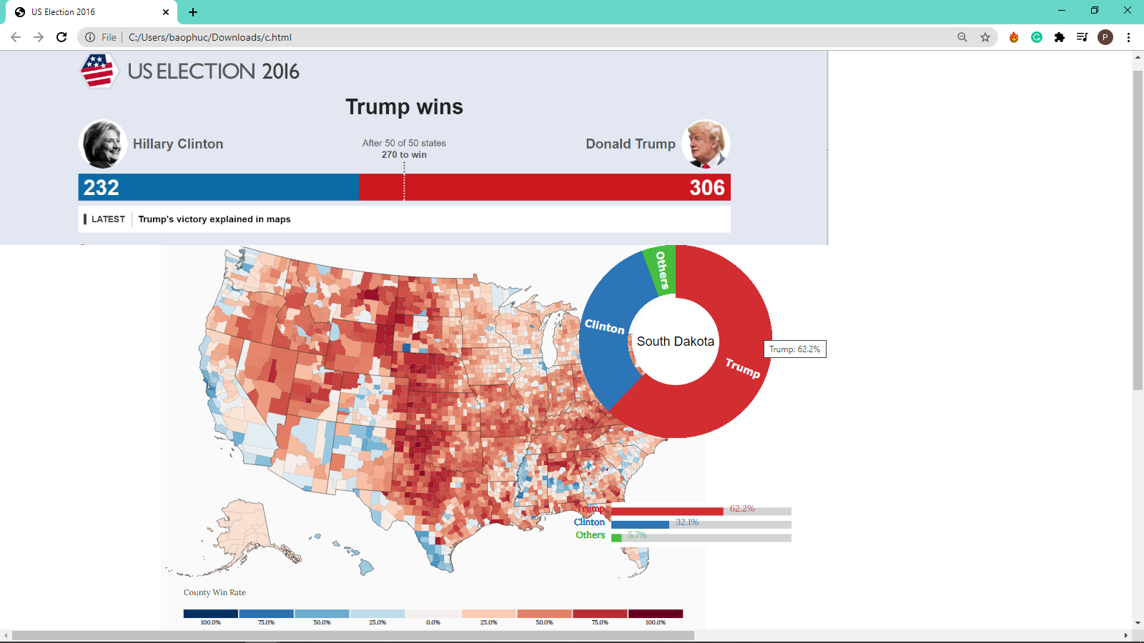

* + - 1. **Code**

We posted our code on github:

<https://github.com/ltminhhoang/project_uselection2016_dsdv/commits/master/c.html>

In this section, we focus on codes for geomap, which plays an important role in our project and easier to point out the functions or methods that we used most in this project. For instance, it interacts with pie chart and bar chart, … Finally, the goal of our storytelling is help you know more about election method of U.S.

1. **Result and conclusion drawn from the chart**

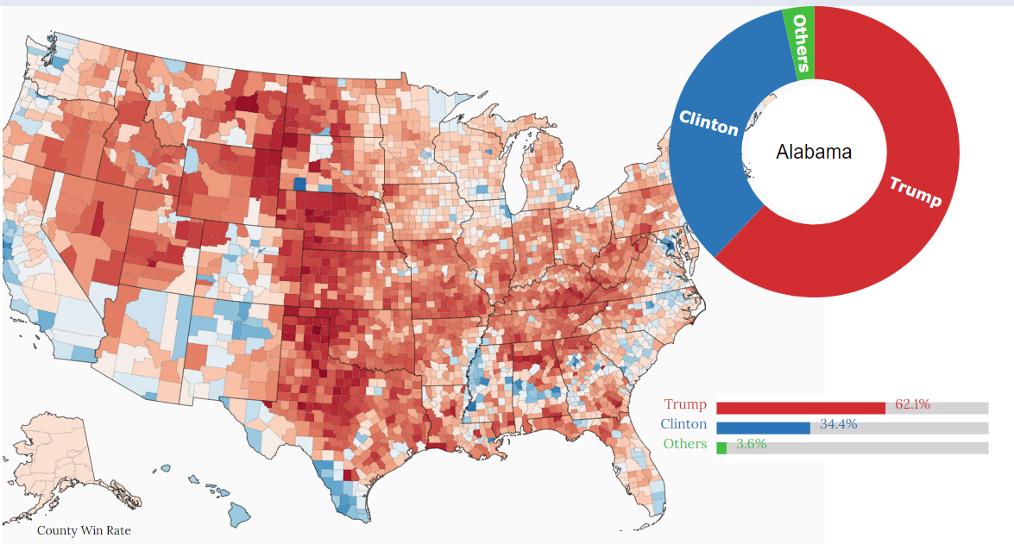

According to the chart, we have figure out some insights about how the election was done back then, and what might happen in the upcoming election on December 14th 2020

**INSIGHTS:**

The **2016 United States presidential election** was the 58th quadrennial presidential election, held on Tuesday, November 8, 2016. The Republican ticket of businessman Donald Trump and Indiana governor Mike Pence defeated the Democratic ticket of former secretary of state Hillary Clinton and U.S. senator from Virginia Tim Kaine

From the chart we can see that Clinton took the lead in the popular vote but she lost in the actual electoral vote which lead to Trump’s victory. By looking at the chart, red vote(Trump) are also most filled the entire chart but he’s actually lost, but why?

The proper answer for this question is the proportion. For example, the total votes from Alabama State for Trump is 60% and votes from New York for Clinton is 40%, even though the percent are higher but the population in those 2 states are different. Let say there are 10000 citizens in Alabama and 20000 in New York, so 60% of 10000 is 6000 and 40% of 20000 is 8000, its obviously that 8000 votes are higher than 6000. Therefore, although the chart filled with red votes but the actually votes for blue is higher due to the proportion of citizen from each state.

* But if Clinton won the popular vote (which mean **more people voted for Clinton) but Trump still won the election?**

This is where the United States Electoral College comes in. It’s been in place since the Constitution was first drawn up and, ideally, it’s supposed to protect against a lot of perceived problems that would come from a straight-up popular vote. Each state is given a share of the United States’ 538 electoral votes based off its population, with totals ranging from California’s 55 to a number of states with only three.

This might seem like a wide margin, but in the big picture, it supposedly levels the playing field for sparsely-populated states like Wyoming and North Dakota, which could see even less national attention if their less-than-a-million populations were siphoned into the United States’ 300 million-plus electorate. **The country is undoubtedly a melting pot of social groups, and by giving a unique say to each state, the Electoral College is supposed to foster individual interests that would be swallowed up in a winner-take-all affair.**

Back to Clinton and Trump --**Hillary won more votes overall, but a multitude of them came from the same few states, like California and New York**. Regardless of how decisively you win them, you can only win them one time, and there’s a **set amount of electoral votes** you earn. Therefore, Trump won the total election thanks to the higher number of electoral votes. And here is an important note that we conclude from the election:

“In order to win, Trump didn’t necessarily win the most votes, but he **won the most votes in the right places**. Under the Electoral College, that’s what matters. “

**WHAT WE LEARNT FROM THE ELECTION:**

* **Listen to everybody, especially those in the margins: I think this is the main reason why Trump won because he listened to everyone. He identified the significant audience and worldview that others might want to believe does not count**
* **See beyond your competitors:** Get a clue about the game you’re really in, have an ability to see the big picture, in this case, Trump had spotted the margins and give them to benefits that they wanted
* **Keep learning:** Don’t learn to become a subject matter expert. Learn to increase awareness, and with the tangible, strategic application of that awareness, to enable greater innovation. When in continual discovery mode about what technologies, approaches and talent is outside the confines of their industry bubble, and on the industry horizon, leaders can proactively protect their business or their function — even when there is large-scale change ahead. Keep your head in the clouds, and the same technologies, approaches and talent you could have used to enhance your business or role will be used against you.

**WHAT CAN WE EXPECT FROM THE 2020 ELECTION BASE ON THE ONE IN 2016**

* Every state with a sizable Hispanic population, for example, will see a small but significant growth in the percentage of eligible voters in that demographic
* Candidates have to focus on the main purpose, the significant audience in order to win (just like what Trump did)

**CONCLUSION:**

This is our group insight about the election, our thought for the upcoming election might be unstable due to the migration and eligibility trends. Whether a state imports or exports more voters, and what we can surmise about those transients — plus, what we know about the newly-minted young voters — could very well be a deciding factor in the 2020 election. We all know a Democrat is theoretically capable of far outpacing Trump in the popular vote. Whether he or she can win the election itself will have a great deal to do with where America’s voters live a year from now.

This is what we learnt from the project:

* The project is hard and take lots of time to build.
* In the process of running is not smooth.
* We will do some interface improvements in the future.

THANK YOU FOR READING