Running accessibility audits with google chome’s developer tools

# What are developer tools?

Google chrome comes with a variety of useful tools for developers wanting to test their web sites. Although not all of these will be useful when developing online courses with a builder tool, the accessibility audit tool is a great way to ensure you are meeting some of the basic accessibility requirements.

Note that the accessibility audit will only work if your online course is hosted online somewhere. This guidance is using the [presentation components page](https://adaptlearning.github.io/v4demo/#/id/co-05) from the example course on the Adapt website. To access developer tools, open the web page in google chrome and click the three dots on the top right corner, then choose “more tools” -> “developer tools”. Alternatively, you can use the keyboard shortcut Ctrl + Shift + I.

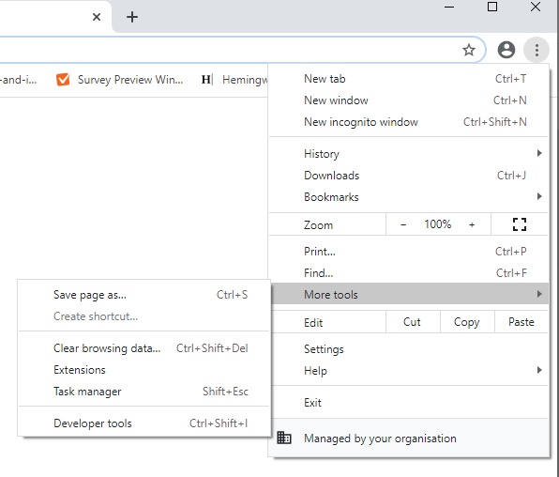

# Running the accessibility audit

Open the “lighthouse” tab in the developer tools window. It will probably be hidden, so will have to click the “>>” button to find it. 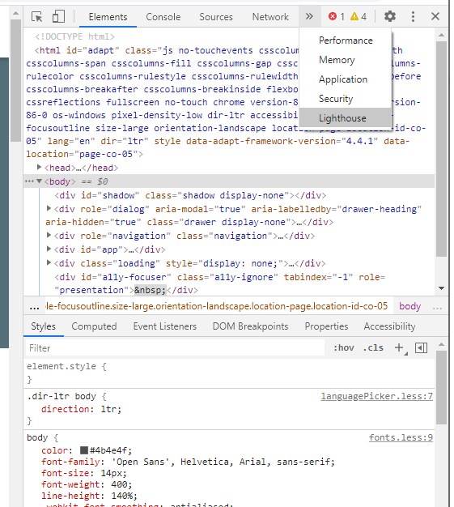

When you have the lighthouse tab open, simply choose your options and generate a report! As you are not directly coding your course, you will probably only be interested in the accessibility output. You will need separate reports for Mobile and Desktop accessibility.

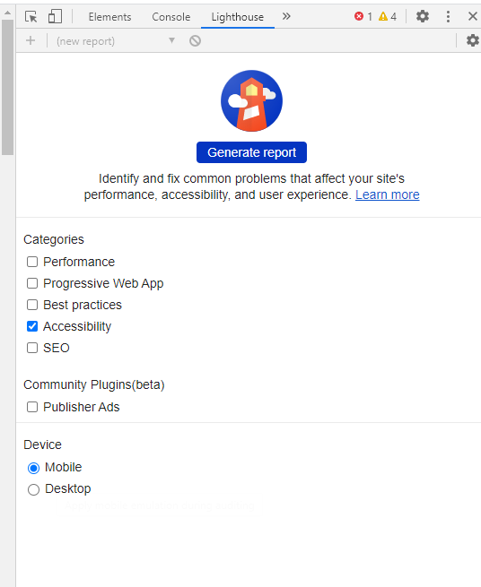

# How to make sense of the output

The report might contain quite a lot of information. The first thing you will probably notice is that overall score, which is colour-coded. In this case, the page has a score of 93, which is good. It means the automated test couldn’t find much wrong with the page. These checks cover the things that can be easily automated, for example ensuring colour contrasts are readable and that images have an alt-text.

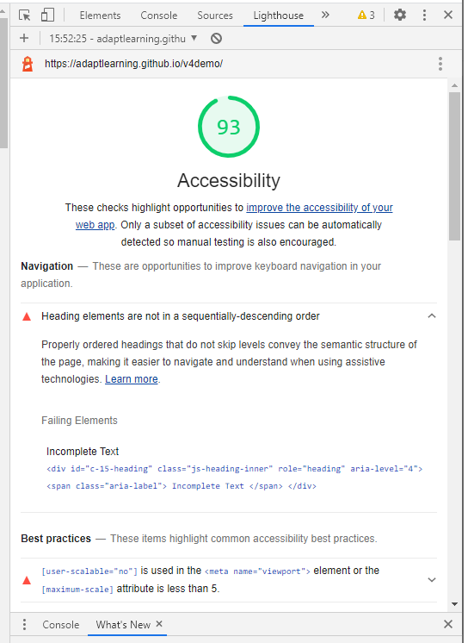

However, those are just the basics, Some checks cannot be fully automated. For example, you need human judgement to decide whether the text is easy to understand. If you scroll further down, you will also see all the elements that passed the accessibility check and items you should check manually. This list is handy, as it contains external links showing you how to do an accessibility audit. You can see this documentation by clicking on items in the list and following the link “Learn more”.

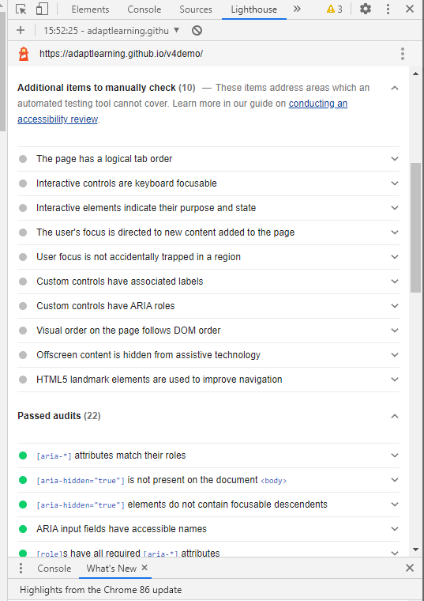

# Saving the report

You can save your report by clicking the three dots at the top of the audit window. Saving as HTML is a good option.

