Software Requirements Specification
for
Timebank

Prepared by Saif Mirza
Group 19
05/01/2019
Table of Contents
Table of Contents ii
1. Introduction 1
1.1 Purpose 1
1.2 Intended Audience and Reading Suggestions 1
1.3 Product Scope 1
1.4 References 1
2. Overall Description 2
2.1 Product Perspective 2
2.2 User Classes and Characteristics 2
2.3 Operating Environment 2
3. Diagrams 3
3.1 Use-Case Diagram 3
3.2 Sequence Diagrams 4
3.3 Class Diagrams 5

Introduction

Purpose
The product is a web-based HTML application in which people can sell service for hours of time. The purpose of this SRS to explain the product being created.

Intended Audience and Reading Suggestions
This document is intended for the developers, managers and testers. This document contains details that are specific to each reader type, so there might be data that does not relate to a certain reader type.

Product Scope
This product can be run on any browser, on any Windows or Mac operating system. We believe this is a vital decision because most consumers own some sort of PC that runs either one of the operating systems.

References
Our Final Project on GitHub: https://github.com/pieman353/timebank/blob/master/README.md

Overall Description

Product Perspective
This is a self-contained product where people on this platform can trade hours as local currency. This system provides a means for people to request different services and also provide diverse services to people on this platform.

User Classes and Characteristics
For this project, there will only be two types of users: Responders and Requestors.
The Requestors will post on the app what type of service they require.
The Responders will then respond to the post if they think they can work on the service

Operating Environment
This product can be operated on any internet browser.

Diagrams

Use Case Diagram
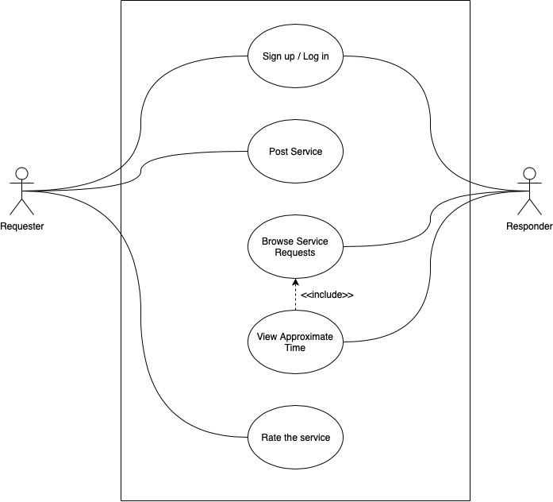

Sequence Diagrams

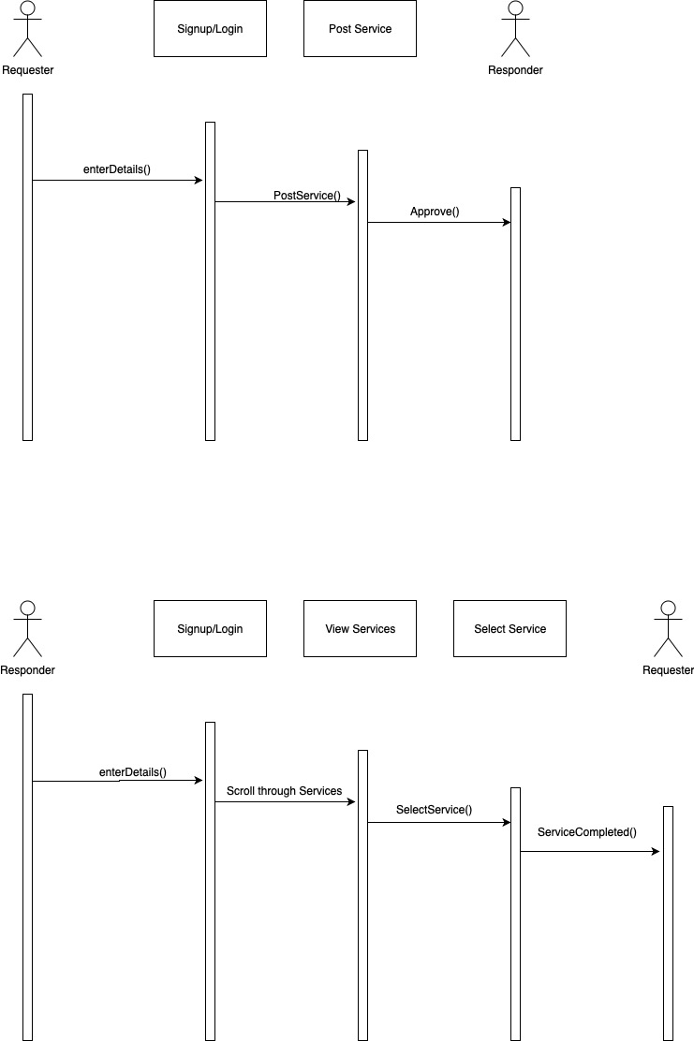

Class Diagram

