CSCI 4300: Web Programming - Spring 2015

Project 4: PHP Programming; Due: Feb 22 (mid-night)

This assignment is about making a simple multi-page "online dating" site that processes HTML forms with PHP. Online dating has become mainstream with popular sites such as eHarmony, Match.com, OkCupid, Chemistry, and Plenty of Fish. Your task for this assignment is to write HTML and PHP code for a fictional online dating site for desperate single geeks, called NerdLuv. Turn in the following files:
- signup.php, a page with a form that the user can use to sign up for a new account
- signup-submit.php, the page that receives data submitted by signup.php and signs up the new user
- matches.php, a page with a form for existing users to log in and check their dating matches
- matches-submit.php, the page that receives data submitted by matches.php and show's the user's matches
There are some provided files on the web site. The first is a complete version of the site's front page, index.php. This front page simply links to your other pages. The other complete provided files are top.html and bottom.html, which contain common header/footer HTML code that you should include in your other pages. We also provide a complete CSS file nerdluv.css with all of the page styles. You should link to this CSS file from all of your pages and use its styles in your code. You should be able to fully style all pages using the styles in nerdluv.css only.

Index Page (index.php) and Overall Site Navigation:

The provided index.php page has a header logo, links to signup.php and matches.php, and footer notes/images. You do not need to modify this file, but you should put it in the same folder with your other files and submit it with your files.
The "Sign Up" link leads to signup.php (left below), and "Check matches" to matches.php (right below):

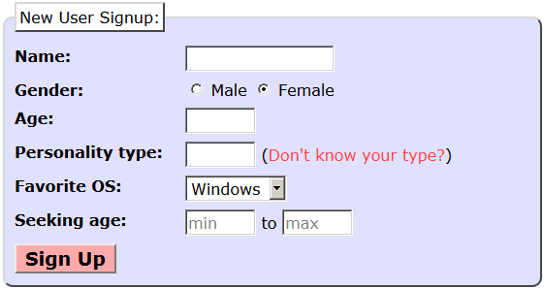  When submitted, the Signup page looks like this:   | 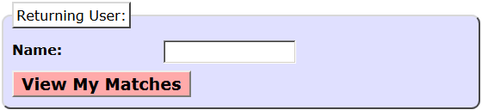  When submitted, the View Matches form looks like this:  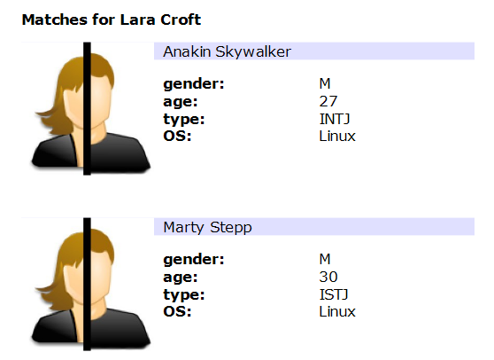
The details about each page's contents and behavior are described on the following pages. Screenshots in this document are from Windows in Firefox, which may differ from your system.

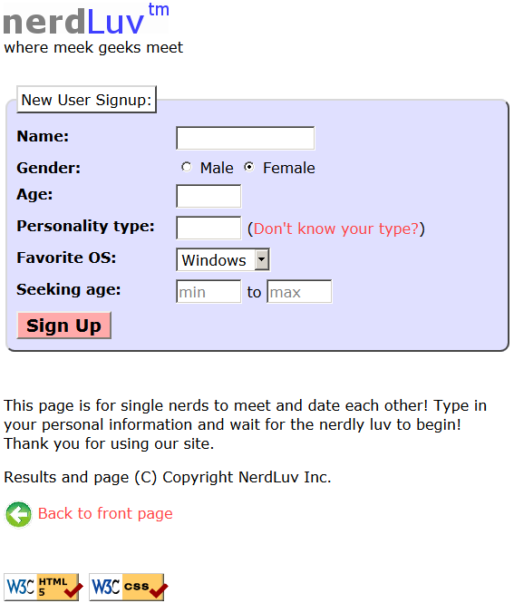
Sign-Up Page (signup.php):
The signup.php page has a header logo, a form to create a new account, and footer notes/images. You must write the HTML code for the form. The form contains the following labeled fields:
- Name: A 16-character box for the user to type a name.
- Gender: Radio buttons for the user to select a gender of Male or Female. When the user clicks the text next to a radio button, that button should become checked. Initially Female is checked.
- Age: A 6-letter-wide text input box for the user to type his/her age in years. The box should allow typing up to 2 characters.
- Personality type: A 6-character-wide text box allowing the user to type a Keirsey personality type, such as ISTJ or ENFP. The box should let the user type up to 4 characters. The label has a link to http://www.humanmetrics.com/cgi-win/JTypes2.asp.
- Favorite OS: A drop-down select box allowing the user to select a favorite operating system. The choices are Windows, Mac OS X, and Linux. Initially "Windows" is selected.
- Seeking age: Two 6-character-wide text boxes for the user to specify the range of acceptable ages of partners. The box should allow the user to type up to 2 characters in each box. Initially both are empty and have placeholder text of "min" and "max" respectively. When the user starts typing, this placeholder text disappears.
- Sign Up: When pressed, submits the form for processing as described below.

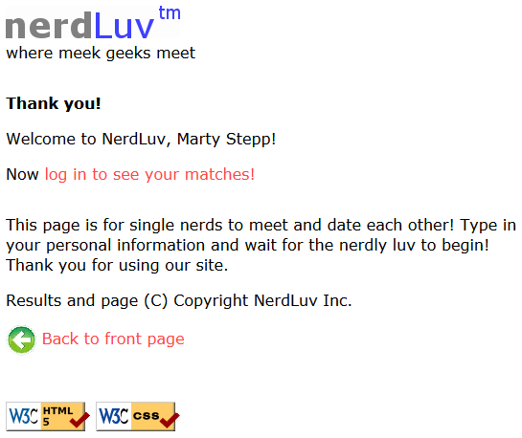
Submitting the Sign-Up Form (signup-submit.php):
When the user presses "Sign Up," the form should submit its data as a POST to signup-submit.php. (The exact names and values of the query parameter(s) are up to you.) Your PHP code should read the data from the query parameters and store it as described below. The resulting page has the usual header and footer and text thanking the user. The text "log in to see your matches!" links to matches.php.
Your site's user data is stored in a file singles.txt, placed in the same folder as your PHP files. We will provide you an initial version of this file. The file contains data records as lines in exactly the following format, with the user's name, gender (M or F), age, personality type, operating system, and min/max seeking age, separated by commas:
Angry Video Game Nerd,M,29,ISTJ,Mac OS X,1,99
Lara Croft,F,23,ENTP,Linux,18,30
Seven of Nine,F,40,ISTJ,Windows,12,50
Your signup-submit.php code should create a line representing the new user's information and add it to the end of the file. See the PHP file_put_contents function in book Chapter 5.

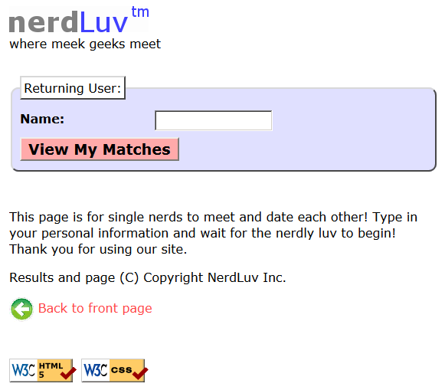
View Matches Page (matches.php):
The matches.php page has a header logo, a form to log in and view the user's matches, and footer notes/images. You must write the HTML for the form. The form has one field:
- Name: A label and 16-letter box for the user to type a name. Initially empty. Submit to the server as a query parameter name.
When the user presses "View My Matches," the form submits its data as a GET request to matches-submit.php. The name of the query parameter sent should be name, and its value should be the encoded text typed by the user. For example, when the user views matches for Rosie O Donnell, the URL should be:
- matches-submit.php?name=Rosie+O+Donnell

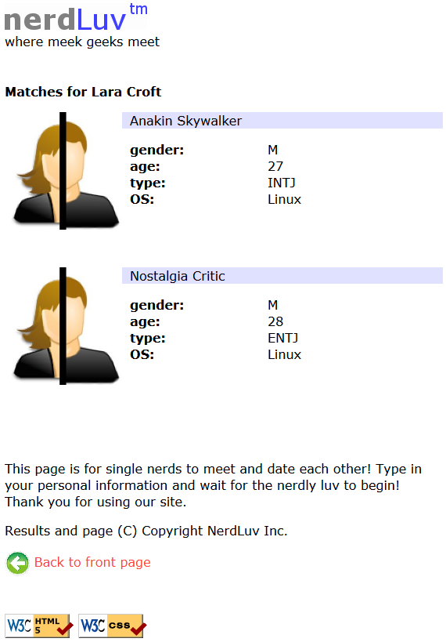
Viewing Matches (matches-submit.php):
When viewing matches for a given user, matches-submit.php should show a central area displaying each match. Write PHP code that reads the name from the page's name query parameter and finds which other singles match the given user. The existing singles to match against are records found in the file singles.txt as described previously. You may assume that the name parameter is passed and will be found in the file.
Below the banner should be a heading of "Matches for (name)". Below this is a list of singles that match the user. A "match" is a person with all of the following qualities:
- The opposite gender of the given user;
- Of compatible ages; that is, each person is between the other's minimum and maximum ages, inclusive;
- Has the same favorite operating system as this user;
- Shares at least one personality type letter in common at the same index in each string.
For example, ISTP and ESFP have 2 in common (S, P).
As you find each match, output the HTML to display the matches, in the order they were originally found in the file. Each match has the image user.jpg, the person's name, and an unordered list with their gender, age, personality type, and OS.

Robust page with form validation:
If the user submits invalid data that doesn't match the above criteria to signup-submit.php, or if the user submits an empty name to matches-submit.php, do not show any matches or sign up the user. Instead display an error message of your choice, such as the one shown at left. Add PHP code in signup-submit.php and matchessubmit.php that tests all query parameters submitted for validity. Use PHP regular expressions to do this. Specifically, you must check the following aspects of each query parameter that is submitted using proper strict regular expressions that allow only these patterns:
- The name must not be blank (both pages).
- The age submitted must be an integer and must be between 0 and 99 inclusive.
- The gender submitted must be male or female. (No other values such as "robot" are allowed.)
- The Keirsey personality type must be a 4-letter string whose letters come from the Keirsey personality dimensions: I or E for the 1st letter, N or S 2nd, F or T 3rd, and J or P 4th.
- The favorite operating system must come from the choices provided.
- The seeking min/max ages submitted must be integers, must be between 0 and 99 inclusive, and the minimum seeking age must be less than or equal to the maximum.

Also make your pages robust against the following simple basic input errors:
- Re-submitting to signup-submit.php a person who is already in the file.
- Trying to view matches on matches-submit.php for a person who isn't in the file.

Note: It may help you to know that PHP has a function exit that you can call to immediately stop the currently running script. This function can be useful if you encounter an error and don't want to display any more of the HTML that is to come later in your code. You can display an appropriate error, end the page, and exit immediately.
- See http://php.net/exit for more information about this function.

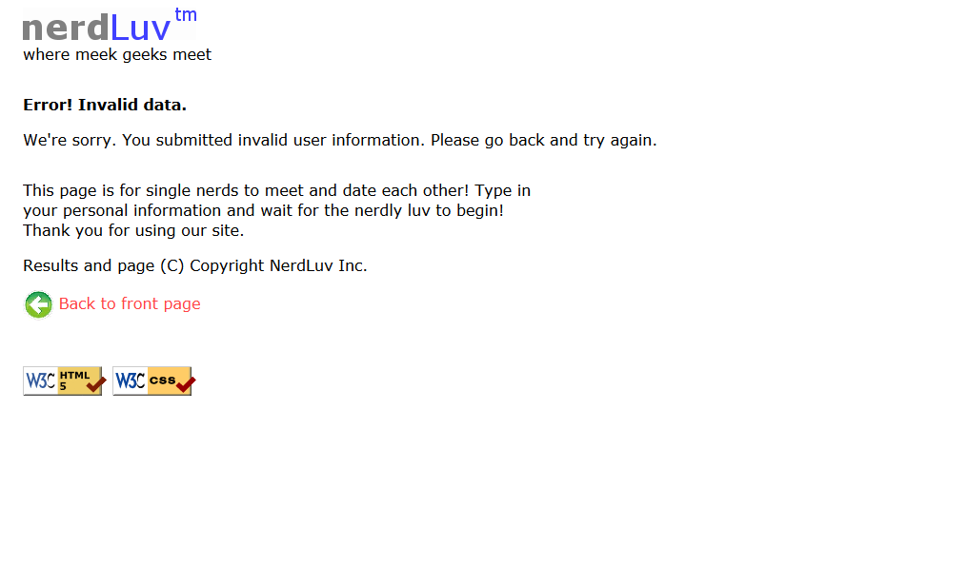

Bonus Extra feature: User photos:
Modify the matches-submit.php page to display photos for each user. There is a set of images in the following folder on the web site for every user that is initially in the input file: https://webster.cs.washington.edu/images/nerdluv/

When the user views his/her matches, instead of displaying the default image of user.jpg, instead display the proper image for each individual user, as shown at left. (See the course web site for screenshots.) The file names exactly match the users' names, except that the file names are all-lowercase and with spaces replaced by dashes. For example, there are image files named marty_stepp.jpg and angry_video_game_nerd.jpg. But the system won't have photos for new users that sign up. So you should modify signup.php to allow new applicants to submit photos. To do uploading of photos, add a file input box to signup.php that allows the user to browse for a file to upload. Use an input tag with type of file. (See screenshot at course web site.)

When signup-submit.php receives a POST, it will save this photo onto the server into a subdirectory named images/ using the naming system described (such as dick_cheney.jpg) and show it when subsequent users search for matches. You may assume that every user submits a valid JPEG image file and that the images/ folder already exists. You will also need to make one small modification to your code for matches-submit.php. When displaying images for each user, some of the images will come from the web URL above (the initially provided users), and some will come from your own local server (any newly signed-up users). To be able to tell which is which, you should insert a test in your code for each match. Test whether the image file exists on the server in the images/ directory; if so, display it from there. If not, assume that it exists on the course web site in the previously named directory and display it from there.

Note: When saving a file into a directory like images/, you may get permission issues. Make sure that your images/ folder on the server has both "Write" and "Execute" permissions enabled for all users.

Styling:
The styles you need are already given to you in nerdluv.css, but you still need to use proper tags and class attributes to make sure they are applied. Be mindful of the styles on forms and form controls. On the course web site are several screenshots of the various pages. Make sure that your form has the same width, colors, fonts, borders, etc. as in these examples. If you choose the right tags to represent your form, it should match. Make sure that form fields line up in columns by using a strong tag or column class so that each text label floats to the left and is 11em wide.
In matches-submit.php, the matches are displayed in a div with class of match. First is a paragraph containing an image of the match, shown with a width of 150px, and the person's name to the right. The paragraph has a light blue background color. The section with the match's gender, age, etc. must be represented as an unordered list (ul).

Uploading and Testing:
Upload all files to a web server to test them; include index.php , top.html, and bottom.html even if you won't modify them. You must change permissions on singles.txt so that PHP can write to it. In FileZilla, right-click singles.txt in the right pane and choose File Permissions.... Enable Group Write by checking the box below.
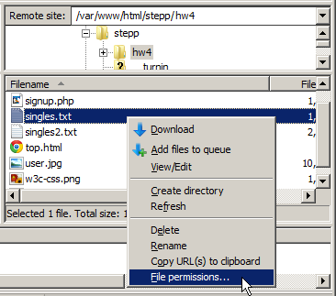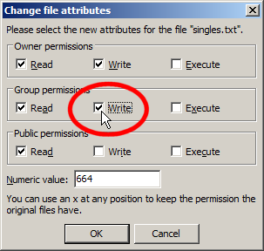

Suggested Development Strategy and Hints:

Based on index.php, write matches.php and matches-submit.php to work properly for existing users.

Write an initial version that outputs every person, even ones who aren't compatible "matches." This way you can debug your file I/O, styles, etc. Then add checks like gender, age, and OS. Focus on the PHP code and behavior first, as opposed to style details (CSS is not an emphasis of this assignment).

Write signup.php and signup-submit.php. If you finish the match page you'll understand forms, making the signup page easier. This is tough; there are more parameters to manage, and you must write to a file.
Use debug print and print_r statements to track down bugs. For example, you can print_r($_GET); or $_POST to see the query parameters submitted. Use Firebug and also View Source to find HTML output problems.
Recall that form controls must have name attributes. Sometimes you must also add a value to affect how data is sent.

Implementation and Grading:
Your HTML output for all pages must pass the W3C HTML validator. (Not the PHP source code itself, but the HTML output it generates.) Do not use HTML tables. Since we are using HTML forms, choose proper form controls and set their attributes accordingly. Properly choose between GET and POST requests for sending data.
Your PHP code should not cause errors or warnings. Minimize use of the global keyword, use indentation/spacing, and avoid lines over 100 characters. Use material from the class and the first six book chapters.
Some HTML sections are shared redundantly between your PHP pages, found in the provided files top.html and bottom.html. Include these files as appropriate in your other pages using the PHP include function.
A major grading focus is redundancy. Use functions, parameters/return, included files/code, loops, variables, etc. to avoid redundancy. If you have PHP code you want to share between multiple pages, you may turn in an optional file named common.php containing this code. You can include your common.php in your other pages.
For full credit, reduce the amount of large chunks of PHP code in the middle of HTML code. Replace such chunks with functions declared at the top or bottom of your file.
Another grading focus is PHP commenting. Put a descriptive comment header at the top of each file, each function, and each section of PHP code.
Format your HTML and PHP code similarly to the examples from class. Properly use whitespace and indentation. Do not place more than one block element on a line or begin a block element past the 100th character.
How to submit:
Mail your ".zip" file to the TA (Udgam Mehetre, uvm39153@uga.edu) with subject line “4300 Project 4, Team name”.

