Introduction

Project 3 - Sudoku Solver
Members - Boris Pisabaj - bpisab3, Robert Barrera - rbarre4, David Qiao - dqiao4
UIC Fall 2017
Professor Troy

Section 1

The project will provide help, as well as solve a standard 9 x 9 grid Sudoku board consisting of 81 cells. Amongst the 81-cell grid, the program will have an additional 11 buttons used for interacting with the grid.
The project aims to aid users in completing a Sudoku puzzle. Tackling the puzzle as a novice can prove a daunting task. With the program's easy to use interface, the user will have no problem filling in cells and erasing errors. The user won't be doing this blind, as the program offers multiple tools to help fill in cells using the power of mathematics.
Multiple algorithms are given to the user to be used at their discretion. These include the Singles, Hidden Singles, Locked Candidates, and Naked Pairs algorithms. These algorithms along side a check-fill system will aid the user in completing their Sudoku puzzle. An auto-fill option is included as well, utilizing the numerous algorithms previously stated.

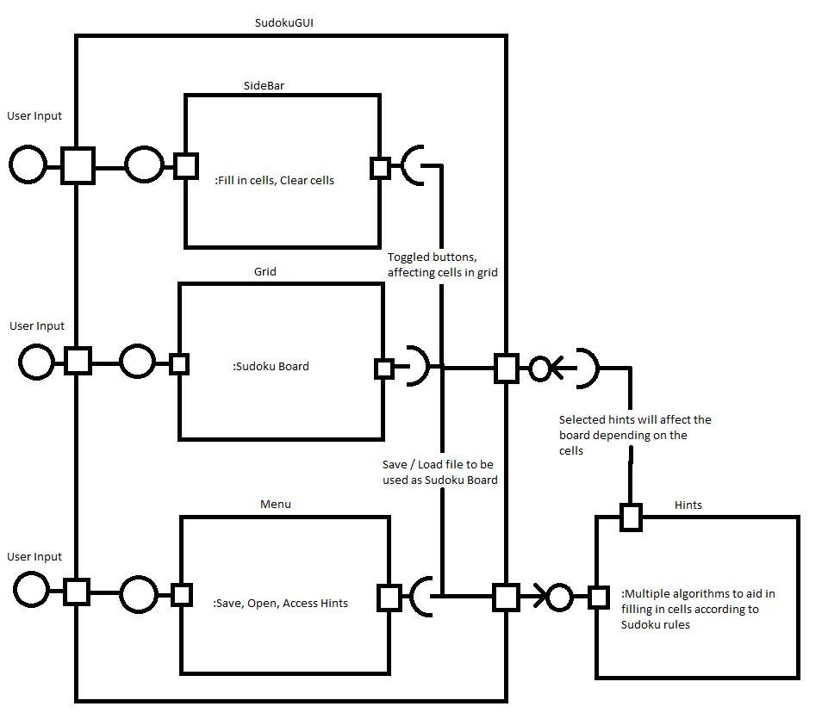
Section 2

Section 3

Sidebar - Consists of ten buttons. Nine buttons represent numbers 1-9, and one is the eraser. Each button is toggled on or off. When on, it will affect cells the user clicks on the grid. If number 1 is toggled, the next cells on the board the user proceeds to click on will be changed to the number 1. This lasts until the button is toggled off.

Grid - This is the main board of the game. Consists of a 9 x 9 grid, 81 cells total. These cells will reflect the text file the user loads into the program. They are affected by input either through the sidebar or from the hint menu.

Menu - Allows the user to save or load a text file. This text file will reflect the main game board that can be found in the Grid. User can exit the program from here. User can also access a Help menu, providing the user with several dialogue boxes explaining how to play Sudoku, use the interface, and provide information on the creators.
User will be able to access various hints to aid in completing the Sudoku puzzle.

Hints - Various hints are implemented to aid user in filling in cells on the Grid. A toggled check on fill mode can be activated, notifying the user if an input to a cell is valid or not.
Four algorithms are provided to fill in a single blank cell each when called.
The user can even fill in all empty cells if they wish.

Section 4

Using this program will allow the user to solve a Sudoku puzzle with ease. Users will develop a better understanding of the game, thanks to the program's guidance. The tools provided will give the user ample information on every move they make.
The algorithms provided are useful, however may not solve every single Sudoku layout.

Section 5

With this program, users are able to effectively and efficiently solve a Sudoku puzzle. Tools using special algorithms will walk them through the game board, providing useful information on how to traverse the puzzle. Boards can be loaded and saved at any time.

