Abstract—The internals of a binary executable file can be difficult to understand, even for someone with an abstract understanding of how computing systems work. Pinvis is a 3D visualization learning tool designed to foster a more concrete understanding of exactly what is happening at the lowest levels of a computing system. This focus on visualizing the entire binary in a way conducive to learning differentiates Pinvis from similar tools, which are usually focused on debugging or performance analysis, and are usually source code based. The visualizations created by Pinvis allow for unique insights and learning opportunities that are not possible using other systems.
PINVIS: A Binary Visualization Learning Tool (April 2012)
Brian E. Pittman

INTRODUCTION
Understanding the internals of a binary executable is a difficult task that is not adequately served by existing tools. Binary executable files are often treated as a black box, only to be understood by the computer system, not by the user. Some classes of tools exist to help visualize components of a binary executable, but usually with a focus on optimizing a program’s performance or debugging a program’s behavior, and often not by analyzing the binary executable directly.
Pinvis[1] is an attempt to visualize interesting aspects of a binary executable file, without requiring access to the source code the executable was built from. The focus of the visualization engine is on providing an intuitive description of what is happening at the lowest levels. To do this we provide:
- A pintool[2] to log all relevant data from a binary executable file, without requiring the source to be available.
- A 3D graphical interface to visualize the data from the pintool
- The visualization engines displays information about dynamic streams, instructions, functions, images, and memory accesses.
- A robust filtering system to allow the user to focus solely on the areas of interest in the binary.
- A stored timeline of the program’s stream execution order which can be stepped through one stream at a time.

The Problem
Binary executable files are difficult to analyze directly. They are intended to be efficiently computer-readable, not user-readable. Even the assembly language instructions can be difficult to read directly. Compilers create obfuscated, heavily optimized code to be fast, not human readable. Loop unrolling and other optimizations mean that the assembly language does not always directly mimic the structure of the original source code. Control flow can be difficult to follow due to complex branching behaviors. Binaries are also often dependent on system libraries whose structure and complexity are not well understood, and whose source code may or may not be available.
Despite all these difficulties, it can be important for the student or developer to have some understanding of what is happening at the lowest levels of the system. A student may look at a 1MB executable built from a 10kB source file and ask “why is the executable so big?” Or the student may wonder “what is the effect of various optimization flags on the binary executable?”
Debugging tools are useful to understand program flow and memory contents, but these tools are by necessity focused on the source code of the program, not the binary, because bugs are fixed at the source code level, not in the binary. Additionally, the source code is often not available, especially when considering the contribution of system-provided libraries to the executable, or when trying to analyze the behavior of tools provided by the operating system or tools of a commercial nature.
Performance analysis tools can be helpful for gaining insight into program behavior, but these tools usually operate at the loop-level, function-level or higher. As with debugging problems, performance problems are solved at the source code level so that is where these tools are focused.
Neither debugging tools nor performance analysis tools are optimally suited for drilling down into a binary executable file and visualizing exactly what is happening at the lowest levels.

Pinvis: A Binary Visualization Learning tool
Pinvis is not a debugging tool, nor is it a performance analysis tool. It is a learning tool, designed to display an intuitive graphical depiction of a binary executable file, in a way that is conducive to understanding exactly what is happening in during a program’s execution.
The focus of Pinvis is on initially providing an overall view of the binary file. From this view the user can note interesting elements of the binary executable file and then drill down to focus on these elements to learn further details of how the binary behaves.
The fundamental unit of a binary executable file is the instruction, so in Pinvis each instruction is represented by a small cube. Instructions are the building blocks of the system, and therefore the building blocks of the visualization engine as well. The individual instructions are then organized into dynamic streams. A dynamic stream is defined as a sequence of instructions, executed sequentially, with no taken branches in the control flow. As soon as a branch is taken, a new dynamic stream is created. This means that the same code can appear in multiple dynamic streams. The streams can be organized into various formats to either get a birds-eye view of the entire executable, or to focus on a specific section. Instructions can be colored to intuitively show which instructions reference memory, or which instructions are called with the greatest frequency. In this way it is possible to gain an intuitive understanding of the innermost workings of the binary.
A 3D visualization is used because there are upwards of thousands of streams in all but the most trivial example codes, and therefore it would be difficult to display all the relevant information in a 2D interface. Animations are used when reordering, hiding or showing streams. This, combined with the 3D, helps to give the visualization a feeling of physicality, that nothing is being hidden from the user. The instruction streams are not being created from nothing, they are just being shuffled around into interesting configurations for the user.
Various kinds of data are made available from the pintool about each stream, and the instructions within. This information is all incorporated into the visualization. For instance, the instruction cubes can be colored to denote whether the instruction reads or writes to memory. The function and image that each stream belongs to is also tracked, and this information is displayed when interacting with a particular stream.
The user can also filter the visible streams to exclude images that are deemed uninteresting. For example, in small programs, there may be thousands of streams which are part of system libraries, and only a few that are from the source code the user is interested in visualizing. In this case the user can simply hide all the system libraries and focus on what is interesting to him or her.

Details
Pinvis is composed of two major pieces: a pintool to collect data on a binary, and a visualization engine to analyze the data collected by the pintool.

Pintool
Intel’s pintool is a tool for the dynamic instrumentation of programs. Pin provides an API that allows the user inject code dynamically into a running executable. Code can be injected based on a variety of interesting conditions, such as when a new basic block of code is entered, or every time a branch instruction is reached. Pin also abstracts away a multitude of implementation differences between various processors, to make it much simpler to collect data without worrying about specific architectures. Pinvis would have been impossible to create without the use of Intel’s pin.
The Pinvis pintool inserts code at the basic block level and the instruction level. In pin, basic blocks are defined as a sequence of instructions, executed in order, ending in a branch instruction, regardless of whether or not the instruction is taken. Since Pinvis is interested in tracking dynamic streams, which only end if the branch is taken, the Pinvis pintool also inserts dynamic code at the instruction level, to check if branch instructions are taken.
Pin’s API is additionally used to collect information on the binary executable file. For each stream, the function name and image name containing the stream is saved. For each instruction we also store whether the instruction reads or writes to memory.
Additionally, the pintool stores a timeline of the execution order of all the dynamic streams in the file. All of this data is output to 2 binary files.

Pinvis
The second piece of the system is the Pinvis visualization engine, which reads the binary files output by the pintool and uses the data contained within to create the visualization. The visualization engine uses the OpenSceneGraph[3] library to create the 3D scene. OpenSceneGraph is a library that provides a scene graph interface to the OpenGL rendering library. The scene graph allows us to define a hierarchy of objects in the scene, and easily define transformations between objects. OpenSceneGraph also has built in support for animations, text rendering, mouse and keyboard event handling, and camera control. These abilities make it a natural choice for Pinvis.
Upon Pinvis startup, the initial view is a top-down look at a grid of all the available streams. This is meant to serve as a birds-eye view of the entire available dataset, and a launching point for more detailed investigation.

Grid Mode & Row Mode
In addition to the grid view, there is a row view where all the streams are laid out in one long row. This view is better for looking at a small selection of streams. To switch between the two modes, the user can press 1 for grid mode or 2 for row mode.

Memory Coloring & Execution Frequency Coloring
The instructions in the streams can be colored in two ways: by pressing 3 the user can display the memory coloring, or by pressing 4 the user can display the execution frequency coloring.
In memory coloring mode, green is used to represent instructions that read memory, and red is used to represent instructions that write memory. In execution frequency mode, each stream is colored based on the relative number of times it is executed. Red streams are executed very frequently relative to other streams in the binary executable file. Green streams are executed relatively infrequently.

Picking and Filtering
By clicking on any visible stream, it is possible to find out more information about that stream. At the bottom of the display, the image name and function name the stream belongs to is displayed.
Once a stream has been selected in this way, it is possible to either hide the stream, along with all other streams from the same image (by pressing ‘h’), or alternatively hide all streams except those belonging to the currently selected stream’s image (by pressing ‘u’). This allows the user to focus on a few streams at a time. By selecting either grid mode or row mode by pressing 1 or 2, it is possible to bring back all the hidden streams and restore the original view.

Timeline
It is also possible to step through the execution of the binary executable file one stream at a time, by pressing ‘n’ to advance forward to the next stream, or ‘p’ to move back to the previous stream. The currently executing stream will be highlighted in blue. Keep in mind that the same stream can be executed multiple times in a row, so the highlighted stream may not always change.
The timeline feature works in conjunction with the filtering system, so that all hidden streams will be skipped when stepping through the execution order. This avoids the unfortunate behavior of having to press ‘n’ 5,000 times to step through an annoying long series of streams from some uninteresting system library.

Usage Examples

A simple assembly language example
Even the smallest C programs contain thousands of streams due to the inclusion of standard C libraries and operating system calls, so to generate a simple Pinvis case we must turn to assembly language examples.
In this example we will use the gnu assembly language[4] to generate a simple example case to demonstrate the correctness of the pintool. The complete source code follows:

.data # start of data segment

x:
.long 1
.long 5
.long 2
.long 18

sum:
.long 0

.text # start of code segment

.globl _start
_start:
movl $4, %eax # EAX: # of words left to sum
movl $0, %ebx # EBX: the sum
movl $x, %ecx # ECX: current word to sum
top: addl (%ecx), %ebx
addl $4, %ecx
decl %eax
jnz top
done: movl %ebx, sum
movl $1, %eax
movl $0, %ebx
int $0x80

The code contains only one branch instruction, and contains three dynamic streams. The first dynamic stream will consist of the initialization code and the first iteration of the loop. The second dynamic stream will consist of the second and third iterations of the loop. The third dynamic stream will consist of the final iteration of the loop, the storage of the final sum, and the exit code. Fig. 1 and 2 show the Pinvis output in row view form of the asm example. Both memory coloring mode and execution frequence mode are displayed.

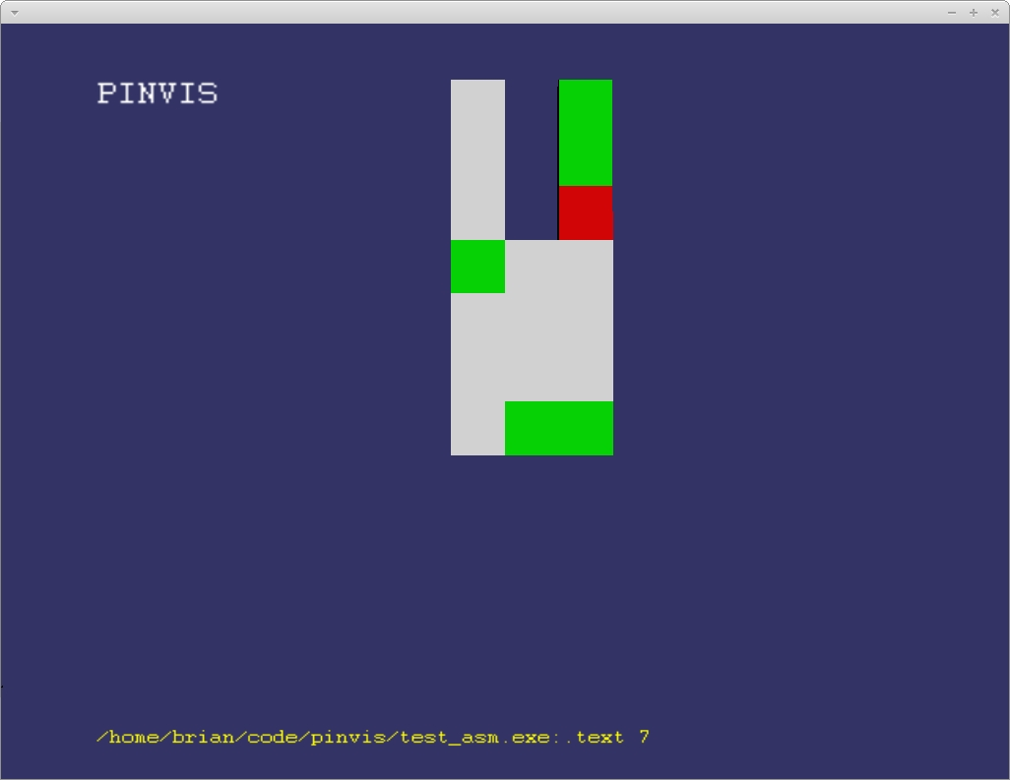
Fig. 1. Assembly code example in Pinvis row mode with memory coloring. The streams are ordered from left to right. Note the memory write in the final stream.

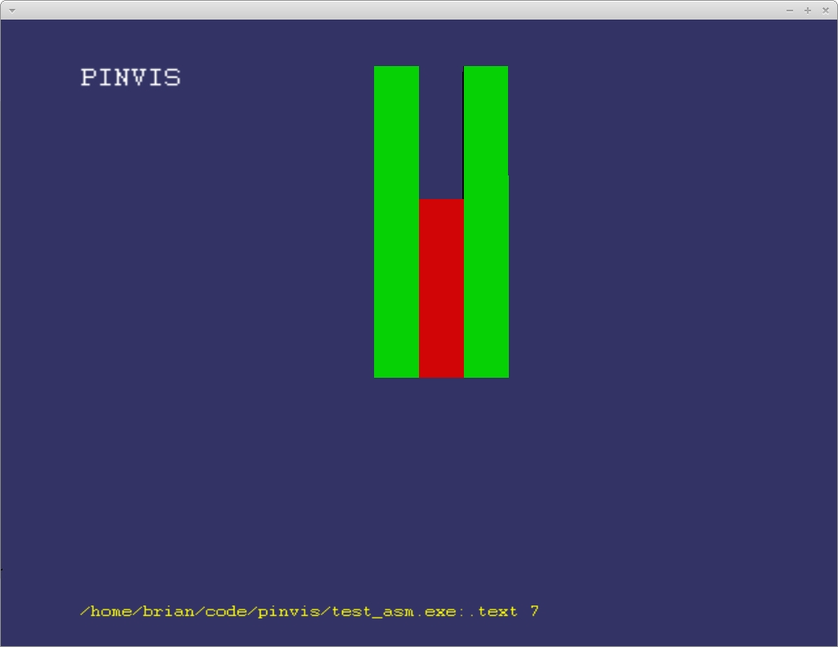
Fig 2. The assembly code example, this time in execution frequency mode. Since the first and last streams are only executed once, but the middle stream is executed twice, it is red, while the other streams are green.

For a more interesting example, we will examine a C program to multiply two 128x128 matrices and write the result to a file. In Fig. 3 the initial grid view in Pinvis is shown. Immediately it is obvious that this is a much more complex case. Most of the streams in this view come from system libraries, though. For instance the very tall solid red streams represent realloc calls. In Fig. 4 we show a view of Pinvis with all the streams from system libraries removed. This view is much more digestible. We can also see several taller streams in this view. From observing that the memory reads and writes match up across the taller streams, we can guess that the code in these streams is the same. The taller streams are the outer loops of the matrix multiplication algorithm, and the inner loops are the shorter streams. In Fig 5. we confirm this suspicion by looking at the same view in execution frequency coloring mode, which makes it immediately obvious which streams contain the triply-nested loop used to perform the actual multiplication. The innermost loop is the shortest, and it is executed more than any other stream in the program. This is an example of the kind of intuitive analysis that is possible using the Pinvis system.

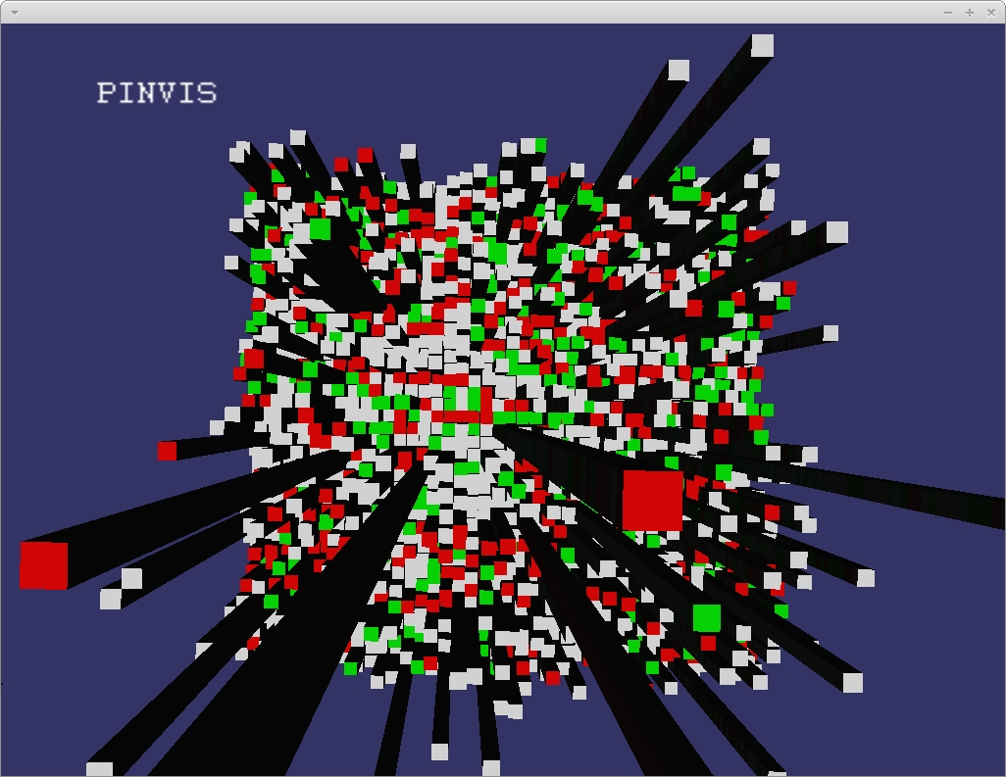
Fig. 3. Pinvis grid view of the full matrix multiplication case. Note the tall red streams which belong to realloc calls.

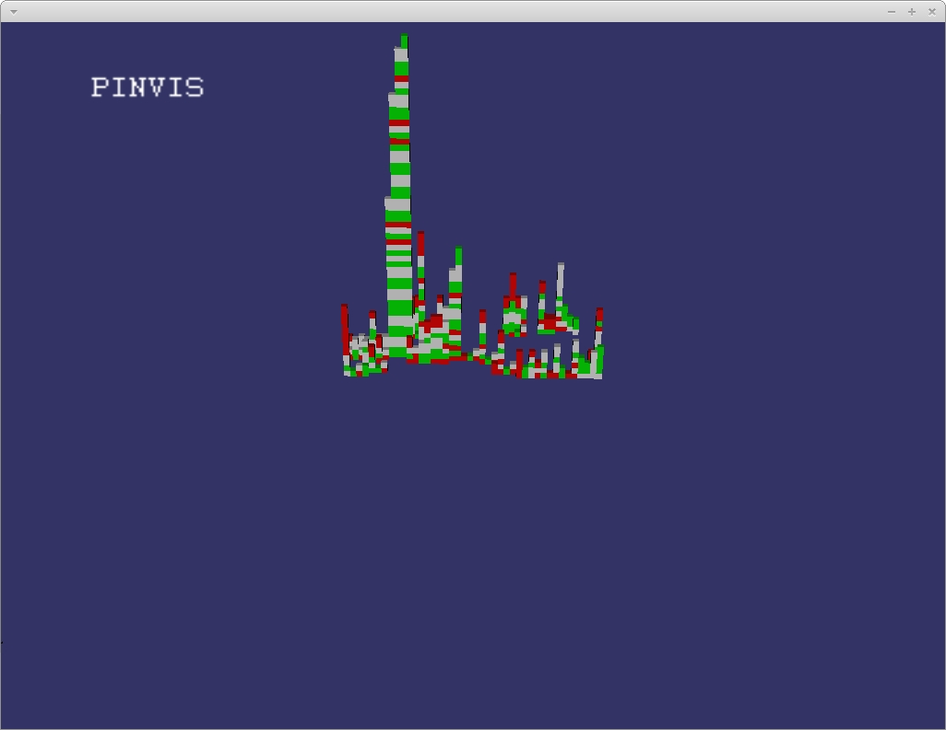
Fig 4. A filtered view of the matrix multiplication case. The tall streams represent the actual multiplication calls. By observing the matching memory/read writes we can guess that these calls belong to the nested loops: the taller streams contain outer loops and the smaller streams are inner loops.

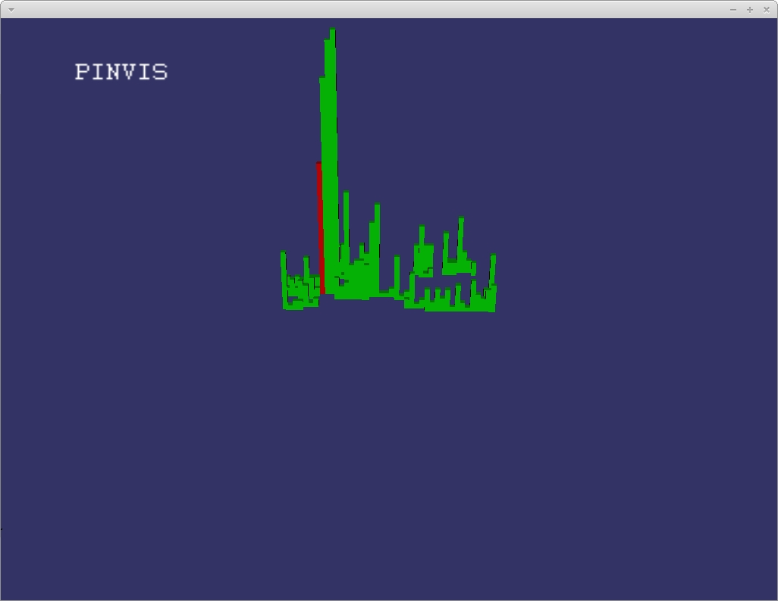
Fig 5. The filtered view of the matrix multiplication case in execution frequency coloring mode.
There are other features of the system which are difficult to convey in pictures, such as the camera control and timeline features. There is a video[5] available which demonstrates some of these features.

Related Work

Debuggers
There are a great variety of debugging tools available, which are somewhat related to the work done by Pinvis. Among the most common is the open-source gdb[6] debugger. gdb is command-line based, although a graphical version called ddd[7] is also available. Other popular debuggers include the integrated Java debugger in Eclipse[8], and Microsoft Visual Studio’s built in debugging[9]. Another interesting commercial debugger is TotalView[10], which is capable of multi-threaded debugging and other advanced features.
The main feature that Pinvis shares with these debuggers is the timeline feature. A basic function of virtually all debuggers is the ability to step through the code one statement at a time. Pinvis’s timeline feature is similar, although it operates on the stream level instead of the statement level. An interesting extension to Pinvis would be a more advanced timeline that allowed stepping into or over streams that are part of system libraries.

Performance Analysis Tools
Pinvis also has some commonalities with various performance analysis tools. The most direct connection is to Intel’s VTune[11] suite, which can be used to analyze performance of a program including multicore utilization and timeline functionality. The main difference is that VTune assumes the source code is available, and is focused exclusively on performance analysis, as opposed to uses as a learning tool.

Conclusions And Further Work
The Pinvis tool in its current state is already useful as a learning tool, and can visualize interesting elements of binary executable files that may not be readily apparently by using other tools such as debuggers or performance analysis tools.
There are many additions that could make it more useful, but were not possible due to time restrictions. One idea which may be worth pursuing is a hierarchical visualization paradigm. In the current system, a cube always represents a single instruction. However it could be interesting to start at a high level, where a cube represents one image. The user could then pick interesting images and drill down a level, where each cube would represent one function. From there interesting functions could be selected, and the next level down would display the current stream/instruction view. This would provide a dynamic level of detail that is unavailable in the current system.
There are also information sources in pin that are not currently being utilized in the visualization engine. The pintool creates a list of “next streams” for each stream: a list of all the streams that are executed after the current stream. This information could be used to generate lines connecting all related streams.
Additionally pin can identify other types of instructions that could be distinguished in the visualization engine. For instance, all return instructions and branch instructions could be highlighted in distinct colors.
The filtering system could also be improved. It would be nice to be able to filter based on function name, and filtering at the pintool level could be useful when analyzing larger executables where the output files can become quite large.

References
- Pinvis https://github.com/bpittman/pinvis
- Intel pintool http://www.pintool.org/
- OpenSceneGraph. http://www.openscenegraph.org/projects/osg
- Gnu assembler http://tigcc.ticalc.org/doc/gnuasm.html
- Pinvis youtube video http://www.youtube.com/watch?v=d8NPgr5jvN4
- gdb http://sources.redhat.com/gdb/
- ddd http://www.gnu.org/software/ddd/
- Eclipse http://www.eclipse.org/
- Microsoft Visual Studio http://www.microsoft.com/visualstudio/en-us
- Totalview http://www.roguewave.com/products/totalview.aspx
- Intel VTune Amplifier SE http://software.intel.com/en-us/articles/intel-vtune-amplifier-xe/

 

