Distributed Genetic Evaluation of Tower Defense Game Positions

Brian Pittman - CPE512 - University of Alabama in Huntsville – 12/7/2010
https://github.com/bpittman/td/

Introduction

Tower Defense games are described by Wikipedia as a "sub-genre of real-time strategy computer games. The goal is to try to stop enemies from crossing the map by building towers which shoot at them as they pass." The goal of this project was to create a small tower defense simulation and develop a distributed genetic algorithm to determine favorable tower placement locations.

The simulation consists of a closed rectangular area. Entities appear from a point on the edge of this area, and attempt to move to a goal point by using simple path-finding techniques. Towers are placed within the area to attempt to destroy the entities before they can reach the goal point. There are 3 types of towers: a long range/low damage tower, a short range/high damage tower, and a tower that temporarily slows the movement speed of the entities, but does no damage. There are a limited number of towers available to be placed. The tower positions are constrained to a rectangular grid within the simulation area, and any position that blocks the movement of entities towards the goal point is invalid. In other words, there must always exist at least one path from the start point to the goal point.

This project uses a distributed genetic algorithm to determine favorable tower positions for destroying the largest number of entities before they reach the goal point. The fitness of each placement is evaluated by running a simulation to determine how many entities reach the goal point.

The project is written in C++ and MPI and the altix.asc.edu cluster was used to test the parallel performance. Google Test Framework was used for unit testing. Hosting was provided by github.com.

Simulation Implementation

The first phase of the implementation was to create a small serial tower defense simulation code, which would be used to determine the fitness evaluations of the simulations analyzed by the genetic algorithm. This implementation was split into several classes.

- Object: Base class for towers, entities, and paths (everything that appears on the map.) Stores its position, and is responsible for determining adjacency with other objects and the distance between two objects.
- Tower: Towers are a subclass of Object. Each tower has a range, a damage value per attack, a target, and a tower type (used for runtime typing.) Primary capabilities of the Tower class are acquiring and firing at targets. SlowTower, LongTower, and ShortTower specializations exist.
- Entity: Entities are agents that attempt to move through the map from the startPoint to the goalPoint. They have health and are slowed/unslowed. They have few responsibilities, as the actual movement of entities is handled outside of this class.
- Path: Paths are objects that mark the squares of the map that entities are allowed to travel. They have no additional data or responsibilities.
- Map: The Map class stores a 2D size that marks its boundaries, lists of towers, entities, and paths that are on the map, and the startPoint and goalPoint of the map. In addition to managing all of this data, the Map is responsible for moving all entities along paths, and ensuring the validity of the position of any new item that is added. For instance, a tower cannot be added on top of a path, and an entity cannot be added off of a path. Towers cannot be on top of other towers, but entities can share a space with other entities.
- Sim: The Sim class contains a Map, and the number of towers and entities that should be used in the simulation. This class is responsible for populating the map with towers, spawning entities, and progressing the simulation one tick at a time. The Sim class can also compute the number of active entities (unspawned entities, and entities which are alive but not at the goal point), and the number of entities at the goal. BigSim is a subclass of Sim which changes the default size of the map, the number of towers, and number of entities.

Serial Genetic Algorithm Implementation

With the basic classes in place, it was time to add a serial genetic algorithm. The first step was to add mutate and crossover methods to the Sim class. When mutating the towers, the position of one tower is randomly changed. When crossing over, the tower positions of two sims are combined by randomly picking tower positions from each of the sims.

The next step was to create a td executable which performed genetic crossover/mutations on a group of Sims (up until this point the classes had only been utilized in a unit-test framework.) Td initially creates a pool of BigSims which are randomly populated with towers and simulated to determine their entitiesAtGoal.

Next, a number of iterations are performed to refine the quality of the tower positions of the sims. A tournament selection technique is used to pick some of the fittest sims (fitness in this case being measured by the lowest number of entities at the goalPoint.) The tournament-winning sims are kept, and all others deleted. Mutation and Crossover techniques are then used to refill the pool of sims, and the next iteration is started.

After a set number of iterations, the fittest sim (the sim with the fewest entitiesAtGoal) is found and printed, and the code exits.

Distributed Genetic Algorithm Implementation

With the serial implementation in place, it was time to extend td to work on multiple processors concurrently. First, the Sim class was extended to serialize tower positions to arrays that could be easily transmitted using MPI, and also deserialize such an array back into towers on the map. The number of entities at the goalPoint was also serialized and deserialized in this manner.

After that, a tdmpi executable was implemented that performs a similar genetic algorithm as its serial brother. On rank zero, a pool of BigSims is created and tournaments are used to find a fit subset. The winning sims are then scattered to all ranks, where they are mutated and crossed over by each rank independently. These permutations are then sent back to rank 0, which begins the next iteration by running tournaments and scattering out the winners.

Local tournaments run on each rank were initially considered as an option, but it was decided that better results would be obtained by running tournaments with all of the sims in one pool, instead of smaller independent sims. However, independent simulations may have cut down on communication costs enough to mitigate this downside. This is left as a future exercise.

Results/Comparisons

All results shown use the BigSim defaults of 15 towers on a 50x50 map, with 100 entities spawned 2 per tick. The startPoint was (0,0) and the goalPoint was (49,49), with a straight diagonal path between them. An interesting exercise would be to test variations on these defaults, including adding more complex paths with multiple startPoints or goalPoints.

Legend for map printouts:

. = Empty square
P = Path
E = Entity
T = Tower
H = Short Tower
L = Long Tower
W = Slow Tower
S = Start Point
G = Goal Point

Serial td best placement after 10 iterations, pool size 300:
S . . H . . . . . . . . . . . . . . . . . . . . . . . . . . . . . . . . . . . . . . . . . . . . . .

. P . . . . . . . . . . . . . . . . . . . . . . . . . . . . . . . . . . . . . . . . . . . . . . . .

. L P . . . . . . . . . . . . . . . . . . . . . . . . . . . . . . . . . . . . . . . . . . . . . . .

. . . E . . . . . . . . . . . . . . . . . . . . . . . . . . . . . . . . . . . . . . . . . . . . . .

. . . . P . . . . . . . . . . . . . . . . . . . . . . . . . . . . . . . . . . . . . . . . . . . . .

. . . . . P . . . . . . . . . . . . . . . . . . . . . . . . . . . . . . . . . . . . . . . . . . . .

. . . . . . P . . . . . . . . . . . . . . . . L . . . . . . . . . . . . . . . . . . . . . . . . . .

. . . . . . . P . . . . . . . . . . . . . . . . . . . . . . . . . . . . . . . . . . . . . . . . . .

. . . . . . . . E . . . . . . . . . . . . . . . . . . . . . . . . . . . . . . . . . . . . . . . . .

. . . . . . . . . P . . . . . . . . . . . . . . . . . . . . . . . . . . . . . . . . . . . . . . . .

. . . . . . . . . . P . . . . . . . . . . . . . . . . . . . . . . . . . . . . . . . . . . . . . . .

. . . . . . . . . . . P . . . . . . . . . . . . . . . . . . . . . . . . . . . . . . . . . . . . . .

. . . . . . . . . . . . P . . H . . . . . . . . . . . . . . . . . . . . . . . . . . . . . . . . . .

. . . . . . . . . . . . . P . . . . . . . . . . . . . . . . . . . . . . . . . . . . . . . . . . . .

. . . . . . . . . . . . . . E . . . . . . . . . . . . . . . . . . . . . . . . . . . . . . . . . . .

. . . . . . . . . . . . . . . E . . . . . . . . . . . . . . . . . . . . . . . . . . . . . . . . . .

. . . . . . . . . . . . . . . . P . . . . . . . . . . . . . . . . . . . . . . . . . . . . . . . . .

. . . . . . . . . . . . . . . . . P . . . . . . . . . . . . . . . . . . . . . . . . . . . . . . . .

. . . . . . . . . . . . . . . . . . E . . H . . . . . . . . . . . . . . . . . . . . . . . . . . . .

. . L . . . . . . . . . . . . . . . . E . . . . . . . . . . . . . . . . . . . . . . . . . . . . . .

. . . . . . . . . . . . . . . . . . . . P . . . . . . . . . . . . . . . . . . . . . . . . . . . . .

. . . . . . . . . . . . . . . . . . . . . E . . . . . . . . . . . . . . . . . . . . . . . . . . . .

. . . . . . . . . . . . . . . . . . . . . . P . . . . . . . . . . . . . . . . . . . . . . . . . . .

. . . . . . . . . . . . . . . . . . . . . . . P . . . . . . . . . . . . . . . . . . . . . . . . . .

. . . . . . . . . . . . . . . . . . . . . . . . E . . . . . . . . . . . . . . . . . . . . . . . . .

. . . . . . . . . . . . . . . . . . . . . . . . . P . . . L . . . . . . . . . . . . . . . . . . . .

. . . . . . . . . . . . . . . . . . . . . . . . . . P H . . . . . L . . . . . . . . . . . . . . . .

. . . . . . . . . . . . . . . . . . . . . . . . . . . E . . . . . . . . . . . . . . . . . . . . . .

. . . . . . . . . . . . . . . . . . . . . . . . . . . . P . . . . . . . . . . . . . . . . . . . . .

. . . . . . . . . . . . . . . . . . . . . . . . . . . . . P . . . . . . . . . . . . . . . . . . . .

. . . . . . . W . . . . . . . . . . . . . . . . . . . . . . P . . . L . . . . . . . . . . . . . . .

. . . . . . . . . . . . . . . . . . . . . . . . . . . . . . . P . . . . . . . . . . . . . . . . . .

. . . . . . . . . . . . . . . . . . . . . . . . . . . . . . . . E . . . . . . . . . . . . . . . . .

. . . . . . . . . . . . . . . . . . . . . . . . . . . . . . . . . E . . . . . . . . . . . . . . . .

. . . . . . . . . . . . . . . . . . . . . . . . . . . . . . . . . . E . . . . . . . . . . . . . . .

. . . . . . . . . . . . . . . . . . . . . . . . . . . . . . . . . . . P . . . . . . . . . . . . . .

. . . . . . . . . . . . . . . . . . . . . . . . . . . . . . . . . . . . P . . . . . . . . . . . . .

. . . . . . . . . . . . . . . . . . . . . . . . . . . . . . . . . . . . . P . . . . . . . . . . . .

. . . . . . . . . . . . . . . . . . . . . . . . . . . . . . . L . . . . . . P . . . . . . . . . . .

. . . . . . . . . . . . . . . . . . . . . . . . . . . . . . . . . . . . . . . P . . . . . . . . . .

. . . . . . . . . . . . . . . . . . . . . . . . . . . . . . . . . . . . . . . . P . . . . . . . . .

. . . . . . . . . . . . . . . . . . . . . . W . . . . . . . . . . . . . . . . . . P . . H . . . . .

. . . . . . . . . . . . . . . . . . . . . . . . . . . . . . . . . . . . . . . . . . E . . . . . . .

. . . . . . . . . . . . . . . . . . . . . . . . . . . . . . . . . . . . . . . . . . . E . . . . . .

. . . . . . . . . . . . . . . . . . . . . . . . . . . . . . . . . . . . . . . . . . . . E . . . . .

. . . . . . . . . . . . . . . . . . . . . . . . . . . . . . . . . . . . . . . . . . . . . E . . . .

. . . . . . . . . . . . . . . . . . . . . . . . . . . . . . . . . . . . . . . . . . . H . . P . . .

. . . . . . . . . . . . . . . . . . . . . . . . . . . . . . . . . . . . . . . . . . . . . . . P . .

. . . . . . . . . . . . . . . . . . . . . . . . . . . . . . . . . . . . . . . . . . . . . . . . P .

. . . . . . . . . . . . . . . . . . . . . . . . . . . . . . . . . . . . . . . . . . . . . . . . . G

This placement allows 42 of 100 entities to reach the goalPoint.

2 Processor tdmpi best placement after 10 iterations, pool size 600:
S . . . . . . . . . . . . . . . . . . . . . . . . . . . . . . . . . . . . . . . . . . . . . . . . .

. P . . . . . . . . . . . . . . . . . . . . . . . . . . . . . . . . . . . . . . . . . . . . . . . .

. . P . . . . . . . . . . . . . . . . . . . . . . . . . . . . . . . . . . . . . . . . . . . . . . .

. . . P . . . H . . . . . . . . . . . . . . . . . . . . . . . . . . . . . . . . . . . . . . . . . .

. . . . P . . . . . . . . . . . . . . . . . . . . . . . . . . . . . . . . . . . . . . . . . . . . .

. . . . . P . . . . . . . . . . . . . . . . W . . . . . . . . . . . . . . . . . . . . . . . . . . .

. . . . . . P . . . . . . . . . . . . . . . . . . . . . . . . . . . . . . . . . . . . . . . . . . .

. . . . . . . P . . . . . . . . . . . . . . . . . . . . . . . . . . . . . . . . . . . . . . . . . .

. . . . . . . . P . . . . . . . . . . . . . . . . . . . . . . . . . . . . . . . . . . . . . . . . .

. . . . . . . . . P . . . . . . . . . . . . . . . . . . . . . . . . . . . . . . . . . . . . . . . .

. . . . . . . . . . P . . . . . . . . . . . . . . . . . . . . . . . . . . . . . . . . . . . . . . .

. . . . . . . . . . . P . . . . . . . . . . . . . . . . . . . . . . . . . . . . . . . . . . . . . .

. . . . . . . . . . . . P . . . . . . . . . . . . . . . . . . . . . . . . . . . . . . . . . . . . .

. . . . . . . . . . . . . P . . . . . . . . . . . . . . . . . . . . . . . . . . . . . . . . . . . .

. . . . . . . . . . . . . . P . . . . . . . . . . . . . . . . . . . . . . . . . . . . . . . . . . .

. . . . . . . . . . . . . . . P . . . . . . . . . . . . . . . . . . . . . . . . . . . . . . . . . .

. . . . . . . . . . . . . . . H P . . . . . . . . . . . . . . . . . . . . . . . . . . . . . . . . .

. . . . . . . . . . . . . . . . . P . L . . . . . . . . . . . . . . . . . . . . . . . . . . . . . .

. . . . . . . . . . . . . . . . . . P . . . . . . . . . . . . . . . . . . . . . . . . . . . . . . .

. . . . . . . . . . . . . . . . . . . P . . . . . . . . . . . . . . . . . . . . . . . . . . . . . .

. . . . . . . . . . . . . . . . . . . . P . . . H . . . . . . . . . . . . . . . . . . . . . . . . .

. . . . . . . . . . . . . . . . . . . . . P . . . . . . . . . . . . . . . . . . . . . . . . . . . .

. . . . . . . . . . . . . . . . . . . . . . P . . . . . . . . . . . . . . . . . . . . . . . . . . .

. . . . . . . . . . . . . . . . . . . . . . . P . . . . . . . . . . . . . . . . . . . . . . . . . .

. . . . . . . . . . . . . . . . . . . . . . . . P . . . . . . . . . . . . . . . . . . . . . . . . .

. . . . . . . . . . . . . . . . . . . . . . . . . P . . . . . . . . . . . . . . . . . . . . . . . .

. . . . . . . . . . . . . . . . . . . . . . . . . . P . . . . . . . . . . . . . . . . . . . . . . .

. . . . . . . . . . . . . . . . . . . . . L . . H . . P . . . L . . . . . . . . . . . . . . . . . .

. . . . . . . . . . . . . . . . . . . . . . . W . . . . P . . . . . . . . . L . . . . . . . . . . .

. . . . . . . . . . . . . . . . . . . . . . . . . . . . . P . L . . . . . . . . . . . . . . . . . .

. . . . . . . . . . . . . . . . . . . . . . . . . . . . . . P . . . . . . . . . . . . . . . . . . .

. . . . . . . . . . . . . . . . . . . . . . . . . . . . . . . P . . . L . . . . . . . . . . . . . .

. . . . . . . . . . . . . . . . . . . . . . . . . . . . . . . . P . . . . . . . . . . . . . . . . .

. . . . . . . . . . . . . . . . . . . . . . . . . . . . . . . . . P . . . . . . . . . . . . . . . .

. . . . . . . . . . . . . . . . . . . . . . . . . . . . . . . . . . P . . . . . . . . . . . . . . .

. . . . . . . . . . . . . . . . . . . . . . . . . . . . L . . . . H . P . . . . . . . . . . . . . .

. . . . . . . . . . . . . . . . . . . . . . . . . . . . . . . . . H . . P . . . . . . . . . . . . .

. . . . . . . . . . . . . . . . . . . . . . . . . . . . . . . . . . . . . P . . . . . . . . . . . .

. . . . . . . . . . . . . . . . . . . . . . . . . . . . . . . . . . . . . . P . . . . . . . . . . .

. . . . . . . . . . . . . . . . . . . . . . . . . . . . . . . . . . . . . . . P . . . . . . . . . .

. . . . . . . . . . . . . . . . . . . . . . . . . . . . . . . . . . . . . . . . P . . . . . . . . .

. . . . . . . . . . . . . . . . . . . . . . . . . . . . . . . . . . . . . . . . . P . . . . . . . .

. . . . . . . . . . . . . . . . . . . . . . . . . . . . . . . . . . . . . . . . . . P . . . . . . .

. . . . . . . . . . . . . . . . . . . . . . . . . . . . . . . . . . . . . . . . . . . P . . . . . .

. . . . . . . . . . . . . . . . . . . . . . . . . . . . . . . . . . . . . . . . . . . . P . . . . .

. . . . . . . . . . . . . . . . . . . . . . . . . . . . . . . . . . . . . . . . . . . . . P . . . .

. . . . . . . . . . . . . . . . . . . . . . . . . . . . . . . . . . . . . . . . . . . . . . P . . .

. . . . . . . . . . . . . . . . . . . . . . . . . . . . . . . . . . . . . . . . . . . . . . . P . .

. . . . . . . . . . . . . . . . . . . . . . . . . . . . . . . . . . . . . . . . . . . . . . . . P .

. . . . . . . . . . . . . . . . . . . . . . . . . . . . . . . . . . . . . . . . . . . . . . . . . G

This placement allows 27 of 100 entities to reach the goalPoint.

4 Processor tdmpi best placement after 10 iterations, pool size 1200:
S . . . . . . . . . . . . . . . . . . . . . . . . . . . . . . . . . . . . . . . . . . . . . . . . .

. P . . . . . . . . . . . . . . . . . . . . . . . . . . . . W . . . . . . . . . . . . . . . . . . W

. . P . . . . . . . . . . . . . . . . . . . . . . . . . . . . . . . . . . . . . . . . . . . . . . .

. . . P . . . . . . . . . . . . . . . . . . . . . . . . . . . . . . . . . . . . . . . . . . . . . .

. H . . P . . H . . . . . . . . . . . . . . . . . . . . . . . . . . . . . . . . . . . . . . . . . .

. . . . . P . . . . . . . . . . . . . . . . . . . . . . . . . . . . . . . . . . . . . . . . . . . .

. . . . . . P . . . . . . . . . . . . . . . . . . . . . . . . . . . . . . . . . . . . . . . . . . .

. . . . . . . P . . . . . . . . . . . . . . . . . . . . . . . . . . . . . . . . . . . . . . . . . .

. . . . . . . . P . . . . . . . . . . . . . . . . . . . . . . . . . . . . . . . . . . . . . . . . .

. . . . . . . . . P . . . . . . . . . . . . . . . . . . . . . . . . . . . . . . . . . . . . . . . .

. . . . . . . . . . P . . . . . . . . . . . . . . . . . . . . . . . . . . . . . . . . . . . . . . .

. . . . . . . . . . . P . . . . . . . . . . . . . . . . . . . . . . . . . . . . . . . . . . . . . .

. . . . . . . . . . . . P . . . . . . . . . . . . . . . . . . . . . . . . . . . . . . . . . . . . .

. . . . . . . . . . . . . P . . . . . . . . . . . . . . . . . . . . . . . . . . . . . . . . . . . .

. . . . . . . . . . . . . . P . . . . . . . . . . . . . . . . . . . . . . . . . . . . . . . . . . .

. . . . . . . . . . . . . . . P . L . . . . . . . . . . . . . . . . . . . . . . . . . . . . . . . .

. . . . . . . . . . . . . . . . P . . . . . . . . . . . . . . . . . . . . . . . . . . . . . . . . .

. . . . . . . . . . . . . . . . . P . . . . . . . . . . . . . . . . . . . . . . . . . . . . . . . .

. . . . L . . . . . . . . . . . . . P . . . . . . . . . . . . . . . . . . . . . . . . . . . . . . .

. . . . . . . . . . . L . . . . . . . P . . . . . . . . . . . . . . . . . . . . . . . . . . . . . .

. . . . . . . . . . . . . . . . . . . . P . . . . . . . . . . . . . . . . . . . . . . . . . . . . .

. . . . . . . . . . . . . . . . . . . . . P . . . . . . . . . . . . . . . . . . . . . . . . . . . .

. . . . . . . . . . . . . . . . . . . . . . P . . . . . . . . . . . . . . . . . . . . . . . . . . .

. . . . . . . . . . . . . . . . . . . . . . . P . . . . . . . . . . . . . . . . . . . . . . . . . .

. . . . . . . . . . . . . . . . . . . . . . . . P . . . H . . . . . . . . . . . . . . . . . . . . .

. . . . . . . . . . . . . . . . . . . . . . . . . P . . . . . . . . . . . . . . . . . . . . . . . .

. . . . . . . . . . . . . . . . . . . . . . . . . . P . . . . . . . . . . . . . . . . . . . . . . .

. . . . . . . . . . . . . . . . . . . . . . . . . . . P . . . . . . . . . . . . . . . . . . . . . .

. . . . . . . . . . . . . . . . . . . . . . . . . . . . P . . . . . . . . . . . . . . . . . . . . .

. . . . . . . . . . . . . . . . . . . . . . . . . . . . . P . . . . . . . . . . . . . . . . . . . .

. . . . . . . . . . . . . . . . . . . . . . . . . . . . . . P . . . . . . . . . . . . . . . . . . .

. . . . . . . . . . . . . . . . . . . . . . . . . . . . . . . P . . . . . . . . . . . . . . . . . .

. . . . . . . . . . . . . . . . . . . . . . . . . . . . . . . . P . . . . . . . . . . . . . . . . .

. . . . . . . . . . . . . . . . . . . . . . . . . . . . . . . . . P . . . . . . . . . . . L . . . .

. . . . . . . . . . . . . . . . . . . . . . . . . . . . . . . . L H P . L . . . . . . . . . . . . .

. . . . . . . . . . . . . . . . . . . . . . . . . . . . . . . . . . . P . . . . . . . . . . . . . .

. . . . . . . . . . . . . . . . . . . . . . . . . . . . . . . . . . . . P . . . . . . . . . . . . .

. . . . . . . . . . . . . . . . . . . . . . . . . . . . . . . . . . . . . P . . . . . . . . . . . .

. . . . . . . . . . . . . . . . . . . . . . . . . . . . . . . . . . . . . . P . . . . . . . . . . .

. . . . . . . . . . . . . . . . . . . . . . . . . . . . . . . . . . . . . . . P . . H . . . . . . .

. . . . . . . . . . . . . . . . . . . . . . . . . . . . . . . . . . . . L . . . P . . . . . . . . .

. . . . . . . . . . . . . . . . . . . . . . . . . . . . . . . . . . . . . . . . . P . . . . . . . .

. . . . . . . . . . . . . . . . . . . . . . . . . . . . . . . . . . . . . . . . . H P . . . . . . .

. . . . . . . . . . . . . . . . . . . . . . . . . . . . . . . . . . . . . . . . . . . P . . . . . .

. . . . . . . . . . . . . . . . . . . . . . . . . . . . . . . . . . . . . . . . . . . . P . . . . .

. . . . . . . . . . . . . . . . . . . . . . . . . . . . . . . . . . . . . . . . . . . . . P . . . .

. . . . . . . . . . . . . . . . . . . . . . . . . . . . . . . . . . . . . . . . . . . . . . P . . .

. . . . . . . . . . . . . . . . . . . . . . . . . . . . . . . . . . . . . . . . . . . . . . . P . .

. . . . . . . . . . . . . . . . . . . . . . . . . . . . . . . . . . . . . . . . . . . . . . . . P .

. . . . . . . . . . . . . . . . . . . . . . . . . . . . . . . . . . . . . . . . . . . . . . . . . G

This placement allows 24 of 100 entities to reach the goalPoint.

8 Processor tdmpi best placement after 10 iterations, pool size 2400:
S . . . . . . . . . . . . . . . . . . . . . . . . . . . . . . . . . . . . . . . . . . . . . . . . .

. P . . . . . . . . . . . . . . . . . . . . . . . . . . . . . . . . . . . . . . . . . . . . . . . .

. . P . . . . . . . . . . . . . . . . . . . . . . . . . . . . . . . . . . . . . . . . . . . . . . .

. . . P . . . . . . . . . . . . . . . . . . . . . . . . . . . . . . . . . . . . . . . . . . . . . .

. . . . P . . . . . . . . . . . . . . . . . . . . . . . . . . . . . . . . . . . . . . . . . . . . .

. . . . . P . . . . . . . . . . . . . . . . . . . . . . . . . . . . . . . . . . . . . . . . . . . .

. . . . L . P . . . . . . . . . . . . . . . . . . . . . . . . . . . . . . . . . . . . . . . . . . .

. . . . . . . P . . . . . . . . . . . . . . . . . . . . . . . . . . . . . . . . . . . . . . . . . .

. . . . . . . . P . . . . L . . . . . . . . . . . . . . . . . . . . . . . . . . . . . . . . . . . .

. . . . . . . . . P . . . . . . . . . . . . . . . . . . . . . . . . . . . . . . . . . . . . . . . .

. . . . . . . . . . P . . . . . . . . . . . . . . . . . . . . . . . . . . . . . . . . . . . . . . .

. . . . . . . . . . . P . . . . . . . . . . . . . . . . . . . . . . . . . . . . . . . . . . . . . .

. . . . . . . . . . . . P . . . . . . . . . . . . . . . . . . . . . . . . . . . . . . . . . . . . .

. . . . . . . . . . . . . P . . . . . . . . . . . . . . . . . . . . . . . . . . . . . . . . . . . .

. . . . . . . . . . . . . . P . . . . . . . . . . . . . . . . . . . . . . . . . . . . . . . . . . .

. . . . . . . . . . . . . . . P . . L . . . . . . . . . . . . . . . . . . . . . . . . . . . . . . .

. . . . . . . . . . . . . . . . P . . . . . . . . . . . . . . . . . . . . . . . . . . . . . . . . .

. . . . . . . . . . . . . . . . . P . . . . . . . . . . . . . . . . . . . . . . . . . . . . . . . .

. . . . . . . . . . . . . . . . . . P . . . . . . . . . . . . . . . . . . . . . . . . . . . . . . .

. . . . . . . . . . . . . . . . . . . P . . H . . . . . . . . . . . . . . . . . . . . . . . . . . .

. . . . . . . . . . . . . . . . . . . . P . . . . . . . . . . . . . . . . . . . . . . . . . . . . .

. . . . . . . . . . . . . . . . . . . . . P . . . . . . . . . . . . . . . . . . . . . . . . . . . .

. . . . . . . . . . . . . . . . . . . . . . P . . . . . . . . . . . . . . . . . . . . . . . . . . .

. . . . . . . . . . . . . . . . . . . . . . . P . . . . . . . . . . . . . . . . . . . . . . . . . .

. . . . . . . . . . . . . . . . . . . . . . . . P . . . . . . . . . . . . . . . . . . . . . . . . .

. . . . . . . . . . . . . . . . . . . . . . . . . P . . . . . . . . . . . . . . . . . . . . . . . .

. . . . . . . . . . . . . . . . . . . . . . . H . . P . . . . . . . . . . . . . . . . . . . . . . .

. . . . . . . . . . . . . . . . . . . . . . . . . . . P . . . . . . . . . . . . . . . . . . . . . .

. . . . . . . . . . . . . . . . . . . . . . . . . . . . P H . . . . . . . . . . . . . . . . . . . .

. . . . . . . . . . . W . . . . . . . . . . . . . . . . . P . . . . . . . . . . . . . . . . . . . .

. . . . . . . . . . . . . . . . . . . . . . . . . . . . . . P . . . . . . . . . . . . . . . . . . .

. . . . . . . . . W . . . . . . . . . . . . . . . . . . . . . P . H . . . . . . . . . . . . . . . .

. . . . . . . . . . . . . . . . . . . . . . . . . . . . . . . . P . . . . . . . . . . . . . . . . .

. . . . . . . . . . . . . . . . . . . . . . . . . . . . . . . . . P . . . . . . . . . . . . . . . .

. . . . . . . . . . . . . . . . . . . . . . . . . . . . . . . . . . P . L . . . . . . . . . . . . .

. . . . . . . . . . . . . . . . . . . . . . . . . . . . . . . . . . . P . L . . . . . . . . . . . .

. . . . . . . . . . . . . . . . . . . . . . . . . . . . . . . . . . . L P . . . . . . . . . . . . .

. . . . . . . . . . . . . . . . . . . . . . . . . . . . . . . . . . . . . P . . . . . . . . . . . .

. . . . . . . . . . . . . . . . . . . . . . . . . . . . . . . . . . . . . . P . . . . . . . . . . .

. . . . . . . . . . . . . . . . . . . . . . . . . . . . . . . . . . . . . . . P H . H . . . . . . .

. . . . . . . . . . . . . . . . . . . . . . . . . . . . . . . . . . . . . L . . P . . . . . . . . .

. . . . . . . . . . . . . . . . . . . . . . . . . . . . . . . . . . . . . . . . . P . . . . . . . .

. . . . . . . . . . . . . . . . . . . . . . . . . . . . . . . . . . . . . . . . . . P . . . . . . .

. . . . . . . . . . . . . . . . . . . . . . . . . . . . . . . . . . . . . . . . . . . P . . . . . .

. . . . . . . . . . . . . . . . . . . . . . . . . . . . . . . . . . . . . . . . . . . . P . . . . .

. . . . . . . . . . . . . . . . . . . . . . . . . . . . . . . . . . . . . . . . . . . . . P . . . .

. . . . . . . . . . . . . . . . . . . . . . . . . . . . . . . . . . . . . . . . . . . . . . P . . .

. . . . . . . . . . . . . . . . . . . . . . . . . . . . . . . . . . . . . . . . . . . . . . . P . .

. . . . . . . . . . . . . . . . . . . . . . . . . . . . . . . . . . . . . . . . . . . . . . . . P .

. . . . . . . . . . . . . . . . . . . . . . . . . . . . . . . . . . . . . . . . . . . . . . . . . G

This placement allows 21 of 100 entities to reach the goalPoint.

The results show that the optimal placement is to put the towers as close to the path as possible. More interesting path configurations may reveal more interesting optimal tower structures, but this is left as a future exercise.

Another interesting note is that the slow towers do not seem to have much effect on the fitness of the position, as they are often left far away from the path. A future implementation might allow adjusting the length of time an entity is slowed, to see if this has an effect. Another possible issue with the slow towers is the targeting method. Currently the towers all target the closest available target, but in the case of the slow tower it might make more sense to target entities that are on the far end of the range.

The fact that entities are shown on the serial map but not the parallel maps is an artifact of the serialization/deserialization process. Only towers and the number of entities at the goalPoint are saved when sending sims between ranks.

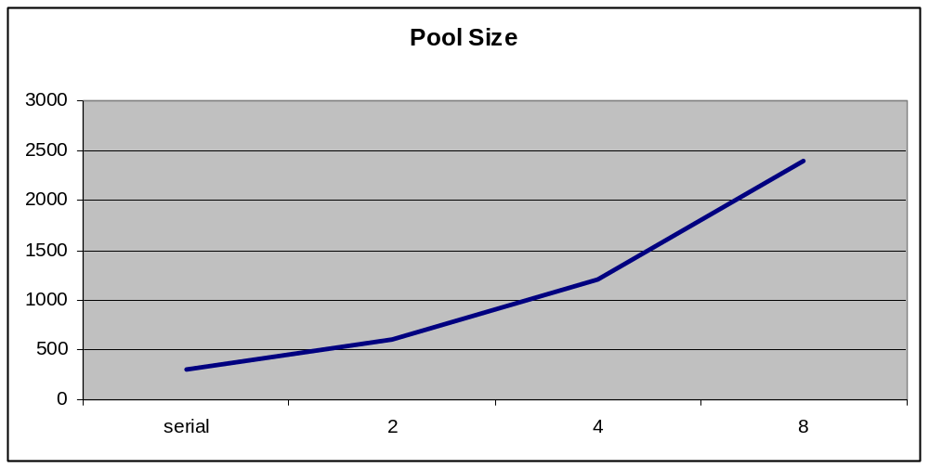

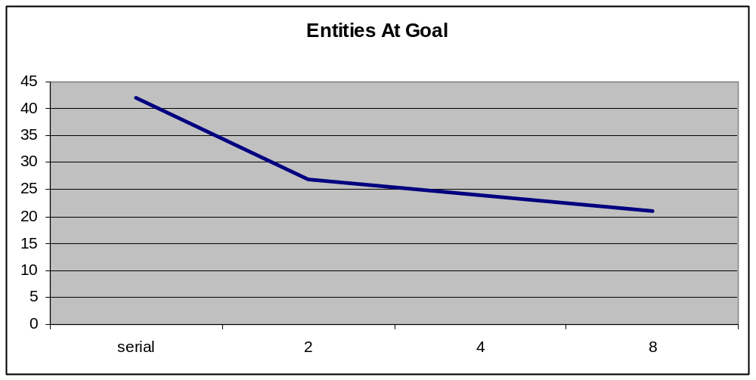
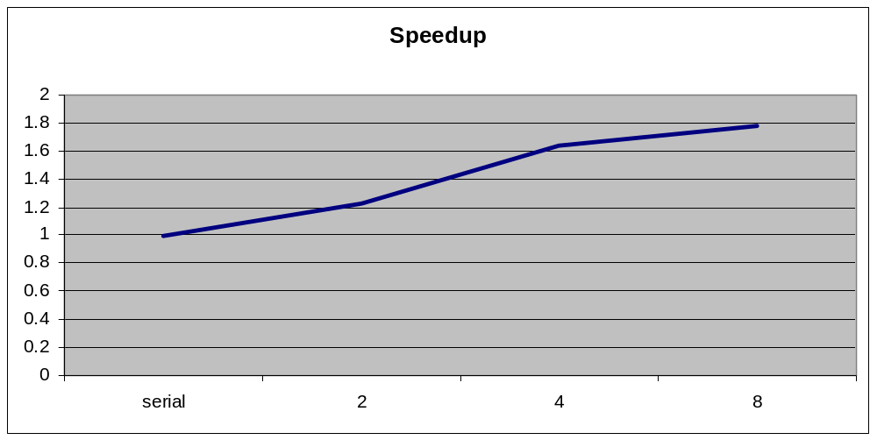

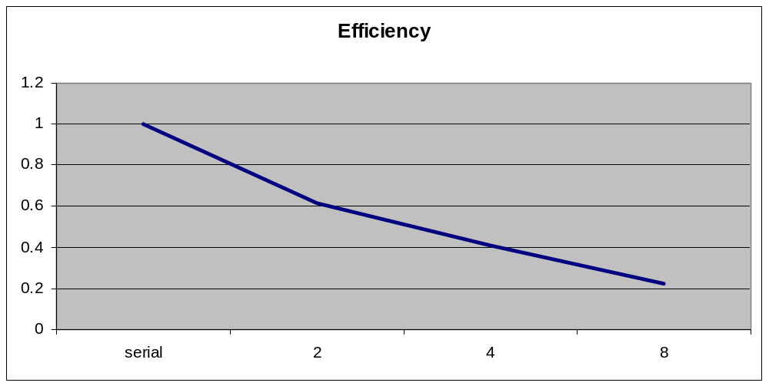

The “Pool Size” chart displays the total number of simulations considered per iteration, for each of the serial, 2 process, 4 process, and 8 process runs. Each additional processor adds another 300 sims per iteration.

In the “Entities At Goal” chart, it can be seen that the number of entities that reach the goal point decreases as the number of processors increases. This makes sense, as the number of simulations considered increases as the number of processors increases, and a larger pool of simulations should lead to fitter solutions.

For the speedup and efficiency calculations, the times are divided by the pool size before the calculations are performed. This is because the different runs are performing different amounts of work, so a straight comparison is not very informative. Modest speedups are noted once this is taken into account, however it seems the communication overhead is significant. Performing tournaments locally and only sending the winners back to the root process could help with this. Another possible bottleneck is the fact that the scatter/gather operations are synchronous. A scheme where a rolling pool on rank 0 is maintained that sends/receives new simulations to the other ranks as needed could possibly be more efficient.

Conclusions

Overall, the project succeeded in the goal of creating a distributed tower defense position evaluation algorithm. Some speedup was shown, but there are bottlenecks that could be addressed in the parallel performance. It was also shown that the quality of results impoved as the number of simulations increased, although the improvement seems to level off somewhat at 8 processors.

There is definitely room for further study on this topic, especially in the area of more complex paths or larger maps with more entities. These would probably yield more interesting tower distribution patterns. Other improvements could involve local tournaments run on each rank, instead of the current centralized rank 0 tournament method. This could lead to better speedup and greater efficiency.

