# Phishing Risk Analysis Report – info@artdarshan.com

## Summary

The email address info@artdarshan.com appears to belong to a small business website (artdarshan.com) that sells art and craft products. The domain seems legitimate based on public website presence, but we cannot confirm if emails sent from this address are genuine without checking technical details like SPF, DKIM, and DMARC records. Therefore, the email should be treated as suspicious until verification.

## Website Check

The website artdarshan.com is active and contains product pages, an About Us section, and a Privacy Policy. This suggests it might be a real business site. However, a working website alone does not confirm that all emails from its domain are safe or legitimate.

## Recommended Technical Checks

Before trusting an email from this domain, the following checks should be done:  
1. SPF Record – ensures authorized servers can send mail for the domain.  
2. DKIM Record – verifies the message was not changed during transmission.  
3. DMARC Policy – defines what happens when SPF/DKIM checks fail.  
4. WHOIS – shows who owns the domain and when it was created.  
5. Blacklist Check – ensures the domain or IP is not reported for spam or phishing.  
6. TLS Certificate – check if the website uses a valid HTTPS certificate.

## Risk Assessment

Without the above verification, the risk level is considered MEDIUM. The site looks legitimate but there is no proof that the emails actually come from that domain. Attackers can spoof email addresses easily.

**Screenshot**

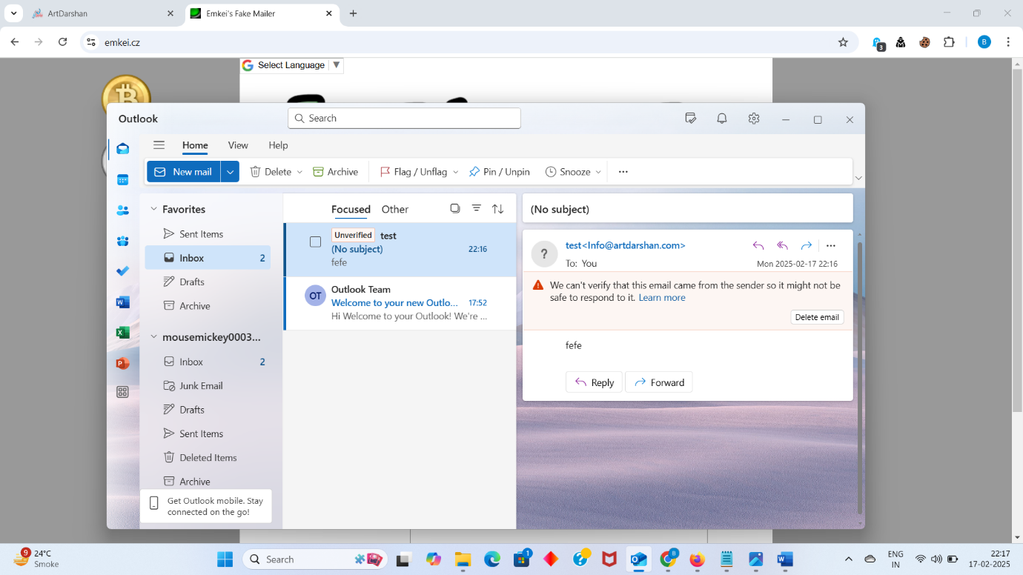

## Recommendations

- Do not click any links or open attachments from emails claiming to be from info@artdarshan.com unless verified.  
- If the message asks for sensitive details like passwords, OTP, or payments, treat it as phishing.  
- Verify by visiting https://artdarshan.com directly and contacting the business through their official contact page.  
- Run SPF, DKIM, and DMARC lookups on MXToolbox or dmarcian to confirm authentication.  
- Report any suspicious emails to your IT or security team.

## Conclusion

The domain artdarshan.com appears legitimate as an art and craft site, but emails from info@artdarshan.com should be verified using SPF/DKIM/DMARC checks before trusting. Treat unsolicited or unexpected messages as potentially suspicious until proven safe.

Reported by,

Bhakti Pathak.