Assignment 2
Software Engineering Lab (CS 331)
Use Case Diagrams
Automated Document Classification and Routing System

1. Introduction
This document presents the use case diagrams for the Automated Document Classification and Routing System. The system is designed to automate the sorting and routing of business documents using machine learning and optical character recognition (OCR) technologies.
The diagrams illustrate the interactions between different actors (users and external systems) and the various functionalities of the system. Each use case represents a specific goal or task that can be accomplished through the system.

Step 1: Identified Use Cases
Based on the Software Requirements Specification (SRS) document, the following use cases have been identified:

1.1 Primary Use Cases
The system supports the following primary use cases:
UC ID | Use Case Name | Description
UC-01 | Upload Documents | User uploads documents to the input directory or email inbox for processing
UC-02 | Monitor Input Directory | System continuously monitors input directory for new documents
UC-03 | Pre-process Document | System enhances document images through grayscale conversion and skew correction
UC-04 | Extract Text (OCR) | System extracts text from documents using Easy OCR for classification
UC-05 | Classify Document | System classifies document type using ML model with confidence score
UC-06 | Route Document | System automatically routes document to appropriate department folder
UC-07 | Quarantine Low-Confidence Documents | System moves documents with confidence below 80% to quarantine folder
UC-08 | Review Quarantined Documents | Human operator reviews and manually classifies quarantined documents
UC-09 | Approve/Correct Classification | Operator approves AI classification or corrects document category
UC-10 | Log Processing Activity | System logs all document processing activities to database for audit trail
UC-11 | Handle Error Documents | System moves corrupt or unreadable documents to error folder and continues
UC-12 | View Processing Dashboard | User accesses verification dashboard to monitor system activity and stats
UC-13 | Configure System Settings | Admin configures folder mappings, confidence thresholds in config.yaml
UC-14 | Flag for Model Retraining | Operator flags misclassified documents to improve ML model training

Step 2: Identified Actors
The following actors have been identified who interact with the system:
Actor | Description
Document Submitter | External user who uploads documents to the system for processing. This could be employees, clients, or automated systems sending files via email or file upload.
Human Operator | Internal staff member who reviews quarantined documents through the verification dashboard. They manually classify documents when the AI confidence is low and flag items for retraining.
System Administrator | IT personnel responsible for configuring the system, setting up folder mappings, adjusting confidence thresholds, and maintaining the technical infrastructure.
File System | External system component that provides input directories and destination folders. Could be local storage or network-mounted drives.
Email Server | External system that acts as an alternative input source, allowing documents to be submitted via email attachments for automatic processing.
Database System | External storage system (SQLite or PostgreSQL) that maintains audit logs of all document processing activities and system events.
OCR Engine | External service component (Easy OCR or Tesseract) that provides text extraction capabilities from image-based documents and scanned PDFs.
ML Classification Model | External AI component (PyTorch-based) that analyzes document content and assigns classification labels with confidence scores.

3. Use Case Diagrams
The following diagrams illustrate the behavioral aspects of the Automated Document Classification and Routing System. Each diagram shows the relationships between actors and use cases, including associations, include relationships, and extend relationships where applicable.

3.1 Overall System Use Case Diagram
This diagram provides a comprehensive view of all use cases in the Automated Document Classification and Routing System. It shows the interactions between all primary actors (Document Submitter, Human Operator, System Administrator) and secondary actors (File System, Email Server, Database System, OCR Engine, ML Model) with their respective use cases.
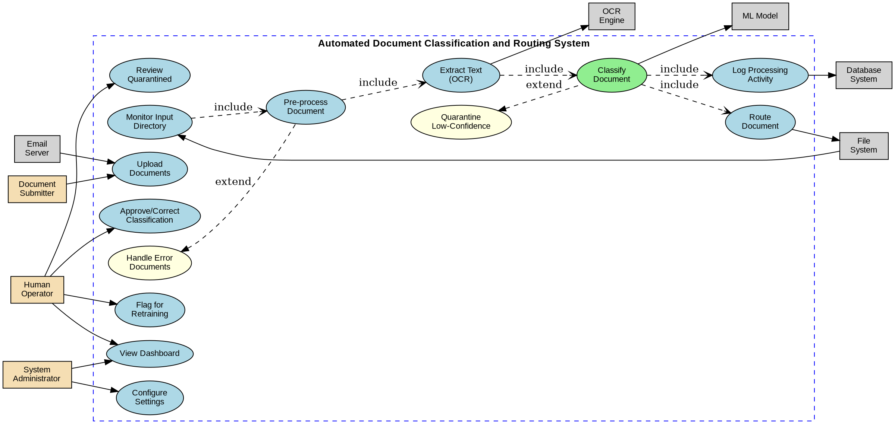

3.2 Document Processing Pipeline Use Case Diagram
This diagram focuses on the core document processing workflow. It illustrates how documents flow through the system from monitoring the input directory, through pre-processing and OCR text extraction, to classification by the ML model, and finally to routing to the appropriate destination. The diagram also shows the error handling mechanism for corrupt files.
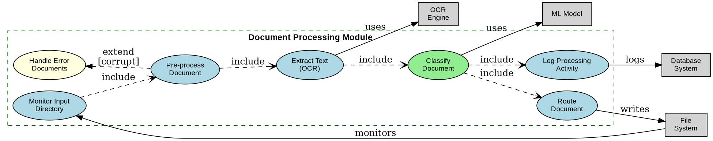

3.3 Human Verification Module Use Case Diagram
This diagram details the human-in-the-loop verification process. When the ML model has low confidence (below 80%), documents are quarantined for manual review. The Human Operator can view these documents through the dashboard, approve or correct classifications, and flag items for model retraining when misclassifications are detected.
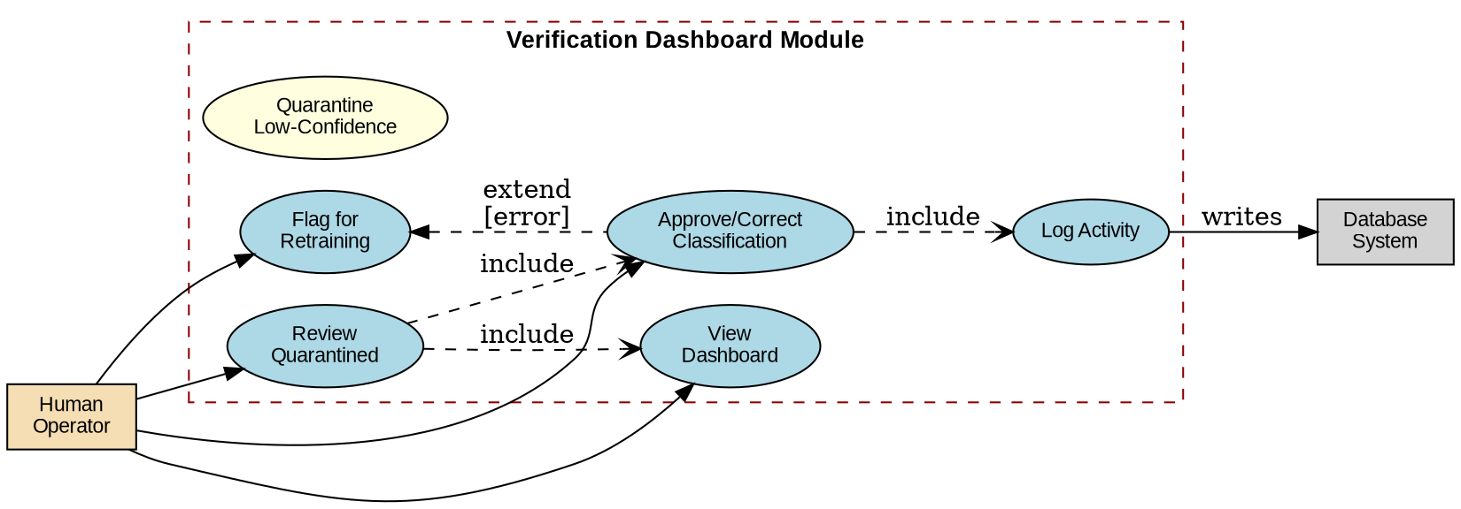

3.4 System Configuration Module Use Case Diagram
This diagram shows the administrative configuration capabilities of the system. The System Administrator can configure folder mappings that determine where different document types are routed, adjust the confidence threshold for automatic classification, and configure which OCR engine to use (Easy OCR or Tesseract).
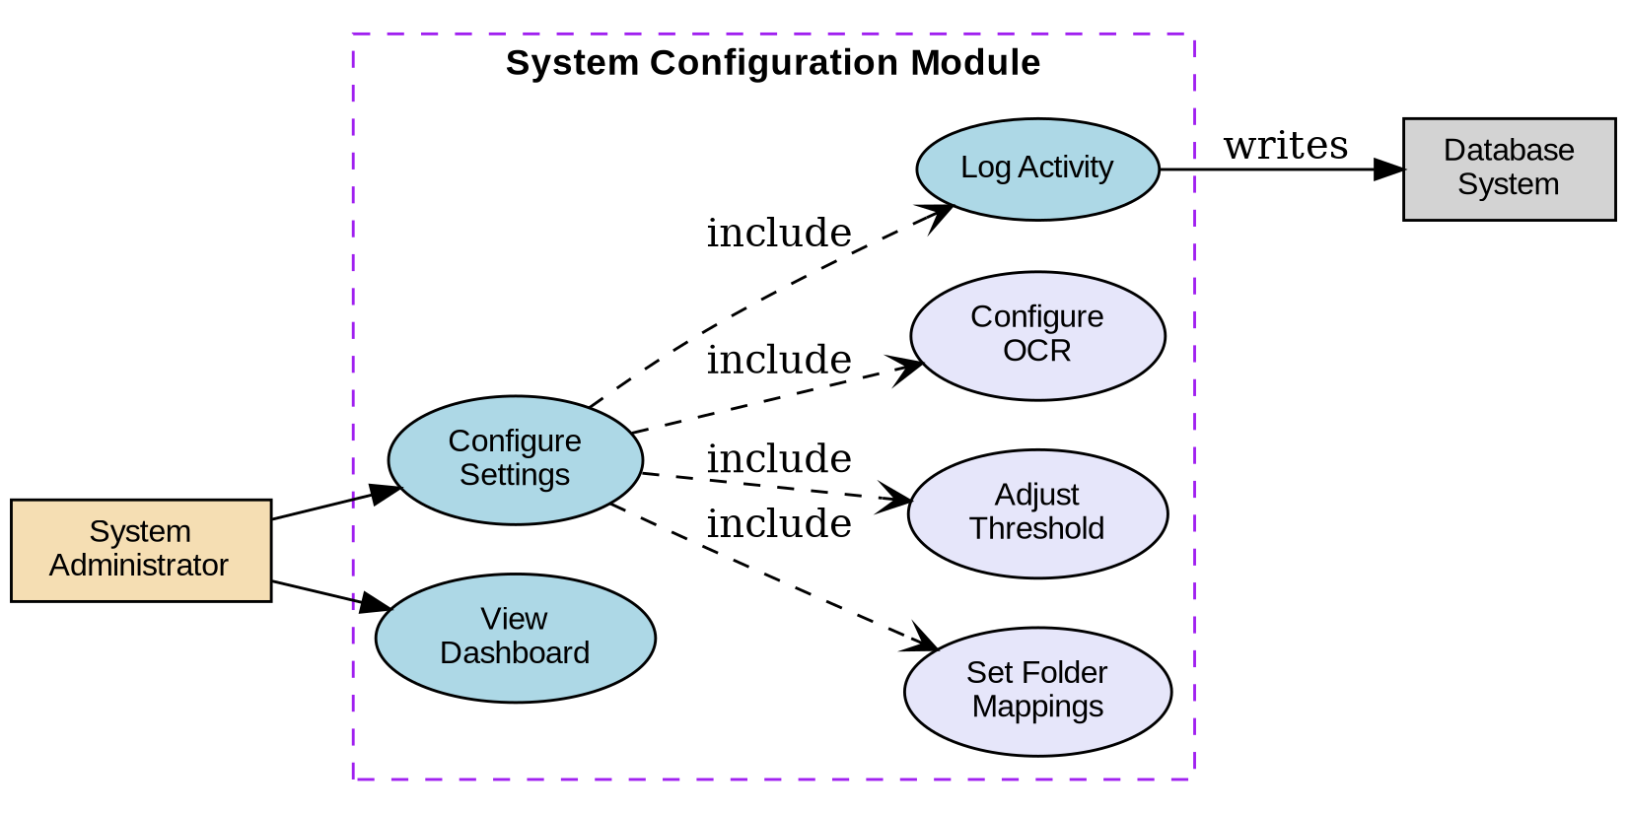

3.5 Document Ingestion Module Use Case Diagram
This diagram illustrates the document submission mechanisms. Documents can enter the system through two channels: direct file upload to the monitored directory or via email attachments. Both methods trigger the monitoring process that initiates the classification pipeline.
