Physical Feasibility

The design of this system relies on the dynamics of the electromagnet and spring components responsible for moving the parts through the system. Figure ## displays a diagram of the underlying components and forces within the system. The forces within the system are the force due to the spring on the bowl, the dampening force due to the material properties of the spring and system, and the electromagnetic input force from the electromagnet. By analyzing the equation of motion within the system, the feasibility of controlling the motion of the parts through the system can be achieved.

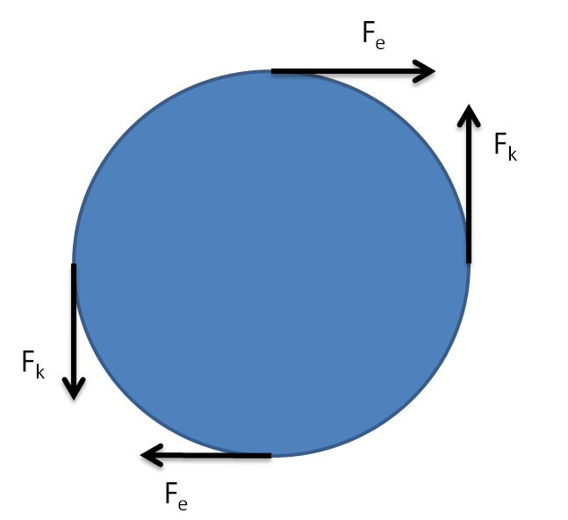

Since all forces are applied at a distance from the axis of rotation, the equation of motion can be written in terms of torques:

$$τ_{e}-τ_{k}-τ_{b}-Iα=0$$

where $τ_{e}$ is the torque due to the electromagnet, $τ_{k}$ is the torque due to the spring, $τ_{b}$ is the torque due to the dampening material properties of the bowl and spring, $I$ is the moment of inertia of the bowl, and $α$ is angular acceleration. The torque due to the electromagnet can be determined by the following equation:

$$τ_{e}=r_{e}F_{e}$$

where $r_{e}$ is the radius at which the electromagnet’s armature is mounted. The electromagnetic force can be described by the expression:

$$F_{e}=\frac{1}{2}i^{2}\frac{∂L(x)}{∂t}$$

where $L$ is the inductance of the electromagnet. The partial derivative can be evaluated by the equation:

$$\frac{∂L(x)}{∂t}=\frac{-β}{{(α+βx)}^{2}}$$

Where $α$ and $β$ are constants related to the form of the electromagnetic coil. Substituting this expression into the electromagnetic force equation yields the expression:

$$F_{e}=\frac{1}{2}i^{2}\frac{-β}{{(α+βx)}^{2}}$$

In the expression above, the current within the coil can be adjusted to change the electromagnetic force. Consequently, the power circuit used to drive the electromagnet can be designed to adjust the current within the electromagnet and easily control the input force for the system.

With the input force defined, other forces within the system need to be further refined. The spring’s torque can be described by the following expression:

$$τ_{k}=r_{k}kx$$

Lastly, the torque due to dampening can be described as:

$$τ_{b}=r_{k}λ\dot{x}$$

These expressions for torque can be substituted into the equation of motion to yield the equation:

$$r_{e}F_{e}-r_{k}kx-r_{k}λ\dot{x}-\frac{I}{r_{p}}\ddot{x}=0$$

Since the spring and electromagnet will be mounted at the same radius from the center of rotation, $r_{e}$ will be equal to $r_{k}$. Furthermore, the system is being designed to control the tangential acceleration of the parts on the outside of the bowl. As a result, $r_{p}$ is equal to $r_{e}$ and $r_{k}$. Consequently, the system can simplified and solved for $\ddot{x}$. Solving for tangential acceleration produces the expression:

$$\ddot{x}=\frac{1}{I}F_{e}-\frac{k}{I}x-\frac{λ}{I}\dot{x}$$

With the equation of motion created, the system is now ready to be put into state space form. The state space variables, $x_{1},x_{2}$ and $u$, can be defined as follows:

$$x_{1}=x$$

$$x_{2}=\dot{x}$$

$$u=F_{e}$$

The system can now be transformed into state space form which yields the expression:

$$\dot{x}=\left[-\begin{matrix}0 & 1 \\ \frac{k}{I} & -\frac{λ}{I}\end{matrix}\right]x+\left[\begin{matrix}0 \\ \frac{1}{I}\end{matrix}\right]u$$

$$y=\left[\begin{matrix}0 & 1\end{matrix}\right]x$$

With the state space equation defined, the system can be simulated and the feasibility of moving the parts through the system can be determined. Matlab was used to simulate the impulse response and frequency response of the system. Using conservative coefficients for the spring constant, damping constant, and the moment of inertia computed from the CAD model, the impulse response and frequency response was plotted. The frequency response of the system is shown in Figure ##. The impulse response is shown in Figure ##.





In the frequency response, the system is observed to have a peak at 28 Hz. Consequently, the system is observed to be operable between 20-40Hz as was desired. Furthermore, the spring characteristics can be tuned to produce a higher or lower operating frequency. From the impulse response, the tangential velocity of the parts on the outer most edge of the bowl can be observed to receive 0.25 m/s from an input force of 1 N. Consequently, the input force can be increased to increase the velocity of the parts so that the parts reach the counting mechanism in sufficient time. With the system’s resonant frequency tunable and the parts’ velocity able to be controlled by the input force, the feasibility of moving the parts with sufficient velocity through the system with electromagnetic and spring components has been deemed possible.

Financial Feasibility

The overall cost of the system will be determined by the building materials, microcontroller, and the electromagnets to power the system. For building materials, the bowl is planned to be 3d printed from ABS plastic. A 1kg reel of ABS plastic can be purchased at Microcenter for $15.99. Additionally, the frame will need to be built out of aluminum angle pieces. These pieces can be purchased in lengths of 96 inches for $18.54. We anticipate the need for 13 feet of aluminum angle for the frame and mounting pieces. The microcontroller we will be using retails for $19.99. Lastly, sufficient electromagnets such as a 50kg holding force magnet cost $19.29. The sum of these materials for the build adds to $111.64. An additional $50 should be allotted for other expenditures for prototyping and other small components. Even with this extra allowance for additional parts, the system falls within reasonable financial limits.