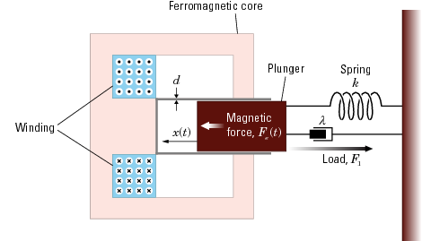

Equation of motion for the plunger:

$$F_{o}+m\ddot{x}+λ\dot{x}+kx=F_{e}$$

Since, $F_{o}$

Magnetic Force:

$$F_{e}=\frac{1}{2}i^{2}\frac{∂L(x)}{∂t}$$

Change in inductance w.r.t. time:

$$\frac{∂L(x)}{∂t}=\frac{-β}{{(α+βx)}^{2}}$$

Magnetic Force with solenoid constants:

$$F_{e}=\frac{1}{2}i^{2}\frac{-β}{{(α+βx)}^{2}}$$

The solenoid constants, α and β, can be solved by taking two force and stroke measurements and solving the expression.

The rotational motion of the bowl feeder can be written as the torque:

$$τ_{out}=Iα$$

The angular acceleration can be written:

$$α=\frac{\ddot{x}}{r}$$

So rewriting yields:

$$τ_{net}=\frac{I}{r}\ddot{x}$$

To find the force needed to create this torque on the bowl, the torque can be written as the product of the force and the radius from the axis of rotation:

$$τ_{net}=rF_{o}=\frac{I}{r}\ddot{x}$$

Solving for the force yields:

$$F_{o}=\frac{I}{r^{2}}\ddot{x}$$

Substituting this expression into the overall equation of motion:

$$\frac{I}{r^{2}}\ddot{x}+m\ddot{x}+λ\dot{x}+kx=F_{e}$$

Simplifying:

$$\left(\frac{I}{r^{2}}+m\right)\ddot{x}+λ\dot{x}+kx=F_{e}$$

Solving for $\ddot{x}$:

$$\left(\frac{I}{r^{2}}+m\right)\ddot{x}=F_{e}-λ\dot{x}-kx$$

$$\ddot{x}=\frac{1}{\frac{I}{r^{2}}+m}F_{e}-\frac{λ}{\frac{I}{r^{2}}+m}\dot{x}-\frac{k}{\frac{I}{r^{2}}+m}x$$

Defining state space variables, $x_{1},x_{2}$ and $u$:

$$x_{1}=x$$

$$x_{2}=\dot{x}$$

$$u=F_{e}$$

Substituting state space variables into equation of motion:

$${\dot{x}}_{2}=\frac{1}{\frac{I}{r^{2}}+m}u-\frac{λ}{\frac{I}{r^{2}}+m}x_{2}-\frac{k}{\frac{I}{r^{2}}+m}x_{1}$$

$$\left[\begin{matrix}\dot{x_{1}} \\ \dot{x_{2}}\end{matrix}\right]=\left[-\begin{matrix}0 & 1 \\ \frac{k}{\frac{I}{r^{2}}+m} & -\frac{λ}{\frac{I}{r^{2}}+m}\end{matrix}\right]\left[\begin{matrix}x_{1} \\ x_{2}\end{matrix}\right]+\left[\begin{matrix}0 \\ \frac{1}{\frac{I}{r^{2}}+m}\end{matrix}\right]\left[u\right]$$

$$y=\left[\begin{matrix}0 & 1\end{matrix}\right]\left[\begin{matrix}x_{1} \\ x_{2}\end{matrix}\right]$$