

**ME 492/ECE491 – Senior Design**

**Group 2 - Fall 2014**

**Final Design Report**

**Industrial Parts Counter**

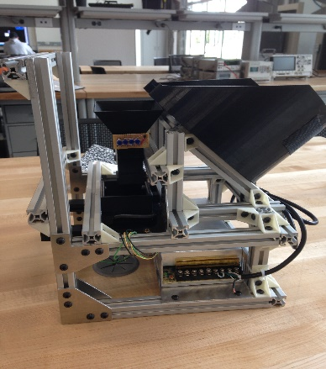

**Professor: Dr. Latcha, Dr. Gu**

**Team Members**: Paul Kruchko (EE), Michael Laba (ME), Bryan Jagielo (EE/CE), Xiaoang Tong (EE), Monika Shaeff (CE), Ran Ao (ME), Xinfeng Shi (ME)

**Table of Contents:**

1. **Introduction**….......................................................................................................................
2. **Design Specifications**...........................................................................................................
3. **Design Overview**….........................................................................................................
4. **Mechanical Subsystem**…..........................................................................................
5. **Electrical/Electronic Subsystem**……...................................................................................
6. **Computer/Software Subsystem** ……...............................................................................
7. **Discussion**……................................................................................................................
   1. **Technical Discussion**
   2. **Professional and Societal Context**
      1. **Engineering Standards**
      2. **Safety**
      3. **Economic factors**
      4. **Reliability**
      5. **Aesthetics**
      6. **Potential customers**
      7. **Societal impact**
   3. **Information Literacy**
8. **Conclusions and Recommendations**
9. **References**
10. **Appendices**

**Introduction:**

1. Description of the project challenge

The challenge was to produce a machine that could be used on an assembly line. The machine would be useful by helping workers count out small fasteners or parts to be assembled as the main assembly passes by on the line. The machine would be able to provide the correct number of parts each time the line worker request it. This would eliminate workers counting by hand and either coming up short on their count or taking too many parts. Extra parts tend to be discarded on the floor which is both a waste of materials and a safety hazard.

1. Brief description of the design solution to the project challenge

The solution that we have come up with is a case feeder design that uses a bowl to hold the main part population. Inside the bowl a disk with cut-outs will take each part one at a time to the top of the bowl and dispense it down a funnel. The funnel is lined with sensors that will count the parts as they fall into the presentation bin. The presentation bin holds the parts until the count goal is achieved. From here the operator pushes on the slider just under the bin. This allows the parts to drop into the operator’s hand. This is how we intend to distribute our parts.

**Design Specifications:**

The system that Group 2 proposes is a closed-loop, feed-back, electronically controlled rotating part feeder that agitates, actuates, and organizes a set of homogenous hardware components that are to be counted and dispensed into the awaiting hands of the operator/user. There are basically four subsystems in the mechanical design: screening subsystem, transportation and detecting subsystem, dispensing subsystem, and supporting frame subsystem.

Basically, the hopper bowl, the disk, the inserts make up the whole screening subsystem. They are all printed by 3D printer to ensure high accuracy of the size. Instead of printing six different disks, different kinds of disk inserts are used to save materials. And also the bowl inserts are used to fit different parts. The hopper bowl was designed according to the total volume of the largest parts to make sure it’s big enough to hold any six kinds of materials. The diameter of the bowl was decided by the diameter of the plate (200mm), which is decided by the length of the materials. All the materials will be put into this gradient hopper bowl, and the plate at the bottom of the bowl will begin to rotate driven by the motor, and also the agitators will begin to stir the parts. The parts inside the bowl will fall into inserts under the influence of gravity and the agitation. When the single part is rotated onto the higher side of the plate, all the parts will drop through the gap one by one, and here the singulation of the parts are completed.

For the transportation subsystem, there is a funnel with sensor inside it. The parts will drop into a funnel one by one, and the eight pairs of IR sensor on two levels can count the part that goes through. When it count to the quantity the user needed, the feedback control will apply to stop the motor. The upper size of the funnel is bigger than the lower size to avoid getting stuck, and also the slop is smooth enough. According to the parts quantity the user need, there will be a motor speed control to speed up the rotation or slow it down. This control will make sure we can transport enough parts in a certain time. After careful examination of the system’s static and dynamic characteristics it was determined that a motor with a minimum torque output of 20oz.-in. would be sufficient. Given that the there is considerable torque loss in the shaft of any given motor (~10%) and the need to both observe and control the speed of the motor it was determined that the 131:1 gear motor offered by Pololu was a desirable material solution for the motoring needs of the system. This motor offers 250 in-oz. of torque at 80 rpm, giving a safety factor of 12.5 and an encoder resolution of 64 counts per revolution, creating enough sample for an adequate velocity measurement. Control can be performed by implementing a PID controller in software on the microcontroller to control velocity output for desired velocity state or an integrated motor controller can be purchased that controls the motor with only a simple command from the microcontroller controlling the rest of the system. Given allocated memory and system response time it might be desired to control the motor using a motor controller.

For the dispensing subsystem, there is a push slider and a presentation. After we get the right number of parts, the motor will stop rotating and the certain parts will be inside of the dispenser. Two springs with proper spring constant are on the dispenser, which can make it go back to the original position after the user push and get the parts.

For the supporting frame subsystem, the frames are utilized to hold up all the mechanical and electronic components. The cross section of the frame is 20mm×20mm, and the material is aluminum alloy to ensure that it’s strong enough to make the whole setup steady. The frames are fixed together by the joints, which are printed by 3D printer.

**Design overview**

In order to discribe the overview of the mechancical system. We first looked at existing machines in industry and broke down what made them successful.

After examining a few machines we came to up with the following flow chart which each part followed in order to be acuratly organized, counted and moved from a major parts group. We would encorporate the same ideas into our design in order to make it successful

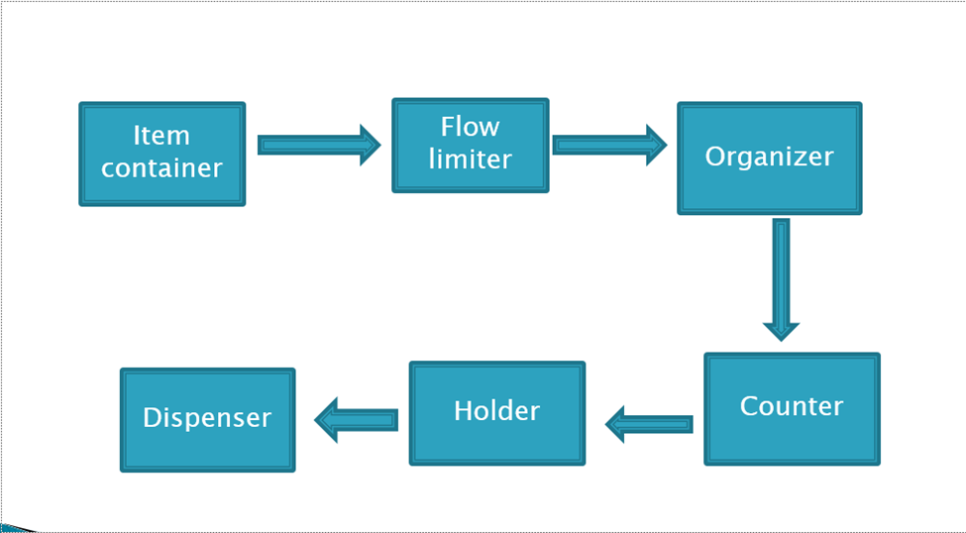

As seen in the above flowchart, the main population had to be first contained. Then the machine had to have some way of initiating the parts to move. Most machines used motors or agitators to create a mass flow from the major population of parts in the machine. The parts then are organized by geometry and orientation from the main material flow. Any part that did not match the orientation or the requested geometric restraints, was rejected back to the major population. This allows for a controlled flow of parts to feed one at a time into the counter. As parts move past the counter, the machine keeps track of how many are going to be dispensed, what the count is and how many parts are left in the bowl. The parts then move to a holder. In the holder, orientation may or may not matter depending on if orientation needs to be held for later processes. In our case we did not need to hold any particular orientation as long as all the parts where contained in the holder. The holders main job is to hold the current count of parts to be dispensed. This is to ensure that the operator is to get all the parts at once out of the dispenser, instead of parts coming out one at a time. The final piece is the dispenser itself. Each machine needed a way of presenting or releasing the held parts to the operator.

We needed to control aspects of the mechanical side, so we made a second chart that would work with the mechanical flow to ensure control to the machine.

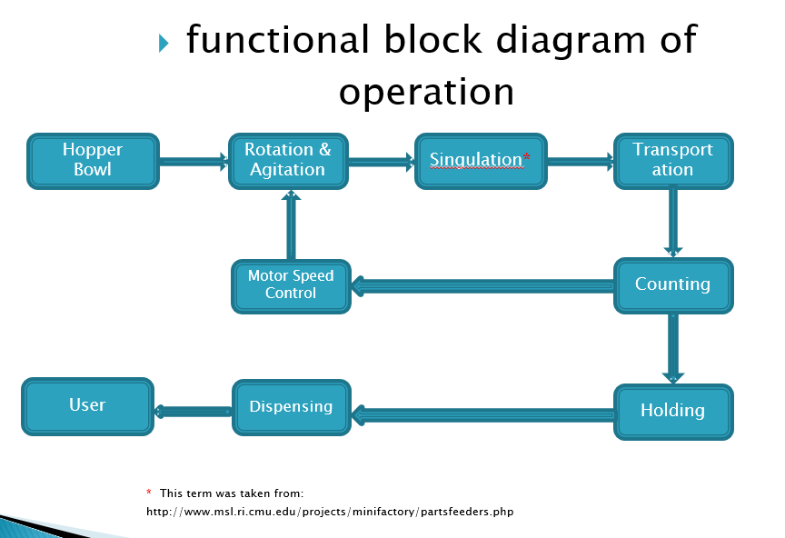

Each section in the diagram above was a strategy used in controlling the number of parts and part flow within the machine. The microcontroller would have feedback from sensors in the funnel and dispensing bin to control the motor speed and ultimately the part flow within the machine. This would mean that we could control the on time delivery of each count, know how many parts have been dispensed, how many parts are in the machine, and most importantly, how many parts are in the count. The microcontroller would have the ability to do the following: allow for user to select part type, count, control motor speed, keep track of parts in the machine, alert the operator when the parts are ready to dispense and start the count again after the operator retrieves the parts.

**Mechanical Subsystem:**

The mechanical subsystem is all pieces or parts of the machine that provide support or function to the machine. Each part of the machine had to be selected or made with both function and the ability to be assembled in mind.

Our first Idea came from industry as a vibration bowl. The idea was that the bowl would be agitatied and acutated such that parts would pushed by friction and solenoid, around the bowl and up a spiral ramp. While moving to the top of the bowl, we could use limiters to orient the parts as they formed a single file line. We quickly realized that the amount of calculations to achieve the forces needed to vibrate the parts would be very difficult.

After more research, we considered two more Ideas. One used conveyor belts and limiters for part flow and the other used a set of rotating disks with slots to pick up parts one at a time and dispense them at the top of the bowl. We chose the case feeder design with the bowl and disk, due to it being less complex, having components that could be easily calculated and we that the fabrication would not be too difficult.

To hold the main population of parts on the disk and agitator, we knew our bowl had to have a volume that would hold the largest part volume but not completely fill the bowl. We also knew that the bowl would have to be able to move the longest screw. These dimentions influenced both our bowl size and slot dimentions at the top of the bowl and on the disks.

Originally we had hoped that we could print the bowl as one piece and the first bowl contained more ABS than what was nessasary. A 3-D printer was expected to be used to make the bowl to ensure persision and because the printer would be able to fabricate our shape and eliminate extra fabrication processes with some other materials. The only thing the printer needs is material which is where the cost for making the parts is incurred. We first tried to eliminate some of the ABS material from the bowl by making the motor hole in the bowl wider. This changed or original plan to mount the motor directly to the bowl which would have made centering the motor shaft and assembly easier. We still had a high ABS volume for the bowl, so to reduce the volume.

During the mechanical process, we have utilized 3D printer for printing some of the major components of the machine. The material of these components is ABS, and the friction factor between ABS is 0.1. The tolerance of the printer is 0.2mm, so we need to consider the tolerance when designing the size of the components.

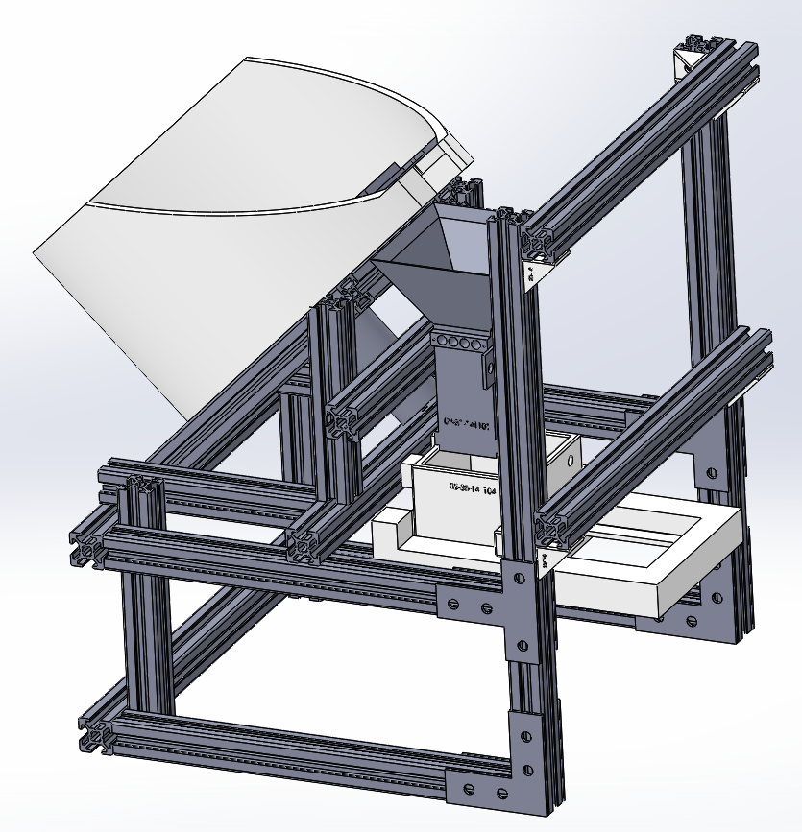

Figure 1. Built Machine Figure 2. Finalized CAD Model of Machine Concept

Our finalized machine design is shown above in figure 1 and 2. As shown above, about fifty unorganized parts will be dropped into the bowl. The motor that is fixed on the frame will rotate a wheel inside the bowl. Depends on the types of the parts, different wheel and different inserts of the bowl will be utilized. The unorganized parts will be rotated into the gaps of the wheel, and sent to the top of the bowl. Then they will drop into the funnel through a big gap on the top of the bowl. There will be eight pairs of IR sensors, which attached on the side of the funnel, waiting for detecting the number and speed of the parts. After controlling the speed and the number of the parts, the rotating process will stop, and the correct number of parts will drop into the presentation bin. The waiting hand can easily push the slider that underneath the presentation bin, and receive the parts when the machine is ready.

The size of the total design including both mechanical and the electronical stuff is . Because we fixed everything together on the stable frame by proper size of screws and nuts, the whole machine is easy to carry and move.

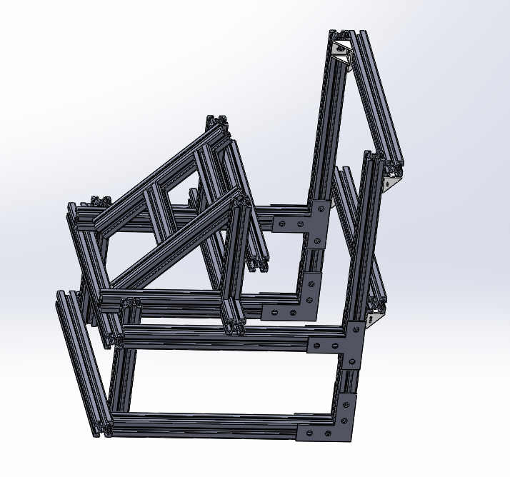

Figure 3. The Supporting Frame for the Total Design

The figure above shows the frame design of our machine. After the roughly drawing the outline of each component, we thought about the method to connect each component. It will be more delicate and easily to use if we can figure out a proper way to hold the whole machine. According to the mechanical and electrical components, we utilize the 8020 Aluminum alloy. It is bought from…. We cut it into different size, and put them together by utilize the proper fastener. Each component is fix one frame by using the nuts and screw. If there is any part that needs to be changed, we can easily change the position, length and angle between the beams, and mount the screw at the proper place that we want.

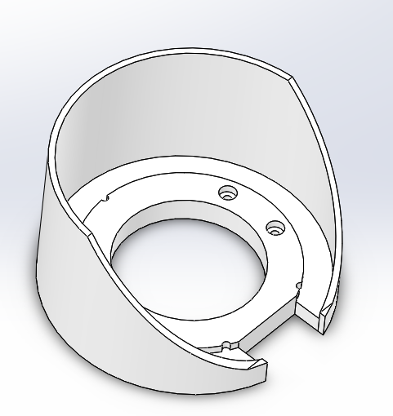

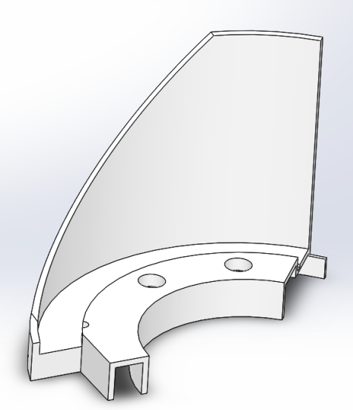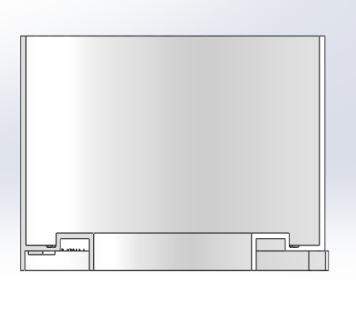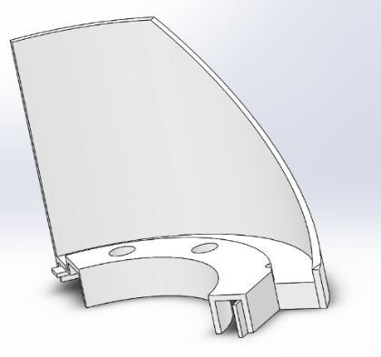

Figure 3. The Bowl and the Three Divided Parts of the Bowl That Used for Printing.

The figure shown above is the bowl. It is held up on the frame with an angel of 45 degree. The bowl is utilized to hold the bowl inserts, wheels and all the unorganized parts. Also, there is a cuboid gap on the side of the bowl, and the size is big enough for carrying all six types of parts. It allows the parts dropping into the funnel. The internal diameter of the bowl is 202cm, and the thickness of the wall is 4mm. For saving the cost of the bowl, we cut off a lot of material from the bottom. Because the bowl was not in a regular shape, we decided to use 3D printer. The size of the bowl was larger than the capability of the printer, so we printed it by dividing it into three parts. Then the left, center, and right part of the bowl were glued together. The glued bowl was firm during the test, and never tried to break apart.

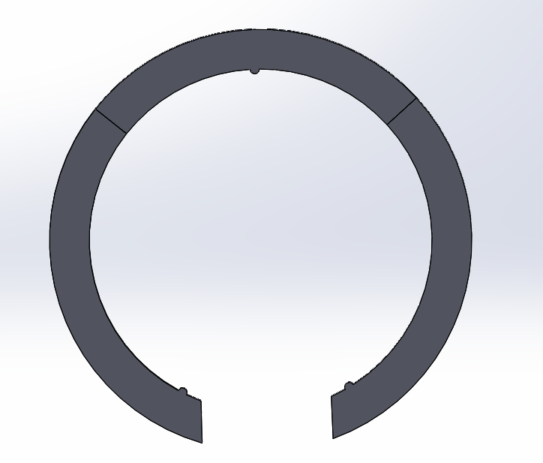

Figure 4. The Inserts of the Bowl

As shown above, the shape of the bowl inserts is same as the shape of the gap inside the bowl. The three small semi-circle are used to fix the position of the inserts. In this case, the rings will not move randomly inside the boal gap. Because the thickness of six parts are different, we have designed four different thicknesses of the rings including 6mm, 4.5mm, and . Then the thickness of the gap can be changed by easily putting the rings in. The size of the ring is larger than the capability size of the printer. Since we used 3D printer to print ABS material inserts, we divided each one into three part.

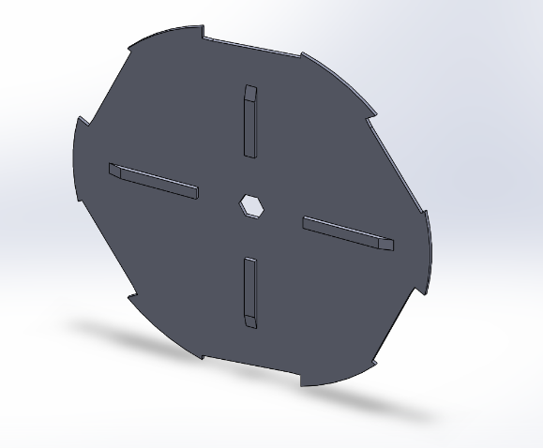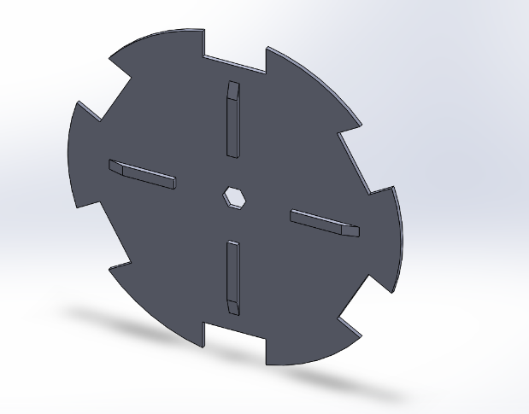

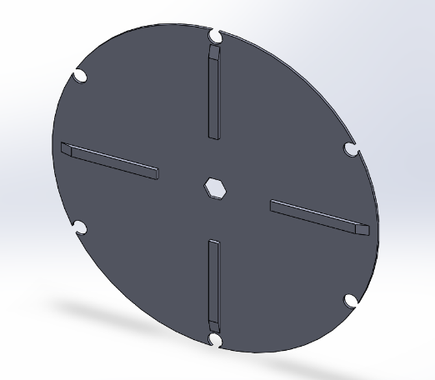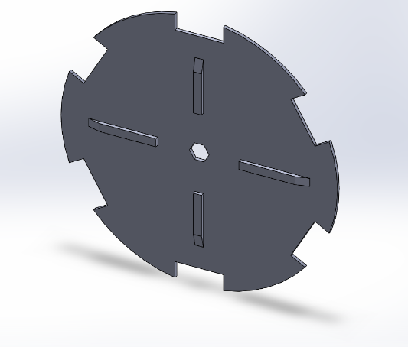

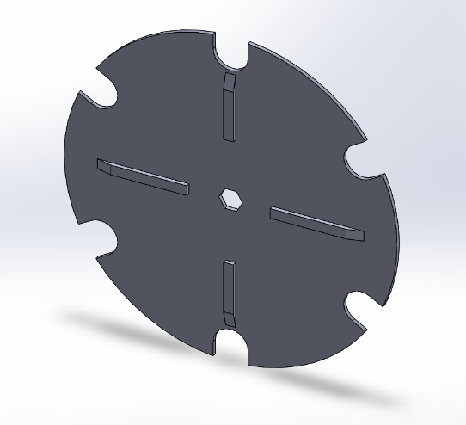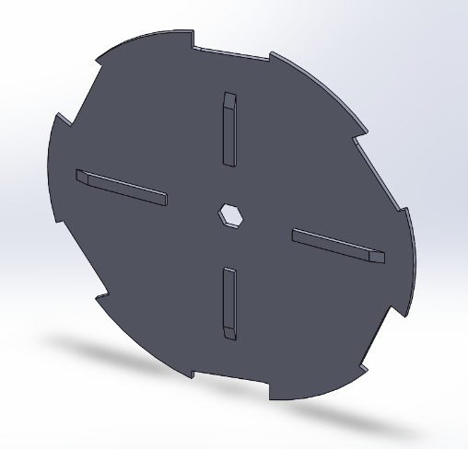

Figure 5. Six types of wheels

The figure shown above is the wheels for each parts. As we know, there are six kind of parts that might be sorted. The inserts of the bowl can used to change the thickness of the gap, and the wheels can change the outline shape of the parts. Because we don’t need to care about the thickness when designing the wheel, the thickness of the wheels are 2mm. Thus, we save a lot of material by printing the thin wheels. There are four agitators on each of the wheels. It is used to stir the parts. Because there are about fifty parts that need to be organized, it is important to make them apart, and they can easily drop into the gaps. All the six wheels are printed by 3D printer. Also, the shaft will be attached to the middle of the wheel in order to send the power for rotation process.

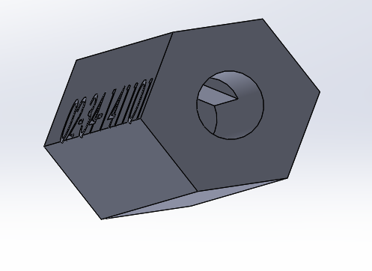

Figure 6. The shaft

The shaft is used to connect the motor and the wheel. Since the hole of the shaft is designed according to the size of the motor, the motor can easily attached to the hole of the shaft. Then, we super glued the shaft and motor, and the shaft will be more stable. The external shape of the shaft can just fit into the wheel. In this way, the wheel can rotate in the same rotational speed while the motor rotating, and the motor can easily control the rotating process of the wheels. The shaft is built by 3D printing.

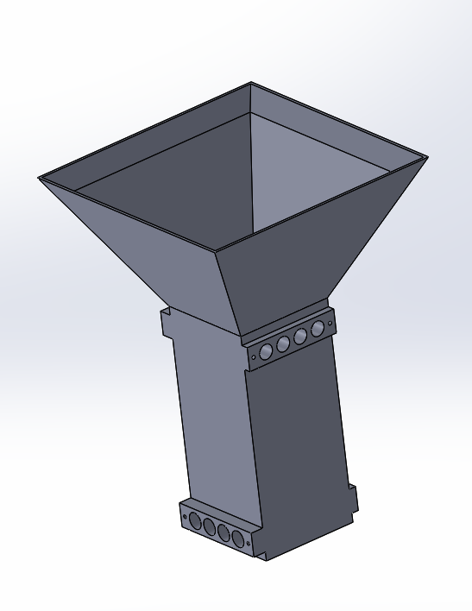

Figure 7. Funnel

The funnel with IR sensors is an important part to counting the number of the parts. As shown above, the upper part of the funnel is right below the gap of the bowl, and the size of the entrance is enough for all the parts to drop in. Then the parts will be detected by the sensors. Eight pairs of sensors are attached to the hole of the funnel in two level. Once the part is detected, the electronic screen will add the number, and the motor will receive the feedback of the speed. In this case, the motor can better control the speed of machine. In order to cut accurate size of the sensor hole, we printed funnel by 3D printer.

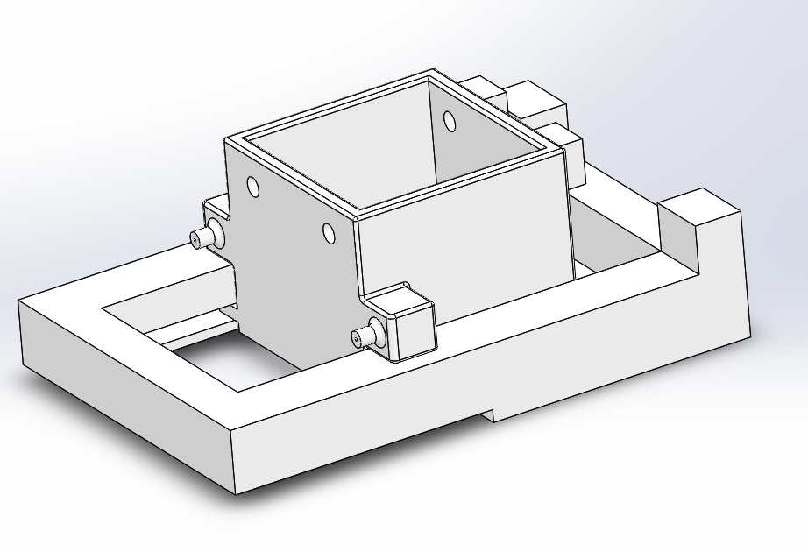

Figure 8. Presentation bin and push slider

As shown above, the parts will drop into the presentation bin after going through the funnel. When the machine is ready, the machine will stop rotating, and the correct number of parts will be stored in the presentation bin. Then, the awaiting hand can easily push the slider underneath, and receive all the needed parts. Both presentation bin and push slider are made by 3D printer, and the material is ABS plastic. The presentation bin is fixed on the frame, and it holds the slider as while. In order to connect presentation bin and slider, and control the position of the push slider, there are two springs on the each side of the dispenser. In this way, the spring will extend when the push slider is pushed, and the spring can pull the slider back to the normal position when the force disappears.

**Electrical Subsystem**

For detective and counting system what we considered and followed is shown in the flow chart

Parts detected

Microcontroller

Counting

parts

Detector

Counting completed feedback

The primary thing we did was figuring out the detective method. After thoughtful consideration, we got the result that laser is stable and reliable, but more expensive. Pressure sensor is hard too. Motion sensor is not sensitive enough to detect small parts. IR sensor is perfect working on short distance detection, sensitive and stable. Moreover, it is cheaper enough. Therefore, it became to our final option.

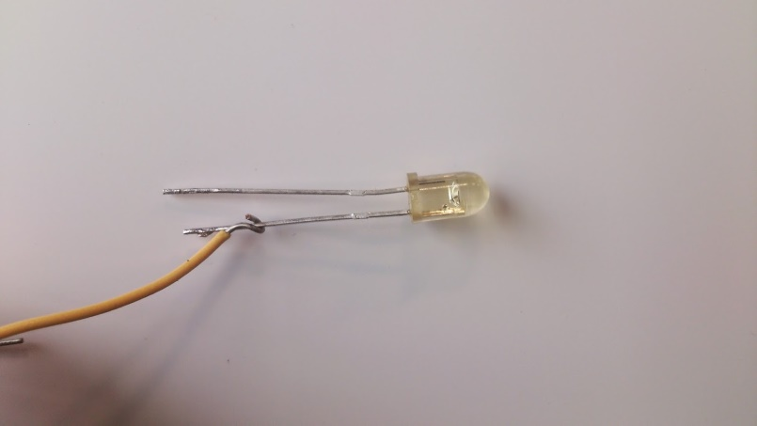

Figure 1 IR led op290

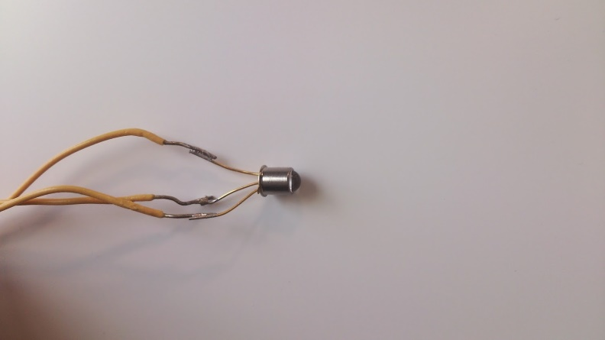

Figure 2 phototransistor OP830SL

Shown in the figure 1, 2 are our IR led and phototransistor. It illustrates infrared detection system which is used through our design. They essentially create a “beam” of IR light between two locations and provide us with a digital “Low” when there is nothing to block it, because when transistor bias, collector pole will pull down to the ground. Inversely, when parts block the “beam” of IR light, BE junction stop work. Thus, collector pole will pull up and the output gets a digital “high”. This efficient system proved to be useful in our design where we needed to know that a part had passed by, such as in counting parts and starting/stopping the machine. During IED and phototransistor selection, angle displacement and

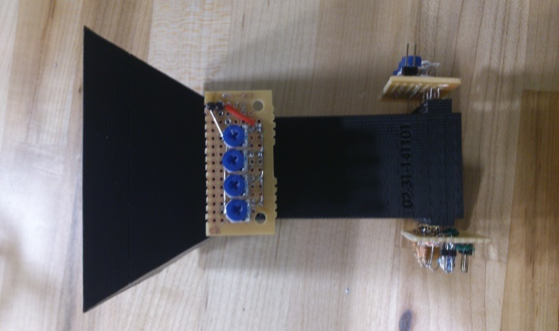

Figure 3 funnel and detection system

The concept sketch of entire system is shown in figure 3. 8 sensors are separated into two layers, 4 sensors parallel with each other to form a cross-section. Two layers have 90 degree difference on angle that if considered from 3 dimensions perspective we can get a grid structure. This structure provided our counting system a most safety detective environment. The sensors are fixed in the funnel which can isolate the sensors from external environment. In this case, we minimized the external disturbing.

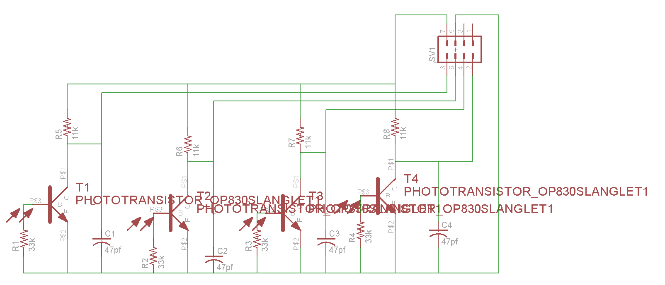

Figure 4 Circuit sketch of receive side for PCB

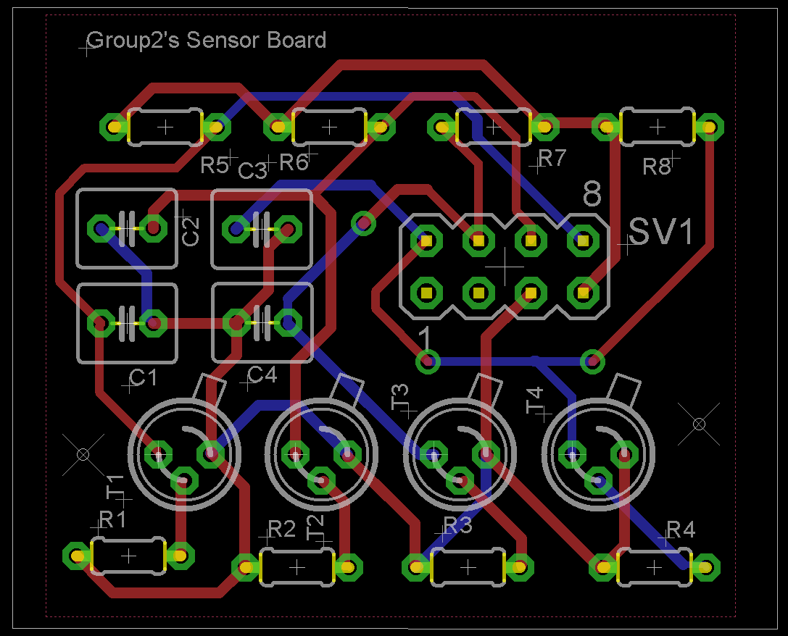

Figure 5 PCB for Receiver side

Shown in figure 4 and 5 are our PCB board design for receiver circuit. The size of board is 42mm*36mm. The interval between each transistor follows the design specification of funnel. Although to print PCB board will be costly, using the PCB can avoid the wires exposure, which decreases the probability of error and block the interference from external environment. Besides, this design optimized the layout of our product, and in order to systematize our product to satisfy the concept of simplification and efficiency, PCB is the best choice for us. However, due to the PCB board need nearly a week's time, but we couldn’t wait for that long. So, finally we changed our mind to solder this board by using common circuit board.

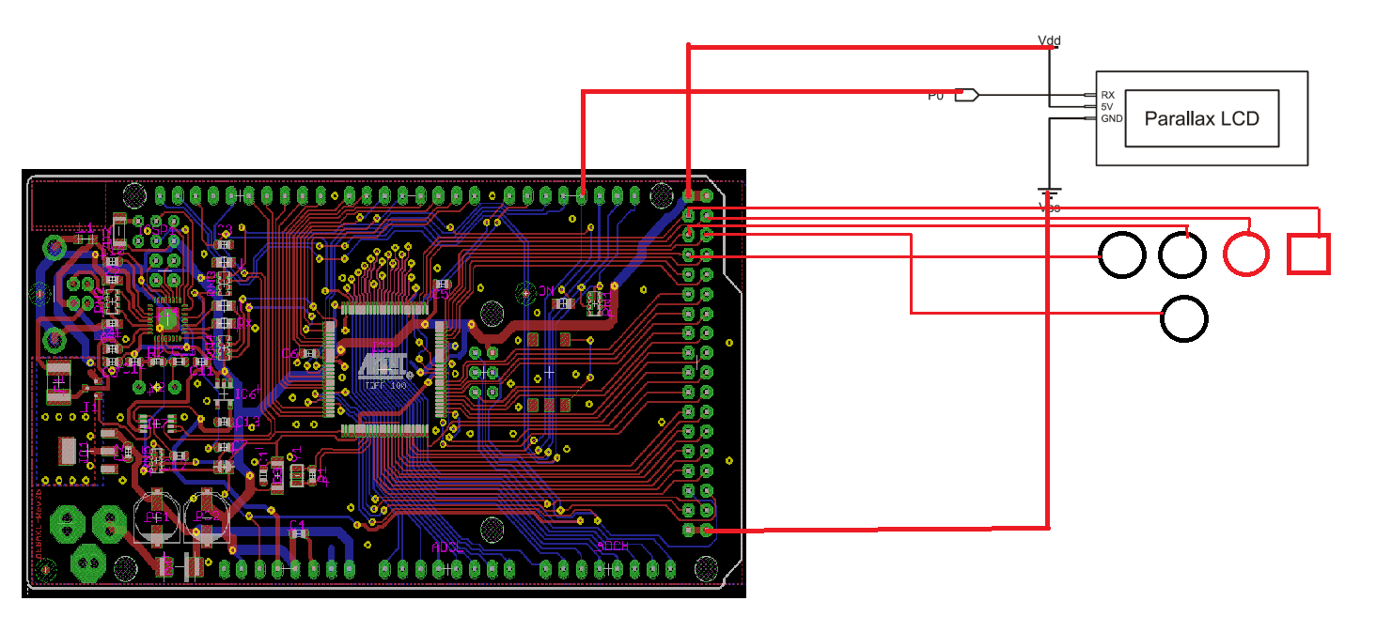

Figure 6. Wires connection of interface

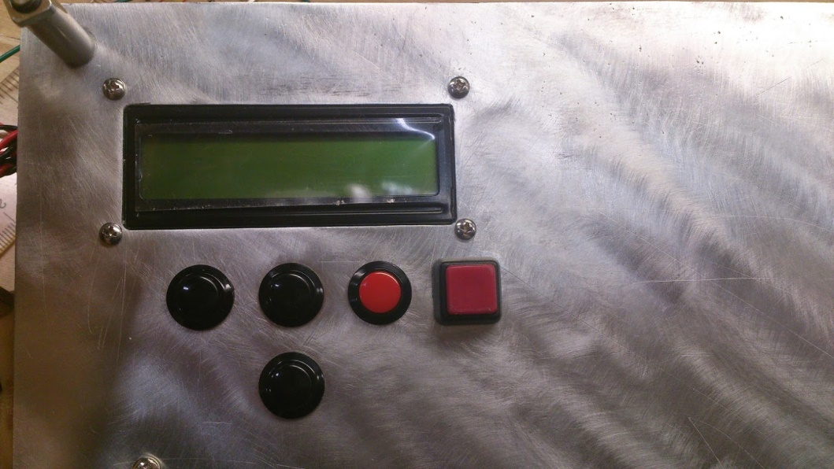

Figure 7 interface out looking

Shown in the figure 8 is wire connection of our interface design. The LCD which we chose is Parallax 27977 with serial interface. Serial interface will reduce the pins usage of Arduino board and also simplifies the coding part. The design of interface follows the idea of concise and high controllability. Five buttons corresponding to the functions: Start. Select, up, down and back which meet the requirements of our expectation to control our design working in order.

Motor setting and connecting

(

)

Wiring and layout

(

)

**Computer/Software Subsystem:**

**Software coding flow chart (interface-LCD display):**

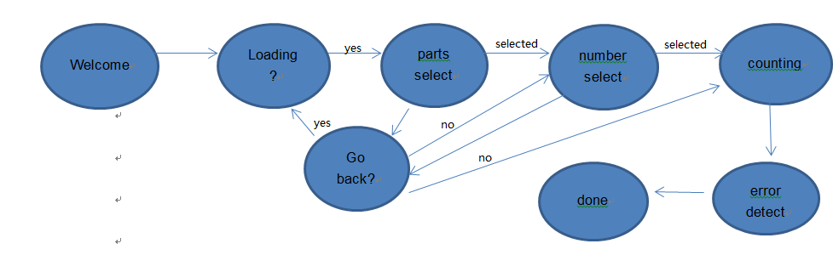

Figure 8 Flowchart of software controlling

Shown above in figure 7 is the flowchart of software working for LCD display part. Following each step we need, we have six steps and 2 judgments during our system’s operation. These logic forms a visual operation platform for user. Consider optimizing users’ experiences, we set back button for use to revise their choice and added error detection to avoid any unexpected error during system counting. Coding used typedef enum and typedef structure to generate a state machine in case switch which could realize to switch the states of LCD display in different mode, and achieve the inverse operation of the program.

**Software coding flow chart (Motor control system):**

**(**

**)**

**Electrical/Electronic Technical Discussion:**

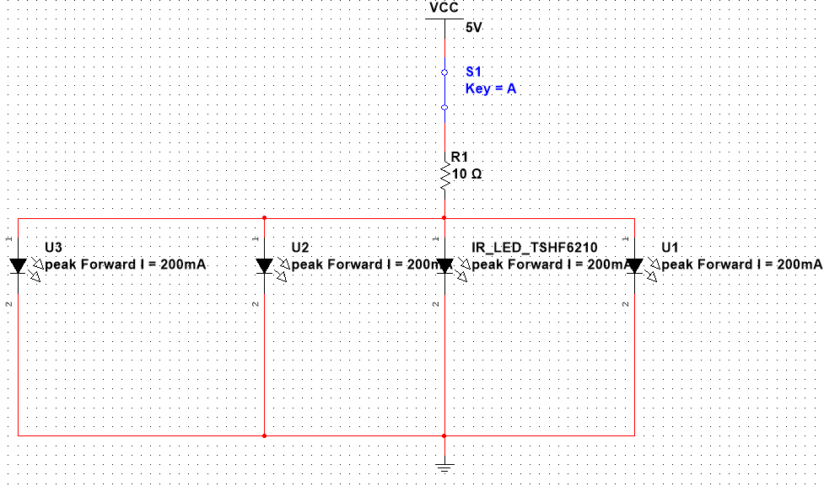

Figure 9 Circuit sketch for emitter side

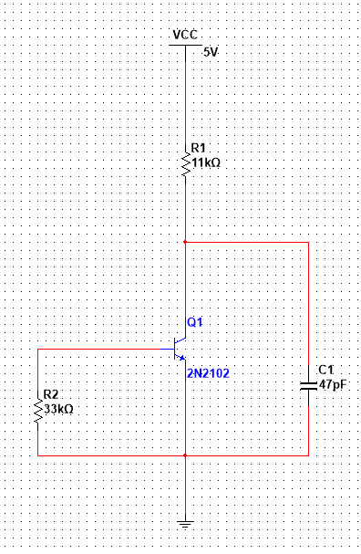

Figure 10 Circuit sketch for receiver side

The circuits shown in figure 9 and 10 are simulation circuit. In receiver circuit, the resistor in base pole side is a pull-down resistor which can clamp the uncertain signal in low and improve the ability to resist electromagnetic interference of the bus. The capacitor in the collector side which connected to ground is used to isolate the noise from ground. In order to avoid the influence of internal resistor of transistor, we picked up 11kΩ as the pull up resistor in the collector side. All the circuit designs of sensor are basin on the knowledge from circuit design courses except refer to the datasheet of the components. In this part, the

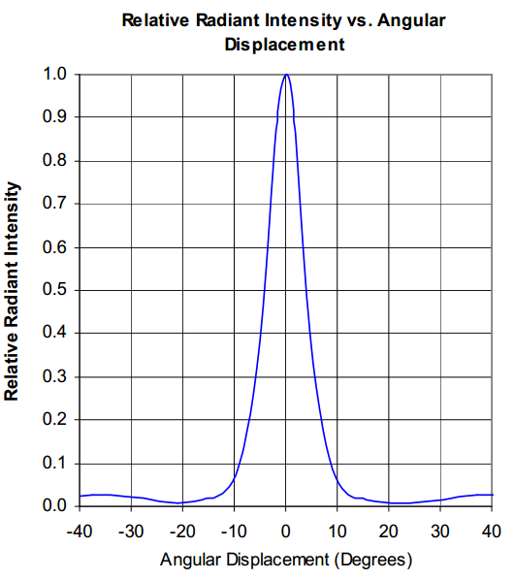

Figure 11 Angle displacement: 10 degrees.

Base on a simple equation the side of plant of illumination equal 26mm * tan10° = 4.584mm. Theoretically on receiver side, IR light will overlap and increase the luminance. As we know, phototransistor is working on switch mode that the only one controllable factor is bias voltage. So, finally we used thyrecotor to control the power of IR led which can change the radiation intensity on the received. To set the voltage across BE junction just higher than the bias voltage by adjusted the value of thyrecotor in lighting conditions. Thus, four sensors will be considered into a single system to analyze which means less instability and easy thinking. The resistance range: refer to datasheet of OP290, the bias voltage of IR led is 0.8v (0.01A) and the max voltage is 3.5v (0.2A).

MAX R:  R=420Ω

MIN R: R=7.5Ω

**Testing of sensor system (sensitive):**

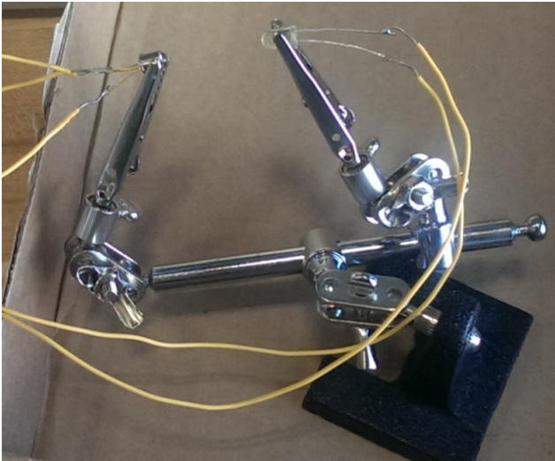

Figure 12. Sensor sensitive testing

In order to test the performance of our detective components, we designed the testing circuit to test repeatedly under different conditions. The testing plat is shown in figure 8.By observing the amount of variation of voltage, we could figure out whether sensor works sensitively. The results are shown in chart below:

|  |  |  |
| --- | --- | --- |
| Distance | Sensitive | Value of resistor |
| 20mm | High/High/High | 100Ω/45Ω/25Ω |
| 26mm | High/High/High | 100Ω/45Ω/25Ω |
| 30mm | Mid/High/High | 100Ω/45Ω/25Ω |
| 40mm | Mid/Mid/High | 100Ω/45Ω/25Ω |
| 50mm | Low/Mid/High | 100Ω/35Ω/25Ω |
| 60mm | Low/Mid/Mid | 100Ω/45Ω/15Ω(a little heated) |
| 70mm | NA/Low/Mid | 100Ω/45Ω/15Ω(a little heated) |
| 80mm | NA/Low/Mid | 100Ω/45Ω/15Ω(a little heated) |

Through the data in the chart, our detection system worked perfectly in the distance of 26mm. Up to 80mm interval between emitter and detector, it still works. So, for the stability and sensitive of our detection system, it could be used in any short range detection.

**Testing of sensor system ( Reflection time):** (most of this part is from Byran’s repeort)

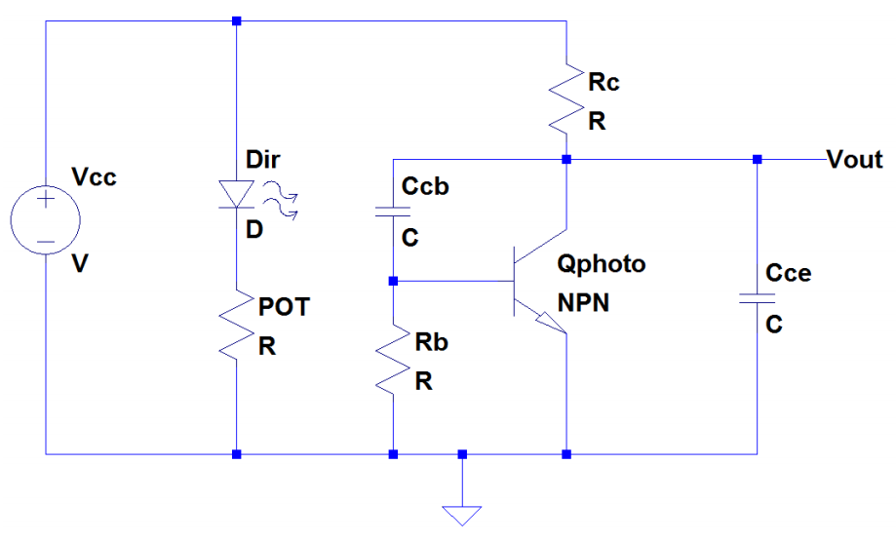

Figure 13 A schematic of the IR LED and phototransistor circuit.

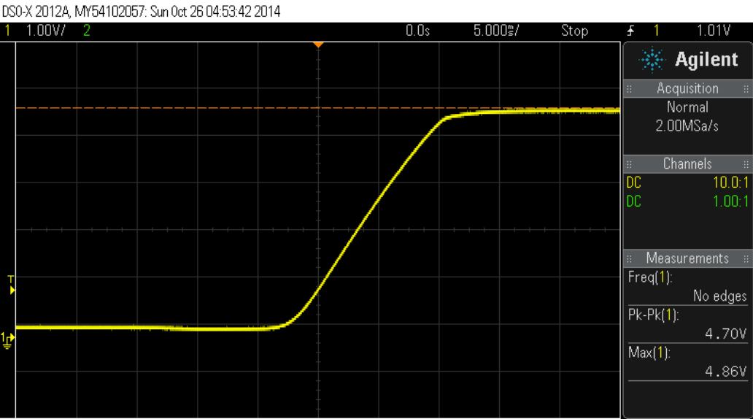

Figure 14. The waveform of the initial test of the phototransistor's rise time.

In order to evaluate the rise time of the circuit, we needed to identify the minimum rise time necessary for the transistor circuit. We identified that the rise time needed to sufficiently small so that the output voltage would reach greater than +3V before the object has completely passed through the path of the beam. To compute a nominal value of this, we examined the kinematics of the situation. We identified that the object would be in freefall and the shortest time interval for detection would occur when the object is at its greatest velocity. With these considerations, we computed the objects velocity at the bottom of the funnel. We found the velocity to be approximately 2.2m/s. Next, using the width of the smallest part, we computed the minimum time interval for detection. We computed the minimum time interval for detection to be approximately 4ms. As a result, we defined that the maximum acceptable rise time must be less than 4ms.

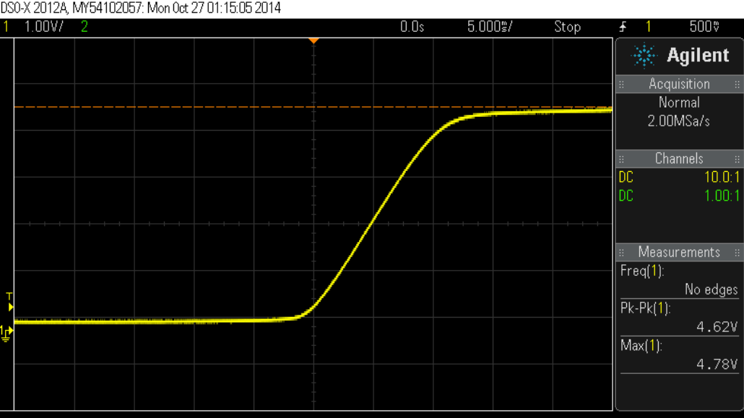

Figure 15 The waveform of the rise time due to changing CCE.

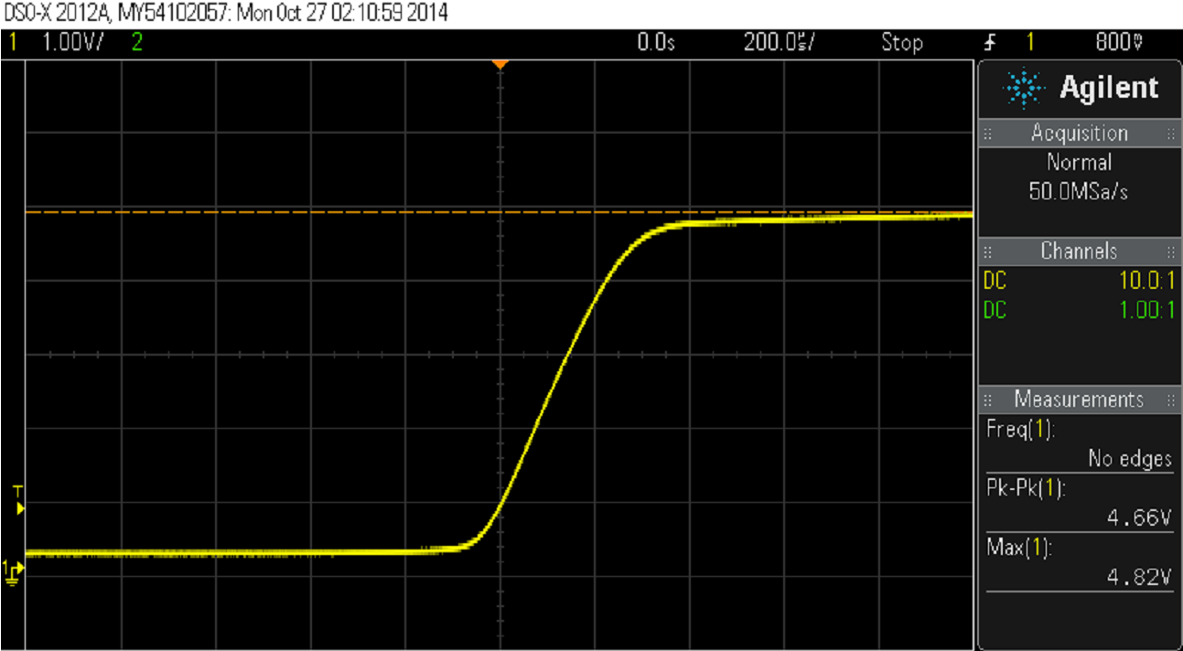

Figure 16 The waveform of the rise time due to removing CCB.

The rise time of the phototransistor was evaluated using the circuit depicted in Figure 13 and the physical configuration depicted in Figure 14. We used a 33kΩ and 11kΩ resistors for RC and RB, respectively, and 1nF and 47nF capacitors for CCE and CCB respectively. By blocking the light we evaluated the response of the phototransistor. Figure 15 displays the rise time of the sensor as observed by the oscilloscope using these values. As can be seen the rise time of the circuit is approximately 10ms, which is unacceptable by the criterion previously established. Figure 15. The waveform of the initial test of the phototransistor's rise time.Since the configuration did not meet standards, we needed to adjust the time constant of the circuit.

Initially, we decreased the value of CCE which decreases the time constant. We changed the value of the capacitor to 1nF. The voltage output after the test as observed by the oscilloscope is depicted below in Figure 16. As can be seen in the figure, changing this capacitor did not affect the rise time significantly.

The rise time of the phototransistor was evaluated using the circuit depicted in Figure 14 and the physical configuration depicted in Figure 15. We used a 33kΩ and 11kΩ resistors for RC and RB, respectively, and 1nF and 47nF capacitors for CCE and CCB respectively. By blocking the light we evaluated the response of the phototransistor. Figure 16 displays the rise time of the sensor as observed by the oscilloscope using these values. As can be seen the rise time of the circuit is approximately 10ms, which is unacceptable by the criterion previously established. Figure 16. The waveform of the initial test of the phototransistor's rise time.Since the configuration did not meet standards; we needed to adjust the time constant of the circuit.

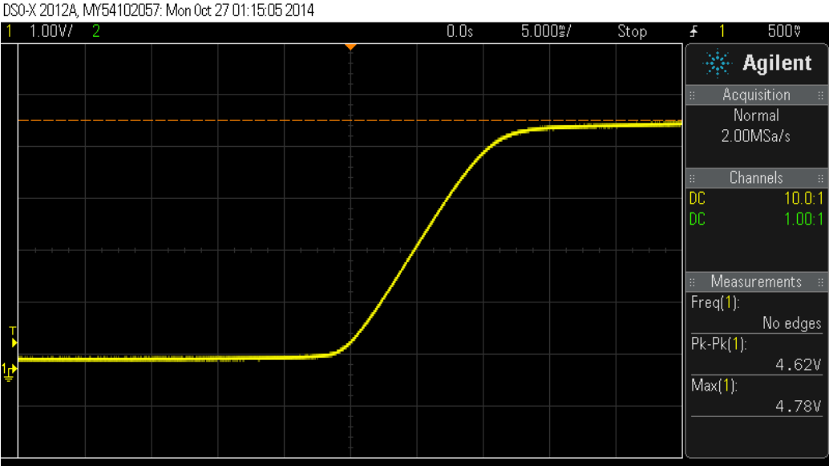

Figure 17. The waveform of the rise time due to changing CCE.

Since CCE did not affect the rise time significantly, we investigated the affect of CCB on the time constant. We quickly realized that this capacitor, which is in parallel with the Miller Capacitance of the transistor, has a much greater effect of the time constant of the circuit due to the current gain of the transistor, β.As a result, we changed CCE to 47pF and removed CCB from the circuit. As a result, the circuit is configured as appears in Figure 17. We tested the circuit under this configuration and observed the rise time to be significantly improved to 350μs, as can be seen in Figure 6. Since the rise time is significantly lower than the criteria established earlier, the circuit meets our specifications.

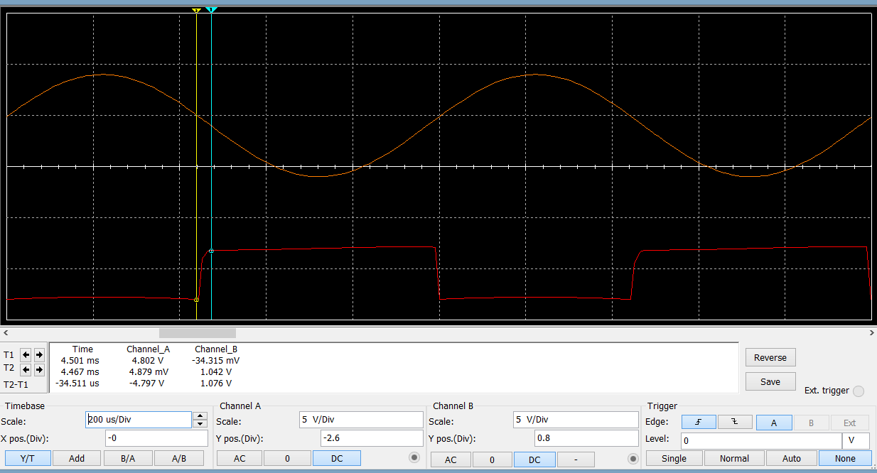

Figure 17 simulation for sensor circuit

Comparing with the simulation result in figure 17 which shows the reflection time of voltage rising is 34.511us, the result (16us) what we got from real testing is lower than our simulation result for more than two times. It illustrated that our actual result is better than our simulation result.

**Sensor’s safety evaluation:**

Our sensors were set in a closed space. Few radiation of IR light could permeate from funnel inside. Furthermore, through our researching, Infrared (IR) radiation consists of wavelengths from 760 nm to 1 mm, and it is subdivided into three regions of increasing wavelength, IR-A (760–1400 nm), IR-B (1400–3000 nm), and IR-C (3000 nm–1 mm). The wavelength of our IR Led is just 890 nm which belong to IR-A. It has been reported that IR-A can penetrate epidermal and dermal layers and reach subcutaneous tissues without increasing the skin temperature significantly. Therefore, our detective system will never damage user in the case IR radiation.

**Interface performance and discussion: TODO**

**Motor performance and discussion:TODO**

**Software coding discussion: TODO**

**Discussion:**

Our final design solution is greatly different from our original design. The original design was made with only functionality in mined and did not take into effect cost, assembly, and control of part size on certain components. The original presented design was made crudely to allow for the original ideas to take shape and preform initial testing based off theory or software.

As we analyzed the idea of price and making parts fit together. It was found that making parts that used thin ABS printed parts where cheaper than our original parts. We became more comfortable with working with ABS after we tested the prototyped design for a 90 corner bracket. The idea for this design was altered from working aluminum brackets for sale on the web at Mcmaster-Carr.com or 80/20.com The brackets used gussets to strengthen the joint. Some used multiple screw locations to stiffen the joint and increase contact area. Since our machine weight is ____ pounds, we felt that with multiple applications of a smaller light weight bracket could be used to have high strength with minimal space. We also removed tabs that fit into slotted sections of the 80/20. This allowed us to use our bracket for a wider range of applications including parts on an angle, which the shelf bought brackets would not be able to do.

In order to ensure that this application would work, we tested the bracket design. A small sample of 10 90 corner brackets was printed in order to test the bracket design strength. In order to get an idea on how the bracket might perform, we used FEA from Solidworks. By comparing an FEA with 1N applied to a mounting face and the other mounting face fixed, we could predict the deflection of the part under loading. This could be compared to the test results in order to estimate how the brackets will perform.

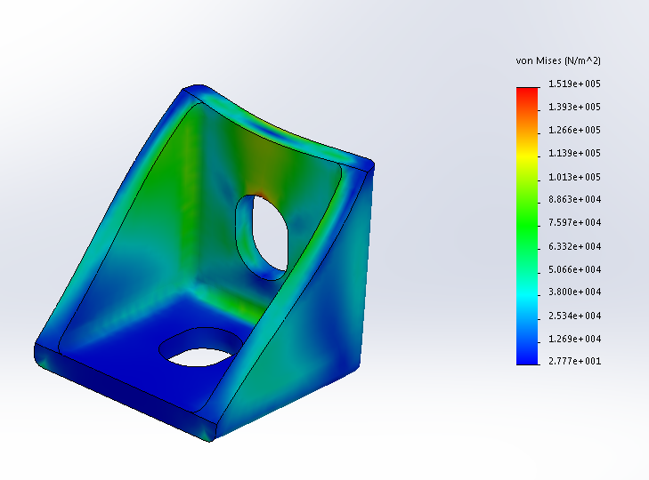

To conduct the experiment, four brackets where secured to a 2x4 using Philips head sheet metal screws. The brackets where up and down in orientation and attached to the edge of the 2x4. The 2x4 was then clamped to a table using a C-clamp to prevent it from moving off the table. By two hooks and string, weight was applied to each of the brackets. The weights had known measurement labels. This test did not need to be very precise, due to the predicted weight that one bracket was to lift was approximately 5 lbs. The test was stopped at 22 lbs because the part was deformed, there was no need to go higher when only 5 lbs was a comfortable working weight of the machine and the design has multiple double brackets applied at the joints.