Counter

The IR sensor emits a LOW signal while the sensors are on. Once the sensor is broken by the part that is falling, the signal emits HIGH. The pins that were used for the sensors were from PIN C which are digital pins. The pins that were used were PCO to PC7. There were eight pins chosen because there were eight sensors used. Four sensors were put at the top of the funnel and four sensors towards the bottom of the funnel. This algorithm used double detection. While the part is falling through the funnel it breaks the first sensor which lets the code know that the top sensor is HIGH by using bitwise AND, and at that moment it counts one. When the second sensor gets broken by the same part falling still, that same thing occurs to the second sensor. It lets the code know that the bottom sensor is now HIGH and it counts now goes up to two. When that part is done going through and the count is up to two, now the modulus comes in play where the number that was received is divided by two and the code looks at the remainder. If the remained is 0 then the main count that is used for the LCD display goes up by one. A small delay was also added for upper and lower sensors after the initial count was received before being able to read the next count again for the next part coming down.

For reading the longer parts there was a separate algorithm written along the same lines of the algorithm that is described above. It only used a single detection. When the longer part falls through the upper and lower sensors the bitwise OR operation is used for the upper and lower bits to get the count updated that way. That also updates the LCD. The longer delay is used to make sure the part is out of the shoot so the counter won’t keep on counting quicker than it should be and allows time for the signal sensor to go back to low. The loops will continue until no more parts fall through.

BUTTONS

SENSORS

MOTOR DRIVER

LCD

STATUS LEDS

DISPENSE SENSOR

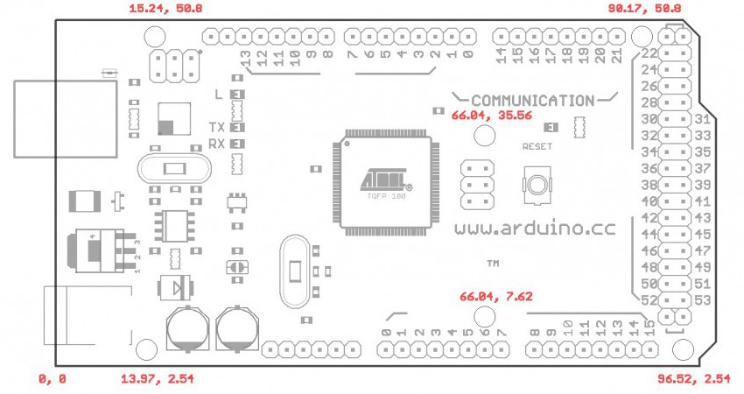

Here is the pin layout for the Arduino Mega2560 board that was used in our project. For the motor driver we used pins 15, 46, and 50-53. This was decided by looking at the motor drive Pololu MD01B. Pin 46 was the PWM, pin 15 was the analog pin, and 50-53 were digital pins. The sensors used pins 30 to 37 which were all digital pins. The buttons used digital pins 22-29 with 28-29 being assigned a byte for the buttons. The LCD used digital pins 18 (TX1) and 19(RX1). The status LEDs used pin 38 and 39 and lastly the dispense sensor used digital pin 40.