Base equation of rotational motion:

$$τ_{e}-τ_{b}-τ_{J}-τ_{L}=0$$

$$τ_{e}=k_{t}i_{a}$$

$$τ_{b}=bω$$

$$τ_{J}=J\dot{ω}$$

Note: To translate the motor torque, viscous friction coefficient, and rotor moment of inertia, these terms must be multiplied by the gear ratio.

Exact equation of rotational motion:

$$k_{t}i_{a}-b_{e}ω-J_{e}\dot{ω}-τ_{L}=0$$

Solving for $\dot{ω}$:

$$\dot{ω}=\frac{k_{t}}{J_{e}}i_{a}-\frac{b_{e}}{J_{e}}ω-\frac{1}{J_{e}}τ_{L}$$

Base equation of electrical circuit:

$$V_{a}-V_{R_{a}}-V_{L_{a}}-V_{c}=0$$

$$V_{R_{a}}=i_{a}R_{a}$$

$$V_{L_{a}}=L_{a}\dot{i_{a}}$$

$$V_{c}=k_{v}ω$$

Exact equation of electrical circuit:

$$V_{a}-i_{a}R_{a}-L_{a}\dot{i_{a}}-k_{v}ω=0$$

Solving for $\dot{i_{a}}$:

$$\dot{i_{a}}=-i_{a}\frac{R_{a}}{L_{a}}-\frac{k_{v}}{L_{a}}ω+\frac{1}{L_{a}}V_{a}$$

Recap:

We have the two equations solved for $\dot{i_{a}}$ and $\dot{ω}$:

$$\dot{i_{a}}=-i_{a}\frac{R_{a}}{L_{a}}-\frac{k_{v}}{L_{a}}ω+\frac{1}{L_{a}}V_{a}$$

$$\dot{ω}=\frac{k_{t}}{J_{e}}i_{a}-\frac{b_{e}}{J_{e}}ω-\frac{1}{J_{e}}τ_{L}$$

We can select the state space vectors as the following:

$$x=\left[\begin{matrix}i_{a} \\ ω\end{matrix}\right] , u=\left[\begin{matrix}V_{a} \\ τ_{L}\end{matrix}\right]$$

We can write the state space equations as the following:

$$\dot{x}=\left[\begin{matrix}-\frac{R_{a}}{L_{a}} & -\frac{k_{v}}{L_{a}} \\ \frac{k_{t}}{J_{e}} & -\frac{b_{e}}{J_{e}}\end{matrix}\right]x+\left[\begin{matrix}\frac{1}{L_{a}} & 0 \\ 0 & -\frac{1}{J_{e}}\end{matrix}\right]u$$

$$y=\left[\begin{matrix}0 & 1\end{matrix}\right]x+\left[\begin{matrix}0 & 0\end{matrix}\right]u$$

Inputting this model yields the following response to a 6V input voltage and a 0.14136 Nm load torque due to friction:



The top plot represents current versus time while the bottom represents angular velocity (in rad/s) of the plate versus time.

Since we will power the motor with a pulse width modulated signal, a constant gain will be used to link the duty cycle with the equivalent DC voltage of the signal. To validate this assumption, the model was simulated with a 12V, 50% duty cycle input signal, which would have the same equivalent voltage as above.



The top plot is current versus time while the bottom plot is angular velocity (in rad/sec) of the plate versus time. As can be seen, the pulse width modulated signal produced approximately the same steady state angular velocity as the constant 6V signal.

After implementing the PWM block, we can also implement a PID speed control to achieve speed control. The final control system would look like below:

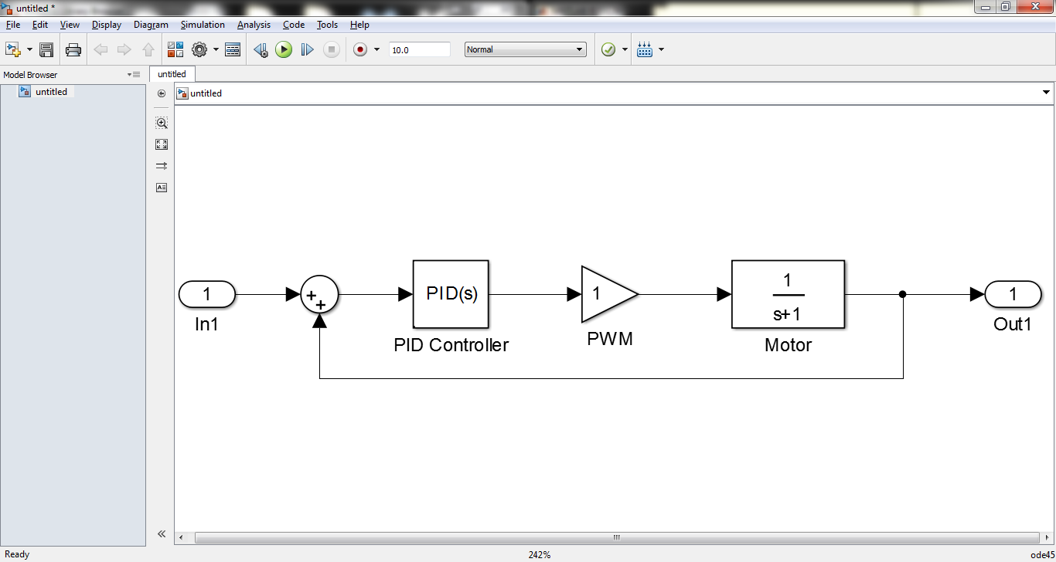

Where the input is the desired angular velocity and the output is angular velocity both in (rad/sec). A simulation of the system is below:

