To control the angular speed of the plate in the bowl, the physics of the system can be modeled and a control system can be implemented. Analyzing the rotation of the plate about the axis of the rotor of the DC servo motor, the equation of motion can be actualized as the sum of torques written as follows:

$$\sum{τ}=J\ddot{θ}$$

where $J$ is the moment of inertia of the plate and parts system and $\ddot{θ}$ is the angular acceleration. Recognizing that the torques acting on the plate consist of the input torque, $τ_{m}$, from the electric motor and the viscous friction between the plate and the bowl, $τ_{f}$, the equation of motion can be rewritten to contain these terms. The equation of motion now reflects the following expression:

$$τ_{m}-τ_{f}=J\ddot{θ}$$

The viscous friction term can be expressed as:

$$τ_{f}=b\dot{θ}$$

where b is the viscous friction coefficient and $\dot{θ}$ is the angular velocity. Substituting the expression for viscous friction, the equation of motion can be rewritten again as followed:

$$τ_{e}-b\dot{θ}=J\ddot{θ}$$

To prepare the equation of motion for modeling in MATLAB, the equation can be rearranged to solve for the angular velocity. Rearranging yields the expression:

$$\ddot{θ}=\frac{1}{J}τ_{e}-\frac{b}{J}\dot{θ}$$

With the equation of motion in the form necessary for state space representation, the state space variables can be declared as follows:

$$x_{1}=θ , x_{2}=\dot{θ} , u=τ_{e} , y=\dot{θ}$$

Using these state space variables, the state space representation can be determined. The state space matrices can be written accordingly:

$$\left[\begin{matrix}\dot{x_{1}} \\ \dot{x_{2}}\end{matrix}\right]=\left[\begin{matrix}0 & 1 \\ 0 & -\frac{b}{J}\end{matrix}\right]\left[\begin{matrix}x_{1} \\ x_{2}\end{matrix}\right]+\left[\begin{matrix}0 \\ \frac{1}{J}\end{matrix}\right]\left[u\right]$$

$$\left[y\right]=\left[\begin{matrix}0 & 1\end{matrix}\right]\left[\begin{matrix}x_{1} \\ x_{2}\end{matrix}\right]$$

As can be noticed from these expressions, the input will be the torque from the motor and the output will be the angular velocity of the plate. The torque from the motor can be adjusted using pulse width modulation and the motor driver circuit described in detail in a separate section. The angular velocity of the plate will be monitoring using a rotary encoder and will provide effective feedback to the system.

In addition to modeling the physics of the system, an appropriate control system can be developed to control the DC servo motor. Below, the independent DC servo motor controller will be implemented to ensure the motor will produce the desired torque in order to maintain the optimal angular velocity for the plate.

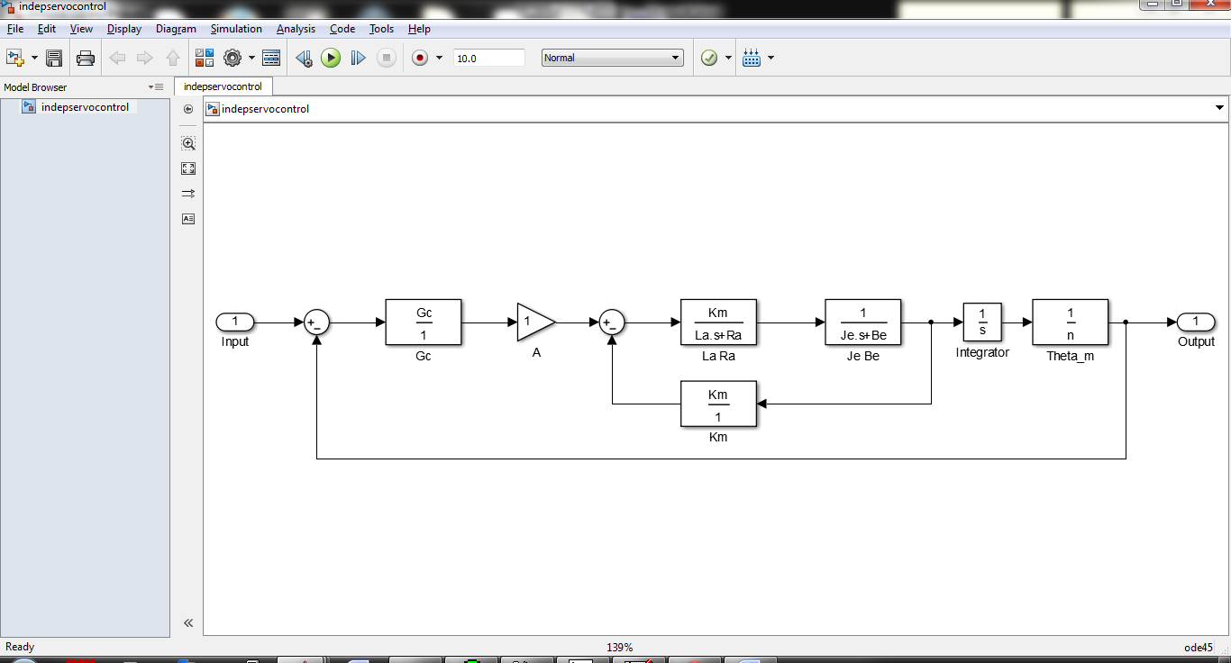

The control system will need the appropriate constants for the motor. In particular the armature resistance, $R_{a}$, and armature inductance, $L_{a}$, and motor constants, $J_{e}$ and $B_{e}$ will be measured or obtained from the selected motor’s data sheet. As a result, fine tuned control of the motor and rotating plate will be achieved for precise delivery of the desired quantity of parts in the appropriate time window.