ENV 790.30 - Time Series Analysis for Energy Data | Spring 2022

Assignment 3 - Due date 02/08/22

Ben Joseph

## Directions

You should open the .rmd file corresponding to this assignment on RStudio. The file is available on our class repository on Github.

Once you have the project open the first thing you will do is change “Student Name” on line 3 with your name. Then you will start working through the assignment by **creating code and output** that answer each question. Be sure to use this assignment document. Your report should contain the answer to each question and any plots/tables you obtained (when applicable).

Please keep this R code chunk options for the report. It is easier for us to grade when we can see code and output together. And the tidy.opts will make sure that line breaks on your code chunks are automatically added for better visualization.

When you have completed the assignment, **Knit** the text and code into a single PDF file. Rename the pdf file such that it includes your first and last name (e.g., “LuanaLima_TSA_A03_Sp22.Rmd”). Submit this pdf using Sakai.

## Questions

Consider the same data you used for A2 from the spreadsheet “Table_10.1_Renewable_Energy_Production_and_Consumption_by_Source.xlsx”. The data comes from the US Energy Information and Administration and corresponds to the January 2022 **Monthly** Energy Review. Once again you will work only with the following columns: Total Biomass Energy Production, Total Renewable Energy Production, Hydroelectric Power Consumption. Create a data frame structure with these three time series only.

R packages needed for this assignment:“forecast”,“tseries”, and “Kendall”. Install these packages, if you haven’t done yet. Do not forget to load them before running your script, since they are NOT default packages.\

library(forecast)

## Registered S3 method overwritten by 'quantmod':  
## method from  
## as.zoo.data.frame zoo

library(tseries)  
library(Kendall)  
library(ggplot2)  
library(readxl)  
library(tinytex)

df <- read_excel("./Data/Table_10.1_Renewable_Energy_Production_and_Consumption_by_Source.xlsx"  
 , sheet = 1, col_names = TRUE, skip =10, na="Not Available")  
df2 <- df[2:586,4:6]  
df2$`Total Biomass Energy Production`<- as.numeric(df2$`Total Biomass Energy Production`)  
df2$`Total Renewable Energy Production`<- as.numeric(df2$`Total Renewable Energy Production`)  
df2$`Hydroelectric Power Consumption`<-as.numeric(df2$`Hydroelectric Power Consumption`)  
head(df2,10)

## # A tibble: 10 × 3  
## `Total Biomass Energy Production` `Total Renewable Ener… `Hydroelectric Powe…  
## <dbl> <dbl> <dbl>  
## 1 130. 404. 273.  
## 2 117. 361. 242.  
## 3 130. 400. 269.  
## 4 126. 380. 253.  
## 5 130. 392. 261.  
## 6 126. 377. 250.  
## 7 130. 367. 236.  
## 8 130. 354. 222.  
## 9 126. 307. 180.  
## 10 130. 323. 192.

##Trend Component

### Q1

Create a plot window that has one row and three columns. And then for each object on your data frame, fill the plot window with time series plot, ACF and PACF. You may use the some code form A2, but I want all three plots on the same window this time. (Hint: use par() function)

ts <- ts(data = df2, start = 1973, frequency = 12)  
  
  
#Biomass Plots  
par(mfrow = c(1,3))  
plot(ts[,1], col="blue", ylab="Trillions of Btu", main="Biomass Energy\n Production",   
 xlab="Year")  
tsBio <- ts(data = df2$`Total Biomass Energy Production`, start = 1973, frequency = 1)  
acfBio <- acf(tsBio, lag.max = 40, type = "correlation",plot=TRUE, main="Biomass \nACF")  
pacfBio <- pacf(tsBio, lag.max = 40, plot = T, main="Biomass \nPACF")

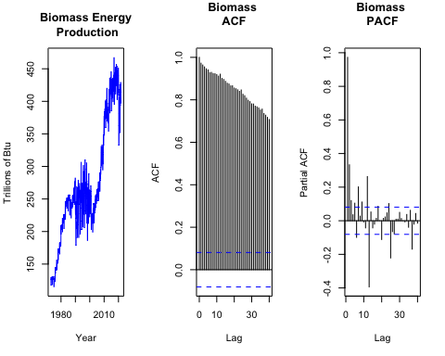

#Renewable Plots  
par(mfrow = c(1,3))  
plot(ts[,2], col="blue", ylab="Trillions of Btu", main="Renewable Energy \n Production",   
 xlab="Year")  
tsRE <- ts(data = df2$`Total Renewable Energy Production`, start = 1973, frequency = 1)  
acfRE <- acf(tsRE, lag.max = 40, type = "correlation", plot=TRUE, main="Renewable \nACF")  
pacfRE <- pacf(tsRE, lag.max = 40, plot = T, main="Renewable \nPACF")

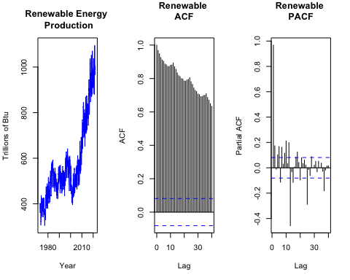

#Hydro Plot  
par(mfrow = c(1,3))  
plot(ts[,3], col="blue", ylab="Trillions of Btu", main="Hydroelectric \nPower \nConsumption",   
 xlab="Year")  
tsHydro <- ts(data = df2$`Hydroelectric Power Consumption`, start = 1973, frequency = 1)  
acfHydro <- acf(tsHydro, lag.max = 40, type = "correlation", plot=TRUE, main="Hydro \nACF")  
pacfHydro <- pacf(tsHydro, lag.max = 40, plot = T, main="Hydro \nPACF")

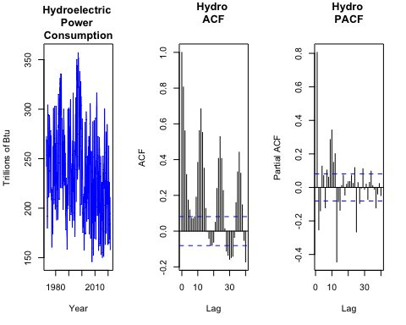

### Q2

From the plot in Q1, do the series Total Biomass Energy Production, Total Renewable Energy Production, Hydroelectric Power Consumption appear to have a trend? If yes, what kind of trend?

### There appears to be a positive stochastic trend in biomass energy production, a positive stochastic trend for renewable energy production, and a slight negative deterministic trend for hydroelectric power consumption.

### Q3

Use the *lm()* function to fit a linear trend to the three time series. Ask R to print the summary of the regression. Interpret the regression output, i.e., slope and intercept. Save the regression coefficients for further analysis.

### As discussed in class, I am going to ignore the intercept coefficient and focus solely on the slope coefficients.

### The analysis shows that for every single month increase, biomass production increases by 0.4744 trillion Btu, renewable energy productioin increases by 0.8805 trillion Btu, and hydroelectric power consumption decreases by 0.0792 trillion Btu.

### All three linear models have highly statistically significant trends as evidenced by the very small p-values associated with the slope coefficients shown in the row labeled “t” on each coefficients table.

nobs = nrow(df2)  
t<-c(1:nobs)  
my_date <- df[,1]  
my_date <- my_date[c(2:586),1]  
df2 <- cbind(my_date,df2)

lmBio = lm(df2$`Total Biomass Energy Production`~t)  
b0Bio=as.numeric(lmBio$coefficients[1])  
b1Bio=as.numeric(lmBio$coefficients[2])  
  
lmRE = lm(df2$`Total Renewable Energy Production`~t)  
b0RE=as.numeric(lmRE$coefficients[1])  
b1RE=as.numeric(lmRE$coefficients[2])  
  
lmHydro = lm(df2$`Hydroelectric Power Consumption`~t)  
b0Hydro=as.numeric(lmHydro$coefficients[1])  
b1Hydro=as.numeric(lmHydro$coefficients[2])  
  
summary(lmBio)

##   
## Call:  
## lm(formula = df2$`Total Biomass Energy Production` ~ t)  
##   
## Residuals:  
## Min 1Q Median 3Q Max   
## -101.892 -24.306 4.932 33.103 82.292   
##   
## Coefficients:  
## Estimate Std. Error t value Pr(>|t|)   
## (Intercept) 1.348e+02 3.282e+00 41.07 <2e-16 ***  
## t 4.744e-01 9.705e-03 48.88 <2e-16 ***  
## ---  
## Signif. codes: 0 '***' 0.001 '**' 0.01 '*' 0.05 '.' 0.1 ' ' 1  
##   
## Residual standard error: 39.64 on 583 degrees of freedom  
## Multiple R-squared: 0.8039, Adjusted R-squared: 0.8035   
## F-statistic: 2389 on 1 and 583 DF, p-value: < 2.2e-16

summary(lmRE)

##   
## Call:  
## lm(formula = df2$`Total Renewable Energy Production` ~ t)  
##   
## Residuals:  
## Min 1Q Median 3Q Max   
## -230.488 -57.869 5.595 62.090 261.349   
##   
## Coefficients:  
## Estimate Std. Error t value Pr(>|t|)   
## (Intercept) 323.18243 8.02555 40.27 <2e-16 ***  
## t 0.88051 0.02373 37.10 <2e-16 ***  
## ---  
## Signif. codes: 0 '***' 0.001 '**' 0.01 '*' 0.05 '.' 0.1 ' ' 1  
##   
## Residual standard error: 96.93 on 583 degrees of freedom  
## Multiple R-squared: 0.7025, Adjusted R-squared: 0.702   
## F-statistic: 1377 on 1 and 583 DF, p-value: < 2.2e-16

summary(lmHydro)

##   
## Call:  
## lm(formula = df2$`Hydroelectric Power Consumption` ~ t)  
##   
## Residuals:  
## Min 1Q Median 3Q Max   
## -94.892 -31.300 -2.414 27.876 121.263   
##   
## Coefficients:  
## Estimate Std. Error t value Pr(>|t|)   
## (Intercept) 259.18303 3.47464 74.593 < 2e-16 ***  
## t -0.07924 0.01027 -7.712 5.36e-14 ***  
## ---  
## Signif. codes: 0 '***' 0.001 '**' 0.01 '*' 0.05 '.' 0.1 ' ' 1  
##   
## Residual standard error: 41.97 on 583 degrees of freedom  
## Multiple R-squared: 0.09258, Adjusted R-squared: 0.09103   
## F-statistic: 59.48 on 1 and 583 DF, p-value: 5.364e-14

ggplot(df2, aes(x=df2$Month, y=df2$`Total Biomass Energy Production`)) +  
 ylab(paste0(colnames(df2))) +  
 geom_line(color="blue") +  
 geom_smooth(color="red",method="lm") +  
 ggtitle("Biomass Energy Production")+  
 theme(plot.title = element_text(hjust = 0.5))+ xlab("Year") + ylab("Trillion Btu")

## Warning: Use of `df2$Month` is discouraged. Use `Month` instead.

## Warning: Use of `df2$`Total Biomass Energy Production`` is discouraged. Use  
## `Total Biomass Energy Production` instead.

## Warning: Use of `df2$Month` is discouraged. Use `Month` instead.

## Warning: Use of `df2$`Total Biomass Energy Production`` is discouraged. Use  
## `Total Biomass Energy Production` instead.

## `geom_smooth()` using formula 'y ~ x'

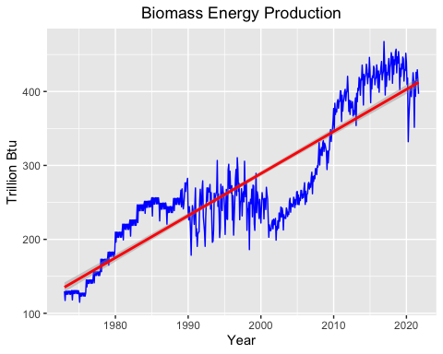

ggplot(df2, aes(x=df2$Month, y=df2$`Total Renewable Energy Production`)) +  
 geom_line(color="blue") +  
 geom_smooth(color="red",method="lm") +  
 ggtitle("Renewable Energy Production")+  
 theme(plot.title = element_text(hjust = 0.5)) + xlab("Year") + ylab("Trillion Btu")

## Warning: Use of `df2$Month` is discouraged. Use `Month` instead.

## Warning: Use of `df2$`Total Renewable Energy Production`` is discouraged. Use  
## `Total Renewable Energy Production` instead.

## Warning: Use of `df2$Month` is discouraged. Use `Month` instead.

## Warning: Use of `df2$`Total Renewable Energy Production`` is discouraged. Use  
## `Total Renewable Energy Production` instead.

## `geom_smooth()` using formula 'y ~ x'

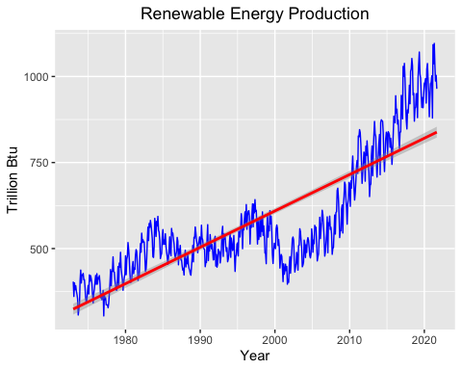

ggplot(df2, aes(x=df2$Month, y=df2$`Hydroelectric Power Consumption`)) +  
 geom_line(color="blue") +  
 geom_smooth(color="red",method="lm") +  
 ggtitle("Hydroelectric Power Consumption") +  
 theme(plot.title = element_text(hjust = 0.5))+ xlab("Year") + ylab("Trillion Btu")

## Warning: Use of `df2$Month` is discouraged. Use `Month` instead.

## Warning: Use of `df2$`Hydroelectric Power Consumption`` is discouraged. Use  
## `Hydroelectric Power Consumption` instead.

## Warning: Use of `df2$Month` is discouraged. Use `Month` instead.

## Warning: Use of `df2$`Hydroelectric Power Consumption`` is discouraged. Use  
## `Hydroelectric Power Consumption` instead.

## `geom_smooth()` using formula 'y ~ x'

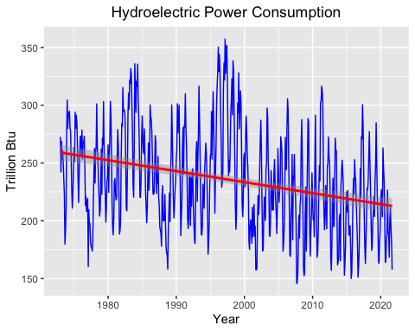

### Q4

Use the regression coefficients from Q3 to detrend the series. Plot the detrended series and compare with the plots from Q1. What happened? Did anything change?

### I detrended the series and overlayed them with the original series, both with their trend lines. The data on each detrended series shifts down to be centered on zero. The trend lines on the detrended series are 0, showing the detrending was successful.

#Biomass  
detrend_bio <- df2[,2]-(b0Bio+b1Bio*t)  
detrend_bio <- as.data.frame(detrend_bio)  
  
ggplot(df2, aes(x=df2$Month, y=df2$`Total Biomass Energy Production`)) +  
 geom_line(color="blue") +  
 ylab(paste0(colnames(df2))) +  
 geom_smooth(color="red",method="lm") +  
 geom_line(aes(y=detrend_bio$detrend_bio), color="green") +  
 geom_smooth(aes(y=detrend_bio$detrend_bio),color="orange",method="lm") +  
 ggtitle("Biomass Energy Production")+  
 theme(plot.title = element_text(hjust = 0.5))+ xlab("Year") + ylab("Trillion Btu")

## Warning: Use of `df2$Month` is discouraged. Use `Month` instead.

## Warning: Use of `df2$`Total Biomass Energy Production`` is discouraged. Use  
## `Total Biomass Energy Production` instead.

## Warning: Use of `df2$Month` is discouraged. Use `Month` instead.

## Warning: Use of `df2$`Total Biomass Energy Production`` is discouraged. Use  
## `Total Biomass Energy Production` instead.

## Warning: Use of `df2$Month` is discouraged. Use `Month` instead.  
  
## Warning: Use of `df2$Month` is discouraged. Use `Month` instead.

## `geom_smooth()` using formula 'y ~ x'  
## `geom_smooth()` using formula 'y ~ x'

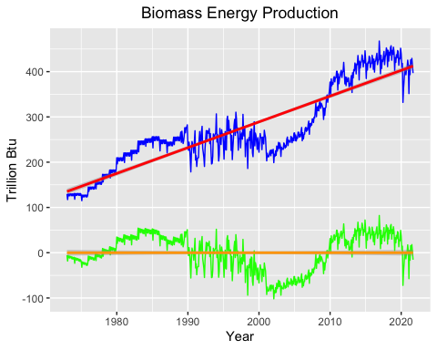

#Renewable  
detrend_RE <- df2[,3]-(b0RE+b1RE*t)  
detrend_RE <- as.data.frame(detrend_RE)  
  
ggplot(df2, aes(x=df2$Month, y=df2$`Total Renewable Energy Production`)) +  
 geom_line(color="blue") +  
 ylab(paste0(colnames(df2))) +  
 geom_smooth(color="red",method="lm") +  
 geom_line(aes(y=detrend_RE$detrend_RE), color="green") +  
 geom_smooth(aes(y=detrend_RE$detrend_RE),color="orange",method="lm") +  
 ggtitle("Renewable Energy Production")+  
 theme(plot.title = element_text(hjust = 0.5))+ xlab("Year") + ylab("Trillion Btu")

## Warning: Use of `df2$Month` is discouraged. Use `Month` instead.

## Warning: Use of `df2$`Total Renewable Energy Production`` is discouraged. Use  
## `Total Renewable Energy Production` instead.

## Warning: Use of `df2$Month` is discouraged. Use `Month` instead.

## Warning: Use of `df2$`Total Renewable Energy Production`` is discouraged. Use  
## `Total Renewable Energy Production` instead.

## Warning: Use of `df2$Month` is discouraged. Use `Month` instead.  
  
## Warning: Use of `df2$Month` is discouraged. Use `Month` instead.

## `geom_smooth()` using formula 'y ~ x'  
## `geom_smooth()` using formula 'y ~ x'

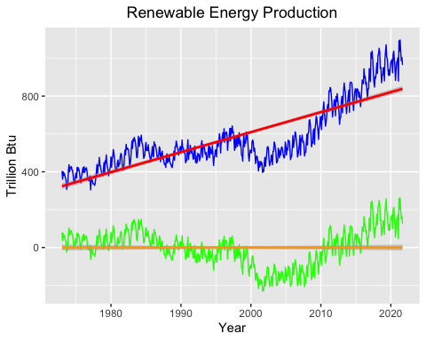

#Hydro  
detrend_Hydro <- df2[,4]-(b0Hydro+b1Hydro*t)  
detrend_Hydro <- as.data.frame(detrend_Hydro)  
  
ggplot(df2, aes(x=df2$Month, y=df2$`Hydroelectric Power Consumption`, label="Hydro")) +  
 geom_line(color="blue") +  
 ylab(paste0(colnames(df2))) +  
 geom_smooth(color="red",method="lm") +  
 geom_line(aes(y=detrend_Hydro$detrend_Hydro), color="green") +  
 geom_smooth(aes(y=detrend_Hydro$detrend_Hydro),color="orange",method="lm") +  
 ggtitle("Hydroelectric Power Consumption")+  
 theme(plot.title = element_text(hjust = 0.5))+ xlab("Year") + ylab("Trillion Btu")

## Warning: Use of `df2$Month` is discouraged. Use `Month` instead.

## Warning: Use of `df2$`Hydroelectric Power Consumption`` is discouraged. Use  
## `Hydroelectric Power Consumption` instead.

## Warning: Use of `df2$Month` is discouraged. Use `Month` instead.

## Warning: Use of `df2$`Hydroelectric Power Consumption`` is discouraged. Use  
## `Hydroelectric Power Consumption` instead.

## Warning: Use of `df2$Month` is discouraged. Use `Month` instead.  
  
## Warning: Use of `df2$Month` is discouraged. Use `Month` instead.

## `geom_smooth()` using formula 'y ~ x'  
## `geom_smooth()` using formula 'y ~ x'

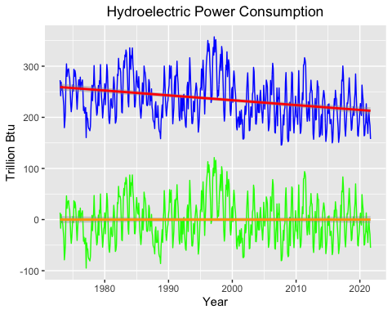

### Q5

Plot ACF and PACF for the detrended series and compare with the plots from Q1. Did the plots change? How?

### I plotted each ACF and PACF for each series next to their original ACF and PCF to show how the plots have chaanged. The ACF plots have only changed minorly. There is an excentuation of the seasonal effect on the ACF after deseasoning the graphs as the peaks and valleys are more differentiated in the deseasoned plots in comparison to the original plots. The PACF graphs look slightly changed. The Biomass and Renewable graphs look like the larger PACF bars actually grew after deseasoning while the Hydro PACF looks almost unchanged.

#Biomass  
par(mfrow = c(1,2))  
acf(tsBio, lag.max = 40, type = "correlation", plot=TRUE, main="Original Biomass \nACF")  
acf(detrend_bio, lag.max = 40, type = "correlation", plot=TRUE, main="Detrended Biomass \nACF")

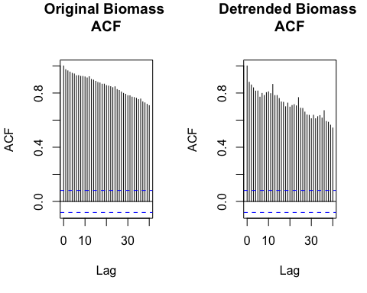

par(mfrow = c(1,2))  
pacf(tsBio, lag.max = 40, plot = T, main="Original Biomass \nPACF")  
pacf(detrend_bio, lag.max = 40, plot = T, main="Detrended Biomass \nPACF")

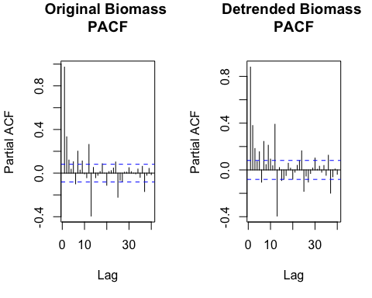

#Renewable  
par(mfrow = c(1,2))  
acf(tsRE, lag.max = 40, type = "correlation", plot=TRUE, main="Original Renewable \nACF")  
acf(detrend_RE, lag.max = 40, type = "correlation", plot=TRUE, main="Detrended Renewable \nACF")

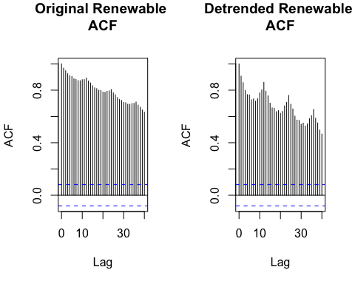

par(mfrow = c(1,2))  
pacf(tsRE, lag.max = 40, plot = T, main="Original Renewable \nPACF")  
pacf(detrend_RE, lag.max = 40, plot = T, main="Detrended Renewable \nPACF")

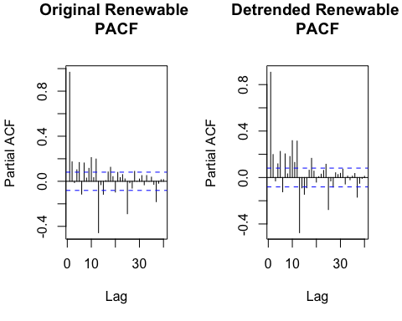

#Hydro  
par(mfrow = c(1,2))  
acf(tsHydro, lag.max = 40, type = "correlation", plot=TRUE, main="Original Hydro \nACF")  
acf(detrend_Hydro, lag.max = 40, type = "correlation", plot=TRUE, main="Detrended Hydro \nACF")

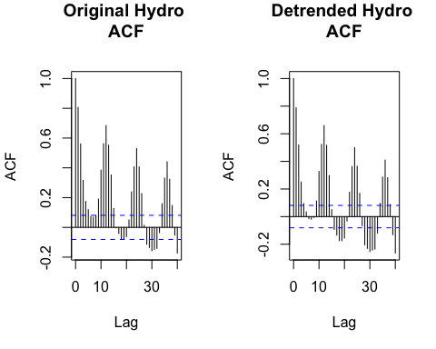

par(mfrow = c(1,2))  
pacf(tsHydro, lag.max = 40, plot = T, main="Original Hydro \nPACF")  
pacf(detrend_Hydro, lag.max = 40, plot = T, main="Detrended Hydro \nPACF")

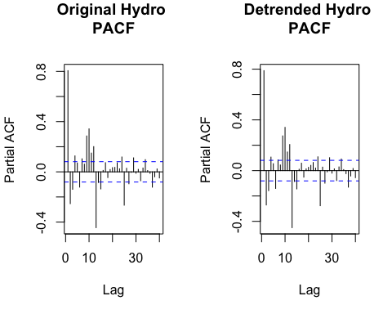

## Seasonal Component

Set aside the detrended series and consider the original series again from Q1 to answer Q6 to Q8.

### Q6

Do the series seem to have a seasonal trend? Which serie/series? Use function *lm()* to fit a seasonal means model (i.e. using the seasonal dummies) to this/these time series. Ask R to print the summary of the regression. Interpret the regression output. Save the regression coefficients for further analysis.

### I somewhat combined the code for questions 6 and 7 so the code is under number 7 but my answer for 6 is here.

### When I fit a seasonal means model to these time series, it showed that the only time series with a statistically significant seasonal trend was hydro. I found this by investigating the summary of the seasonal means model. The righthand column of the coefficients table shows the probability of observing as extreme of a coefficient as our model produced if in fact the true value is zero. The fact that these probabilities were all above 0.05, our significance level, for biomass and renewables indicates there was no statistical significance to the seasonal variation in the data. For hydro, the p-values of the dummy coefficients were statistically significant for all dummy variables except for two, indicating a strong seasonal trend.

##$ These results make sense conseptually as there is nothing inherently seasonal about biomass energy production. For renewables, solar produces more during the summer, but wind produces more in the winter. These could be cancelling each other our, effectively nullifying any seasonal trend. Hydro, however is highly affected by seasonal variations in windfall.

### Q7

Use the regression coefficients from Q6 to deseason the series. Plot the deseason series and compare with the plots from part Q1. Did anything change?

### For each series, I displayed two plots side-by-side: one with the original data overlayed with the projected seasonal trend and one with the original data overlayed with the deseasoned data. This shifted the time series so that the mean was at zero. It also had the affect of smoothing out portions of the hydro production curve. The other two curves may have had some smoothing affect but it was not as obvious. This is unsurprising given the lack of the statistically significant seasonal trend as explained in the previous question.

# install.packages("gridExtra") #Installed to do par() equivalent on ggplot  
library(gridExtra)  
  
# Identifyinig the seasonal trend  
dummiesBio <- seasonaldummy(ts[,1]) #creates dummies  
seas_means_model_Bio=lm(ts[,1]~dummiesBio) #generate intercept and dummy coefficients for biomass data indexed by dummy  
summary(seas_means_model_Bio) # viewing dummy coefficients and intercept

##   
## Call:  
## lm(formula = ts[, 1] ~ dummiesBio)  
##   
## Residuals:  
## Min 1Q Median 3Q Max   
## -156.96 -51.40 -22.15 60.65 183.31   
##   
## Coefficients:  
## Estimate Std. Error t value Pr(>|t|)   
## (Intercept) 284.241 12.962 21.928 <2e-16 ***  
## dummiesBioJan -1.498 18.238 -0.082 0.9346   
## dummiesBioFeb -30.582 18.238 -1.677 0.0941 .   
## dummiesBioMar -8.873 18.238 -0.486 0.6268   
## dummiesBioApr -21.009 18.238 -1.152 0.2498   
## dummiesBioMay -14.065 18.238 -0.771 0.4409   
## dummiesBioJun -19.601 18.238 -1.075 0.2829   
## dummiesBioJul -3.499 18.238 -0.192 0.8479   
## dummiesBioAug -0.252 18.238 -0.014 0.9890   
## dummiesBioSep -12.518 18.238 -0.686 0.4928   
## dummiesBioOct -3.629 18.331 -0.198 0.8432   
## dummiesBioNov -9.592 18.331 -0.523 0.6010   
## ---  
## Signif. codes: 0 '***' 0.001 '**' 0.01 '*' 0.05 '.' 0.1 ' ' 1  
##   
## Residual standard error: 89.81 on 573 degrees of freedom  
## Multiple R-squared: 0.01056, Adjusted R-squared: -0.008439   
## F-statistic: 0.5557 on 11 and 573 DF, p-value: 0.8647

beta_int_Bio=seas_means_model_Bio$coefficients[1] #saving intercept in beta_int_Bio  
beta_coeff_Bio=seas_means_model_Bio$coefficients[2:12] #saving dummy coefficients in array called beta_coeff_Bio  
Bio_seas_comp=array(0,nobs) #creating array to hold seasonal trend  
for(i in 1:nobs){  
 Bio_seas_comp[i]=(beta_int_Bio+beta_coeff_Bio%*%dummiesBio[i,])   
} #populating Bio_seas_comp using for loop with beta coefficients from the lm() function  
  
#Removing seasonal component  
  
bioSeasonPlot1 <- ggplot(df2, aes(x=df2$Month, y=df2$`Total Biomass Energy Production`)) + #plotting original data w seasonal component  
 geom_line(color="blue") +  
 ylab(paste0(colnames(df2))) +  
 geom_line(aes(y=Bio_seas_comp), color="red") +  
 ggtitle("Biomass Seasonal \nTrend")+  
 theme(plot.title = element_text(hjust = 0.5))+ xlab("Year") + ylab("Trillion Btu")   
  
deseason_Bio <- ts[,1]-Bio_seas_comp # subtracting seasonal component in deseason_Bio  
  
bioSeasonPlot2 <- ggplot(df2, aes(x=df2$Month, y=df2$`Total Biomass Energy Production`)) + #plotting original data w deseasoned data  
 geom_line(color="blue") +  
 ylab(paste0("Inflow ",colnames(ts)[1],sep="")) +  
 geom_line(aes(y=deseason_Bio), col="green") +  
 ggtitle("Biomass \nDeseasoned")+  
 theme(plot.title = element_text(hjust = 0.5))+ xlab("Year") + ylab("Trillion Btu")   
  
grid.arrange(bioSeasonPlot1, bioSeasonPlot2, ncol=2) #plotting side by side

## Warning: Use of `df2$Month` is discouraged. Use `Month` instead.

## Warning: Use of `df2$`Total Biomass Energy Production`` is discouraged. Use  
## `Total Biomass Energy Production` instead.

## Warning: Use of `df2$Month` is discouraged. Use `Month` instead.  
  
## Warning: Use of `df2$Month` is discouraged. Use `Month` instead.

## Warning: Use of `df2$`Total Biomass Energy Production`` is discouraged. Use  
## `Total Biomass Energy Production` instead.

## Warning: Use of `df2$Month` is discouraged. Use `Month` instead.

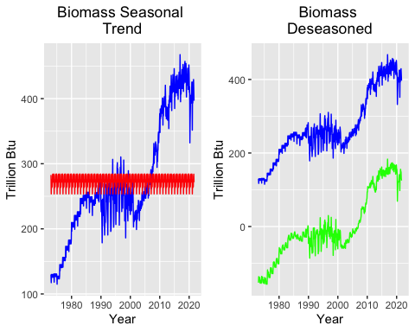

# Identifyinig the seasonal trend  
dummiesRE <- seasonaldummy(ts[,2]) #creates dummies  
seas_means_model_RE=lm(ts[,2]~dummiesRE) #generate intercept and dummy coefficients for renewable data indexed by dummy  
summary(seas_means_model_RE) # viewing dummy coefficients and intercept

##   
## Call:  
## lm(formula = ts[, 2] ~ dummiesRE)  
##   
## Residuals:  
## Min 1Q Median 3Q Max   
## -272.95 -111.55 -59.35 65.68 480.41   
##   
## Coefficients:  
## Estimate Std. Error t value Pr(>|t|)   
## (Intercept) 589.971 25.464 23.169 <2e-16 ***  
## dummiesREJan 11.793 35.828 0.329 0.7422   
## dummiesREFeb -40.992 35.828 -1.144 0.2530   
## dummiesREMar 21.892 35.828 0.611 0.5414   
## dummiesREApr 8.908 35.828 0.249 0.8037   
## dummiesREMay 37.500 35.828 1.047 0.2957   
## dummiesREJun 19.465 35.828 0.543 0.5871   
## dummiesREJul 8.115 35.828 0.227 0.8209   
## dummiesREAug -18.359 35.828 -0.512 0.6086   
## dummiesRESep -62.115 35.828 -1.734 0.0835 .   
## dummiesREOct -51.377 36.012 -1.427 0.1542   
## dummiesRENov -41.789 36.012 -1.160 0.2464   
## ---  
## Signif. codes: 0 '***' 0.001 '**' 0.01 '*' 0.05 '.' 0.1 ' ' 1  
##   
## Residual standard error: 176.4 on 573 degrees of freedom  
## Multiple R-squared: 0.03139, Adjusted R-squared: 0.0128   
## F-statistic: 1.688 on 11 and 573 DF, p-value: 0.07235

beta_int_RE=seas_means_model_RE$coefficients[1] #saving intercept in beta_int_RE  
beta_coeff_RE=seas_means_model_RE$coefficients[2:12] #saving dummy coefficients in array called beta_coeff_RE  
RE_seas_comp=array(0,nobs) #creating array to hold seasonal trend  
for(i in 1:nobs){  
 RE_seas_comp[i]=(beta_int_RE+beta_coeff_RE%*%dummiesRE[i,])   
} #populating RE_seas_comp using for loop with beta coefficients from the lm() function  
  
#Removing seasonal component  
  
reSeasonPlot1 <- ggplot(df2, aes(x=df2$Month, y=df2$`Total Renewable Energy Production`)) + #plotting original data w seasonal component  
 geom_line(color="blue") +  
 ylab(paste0(colnames(df2))) +  
 geom_line(aes(y=RE_seas_comp), color="red") +  
 ggtitle("Renewable Seasonal \nTrend")+  
 theme(plot.title = element_text(hjust = 0.5))+ xlab("Year") + ylab("Trillion Btu")   
  
deseason_RE <- ts[,2]-RE_seas_comp # subtracting seasonal component in deseason_RE  
  
reSeasonPlot2 <- ggplot(df2, aes(x=df2$Month, y=df2$`Total Renewable Energy Production`)) + #plotting original data w deseasoned data  
 geom_line(color="blue") +  
 ylab(paste0("Inflow ",colnames(ts)[2],sep="")) +  
 geom_line(aes(y=deseason_RE), col="green") +  
 ggtitle("Renewables \nDeseasoned")+  
 theme(plot.title = element_text(hjust = 0.5))+ xlab("Year") + ylab("Trillion Btu")   
  
grid.arrange(reSeasonPlot1, reSeasonPlot2, ncol=2) #plotting side by side

## Warning: Use of `df2$Month` is discouraged. Use `Month` instead.

## Warning: Use of `df2$`Total Renewable Energy Production`` is discouraged. Use  
## `Total Renewable Energy Production` instead.

## Warning: Use of `df2$Month` is discouraged. Use `Month` instead.  
  
## Warning: Use of `df2$Month` is discouraged. Use `Month` instead.

## Warning: Use of `df2$`Total Renewable Energy Production`` is discouraged. Use  
## `Total Renewable Energy Production` instead.

## Warning: Use of `df2$Month` is discouraged. Use `Month` instead.

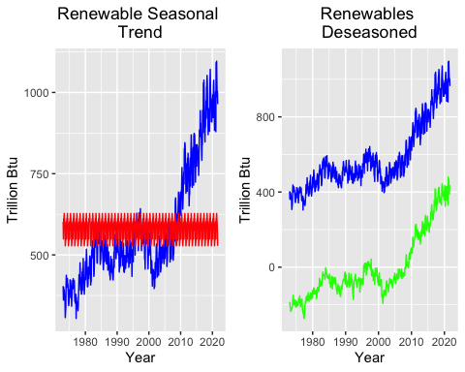

# Identifyinig the seasonal trend  
dummiesHydro <- seasonaldummy(ts[,3]) #creates dummies  
seas_means_model_Hydro=lm(ts[,3]~dummiesHydro) #generate intercept and dummy coefficients for renewable data indexed by dummy  
summary(seas_means_model_Hydro) # viewing dummy coefficients and intercept

##   
## Call:  
## lm(formula = ts[, 3] ~ dummiesHydro)  
##   
## Residuals:  
## Min 1Q Median 3Q Max   
## -90.253 -23.017 -3.042 21.487 99.478   
##   
## Coefficients:  
## Estimate Std. Error t value Pr(>|t|)   
## (Intercept) 237.841 4.892 48.616 < 2e-16 ***  
## dummiesHydroJan 13.558 6.883 1.970 0.04936 *   
## dummiesHydroFeb -8.090 6.883 -1.175 0.24037   
## dummiesHydroMar 20.067 6.883 2.915 0.00369 **   
## dummiesHydroApr 16.619 6.883 2.414 0.01607 *   
## dummiesHydroMay 39.961 6.883 5.805 1.06e-08 ***  
## dummiesHydroJun 31.315 6.883 4.549 6.57e-06 ***  
## dummiesHydroJul 10.511 6.883 1.527 0.12732   
## dummiesHydroAug -17.853 6.883 -2.594 0.00974 **   
## dummiesHydroSep -49.852 6.883 -7.242 1.43e-12 ***  
## dummiesHydroOct -48.086 6.919 -6.950 9.96e-12 ***  
## dummiesHydroNov -32.187 6.919 -4.652 4.08e-06 ***  
## ---  
## Signif. codes: 0 '***' 0.001 '**' 0.01 '*' 0.05 '.' 0.1 ' ' 1  
##   
## Residual standard error: 33.89 on 573 degrees of freedom  
## Multiple R-squared: 0.4182, Adjusted R-squared: 0.4071   
## F-statistic: 37.45 on 11 and 573 DF, p-value: < 2.2e-16

beta_int_Hydro=seas_means_model_Hydro$coefficients[1] #saving intercept in beta_int_Hydro  
beta_coeff_Hydro=seas_means_model_Hydro$coefficients[2:12] #saving dummy coefficients in array called beta_coeff_Hydro  
Hydro_seas_comp=array(0,nobs) #creating array to hold seasonal trend  
for(i in 1:nobs){  
 Hydro_seas_comp[i]=(beta_int_Hydro+beta_coeff_Hydro%*%dummiesHydro[i,])   
} #populating Hydro_seas_comp using for loop with beta coefficients from the lm() function  
  
#Removing seasonal component  
  
HydroSeasonPlot1 <- ggplot(df2, aes(x=df2$Month, y=df2$`Hydroelectric Power Consumption`)) + #plotting original data w seasonal component  
 geom_line(color="blue") +  
 ylab(paste0(colnames(df2))) +  
 geom_line(aes(y=Hydro_seas_comp), color="red") +  
 ggtitle("Hydro Seasonal \nTrend")+  
 theme(plot.title = element_text(hjust = 0.5))+ xlab("Year") + ylab("Trillion Btu")   
  
deseason_Hydro <- ts[,3]-Hydro_seas_comp # subtracting seasonal component in deseason_Hydro  
  
HydroSeasonPlot2 <- ggplot(df2, aes(x=df2$Month, y=df2$`Hydroelectric Power Consumption`)) + #plotting original data w deseasoned data  
 geom_line(color="blue") +  
 ylab(paste0("Inflow ",colnames(ts)[3],sep="")) +  
 geom_line(aes(y=deseason_Hydro), col="green") +  
 ggtitle("Hydro \nDeseasoned")+  
 theme(plot.title = element_text(hjust = 0.5))+ xlab("Year") + ylab("Trillion Btu")   
  
grid.arrange(HydroSeasonPlot1, HydroSeasonPlot2, ncol=2) #plotting side by side

## Warning: Use of `df2$Month` is discouraged. Use `Month` instead.

## Warning: Use of `df2$`Hydroelectric Power Consumption`` is discouraged. Use  
## `Hydroelectric Power Consumption` instead.

## Warning: Use of `df2$Month` is discouraged. Use `Month` instead.  
  
## Warning: Use of `df2$Month` is discouraged. Use `Month` instead.

## Warning: Use of `df2$`Hydroelectric Power Consumption`` is discouraged. Use  
## `Hydroelectric Power Consumption` instead.

## Warning: Use of `df2$Month` is discouraged. Use `Month` instead.

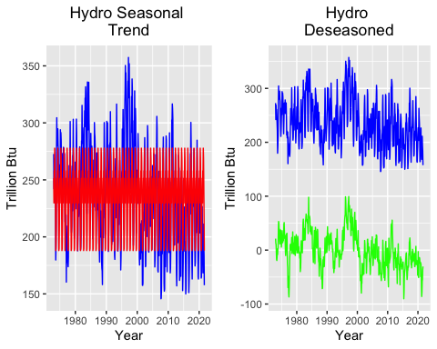

### Q8

Plot ACF and PACF for the deseason series and compare with the plots from Q1. Did the plots change? How?

### I plotted the time series, ACF, and PACF in the same plot window like I did in Q1 and also displayed the same plots as in Q1 for the sake of comparison.

### Deseasoning seems to have taken away seasonal variation in the ACFs and significantly shrunk the PACFs for both Biomass and Renewable Energy time series. This indicates that it was successful in removing a seasonal trend which is surprising given the lack of statistical significance in the summary of the regression analysis.

### Unsurprisingly, the largest change is in the hydro time series. Where the ACF was originally shaped like a sine wave, it is now mostly steadily declining. Where the PACF originally showed seasonality, all the data past lag 2 is mostly negligable.

##plot deseasoned data, acf, pcf  
  
par(mfrow = c(1,3))  
plot(deseason_Bio, col="blue", ylab="Trillions of Btu", main="Deseasoned Biomass \n Production",   
 xlab="Year")  
tsDeseasBio <- ts(data = deseason_Bio, start = 1973, frequency = 1)  
acfDeseasBio <- acf(tsDeseasBio, lag.max = 40, type = "correlation",plot=TRUE, main="Deseasoned \nBiomass ACF")  
pacf(tsDeseasBio, lag.max = 40, plot = T, main="Deseasoned \nBiomass PACF")

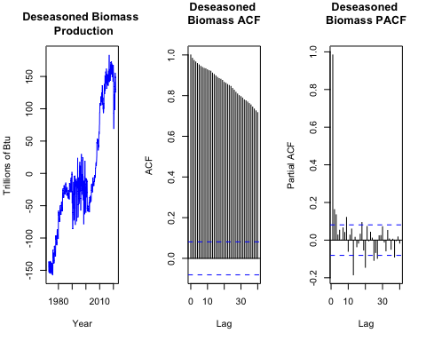

##include original plots for comparison   
  
par(mfrow = c(1,3))   
plot(ts[,1], col="blue", ylab="Trillions of Btu", main="Original Biomass\n Production",   
 xlab="Year")  
plot(acfBio, main = "Original \nBiomass ACF")  
plot(pacfBio, main = "Original \nBiomass PACF")

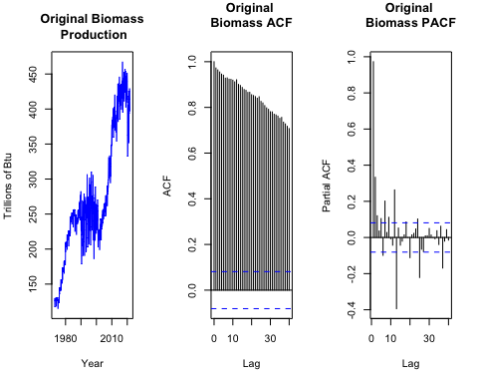

##plot deseasoned data, acf, pacf  
  
par(mfrow = c(1,3))  
plot(deseason_RE, col="blue", ylab="Trillions of Btu", main="Deseasoned Renewable \n Production",   
 xlab="Year")  
tsDeseasRE <- ts(data = deseason_RE, start = 1973, frequency = 1)  
acfDeseasRE <- acf(tsDeseasRE, lag.max = 40, type = "correlation",plot=TRUE, main="Deseasoned \nRenewable ACF")  
pacf(tsDeseasRE, lag.max = 40, plot = T, main="Deseasoned \nRenewable PACF")

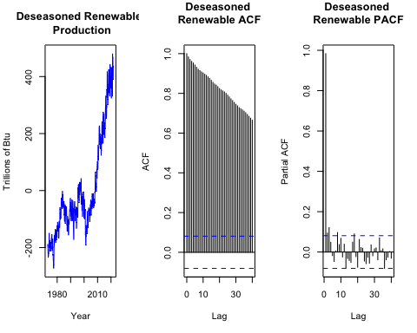

##include original plots for comparison   
  
par(mfrow = c(1,3))   
plot(ts[,2], col="blue", ylab="Trillions of Btu", main="Original Renewable \n Production",   
 xlab="Year")  
plot(acfRE, main = "Original \nRenewables ACF")  
plot(pacfRE, main = "Original \nRenewables PACF")

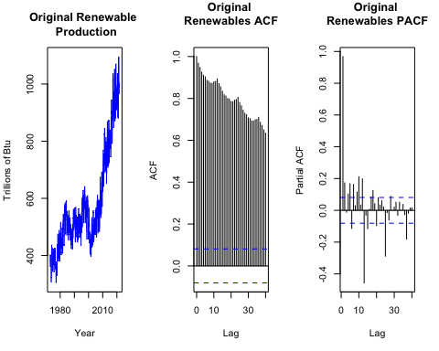

##plot deseasoned data, acf, pacf  
  
par(mfrow = c(1,3))  
plot(deseason_Hydro, col="blue", ylab="Trillions of Btu", main="Deseasoned Hydro",   
 xlab="Year")  
tsDeseasHydro <- ts(data = deseason_Hydro, start = 1973, frequency = 1)  
acfDeseasHydro <- acf(tsDeseasHydro, lag.max = 40, type = "correlation",plot=TRUE, main="Deseasoned \nHydro ACF")  
pacf(tsDeseasHydro, lag.max = 40, plot = T, main="Deseasoned \nHydro PACF")

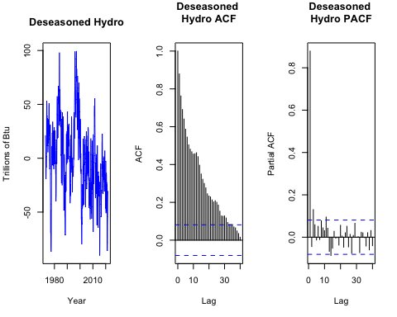

##include original plots for comparison   
  
par(mfrow = c(1,3))   
plot(ts[,3], col="blue", ylab="Trillions of Btu", main="Original Hydro",   
 xlab="Year")  
plot(acfHydro, main = "Original \nHydro ACF")  
plot(pacfHydro, main = "Original \nHydro PACF")

