Module 3: Git And Jenkins

Assignment - 1

Action Items

• Create two separate branches from master

• Make changes in the same function of the source code in both the branches

• Merge branch1 into the master

• Try and merge branch2 into the master (merge conflict should arise)

• Install a merge tool of your choice and resolve the merge conflict using

git merge tool command

Answers:

I have created two folder test1(for Harry )and test2 (for Kane ) .

Step 1 and 2

# **Clone Master Branch from Git Repository and Modified “index.html”**

DELL@DESKTOP-KMU6QJU MINGW64 /d/test1

$ git clone https://github.com/bpjsons/edurekaApp.git

Cloning into 'edurekaApp'...

remote: Enumerating objects: 28, done.

remote: Counting objects: 100% (28/28), done.

remote: Compressing objects: 100% (21/21), done.

remote: Total 28 (delta 6), reused 24 (delta 2), pack-reused 0

Receiving objects: 100% (28/28), 711.07 KiB | 1.79 MiB/s, done.

Resolving deltas: 100% (6/6), done.

DELL@DESKTOP-KMU6QJU MINGW64 /d/test1

$ cd edurekaApp

DELL@DESKTOP-KMU6QJU MINGW64 /d/test1/edurekaApp (master)

$ git status

On branch master

Your branch is up to date with 'origin/master'.

Changes not staged for commit:

(use "git add <file>..." to update what will be committed)

(use "git restore <file>..." to discard changes in working directory)

modified: index.html

no changes added to commit (use "git add" and/or "git commit -a")

DELL@DESKTOP-KMU6QJU MINGW64 /d/test1/edurekaApp (master)

$ git add .

DELL@DESKTOP-KMU6QJU MINGW64 /d/test1/edurekaApp (master)

$ git status

On branch master

Your branch is up to date with 'origin/master'.

Changes to be committed:

(use "git restore --staged <file>..." to unstage)

modified: index.html

DELL@DESKTOP-KMU6QJU MINGW64 /d/test1/edurekaApp (master)

$ git commit -m "modify index.html from master branch"

[master a5fc759] modify index.html from master branch

1 file changed, 10 insertions(+), 52 deletions(-)

DELL@DESKTOP-KMU6QJU MINGW64 /d/test1/edurekaApp (master)

$ git push origin master

Enumerating objects: 5, done.

Counting objects: 100% (5/5), done.

Delta compression using up to 6 threads

Compressing objects: 100% (3/3), done.

Writing objects: 100% (3/3), 554 bytes | 554.00 KiB/s, done.

Total 3 (delta 1), reused 0 (delta 0), pack-reused 0 (from 0)

remote: Resolving deltas: 100% (1/1), completed with 1 local object.

To https://github.com/bpjsons/edurekaApp.git

efe546c..a5fc759 master -> master

DELL@DESKTOP-KMU6QJU MINGW64 /d/test1/edurekaApp (master)

$

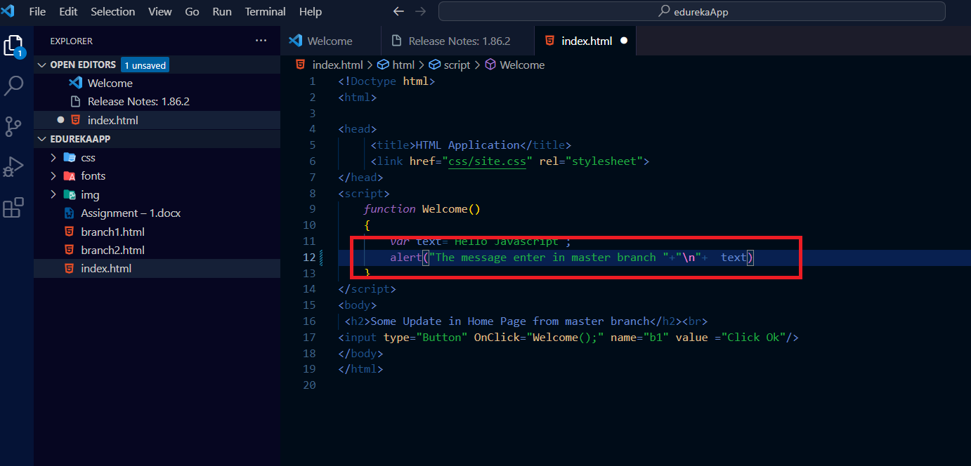

# **Create new Branch “branch1” and modify “index.html” by Harry**

In folder test1 Harry create “branch1” from “master” branch and modify the “index.html” file he added new line "The message enter in branch1 branch” in index.html file by using following setps.

# **Create “branch1” and modified the html file**

DELL@DESKTOP-KMU6QJU MINGW64 /d/test1/edurekaApp (master)

$ git checkout -b branch1

Switched to a new branch 'branch1'

DELL@DESKTOP-KMU6QJU MINGW64 /d/test1/edurekaApp (branch1)

$ git status

On branch branch1

Changes not staged for commit:

(use "git add <file>..." to update what will be committed)

(use "git restore <file>..." to discard changes in working directory)

modified: index.html

no changes added to commit (use "git add" and/or "git commit -a")

# **Commit code into “branch 1”**

DELL@DESKTOP-KMU6QJU MINGW64 /d/test1/edurekaApp (branch1)

$ git add .

DELL@DESKTOP-KMU6QJU MINGW64 /d/test1/edurekaApp (branch1)

$ git status

On branch branch1

Changes to be committed:

(use "git restore --staged <file>..." to unstage)

modified: index.html

DELL@DESKTOP-KMU6QJU MINGW64 /d/test1/edurekaApp (branch1)

$ git commit -m "modify index.html form branch 1"

[branch1 3a02632] modify index.html form branch 1

1 file changed, 3 insertions(+), 1 deletion(-)

DELL@DESKTOP-KMU6QJU MINGW64 /d/test1/edurekaApp (branch1)

$ git push origin branch1

Enumerating objects: 5, done.

Counting objects: 100% (5/5), done.

Delta compression using up to 6 threads

Compressing objects: 100% (3/3), done.

Writing objects: 100% (3/3), 357 bytes | 357.00 KiB/s, done.

Total 3 (delta 2), reused 0 (delta 0), pack-reused 0 (from 0)

remote: Resolving deltas: 100% (2/2), completed with 2 local objects.

remote:

remote: Create a pull request for 'branch1' on GitHub by visiting:

remote: https://github.com/bpjsons/edurekaApp/pull/new/branch1

remote:

To https://github.com/bpjsons/edurekaApp.git

* [new branch] branch1 -> branch1

DELL@DESKTOP-KMU6QJU MINGW64 /d/test1/edurekaApp (branch1)

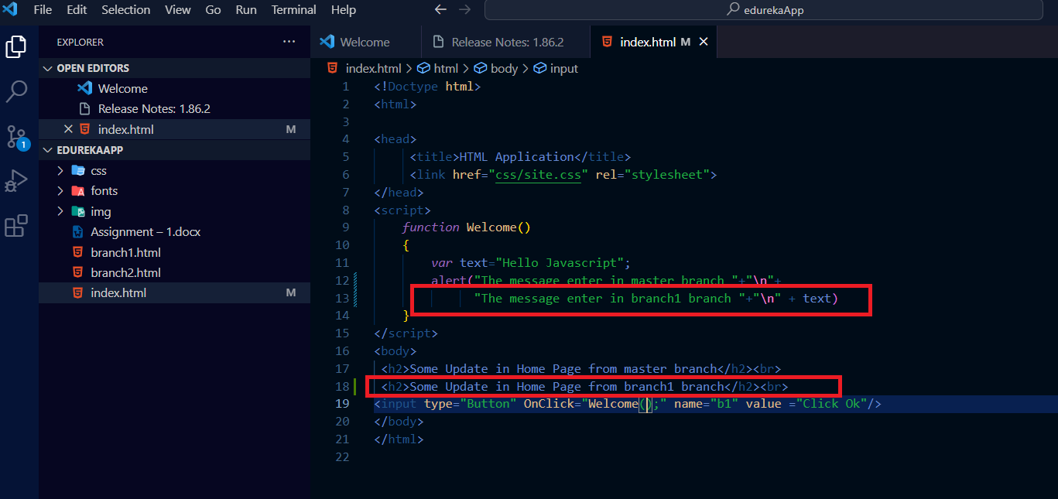

# **Create new Branch “branch2” and modify “index.html” by Kane.**

In folder test2 Kane created “branch2” from the “master” branch and modified the “index.html” file. He added a new line, "The message entered in branch2 branch,” in the function Welcome in the index.html file by using the following setps.

# Clone the master repository by Kane in test2 folder

DELL@DESKTOP-KMU6QJU MINGW64 /d/test2

$ git clone https://github.com/bpjsons/edurekaApp.git

Cloning into 'edurekaApp'...

remote: Enumerating objects: 34, done.

remote: Counting objects: 100% (34/34), done.

remote: Compressing objects: 100% (25/25), done.

remote: Total 34 (delta 9), reused 29 (delta 4), pack-reused 0

Receiving objects: 100% (34/34), 711.86 KiB | 457.00 KiB/s, done.

Resolving deltas: 100% (9/9), done.

DELL@DESKTOP-KMU6QJU MINGW64 /d/test2

$ cd edurekaApp

# **Create “branch2” and modified the html file**

DELL@DESKTOP-KMU6QJU MINGW64 /d/test2/edurekaApp (master)

$ git checkout -b branch2

Switched to a new branch 'branch2'

DELL@DESKTOP-KMU6QJU MINGW64 /d/test2/edurekaApp (branch2)

$ git status

On branch branch2

Changes not staged for commit:

(use "git add <file>..." to update what will be committed)

(use "git restore <file>..." to discard changes in working directory)

modified: index.html

no changes added to commit (use "git add" and/or "git commit -a")

# **Commit code into “branch 2”**

DELL@DESKTOP-KMU6QJU MINGW64 /d/test2/edurekaApp (branch2)

$ git add .

DELL@DESKTOP-KMU6QJU MINGW64 /d/test2/edurekaApp (branch2)

$ git status

On branch branch2

Changes to be committed:

(use "git restore --staged <file>..." to unstage)

modified: index.html

DELL@DESKTOP-KMU6QJU MINGW64 /d/test2/edurekaApp (branch2)

$ git commit -m "modify index.html from branch 2"

[branch2 65f7c4f] modify index.html from branch 2

1 file changed, 3 insertions(+), 1 deletion(-)

DELL@DESKTOP-KMU6QJU MINGW64 /d/test2/edurekaApp (branch2)

$ git push origin branch2

Enumerating objects: 5, done.

Counting objects: 100% (5/5), done.

Delta compression using up to 6 threads

Compressing objects: 100% (3/3), done.

Writing objects: 100% (3/3), 357 bytes | 357.00 KiB/s, done.

Total 3 (delta 2), reused 0 (delta 0), pack-reused 0 (from 0)

remote: Resolving deltas: 100% (2/2), completed with 2 local objects.

remote:

remote: Create a pull request for 'branch2' on GitHub by visiting:

remote: https://github.com/bpjsons/edurekaApp/pull/new/branch2

remote:

To https://github.com/bpjsons/edurekaApp.git

* [new branch] branch2 -> branch2

DELL@DESKTOP-KMU6QJU MINGW64 /d/test2/edurekaApp (branch2)

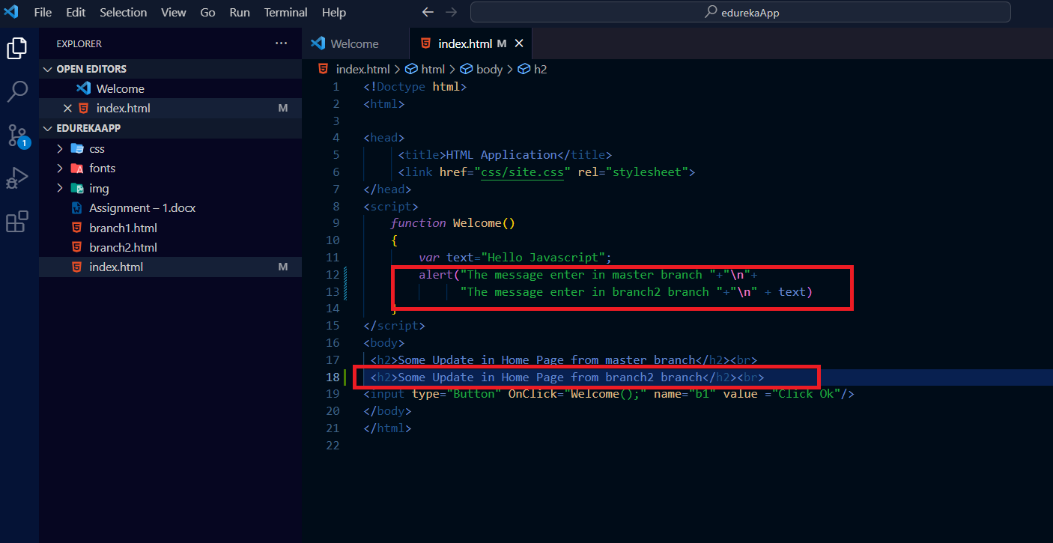

Step 3

# **Marge “Branch1” into the Master Branch by Herry**

DELL@DESKTOP-KMU6QJU MINGW64 /d/test1/edurekaApp (master)

$ git checkout branch 1

error: pathspec 'branch' did not match any file(s) known to git

error: pathspec '1' did not match any file(s) known to git

DELL@DESKTOP-KMU6QJU MINGW64 /d/test1/edurekaApp (master)

$ git checkout branch1

Switched to a new branch 'branch1'

branch 'branch1' set up to track 'origin/branch1'.

DELL@DESKTOP-KMU6QJU MINGW64 /d/test1/edurekaApp (branch1)

$ git checkout master

Switched to branch 'master'

Your branch is up to date with 'origin/master'.

DELL@DESKTOP-KMU6QJU MINGW64 /d/test1/edurekaApp (master)

$ git merge branch1

Updating a5fc759..3a02632

Fast-forward

index.html | 4 +++-

1 file changed, 3 insertions(+), 1 deletion(-)

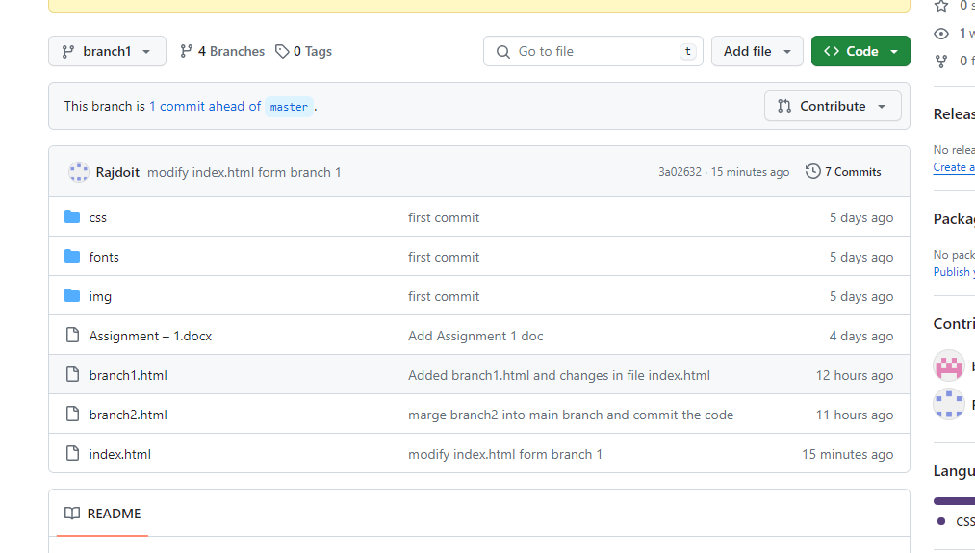

# **Marge “Branch2” into the Master Branch by Kain**

DELL@DESKTOP-KMU6QJU MINGW64 /d/test2/edurekaApp (branch2)

$ git checkout master

Switched to branch 'master'

Your branch is ahead of 'origin/master' by 1 commit.

(use "git push" to publish your local commits)

DELL@DESKTOP-KMU6QJU MINGW64 /d/test2/edurekaApp (master)

$ git merge branch2

Auto-merging index.html

CONFLICT (content): Merge conflict in index.html

Automatic merge failed; fix conflicts and then commit the result.

DELL@DESKTOP-KMU6QJU MINGW64 /d/test2/edurekaApp (master|MERGING)

Find the Conflict during merge

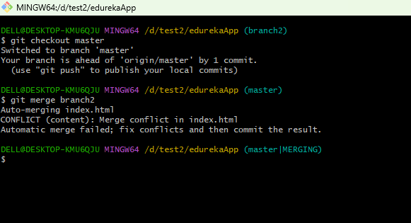

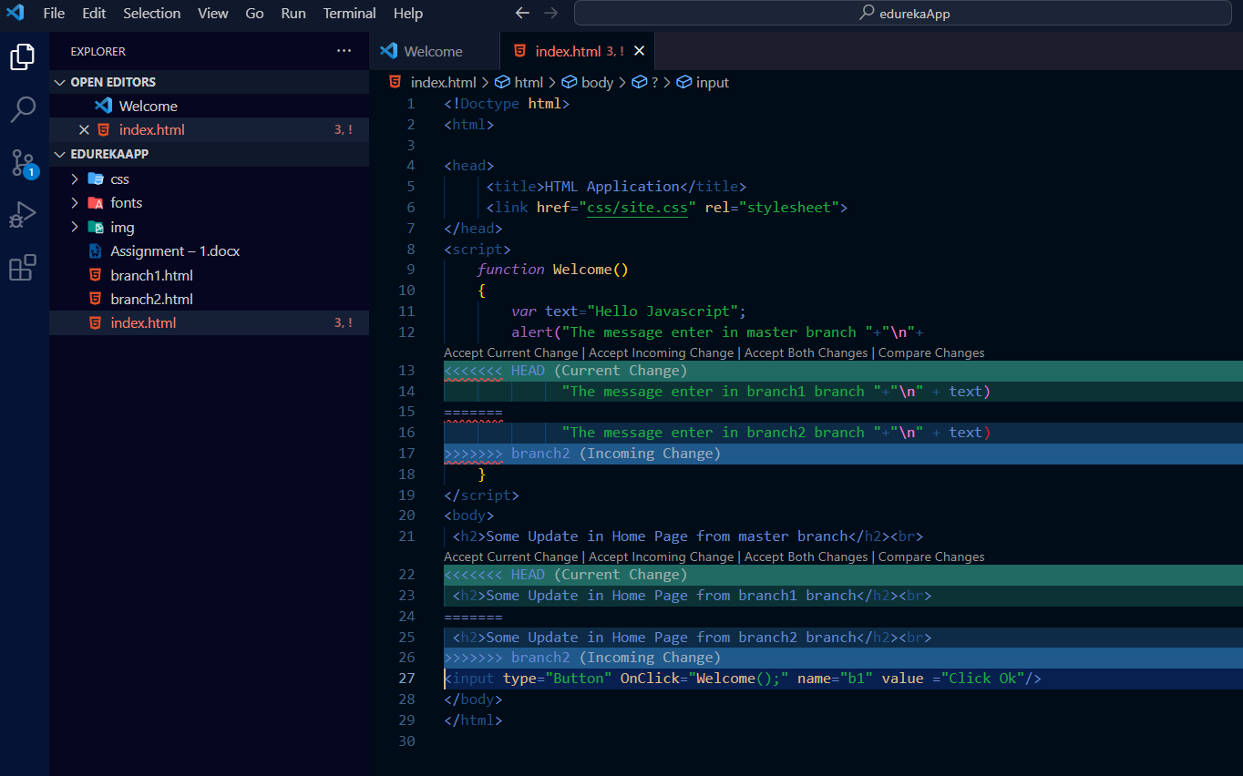

Accepted “incoming Code” by Kain and resolved the conflict in Master Branch

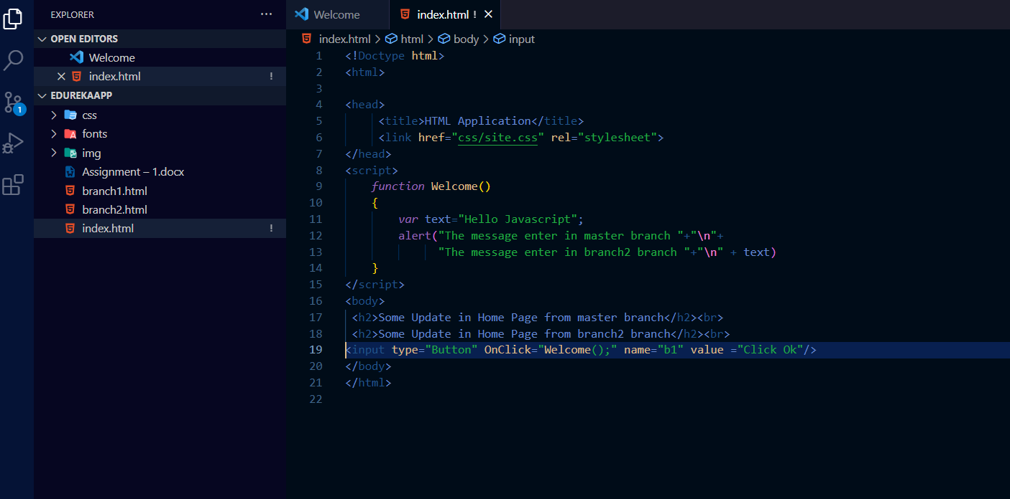

Resolved changes done into the “master” branch and push the code in repository

DELL@DESKTOP-KMU6QJU MINGW64 /d/test2/edurekaApp (master|MERGING)

$ git branch

branch1

branch2

* master

DELL@DESKTOP-KMU6QJU MINGW64 /d/test2/edurekaApp (master|MERGING)

$ git status

On branch master

Your branch is ahead of 'origin/master' by 1 commit.

(use "git push" to publish your local commits)

You have unmerged paths.

(fix conflicts and run "git commit")

(use "git merge --abort" to abort the merge)

Unmerged paths:

(use "git add <file>..." to mark resolution)

both modified: index.html

no changes added to commit (use "git add" and/or "git commit -a")

DELL@DESKTOP-KMU6QJU MINGW64 /d/test2/edurekaApp (master|MERGING)

$ git add .

DELL@DESKTOP-KMU6QJU MINGW64 /d/test2/edurekaApp (master|MERGING)

$ git status

On branch master

Your branch is ahead of 'origin/master' by 1 commit.

(use "git push" to publish your local commits)

All conflicts fixed but you are still merging.

(use "git commit" to conclude merge)

Changes to be committed:

modified: index.html

DELL@DESKTOP-KMU6QJU MINGW64 /d/test2/edurekaApp (master|MERGING)

$ git commit -m "resolved confilct"

[master fd15cd4] resolved confilct

DELL@DESKTOP-KMU6QJU MINGW64 /d/test2/edurekaApp (master)

$ git push origin master

Enumerating objects: 1, done.

Counting objects: 100% (1/1), done.

Writing objects: 100% (1/1), 223 bytes | 223.00 KiB/s, done.

Total 1 (delta 0), reused 0 (delta 0), pack-reused 0 (from 0)

To https://github.com/bpjsons/edurekaApp.git

a5fc759..fd15cd4 master -> master

DELL@DESKTOP-KMU6QJU MINGW64 /d/test2/edurekaApp (master)