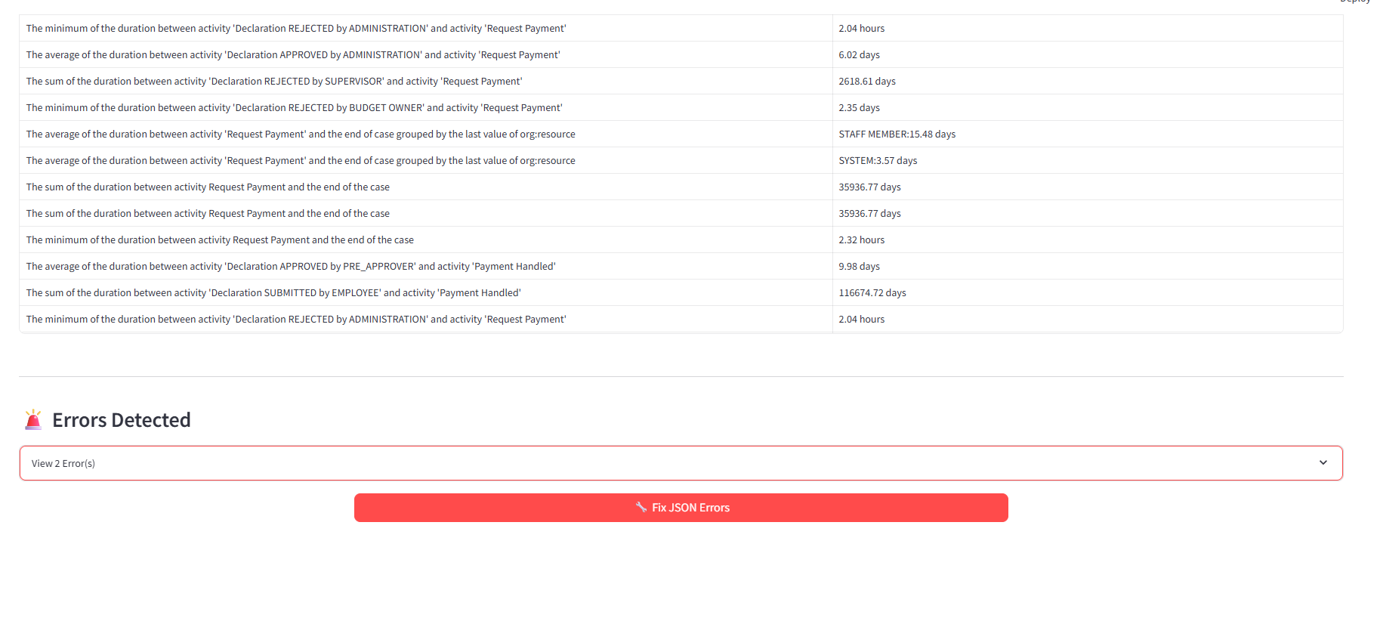
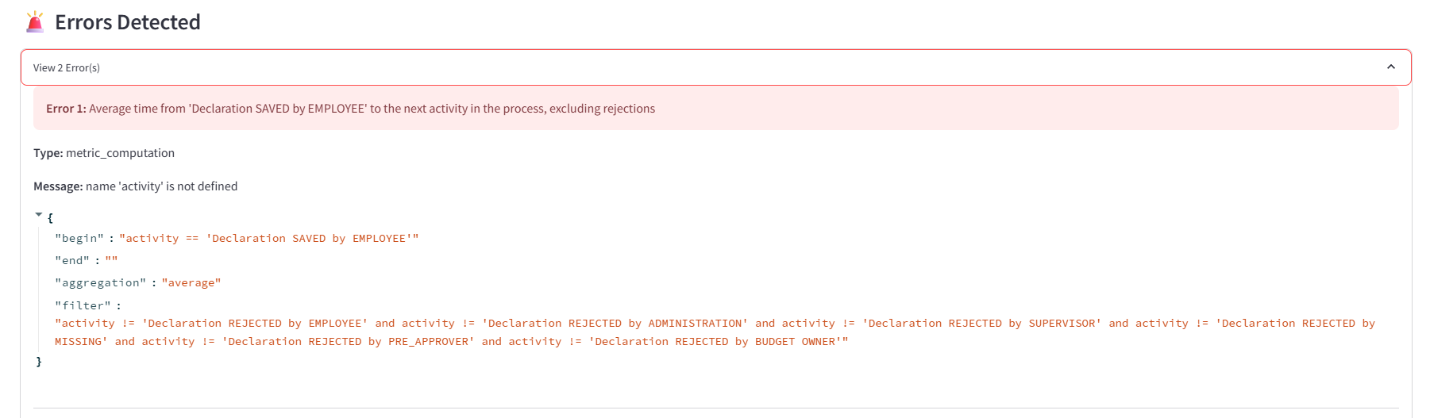

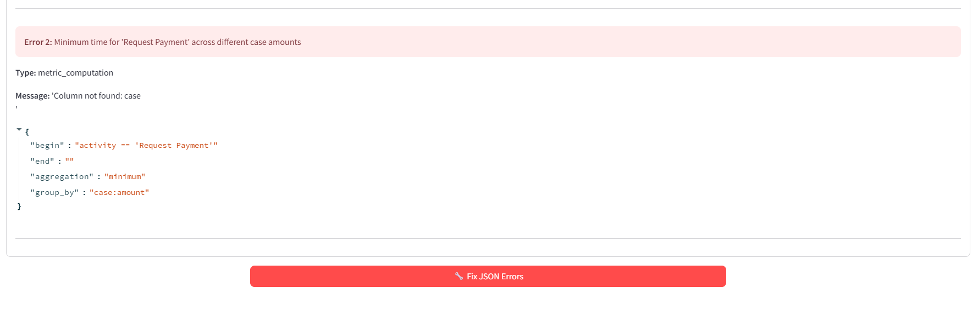

# {
# "PPIname": "Average time from 'Declaration SAVED by EMPLOYEE' to the next activity in the process, excluding rejections",
# "PPIjson": {
# "begin": "activity == 'Declaration SAVED by EMPLOYEE'",
# "end": "",
# "aggregation": "average",
# "filter": "activity != 'Declaration REJECTED by EMPLOYEE' and activity != 'Declaration REJECTED by ADMINISTRATION' and activity != 'Declaration REJECTED by SUPERVISOR' and activity != 'Declaration REJECTED by MISSING' and activity != 'Declaration REJECTED by PRE_APPROVER' and activity != 'Declaration REJECTED by BUDGET OWNER'"
# }
# },
# {
# "PPIname": "Minimum time for 'Request Payment' across different case amounts",
# "PPIjson": {
# "begin": "activity == 'Request Payment'",
# "end": "",
# "aggregation": "minimum",
# "group_by": "case:amount"
# }
# }
# ]

