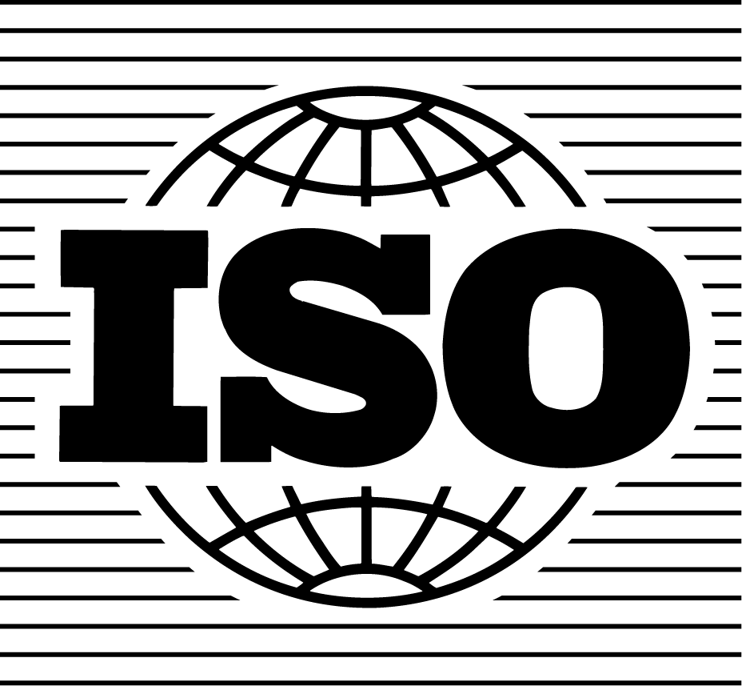

Document: ISO/TC 176/SC 2/N 544R3
Our ref

Secretariat of ISO/TC 176/SC 2 Date: 15 October 2008

ISO 9000 Introduction and Support Package:
Guidance on the Concept and Use of the Process Approach for management systems

In conjunction with the publication of the International Standard ISO 9001:2008, ISO/TC 176/SC 2 has published a number of guidance modules:

- Guidance on ISO 9001:2008 Sub-clause 1.2 'Application'
- Guidance on the Documentation requirements of ISO 9001:2008
- Guidance on the Terminology used in ISO 9001 and ISO 9004
- Guidance on the Concept and Use of the Process Approach for management systems
- Guidance on 'Outsourced Processes'

Together these are being made available as the ISO/TC 176/SC 2 “ISO 9000 Introduction and Support Package”.

Feedback from users of the standards will be used to determine whether additional modules should be developed, or if these published modules should be revised.

The modules, and further information on the ISO 9001:2008 standard, may be downloaded from the following web sites:

www.iso.org
www.iso.org/tc176/sc2

C Corrie
For the BSI Secretariat of
ISO/TC 176/SC 2
1) Introduction

Key words: management system, process approach, system approach to management

Content

1. Introduction 2
2. What is a process? 4
3. Types of processes 4
4. Understanding the process approach 6
5. Implementing the process approach 8
5.1 Identification of processes of the organization 8
5.2 Planning of the process 10
5.3 Implementation and measurement of the process 13
5.4 Analysis of the process 13
5.5 Corrective action and improvement of the process 13

1. Introduction

This guidance document provides an understanding of the concepts, intent and the application of the “process approach” to the ISO 9000 family of Quality Management System standards. The guidance may also be used to apply the process approach to any management system regardless the type or the size of organization. This includes but is not limited to management systems for:
- Environment (ISO 14000 family),
- Occupational Health and Safety,
- Business Risk,
- Social Responsibility.

This guide also aims to promote a consistent approach to the description of processes and use of process related terminology.

The purpose of the process approach is to enhance an organization’s effectiveness and efficiency in achieving its defined objectives. In relation to ISO 9001:2008 this means enhancing customer satisfaction by meeting customer requirements.

Benefits of the process approach are:
- Integration and alignment of processes to enable achievement of desired outcomes
- Ability to focus effort on process effectiveness and efficiency.
- Provision of confidence to customers, and other interested parties, about the consistent performance of the organization.
- Transparency of operations within the organization.
- Lower costs and creation of shorter cycle times, through the effective use of resources.
- Improved, consistent and predictable results.
- Provision of opportunities for focused and prioritized improvement initiatives.
- Encouragement of the involvement of people and the clarification of their responsibilities.

2. What is a process?

A “Process” can be defined as a “set of interrelated or interacting activities, which transforms inputs into outputs”. These activities require allocation of resources such as people and materials. Figure 1 shows a generic process.

A major advantage of the process approach, when compared to other approaches, is in the management and control of the interactions between these processes and the interfaces between the functional hierarchies of the organization (as further explained in section 4).
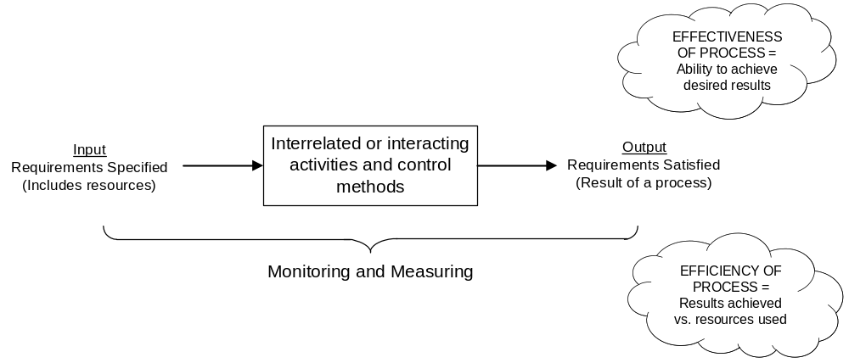
Figure 1. A generic process

Inputs and intended outputs may be tangible (such as equipment, materials or components) or intangible (such as energy or information). Outputs can also be unintended, such as waste or pollution.

Each process has customers and other interested parties (who may be either internal or external to the organization), with needs and expectations about the process, who define the required outputs of the process.

A system should be used to gather data to provide information about process performance, which should then be analyzed to determine if there is any need for corrective action or improvement.

All processes should be aligned with the objectives, scope and complexity of the organization, and should be designed to add value to the organization.

Process effectiveness and efficiency can be assessed through internal or external review processes.

3. Types of processes

3.1 References to processes in ISO 9001:2008:

ISO 9001:2008 states:

In sub clause 0.1 General: “The design and implementation of an organization‘s quality management system is influenced by: its business environment, changes in that environment, or risks associated with that environment; its varying needs; its particular objectives; the products it provides; the processes it employs; its size and organizational structure. It is not the intent of this International Standard to imply uniformity in the structure of quality management systems or uniformity of documentation”.

In sub clause 0.2 Process Approach: “The application of a system of processes within an organization, together with the identification and interactions of these processes, and their management to produce the desired outcome, can be referred to as the “process approach“.

In sub clause 4.1 General requirements: “The organization shall establish, document, implement and maintain a quality management system and continually improve its effectiveness in accordance with the requirements of this International Standard. The organization shall:
a) determine the processes needed for the quality management system and their application throughout the organization (see 1.2),
b) determine the sequence and interaction of these processes,
c) determine criteria and methods needed to ensure that both the operation and control of these processes are effective,
d) ensure the availability of resources and information necessary to support the operation and monitoring of these processes,
e) monitor, measure (where applicable), and analyse these processes, and
f) implement actions necessary to achieve planned results and continual improvement of these processes.

These processes shall be managed by the organization in accordance with the requirements of this International Standard”.

Based on the above, each organization should define the number and type of processes needed to fulfil its business objectives. It is permissible for a process that is required by ISO 9001:2008 to be part of a process (or processes) that is already established by the organization, or to be defined by the organization in terms that are different to those in ISO 9001.

3.2 Typical types of processes that can be identified:

In accordance with 3.1 above, organizations have to define the number and types of processes needed to fulfil their business objectives. While these will be unique to each organization, it is however possible to identify typical processes, such as:

- Processes for the management of an organization. These include processes relating to strategic planning, establishing policies, setting objectives, ensuring communication, ensuring availability of resources for the other organization’s quality objectives and desired outcomes and for management reviews.

- Processes for managing resources. These include all the processes that are necessary to provide the resources needed for the organization’s quality objectives and desired outcomes.

- Realization processes. These include all processes that provide the desired outcomes of the organization.

- Measurement, analysis and improvement processes. These include the processes needed to measure and gather data for performance analysis and improvement of effectiveness and efficiency. They include measuring, monitoring, auditing, performance analysis and improvement processes (e.g. for corrective and preventive actions). Measurement processes are often documented as an integral part of the management, resource and realization processes; whereas analysis and improvement processes are treated frequently as autonomous processes that interact with other processes, receive inputs from measurement results, and send outputs for the improvement of those processes.

4. Understanding the process approach

A process approach is a powerful way of organizing and managing activities to create value for the customer and other interested parties.

Organizations are often structured into a hierarchy of functional units. Organizations are usually managed vertically, with responsibility for the intended outputs being divided among functional units.

The end customer or other interested party is not always visible to all involved. Consequently, problems that occur at the interface boundaries are often given less priority than the short-term goals of the units. This leads to little or no improvement to the interested party, as actions are usually focused on the functions, rather than on the intended output.

The process approach introduces horizontal management, crossing the barriers between different functional units and unifying their focus to the main goals of the organization.

It also improves the management of process interfaces (see Figure 2).

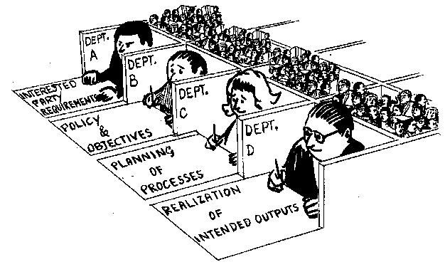 | 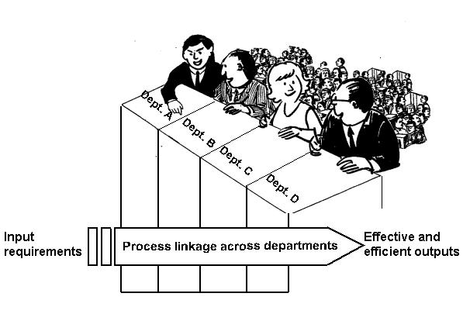

Figure 2. Example of Process linkages across departments in an organization.

The performance of an organization can be improved through the use of the process approach. The processes are managed as a system defined by the network of the processes and their interactions, thus creating a better understanding of added value.

Note: The consistent operation of this network is often referred to as the "system approach" to management.
Often the outputs from one process can be the inputs into other processes and are interlinked into the overall network or system (for generic examples, see Figure 3 and Figure 4).

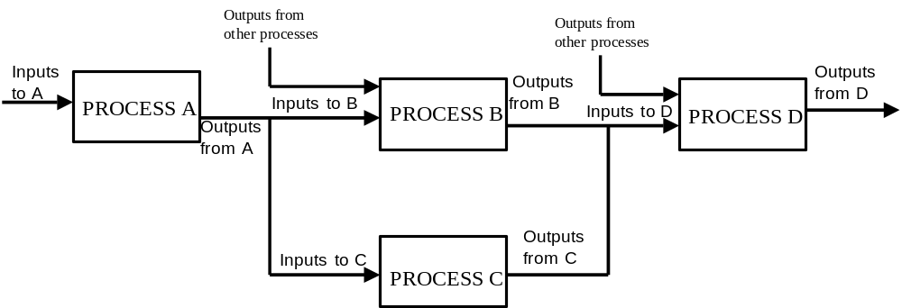

Figure 3. Example of a generic process sequence

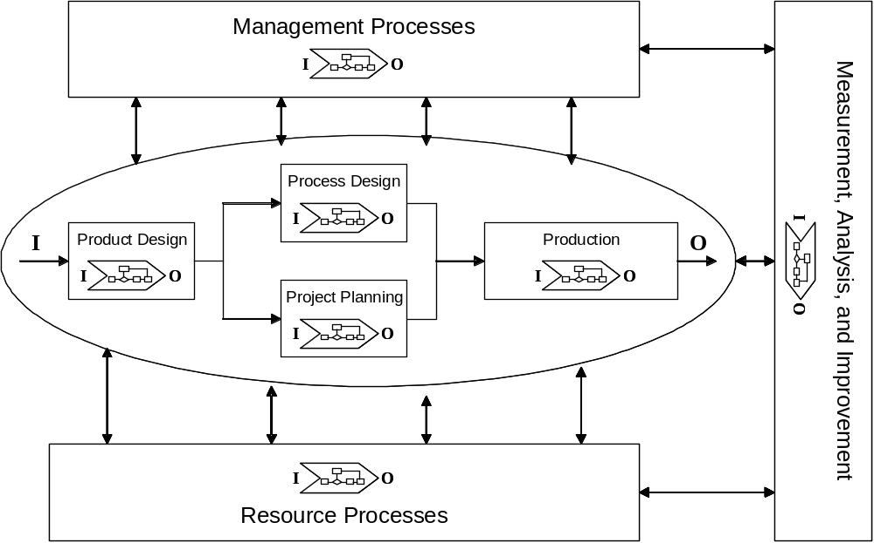

Figure 4. Example of a process sequence and its interactions.

5. Implementing the process approach

The following implementation methodology can be applied to any type of process. The step sequence is only one method and is not intended to be prescriptive. Some steps may be carried out simultaneously.

5.1 Identification of the processes of the organization

Steps in the process approach | What to do? | Guidance
5.1.1  Define the purpose of the organization | The organization should identify its customers and other interested parties as well as their requirements, needs and expectations, to define the organization’s intended outputs. | Gather, analyze and determine customer and other interested parties’ requirements, and other needs and expectations. Communicate frequently with customers and other interested parties to ensure continual understanding of their requirements, needs and expectations.  Determine the requirements for quality management, environmental management, occupational health and safety, management, business risk, social responsibilities and other management system disciplines that will be applied within the organization.
5.1.2  Define the policies and objectives of the organization | Based on the analyses of the requirements, needs and expectations, establish the organization’s policies and objectives. | Top management should decide which markets the organization should address and develop relevant policies. Based on these policies, management should then establish objectives for the desired outcome (e.g. products, environmental performance, occupational health and safety performance).
5.1.3  Determine the processes in the organization | Determine all the processes needed to produce the intended outputs. | Determine the processes needed for achieving the intended outputs. These processes include Management, Resources, Realization and Measurement, Analysis and Improvement.  Identify all process inputs and outputs, along with the suppliers, customers and other interested parties (who may be internal or external).
5.1.4  Determine the sequence of the processes | Determine how the processes flow in sequence and interaction. | Define and develop a description of the network of processes and their interaction. Consider the following:  - The customer of each process,  - The inputs and outputs of each process,  - Which processes are interacting,  - Interfaces and their characteristics,  - Timing and sequence of the interacting processes,  - Effectiveness and efficiency of the sequence.  Note: As an example, realization processes (such as product delivered to a customer) will interact with other processes (such as the management, measurement and monitoring, and resource provision processes).  Methods and tools such as block diagrams, matrix and flowcharts can be used to support the development of process sequences and their interactions.
5.1.5  Define process  ownership | Assign responsibility and authority for each process. | Management should define individual roles and responsibilities for ensuring the implementation, maintenance and improvement of each process and its interactions. Such an individual is usually referred to as the "process owner".  To manage process interactions, it may be useful to establish a "process management team", that has an overview across all the processes, and which includes representatives from each of the interacting processes.
5.1.6  Define process documentation | Determine those processes that are to be documented and how they are to be documented. | Processes exist within the organization and the initial approach should be limited to determining and managing them in the most appropriate way. There is no “catalogue”, or list of processes, that have to be documented.  The main purpose of documentation is to enable the consistent and stable operation of the processes.  The organization should determine which processes are to be documented, on the basis of:  - The size of the organization and its type of activities,  - The complexity of its processes and their interactions,  - The criticality of the processes, and  - The availability of competent personnel.  When it is necessary to document processes, a number of different methods can be used such as graphical representations, written instructions, checklists, flow charts, visual media, or electronic methods.  Note: For more guidance see the ISO 9000 Introduction and Support Package module Guidance on the Documentation Requirements of ISO 9001:2008

5.2 Planning the process

Steps in the process approach | What to do? | Guidance
5.2.1  Define the activities within the process | Determine the activities needed to achieve the intended outputs of the process. | Define the required inputs and outputs of the process.  Determine the activities required to transform the inputs into the desired outcomes.  Determine and define the sequence and interaction of the activities within the process.  Determine how each activity will be performed.  Note: In some cases, the customer may specify requirements not only for the outputs but also for the realization of the process.
5.2.2  Define the monitoring and measurement requirements | Determine where and how monitoring and measuring should be applied. This should be both for control and improvement of the processes and the intended process outputs. Monitoring is always applicable but measurement may not be practicable or even possible. Nevertheless measurement gives more objective data on the performance of the process and it is a powerful management and improvement tool.  Determine the need for recording results. | Identify the monitoring and measuring criteria for process control and process performance, to determine the effectiveness and efficiency of the process, taking into account such factors as:  - Conformity with requirements,  - Customer satisfaction,  - Supplier performance,  - On time delivery,  - Lead times,  - Failure rates,  - Waste,  - Process costs,  - Incident frequency.
5.2.3  Define the resources needed | Determine the resources needed for the effective operation of each process. | Examples of resources include:  - Human resources,  - Infrastructure,  - Work environment,  - Information,  - Natural resources,  - Materials,  - Financial resources
5.2.4  Verify the process against its planned objectives | Confirm that the characteristics of the processes are consistent with the purpose of the organization (see 5.1.1) | Verify that all the requirements identified in 5.1.1 are satisfied. If not, consider what additional process activities are required and return to 5.2.1 to improve the process.

5.3 Implementation and measurement of the process

Implement the processes and their activities as planned.
The organization may develop a project for implementation that includes, but is not limited to
- Communication,
- Awareness,
- Training,
- Change management,
- Management involvement,
- Applicable review activities.
Apply the controls, and perform the monitoring and measurements as planned.

5.4 Analysis of the process

Analyze and evaluate process information obtained from monitoring and measuring data, in order to quantify process performance. Where appropriate, use statistical methods.

Compare the results of process performance information with the defined requirements of the process, to confirm process effectiveness and efficiency and to identify any need for corrective action.

Identify process improvement opportunities based on the results of the analysis of process information.

Report to top management, and other relevant people in the organization, on the performance of the process, as appropriate.

5.5. Corrective action and improvement of the process

Whenever corrective actions are needed, the method for implementing them should be defined. This should include the identification and elimination of the root causes of the problems (e.g. errors, defects, lack of adequate process controls). The effectiveness of the actions taken should be reviewed. Implement the corrective actions and verify their effectiveness according to plan.

When planned process outcomes are being achieved and requirements fulfilled, the organization should focus its efforts on actions to improve process performance to higher levels, on a continual basis.

The method for improvement should be defined and implemented (examples of improvements include: process simplification, enhancement of efficiency, improvement of effectiveness, reduction of process cycle time). Verify the effectiveness of the improvement.

Risk analysis tools may be employed to identify potential problems. The root cause(s) of these potential problems should also be identified and eliminated, preventing occurrence in all processes with similarly identified risks.

The Plan-Do-Check-Act (PDCA) methodology can be a useful tool to define, implement and control corrective actions and improvements. Extensive literature exists about the PDCA cycle in numerous languages.

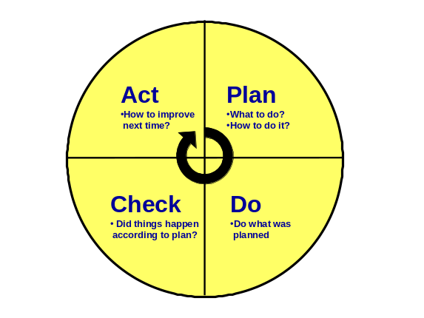
“Plan” | Establish the objectives and processes necessary to deliver results in accordance with customer, statutory and regulatory requirements and the organization's policies;
“Do” | Implement the processes;
“Check” | Monitor and measure processes and product against policies, objectives and requirements for the product and report the results;
“Act” | Take actions to continually improve process performance;”

The PDCA is a dynamic methodology that can be deployed within each of the organization’s processes and across their interactions. It is intimately associated with planning, implementation, verification and improvement.

Maintaining and improving process performance can be achieved by applying the PDCA concept at all levels within an organization. This applies equally to all processes, from high-level strategic processes to simple operational activities.

