**Bipin Dahal ID: 77202688**

**ToDo App**

Description

To Do app is an android based mobile application. It is developed on android studio with java programming language. The TODO app lets a user create, read, update and delete to-do tasks. A task has a description and date to show when it was created. Check box is present in the list view page. Check box can be checked to show the task is completed.

Instructions

* Download the zip file or clone the repository
* Unzip the file
* Open the project on android studio
* Run

Requirement

* Android Studio 3.6 or newer
* Android 4.4+

Features

* Add new task
* Pick a date from calendar
* Mark task as completed / uncompleted
* Edit Task
* View Task
* Delete Task

Framework used

* MVVM (Model View ViewModel)

Database

* SQLite

User Interface

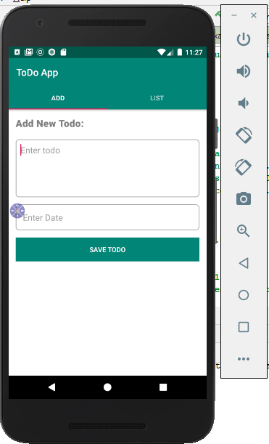

Figure 1: Initial view of ToDo app

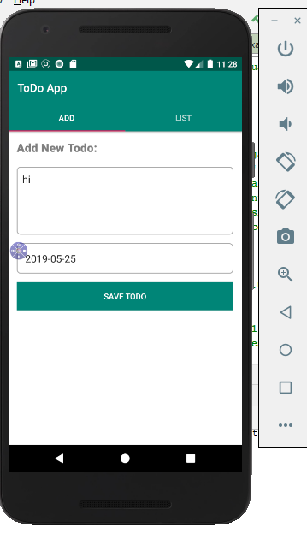

Figure 2: Adding to do activity

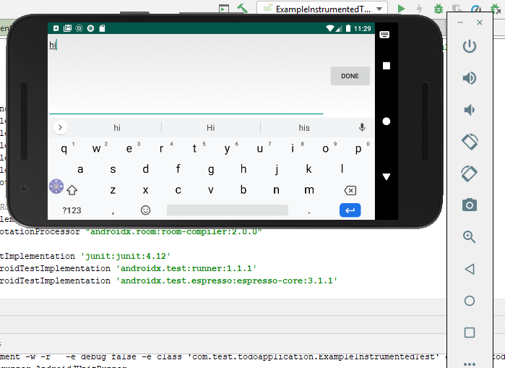

Figure 3: Rotating screen

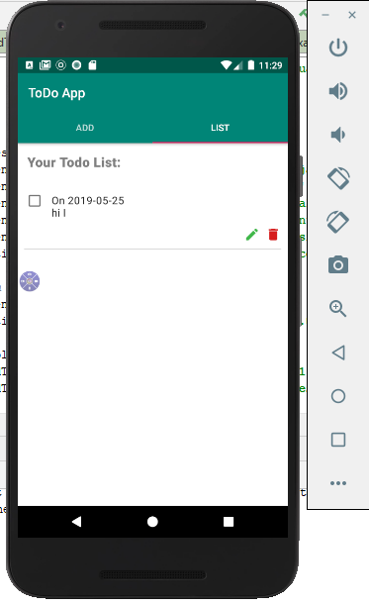

Figure 4: Showing added to do list

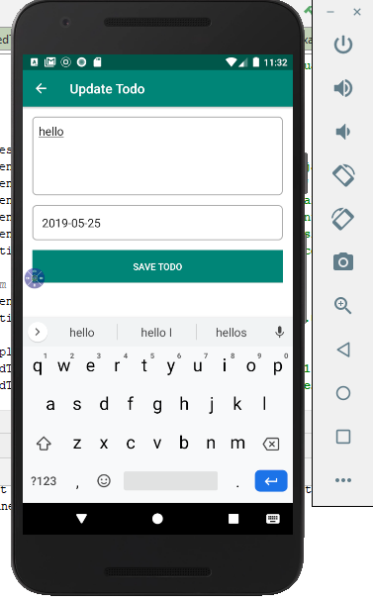

Figure 5: Updating recent added to do activity

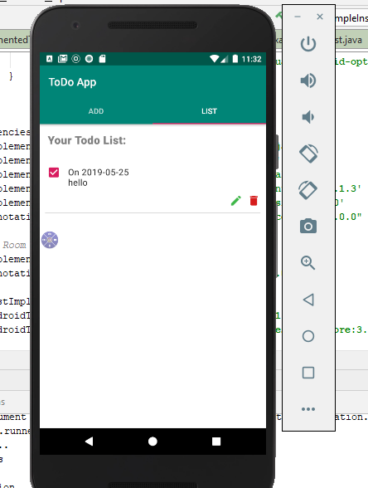

Figure 6: Showing to do activity after updating

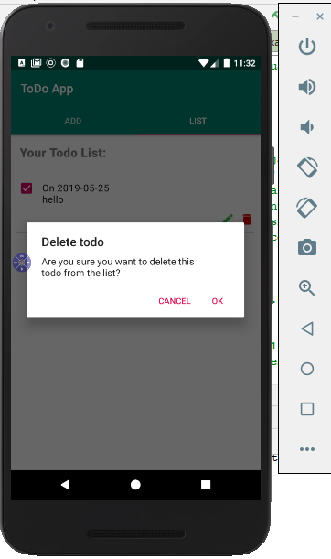

Figure 7: Deleting to do activity

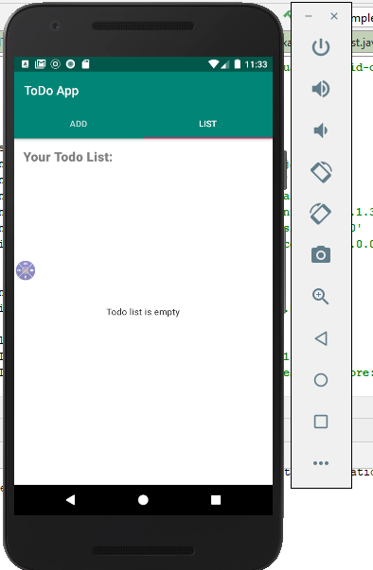

Figure 8: list view page after deleting to do activity