USER GUIDE

News Classification Automation
User Guide
Choose the right route, complete the work and download the correct output.

1 Choose the route
What you have | Open | Result
Raw daily workbook | New Run | Preparation, repeat review, then classification or qualified download
Workbook ready for tagging | Classify & Validate | System classification, validation and reviewed output
System and manual results | Accuracy Check | One saved comparison report

Tabs at a glance
Tab | Use
Overview | Find a run, resume work, open validation or download original system results
New Run | Prepare a raw daily workbook and review repeated articles
Classify & Validate | Run classification, read articles, correct results and download
Accuracy Check | Compare system classifications with a complete manual file
Portfolio & Exclusions | Maintain coverage, exclusions, languages and the repeat threshold
Rules | Read active logic, download JSON or save a new rule version

2 Use Overview
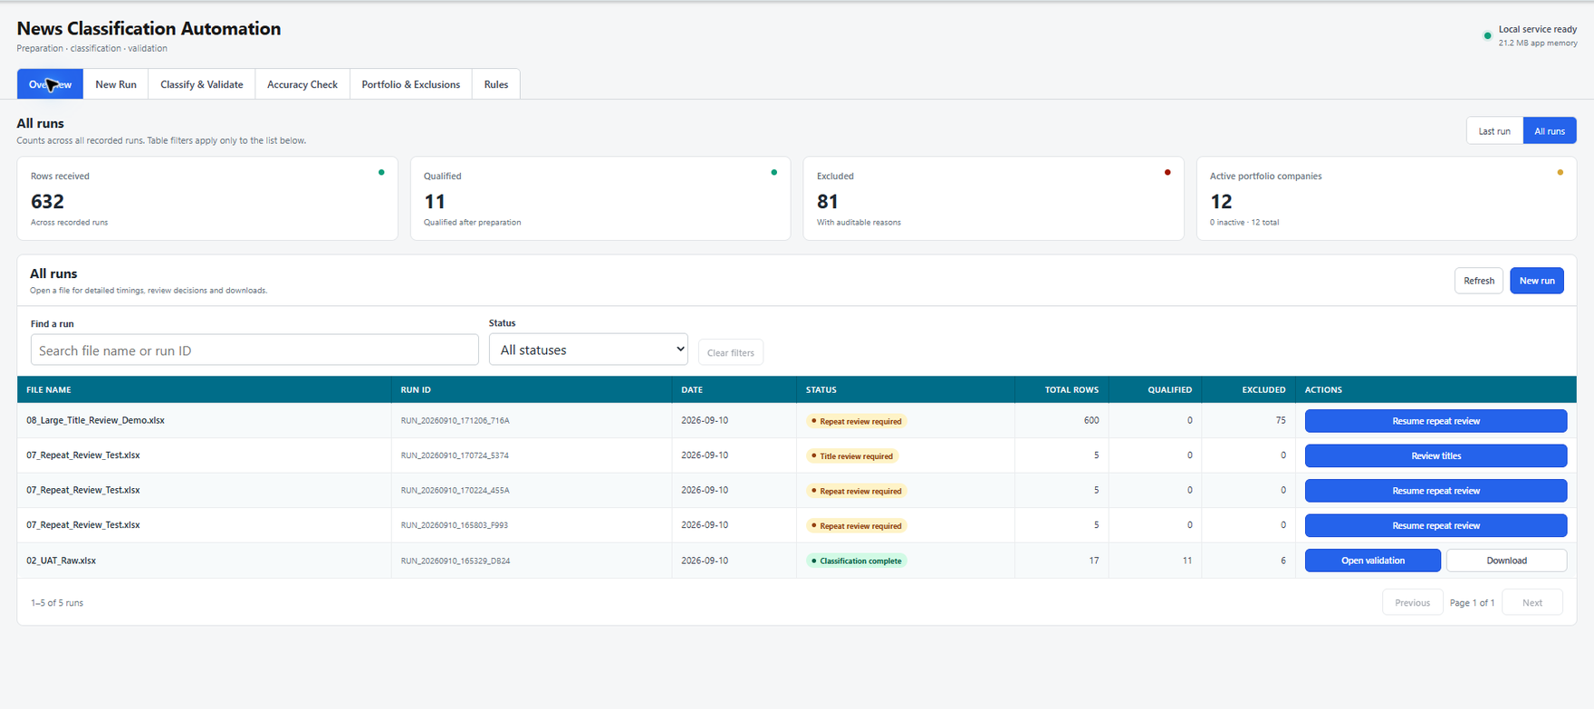
Overview shows current workload, status and the next available action
1 Choose the card scope Use Last run or All runs. This changes the four summary cards only.
2 Find a run Search by file name or run ID, or filter the list by status.
3 Open details Select the file name to see counts, timings, audit reports and saved downloads.
4 Continue work Use Actions to review titles, resume repeat review, choose the next step or open validation.
Download in Actions This is the original-system-results file used by Accuracy Check. Keep it unchanged.

3 Run a raw daily file
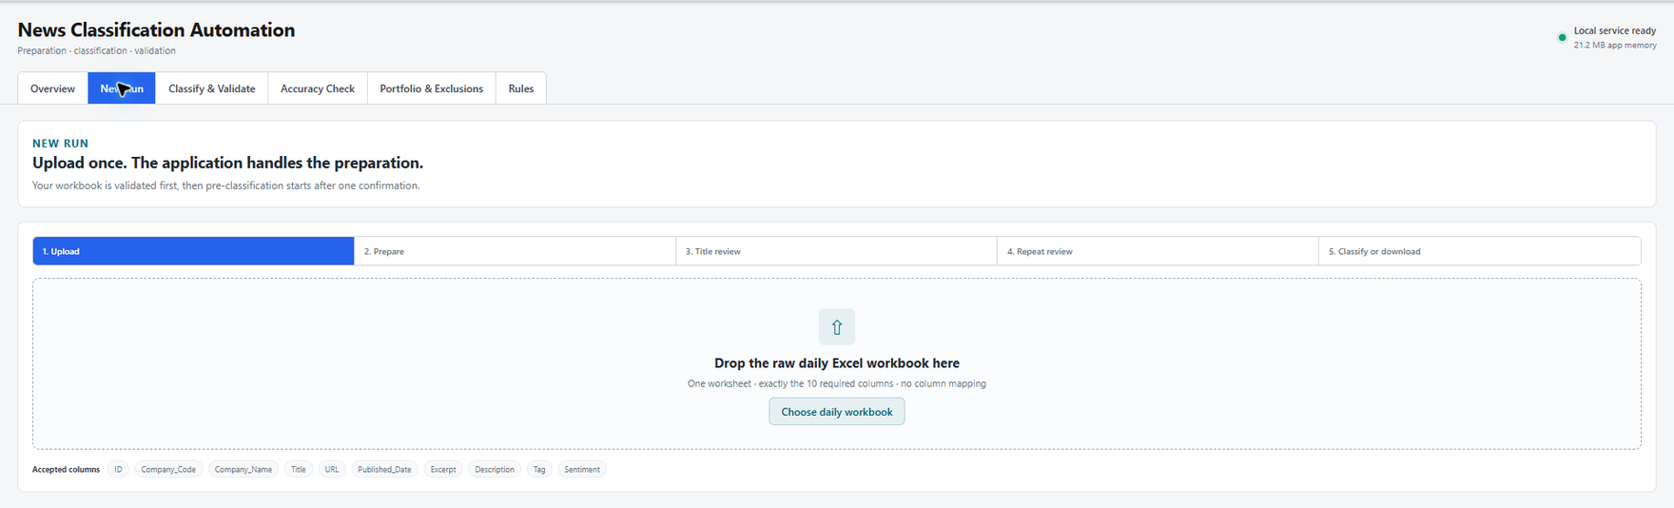
New Run accepts one raw workbook without column mapping
Required workbook Use one worksheet and exactly these ten columns.
Required columns
ID | Company_Code | Company_Name | Title | URL | Published_Date | Excerpt | Description | Tag | Sentiment

1 Upload Open New Run and drag the file into the upload area, or select Choose daily workbook.
2 Validate Correct any missing, duplicate or extra columns, or any multiple-sheet error.
3 Prepare Confirm Start Pre-Classification Preparation and wait for the totals.
4 Check Review Total rows, Qualified, Excluded and Repeat review. Download Before review if an audit file is needed.

Title Review
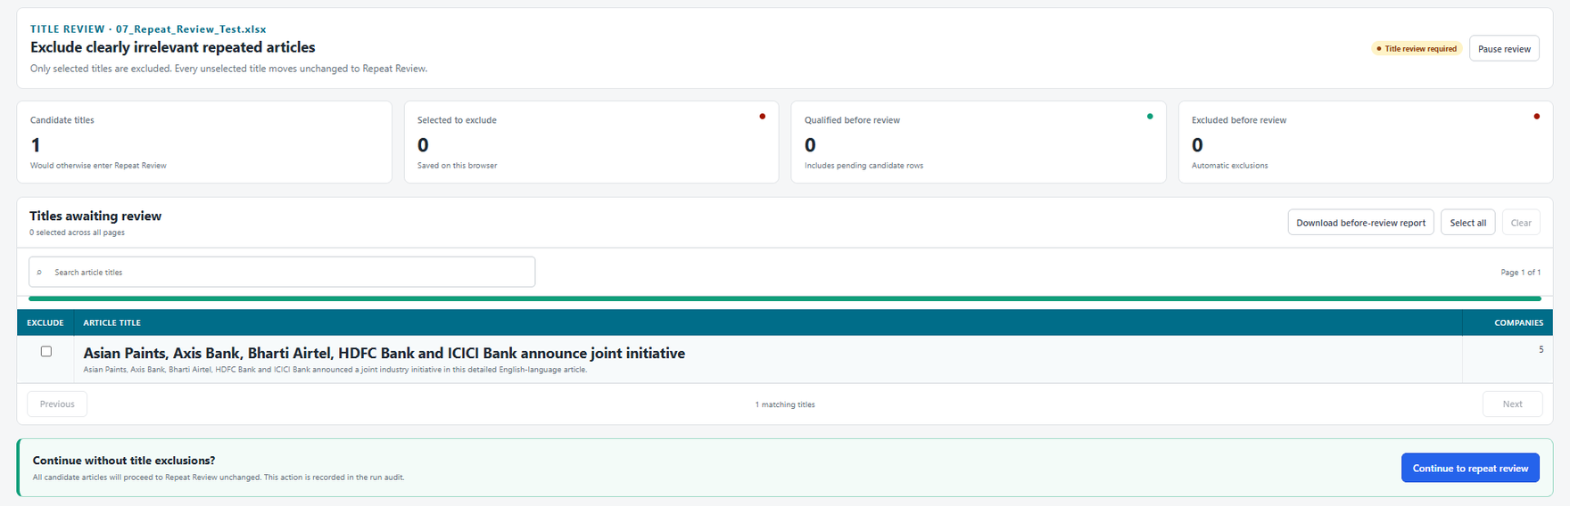
Select only clearly irrelevant repeated titles
Click anywhere on a title row to select it for exclusion; click again to clear it. Unselected titles continue to Repeat Review. Use Search, Select all or Clear when needed.

4 Complete repeat review
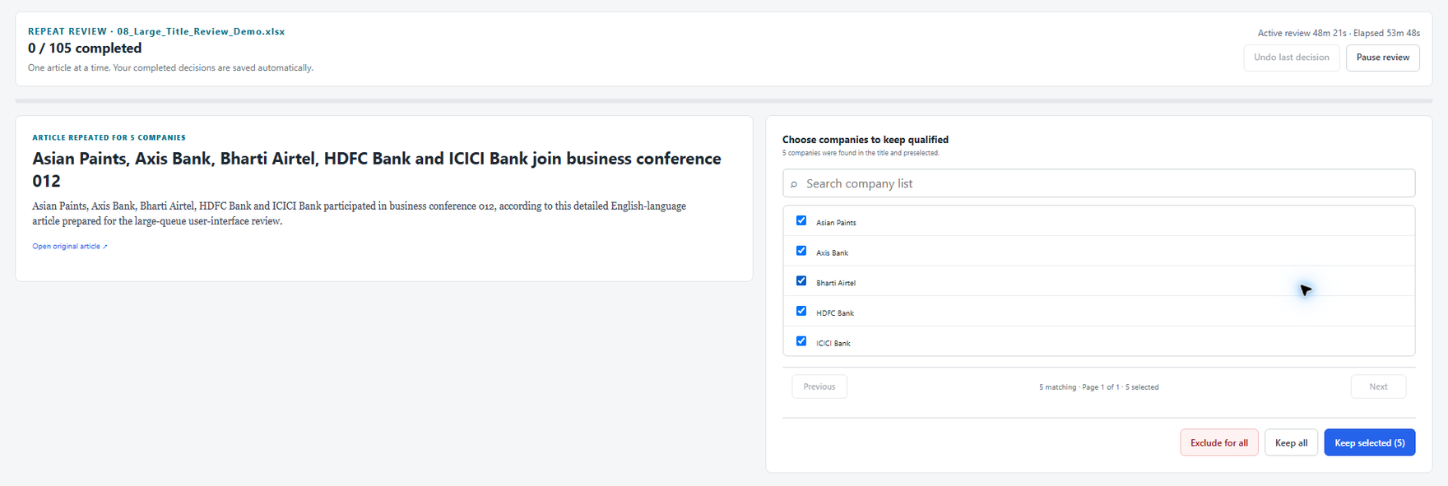
The article and company list stay side by side
1 Read Review the title, excerpt and original article when needed.
2 Check companies Names found in the title are preselected. Search the list when it is long.
3 Decide Choose Exclude for all, Keep all or Keep selected. The next article opens automatically.
4 Pause safely Every completed decision is saved. Select Pause review and resume later from Overview.

After the last review
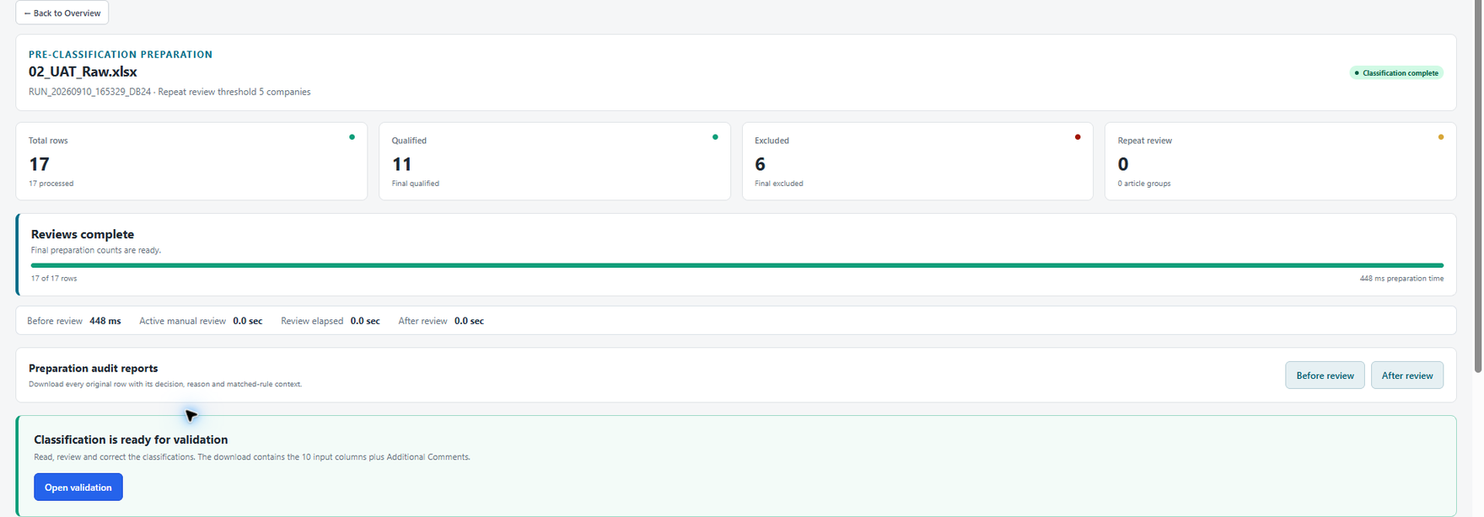
The run page separates preparation time from manual review time
Review final Qualified and Excluded counts, then choose the next step: proceed to classification, download qualified rows, create balanced part files, or decide later. Repeated article groups stay together, so part sizes may vary slightly.

5 Classify and validate
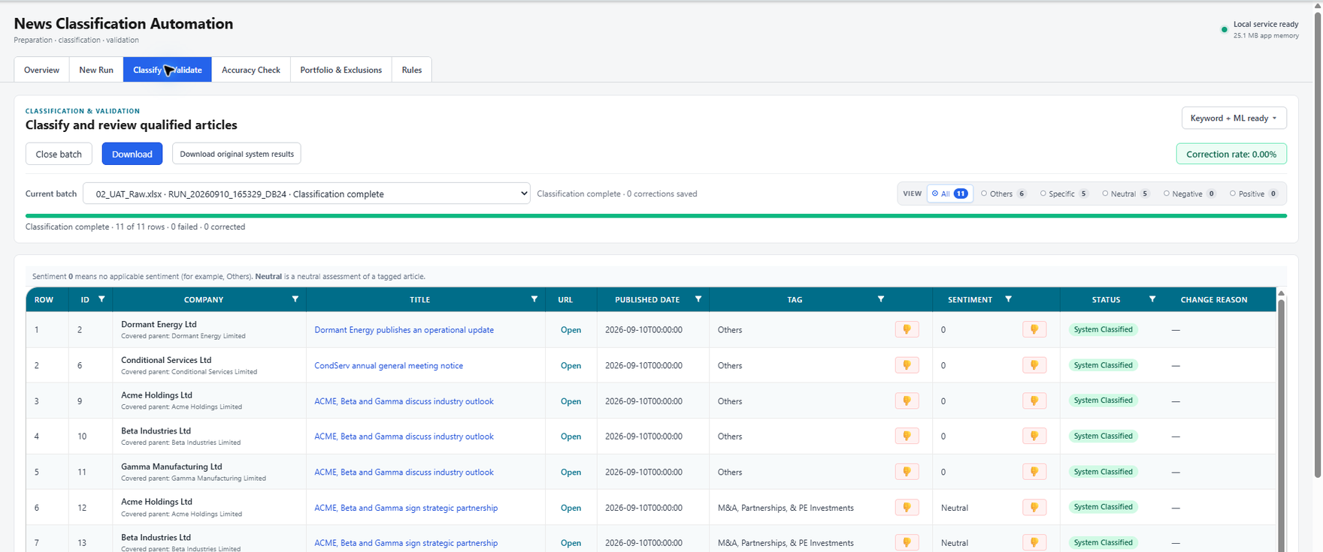
A completed batch opens directly in validation mode
1 Start For classification only, choose a one-sheet workbook with the same exact ten columns, then select Classify workbook.
2 Reopen Use Current batch or Previous batch to return to saved work.
3 Filter Use All, Others, Specific, Neutral, Negative or Positive. Column filters are also available.
4 Read Select the article title to open the reader. Select the thumbs-down button beside Tag or Sentiment to correct it.
5 Correct Change Tag and or Sentiment, enter the required Reason for change, then save. Status changes to Corrected.
6 Download The reviewed workbook contains the ten input columns plus Additional Comments.
End-to-end runs If Proceed to classification was selected after preparation, the completed batch appears here automatically.

6 Run Accuracy Check
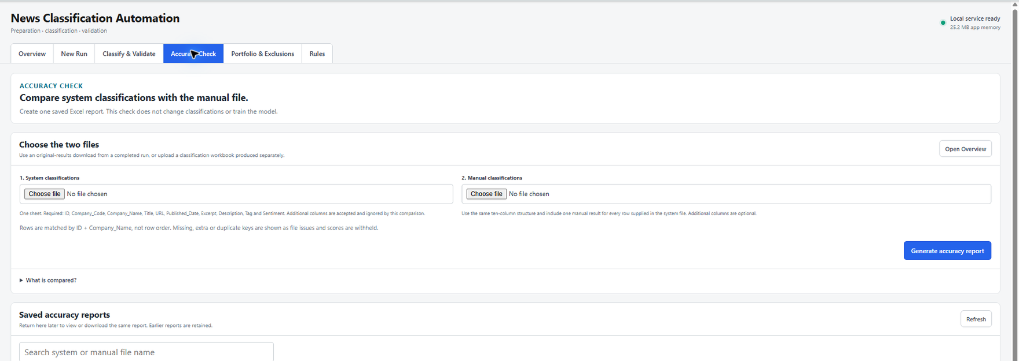
Accuracy Check compares a system file with the matching manual file
File | Use
1 System classifications | Preferred: Download original system results from a completed raw run and keep the workbook unchanged. A classification-only system workbook may also be used.
2 Manual classifications | Use the complete manual .xlsx file for the same supplied rows, including Others with sentiment 0.

1 Upload both files Additional columns are ignored by the comparison.
2 Generate Select Generate accuracy report. The check does not change classifications or train the model.
3 Read Rows are matched by ID plus original Company_Name, not by row order or Company_Code.
4 Resolve issues Missing, extra, invalid or duplicate keys are listed and scores are withheld until the files are unambiguous.
5 Download Return to Saved accuracy reports at any time to view or download the same report.
App-generated system file It contains System classifications and Snapshot details sheets. Keep both sheets unchanged.

Report sheets
Sheet | Use
Summary | Main scores, counts and interpretation
Category performance | Category and sentiment precision, recall and F1
Row comparison | Every compared row
Differences | Mismatched or unresolved rows
Validation details | File metadata and comparison issues

7 Maintain Portfolio and Exclusions
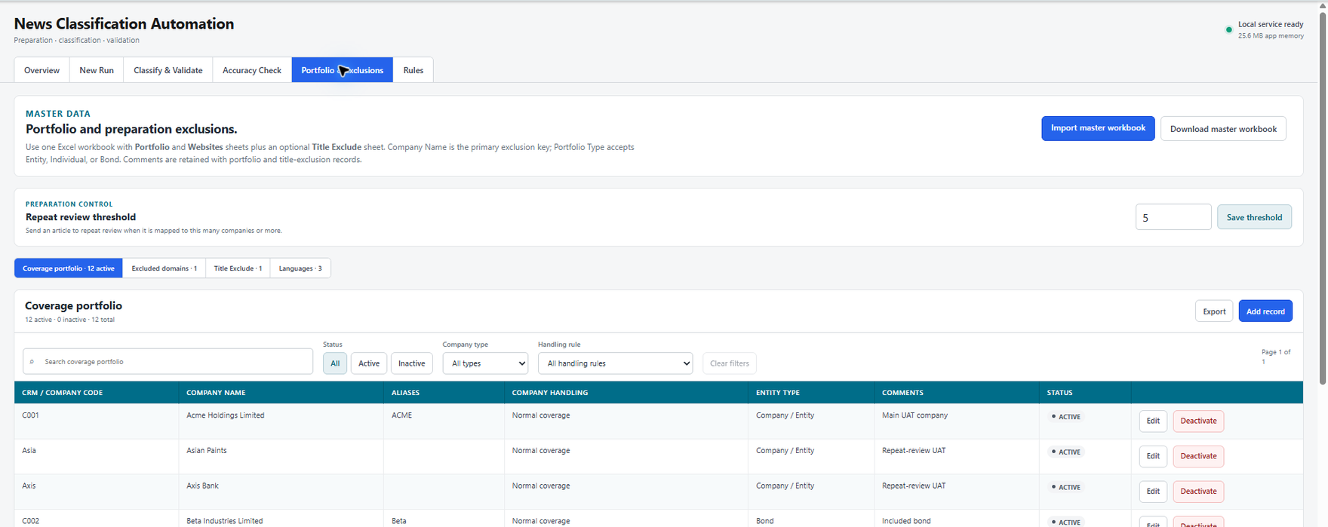
Coverage, exclusions, languages and repeat review settings are maintained together
- Use Download master workbook, complete the Portfolio and Websites sheets and optional Title Exclude sheet, then select Import master workbook.
- Company Name is the primary matching and exclusion key. CRM Code is reference information.
- Entity and Bond follow normal inclusion rules. Individual and inactive companies are excluded.
- Use | between aliases. Maintain comments where an explanation will help future users.
- Set and save Repeat review threshold. The starting value is 5 companies.
- Use filters to check Active, Inactive, company type and handling rule records.

8 Use Rules
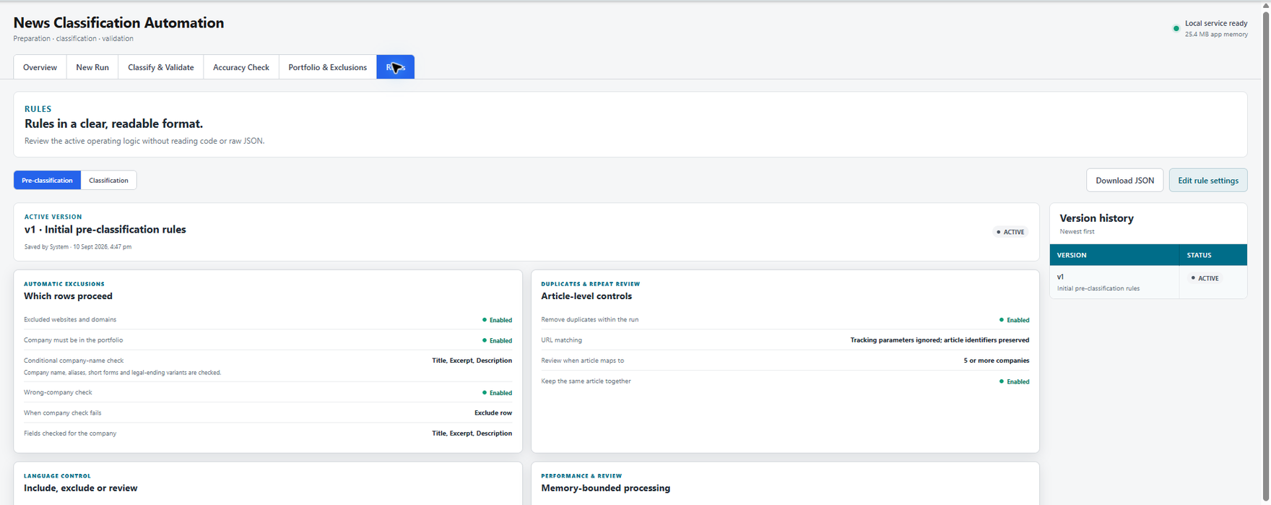
Rules are readable on screen and retained as auditable versions
1 Choose the rulebook Open Pre-classification or Classification.
2 Read Check the active version and the plain-language rule cards.
3 Download Use Download JSON when a copy of the active rules is needed.
4 Update Use Edit rule settings, validate the JSON and save a new active version. Earlier versions remain in history.
Model reminder Changing classification rules does not retrain the Tag model. Use Retrain model in Classify & Validate when training data changes.

Before closing a job
Check | Done when
Service | Local service ready is shown
Review | The queue is completed or Pause review was selected
Output | The required qualified, classified or accuracy file was downloaded
Accuracy evidence | Original system results were kept unchanged when comparison is planned

