Supplemental material 1:
Presession family OPM-MEG eligibility form
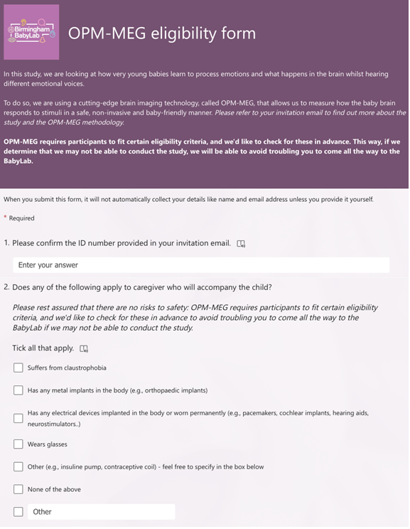
The Infant OPM-MEG eligibility form was emailed to parents alongside the invitation to participate in the study to avoid unnecessary travel for ineligible families. The form was implemented via MS Forms. Screenshots of the form are shown below to illustrate its visual presentation and layout, followed by the full text for reference and accessibility.
