Supplemental material 3:
Presession methods info sheet

METHOD INFORMATION SHEET
BABY & CHILD OPM-MEG
Ethics Approval Reference: […]

At […], we study infants’ and children’s cognitive development using and adapting different techniques. One of them is called Optically Pumped Magnetometers - Magnetoencephalography (OPM-MEG). This technique allows us to measure natural brain activity in response to different experiences, such seeing a face, feeling a touch, hearing someone talk or listening to music.
We are seeking your participation in a Baby OPM-MEG research project. With your help we hope to make a contribution to our knowledge about the ways in which babies and children develop and learn.
Before you decide whether or not to take part, it is important that you understand why the research is being done and what it will involve. Please take time to read this information carefully. If there is anything you do not understand, or if you would like more information, please ask us. Thank you for taking the time to read this.
What will happen if we take part?
This study will consist of one OPM-MEG session at […] in which your child will engage in an activity (e.g., listening to sounds, watching images) or sleep while we record their brain activity. OPM-MEG sensors we will use are completely safe and non-invasive: they only record what is happening in the brain and do not influence the child's body, brain, or brain activity. You will be with your child at all times. At the beginning of this session, we will take some time to explain you the study, get familiarized with the environment and answer your questions. We will also measure your baby’s head circumference so that we can prepare the OPM-MEG equipment. We may also use this period to place sensors that will help us to track the heart rate and position of your child’s head and eyes during the experiment. For some studies (this will be indicated in the Information sheet you received in the invitation email), we may also place little coin-sized tactors on the soles of your child’s hands and feet: they will deliver light vibrations (that feel like light tickles). Following the preparation, you will gently place your baby on a dedicated OPM-MEG bed, the top of which can slide. Once your baby is happy and settled, we will slide the top of the bed such that their head is positioned inside the OPM-MEG helmet and begin the study. During and after the study we will also take some photos and video recordings of your baby to calculate how their head is positioned in the helmet. Each task scan will take approximately 15-20 minutes. You will be able to take a break or stop the study at any point. In total, your visit will last approximately 120 minutes.

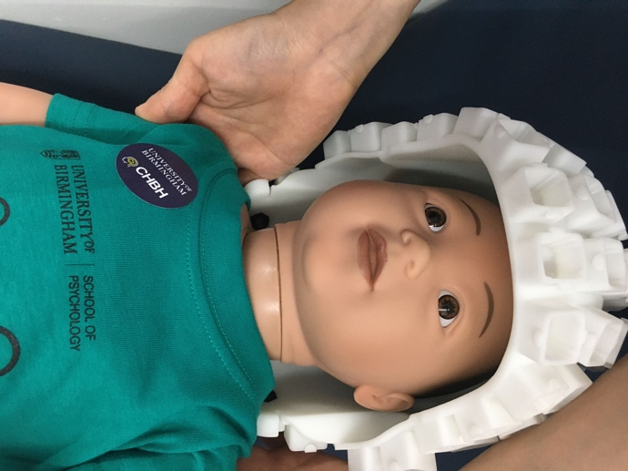
How does OPM MEG work?
Our brain cells (neurons) communicate through tiny electrical impulses. When neurons are active magnetic fields are created that are strong enough to be detected on the surface of the head. OPM sensors capture these subtle changes in tiny magnetic fields generated by brain activity in a completely safe and non-invasive way. How do OPM-MEG sensors work? OPM-MEG sensors are small boxes containing a very weak laser (similar to optical sensors of a computer mouse), and light sensors. The effects of the laser beam on the sensors is influenced by the tiny magnetic fields which are generated by neural activity in the brain, and so we are able to measure brain activity by this means.
Because the magnetic fields which we are trying to detect are very small, we need to carry out OPM-MEG studies in a specially designed lab room which shields us from the normal magnetic interference which is all around us in everyday modern life. To measure magnetic fields around the head, we will use a “sensor helmet” containing 20-100 sensors. This enables us to create a 3D image of brain activity. Because small movements can interfere with OPM-MEG recordings, the helmets are fixed to a chair or a bed and we make them comfortable to wear.
It is important to know that:
- OPM-MEG is non-invasive. Nothing influences the brain, and OPM-MEG just records what it can measure on the surface of the head.
- OPM does not generate any magnetic fields and does not involve any radiation.
- There are no known risks associated with OPM-MEG.

What should you and your child wear?
OPM-MEG is a very sensitive technique, and the brain recording can be affected by the presence of small metals in the room, even such tiny things like metal buttons. Therefore, please make sure that you and your child are wearing loose cotton clothes with as few pockets, metal buttons and zips as possible. T-shirts, light sweaters, leggings and tracksuit bottoms for parents and baby grows for infants (ideally without metal buttons) are ideal. If you are unsure, we can provide you with a loose top and/or trousers (scrubs) to change into. All jewellery, body piercings and hair accessories will need to be removed before the session. You may also be asked to remove your glasses for the duration of the recording to be in the recording booth with your child. If you or your or your child have metal in your body (e.g. plates, dental work, pacemakers), please let the researcher know in advance. There is no risk to safety, but it is useful for the researchers to know in order to fine tune brain recordings.

Further useful information:

Why have your child been invited?
Your child has been invited because you have volunteered to be part of […] database.
Does your child have to take part?
No. It is up to you to decide whether or not to take part. If you do decide to take part on behalf of your child, you will be given this information sheet to keep and a consent form to sign. You can ask the researcher questions about the study before you decide whether to participate. You are free to withdraw your child from the study at any time, including following data collection, without giving a reason. As well as asking for your consent to take part, we will also be monitoring your child’s behaviour to determine whether they are reasonably comfortable taking part. If they are not, we will end or pause the study. If you decide to withdraw, and data has been collected up until that point you will not have to consent to have the data included in any analysis. You can withdraw your data from this study by notifying the researcher, until up to 1 week after participation.
Are there any benefits from taking part in this study?
No. There will not be any direct benefits to your child directly in this study. It is hoped that the results from this research will help us to identify better measures for future studies in patients with neuropsychological conditions that are associated with impaired attentional control: for example, attention-deficit disorder.
Payments and Expenses
Your child will receive a non-monetary gift e.g. a t-shirt or a tote bag. We will provide free parking.
Brain health
OPM-MEG is not a useful diagnostic tool in detecting neurological conditions or undiagnosed epileptic seizures and structural abnormalities. Furthermore, the researchers at the […] are not trained in detecting functional or structural abnormalities. This means that should your child have any abnormalities in the structure or functionality of their brain this study would not help in detecting or diagnosing those.
- Although the brain images we create are not diagnostic scans, in the unlikely event that any unusual findings are noted further advice would be sought, and you would be informed. This is very unlikely.
- OPM-MEG will not induce functional or structural abnormalities to the brain. If you have any concerns regarding any symptoms, please consult your GP.
- If you suspect that your child may have an undiagnosed medical condition then please consult your GP. In this case your child should not take part in this study and you do not need to give a reason for withdrawal.
- If you know that your child has a medical condition affecting the brain you should either withdraw from the study (you do not have to give a reason); or you could inform the researcher and check whether he/she is eligible to take part.

Should you have any questions please feel free to ask the researcher now or at any point.
Will my child’s participation in the study be kept confidential?
Yes:
- Any personal information collected about your child during the study will be kept strictly confidential and can only be accessed by the named researchers for this study.
- All collected data and task results will be assigned a code linked to your child’s name. The file that links your child’s name with the data will be kept in a secure, password protected computer file and will be kept indefinitely. This password protected file can only be viewed by the researchers from this study and a limited number of key research personnel. We keep the identifying details on record in case you ever need to return to the centre to take part in multiple studies. The datasets collected are anonymised and only the code together with this password protected file can be used to identify your child. Your child’s gender and age on the day of data collection will be stored with the collected data. The file that links your child’s name with the other task results will be kept in a secure, password protected computer file and will be deleted as soon as it is not needed.
- A copy of your consent form will be kept securely for ten years.

Sometimes, new methods to analyse data become available after a study has ended. Therefore, we may in future ask for your permission to use the anonymised data in future studies. We may also ask your permission to share anonymised data, such as your child’s anonymised scan data, with other researchers.
What will happen to the results of the study?
We expect that the results of this study will be published in scientific journals and presented at scientific meetings. Participants will never be identified. We will not give feedback on the results of each individual participant as this is usually not meaningful.
Who has reviewed this study?
All research studies are checked by an ethics committee to ensure the research is conducted safely and to the best standards. This research has been reviewed by, and received favourable opinion through […].
Who is organising and funding the research?
The primary investigators involved in this project are […].
This study is organised by […].

What if I would like to contact someone with questions or complaints?

Contact Details
If you would like to discuss the research with someone beforehand (or if you have questions afterwards), please contact:
[…]

Who is conducting the research?
The research is conducted by the people below:
[…]
If you have any questions or require further details please contact these people.

