Supplemental material 8:
Preprocessing: ICA examples
Cardiac components were identified by visual inspection of their spatial topography and temporal activation. A component was classified as cardiac when its time course showed regular, sharply peaked deflections at a frequency consistent with infant resting heart rate (≈ 140 bpm) and its topography showed a smooth field pattern with the maximum projected onto sensors at the rim of the helmet, consistent with a deep extracranial source rather than a cortical generator. Components meeting both criteria were excluded, and the signal was reconstructed from the remaining components. Figure SM7.1 shows two representative examples.
Sub 102
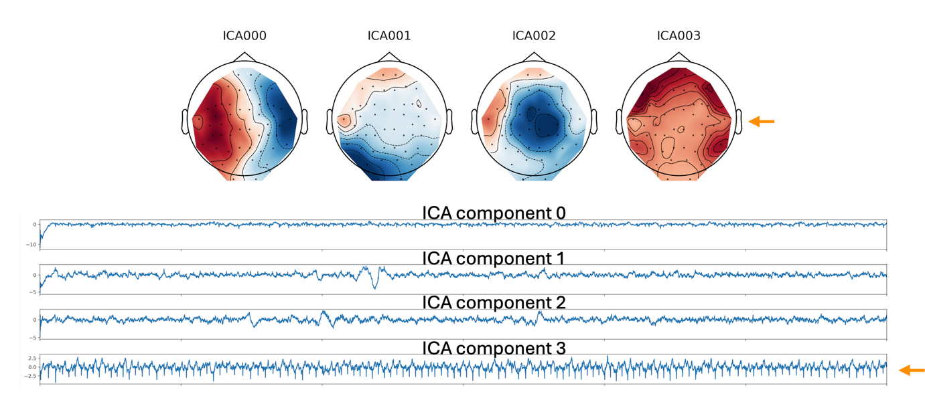
Sub 107
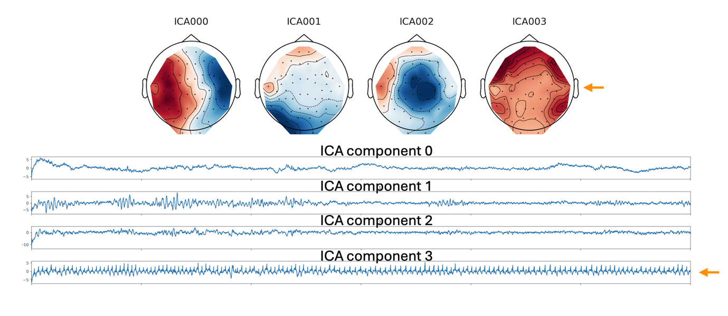Figure SM7.1. Visual identification of cardiac independent components in two representative infants. Each panel (sub-102, sub-104) shows the spatial topographies (top) and temporal activations (bottom) of the ICA components, with orange arrows marking the components classified as cardiac.

