Supplemental material 10:
Preprocessing: Bad epoch examples
Manual artefact removal remains common practice in infant electrophysiological research. We carried out a manual artefact inspection on detrended epochs (-100 to 600 ms relative to stimulus onset) to identify and remove large movement-related artefacts. Figure SM10.X shows one representative example of the visual cleaning.
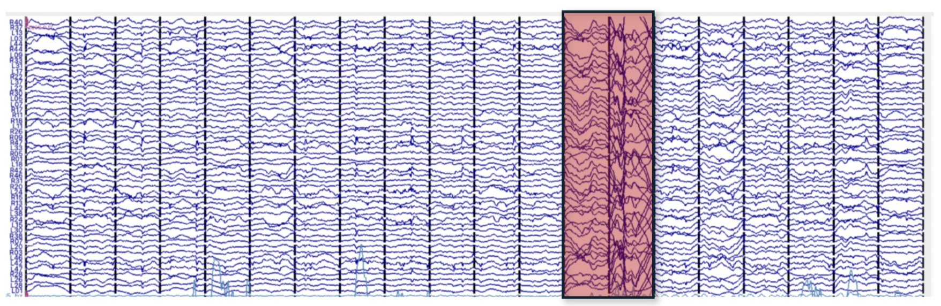
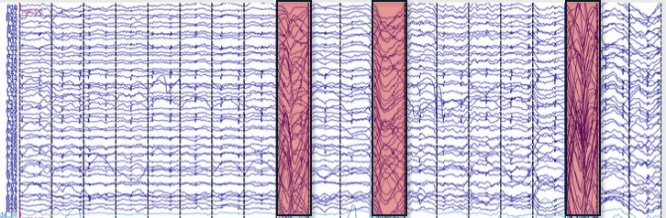
Figure SM8.1. Example of manual artefact inspection. Each segment shows a single epoch (-100 to 600 ms relative to stimulus onset) across the OPM channels. Epochs marked as bad during visual inspection are highlighted in red, accepted epochs in blue. Rejected epochs typically show large transient deflections, consistent with infant movement-related artefacts.

