Supplemental material 10:
Results: Outcomes of different preprocessing routines
To illustrate the contribution of each step in the preprocessing pipeline, this supplementary material presents the event-related fields (ERFs) at three successive stages: (i) after band-pass filtering only, (ii) after filtering and manual rejection of epochs containing large movement-related artefacts, and (iii) after filtering, manual rejection, and additional removal of cardiac independent components by ICA.
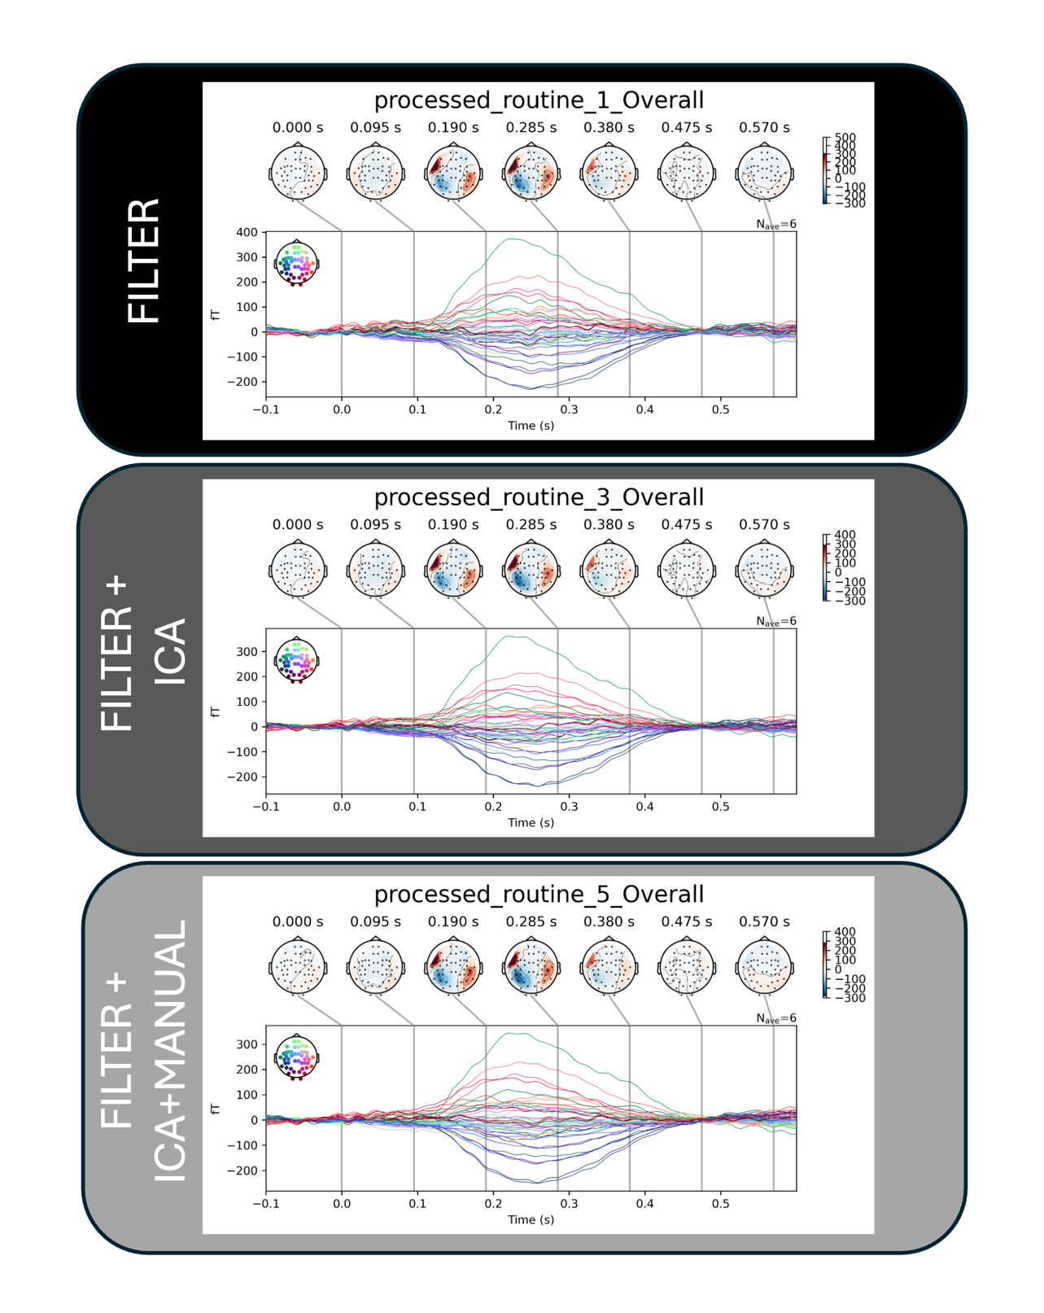
Figure SM9.1. Grand-average ERF collapsed across conditions (i.e. responses to frequent and infrequent tones averaged together).
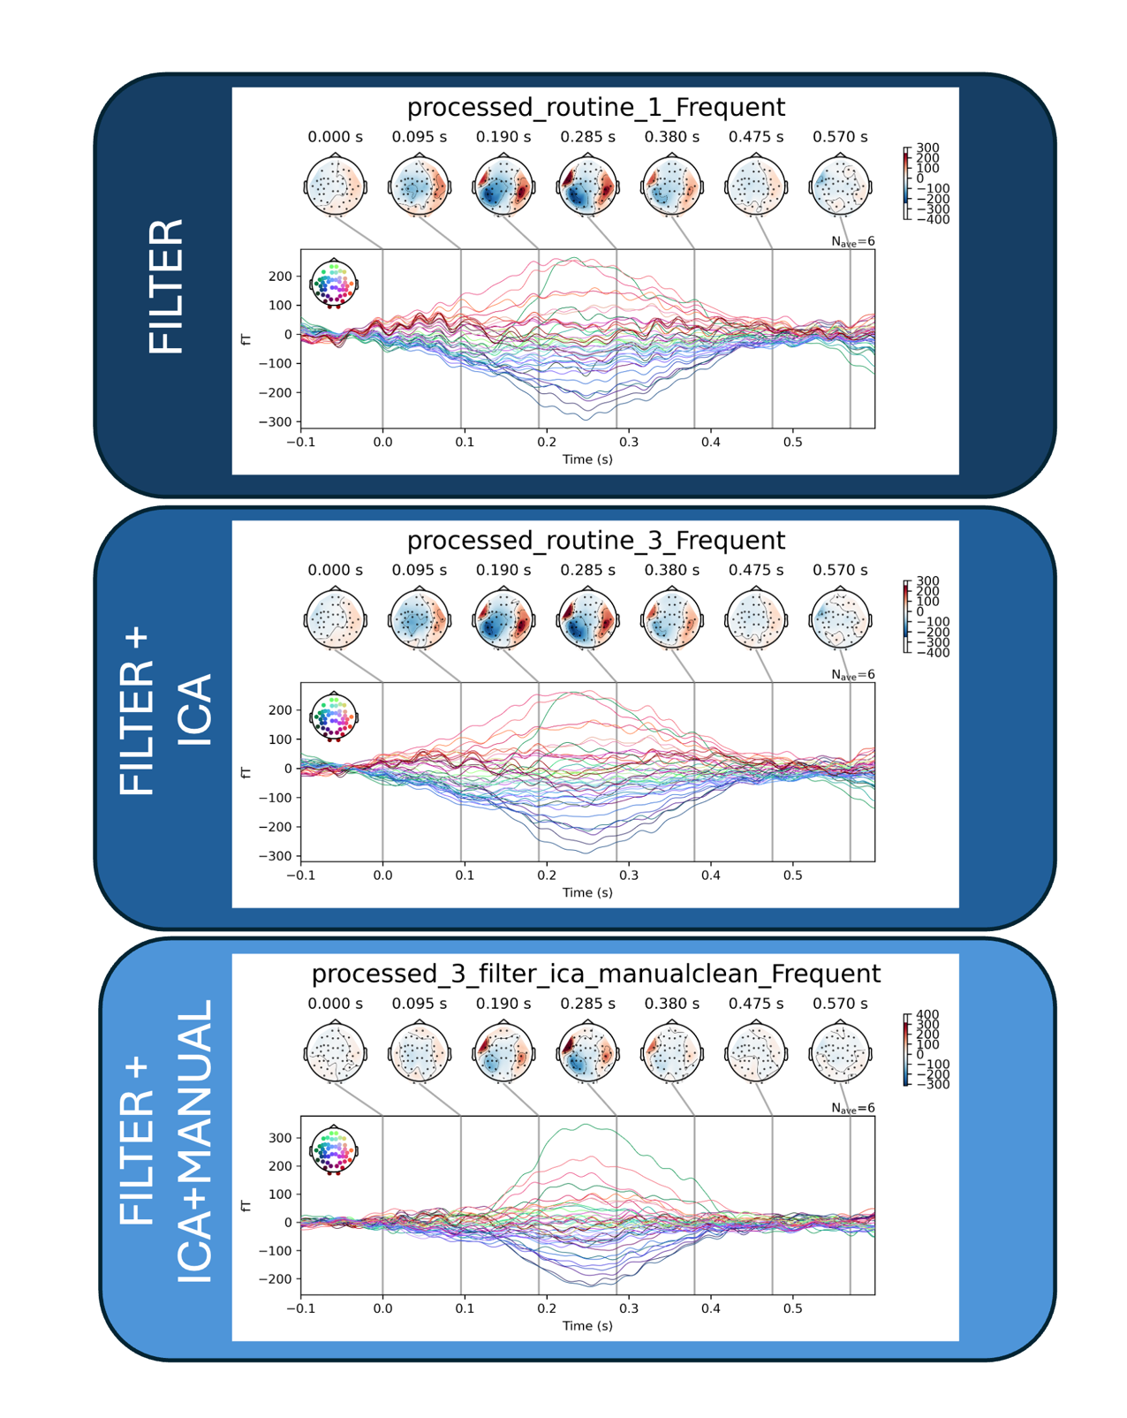
Figure SM9.2. Grand-average ERF to frequent auditory stimuli.

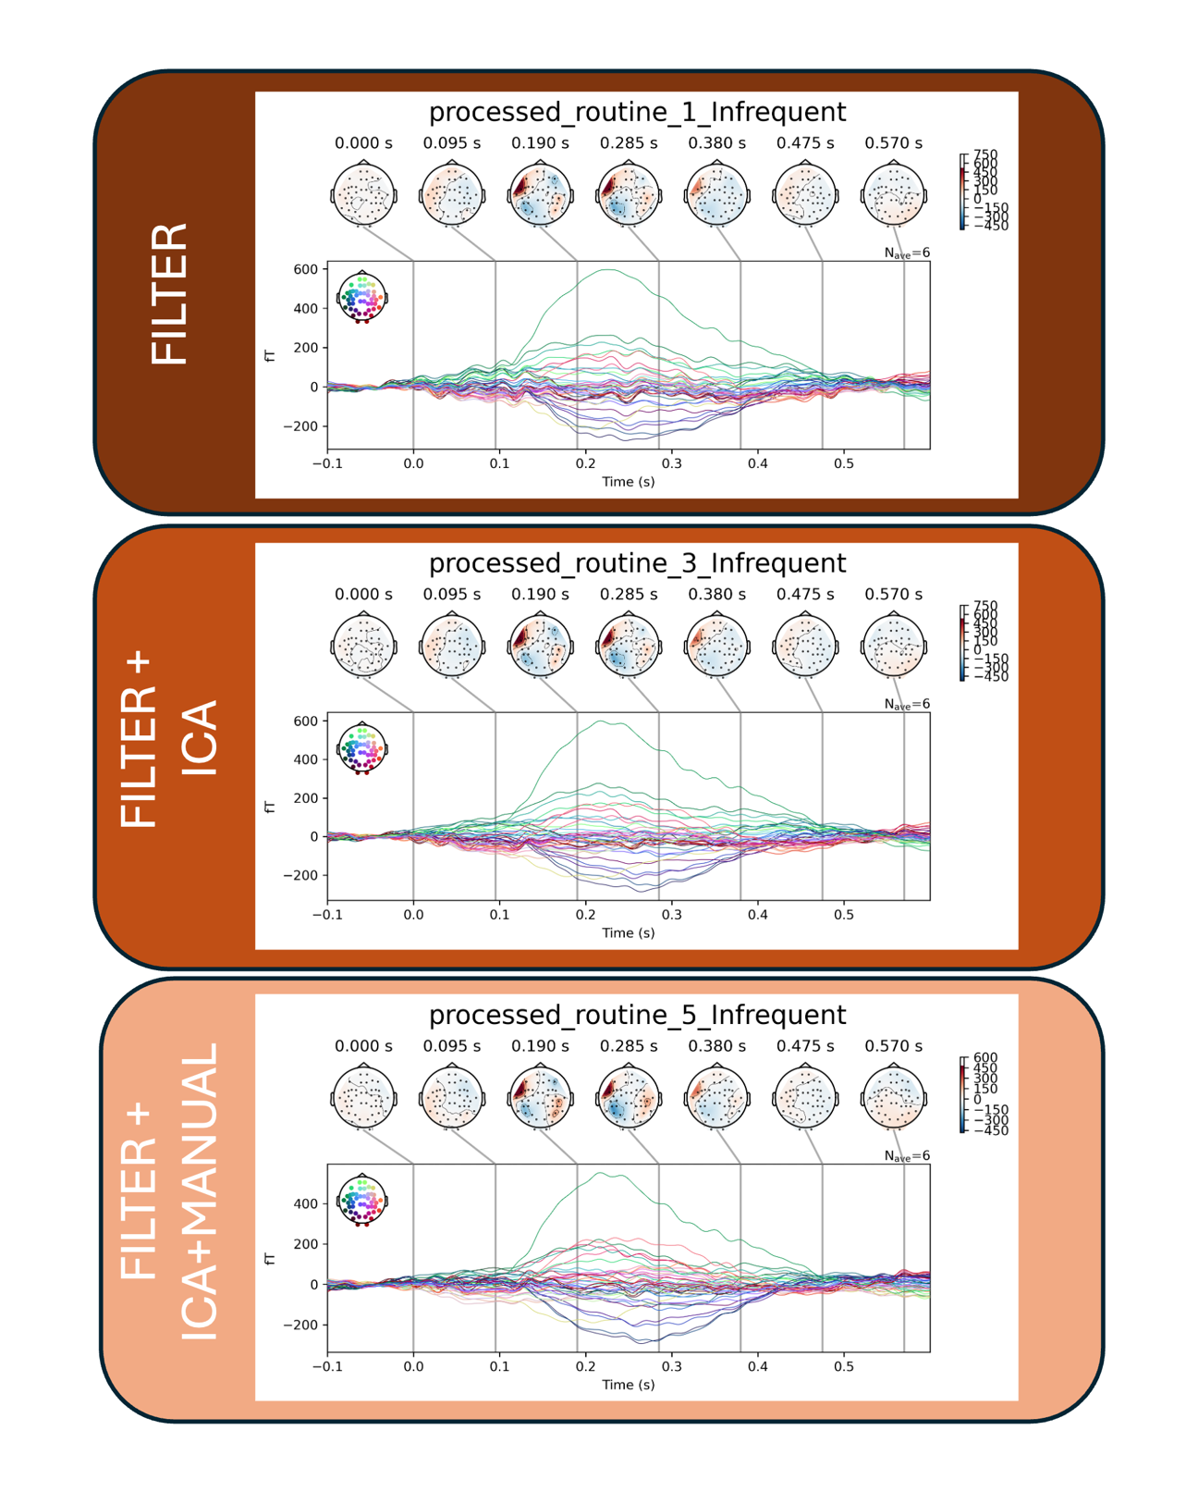

Figure SM9.3. Grand-average ERF to infrequent auditory stimuli

